

MATERIAL PLASMA EXPOSURE eXPERIMENT (MPEX)

DESCRIPTION DOCUMENT

MPEX-11-RPT-007-R0

Cornwall Lau

Juergen Rapp

Theodore Biewer

Tim Bigelow

Juan Caneses

Rick Goulding

Mike Kaufman

Arnold Lumsdaine

Etc.

February 2021

Prepared by

OAK RIDGE NATIONAL LABORATORY

Oak Ridge, TN 37831-6283

managed by

UT-BATTELLE, LLC

for the

US DEPARTMENT OF ENERGY

under contract DE-AC05-00OR22725

CONTENTS

[LIST OF FIGURES vi](#_Toc62820298)

[LIST OF TABLES xiv](#_Toc62820299)

[LIST OF ACRONYMS xv](#_Toc62820300)

[1. SUMMARY 1](#_Toc62820301)

[2. MISSION OF MPEX AND ITS SPECIFICATIONS 2](#_Toc62820302)

[2.1 The importance of plasma material interactions for fusion 2](#_Toc62820303)

[2.2 Technical challenges to be addressed on the road to reactors 2](#_Toc62820304)

[2.3 Science challenge in the PMI regime of future fusion reactors 3](#_Toc62820305)

[2.4 Role of linear plasma devices for PMI/PFC R&D 6](#_Toc62820306)

[2.5 Needed experimental conditions for PMI investigations 7](#_Toc62820307)

[2.5.1 Target plasma parameters and heat fluxes 7](#_Toc62820308)

[2.5.2 Angle of target to magnetic field 8](#_Toc62820309)

[2.5.3 Magnetic field strength and electron density 9](#_Toc62820310)

[2.5.4 Summary of target plasma parameter requirements 10](#_Toc62820311)

[2.6 Need for new Material-Plasma Exposure eXperiment 11](#_Toc62820312)

[2.7 Technical objectives, functional requirements, and their implementation 12](#_Toc62820313)

[2.7.1 Functional requirements 12](#_Toc62820314)

[2.7.2 Interpretation of MPEX Functional requirements 13](#_Toc62820315)

[2.7.3 Operational considerations 14](#_Toc62820316)

[2.8 Engineering design of MPEX 14](#_Toc62820317)

[2.8.1 Engineering considerations 14](#_Toc62820318)

[2.8.2 Principal features of the engineering design 15](#_Toc62820319)

[2.9 MPEX conceptual design overview 16](#_Toc62820320)

[2.9.1 Plasma source and heating system 17](#_Toc62820321)

[2.9.2 Magnet system 17](#_Toc62820322)

[2.9.3 Vacuum system 18](#_Toc62820323)

[2.9.4 Cooling system and in-vessel components 19](#_Toc62820324)

[2.9.5 Instrumentation and control 20](#_Toc62820325)

[2.9.6 Diagnostics 20](#_Toc62820326)

[2.9.7 Infrastructure 20](#_Toc62820327)

[2.10 References for Chapter 2 20](#_Toc62820328)

[3. PHYSICS BASIS 21](#_Toc62820329)

[3.1 Plasma modeling for sizing the systems 22](#_Toc62820330)

[3.1.1 Description of modeling tools 22](#_Toc62820331)

[3.1.2 Length of the device 24](#_Toc62820332)

[3.1.3 Plasma diameter requirements 45](#_Toc62820333)

[3.1.4 Pumping requirements 46](#_Toc62820334)

[3.1.5 Impurity transport 47](#_Toc62820335)

[3.1.6 B2-Eirene simulations with Bohm diffusion transport coefficients 52](#_Toc62820336)

[3.2 Helicon plasma source 58](#_Toc62820337)

[3.2.1 Key contributions from the Proto-MPEX program on plasma production 58](#_Toc62820338)

[3.2.2 Production of high-density helicon deuterium plasmas 59](#_Toc62820339)

[3.2.3 Neutral gas control and differential pumping requirements for the heating systems 67](#_Toc62820340)

[3.2.4 Quantification of plasma source performance 69](#_Toc62820341)

[3.2.5 Characterization of a steady-state water cooled helicon plasma source for MPEX 73](#_Toc62820342)

[3.2.6 Conclusions and implications for MPEX 84](#_Toc62820343)

[3.3 Electron heating 85](#_Toc62820344)

[3.3.1 Physics of O-X-B EBW heating for MPEX 85](#_Toc62820345)

[3.3.2 Physics of UH heating for MPEX 94](#_Toc62820346)

[3.3.3 Physics of 2nd harmonic X-mode ECH heating for MPEX 95](#_Toc62820347)

[3.3.4 Physics of whistler heating for MPEX 96](#_Toc62820348)

[3.3.5 Effect of magnetic field ripple on parallel electron transport during microwave plasma heating. 97](#_Toc62820349)

[3.4 Ion heating 109](#_Toc62820350)

[3.4.1 Introduction 109](#_Toc62820351)

[3.4.2 Theory 110](#_Toc62820352)

[3.4.3 Conclusions 127](#_Toc62820353)

[3.5 Combined heating 128](#_Toc62820354)

[3.6 References for Chapter 3 129](#_Toc62820355)

[4. PLASMA SOURCE AND HEATING SYSTEMS 134](#_Toc62820356)

[4.1 Helicon Plasma Production System 134](#_Toc62820357)

[4.1.1 Overview 134](#_Toc62820358)

[4.1.2 Electrical aspects of the helicon plasma source design 135](#_Toc62820359)

[4.1.3 Helicon antenna mechanical description 138](#_Toc62820360)

[4.1.4 Helicon antenna thermal / structural analysis 140](#_Toc62820361)

[4.2 ECH heating system 142](#_Toc62820362)

[4.2.1 Overview 142](#_Toc62820363)

[4.2.2 Technology requirements for all microwave heating schemes 143](#_Toc62820364)

[4.2.3 ECH chamber mechanical description 145](#_Toc62820365)

[4.3 ICH heating system 147](#_Toc62820366)

[4.3.1 Overview 147](#_Toc62820367)

[4.3.2 Engineering considerations 147](#_Toc62820368)

[4.3.3 Mechanical description 160](#_Toc62820369)

[4.4 Heal load specifications 162](#_Toc62820370)

[4.4.1 Target 163](#_Toc62820371)

[4.4.2 Dump tank 163](#_Toc62820372)

[4.4.3 Dump plate 164](#_Toc62820373)

[4.4.4 Helicon window and limiter 164](#_Toc62820374)

[4.4.5 Skimmer 164](#_Toc62820375)

[4.4.6 Vacuum chamber upstream of helicon 164](#_Toc62820376)

[4.4.7 Microwave absorber 164](#_Toc62820377)

[4.4.8 ICH heating 165](#_Toc62820378)

[4.4.9 Summary of heat load specifications 166](#_Toc62820379)

[4.5 References for Chapter 4 166](#_Toc62820380)

[5. MAGNET SYSTEMS 167](#_Toc62820381)

[5.1 Overview of MPEX Magnet System 167](#_Toc62820382)

[5.2 Requirements 168](#_Toc62820383)

[5.2.1 General requirements 168](#_Toc62820384)

[5.2.2 Magnet operating requirements 169](#_Toc62820385)

[5.3 References for Chapter 5 170](#_Toc62820386)

[6. VACUUM SYSTEMS 172](#_Toc62820387)

[6.1 Introduction 172](#_Toc62820388)

[6.1.1 Results from Proto-MPEX 172](#_Toc62820389)

[6.1.2 Gas load requirements for MPEX 173](#_Toc62820390)

[6.2 Vacuum System Overview 174](#_Toc62820391)

[6.3 References for Chapter 6 178](#_Toc62820392)

[7. COOLING SYSTEM AND IN-VESSEL COMPONENTS 178](#_Toc62820393)

[7.1 Target design 178](#_Toc62820394)

[APPENDIX A. ACTIVITIES BY NUCLIDE FOR FIVE LIKELY MATERIALS IRRADIATED IN HFIR AND COOLED FOR AT LEAST 2 YEARS A-1](#_Toc62820395)

[APPENDIX B. DOSE EQUIVALENT RATES (MREM/HR) FOR SEVERAL MPEX MATERIAL SAMPLES THAT WERE IRRADIATED IN THE HFIR CENTRAL FLUX TRAP FOR 10 CYCLES AS A FUNCTION OF COOLING TIME B-1](#_Toc62820396)

[APPENDIX C. DIFFERENCES IN SNS AND HFIR IRRADIATIONS C-1](#_Toc62820397)

[APPENDIX D. PLASMA-FACING COMPONENTS EXPOSED TO HIGH THERMAL FLUXES D-1](#_Toc62820398)

[APPENDIX E. COLD HIGH-DENSITY DIVERTOR PLASMAS IN FUTURE FUSION REACTORS E-1](#_Toc62820399)

[APPENDIX F. COMPLEXITY OF FUSION REACTOR MATERIAL SURFACES F-1](#_Toc62820400)

[APPENDIX G. IMPACT OF NEUTRON IRRADIATION ON PLASMA FACING MATERIALS AND COMPONENTS G-1](#_Toc62820401)

[APPENDIX H. COOLING WATER CHEMISTRY H-1](#_Toc62820402)

LIST OF FIGURES

[Figure 2‑1. Conceptual design CAD model of MPEX device. 16](#_Toc41525396)

[Figure 2‑2. Plasma source and heating components and vacuum systems components. 17](#_Toc41525397)

[Figure 2‑3. MPEX magnet system, shown with the device in cross-section. 18](#_Toc41525398)

[Figure 2‑4. Conceptual design model of MPEX shown in building location. 19](#_Toc41525399)

[Figure 3‑1. Contours of the calculated source and target temperatures as a function of the density and parallel heat flux output by the plasma source. 22](#_Toc41525400)

[Figure 3‑2. Schematic geometry used for plasma-neutrals modeling of MPEX. 24](#_Toc41525401)

[Figure 3‑3. Example of an axial electron density profile with source at z=0 and target at z=3m, shown in metric coordinates (left) and axial mesh coordinates (right). 25](#_Toc41525402)

[Figure 3‑4. Source ion flux profiles for different total ion source fluxes and source heat flux profiles for different total source power. 25](#_Toc41525403)

[Figure 3‑5. Upstream electron density profiles (at the source) for a 4 m long device: (a) 200 kW, (b) 300 kW, (c) 400 kW, (d) 500 kW. The total ion fluxes are parameterized. 26](#_Toc41525404)

[Figure 3‑6. Contours of constant source electron temperature as function of source electron density and combined heating power density (electron and ions). 27](#_Toc41525405)

[Figure 3‑7. Contours of constant peak electron density as function of source electron density and combined heating power density (electron and ions) for different device lengths (2, 3, 4, and 5 m). 28](#_Toc41525406)

[Figure 3‑8. Peak electron density in front of the target as function of the upstream electron density (at source): (a) for 2 m long device, (b) for 4 m long device. 29](#_Toc41525407)

[Figure 3‑9. Parameterization of the momentum conservation factor fmom with the source ion flux, upstream electron density, and the device length. 29](#_Toc41525408)

[Figure 3‑10. Parameterization of the power loss fpower with the source ion flux. 30](#_Toc41525409)

[Figure 3‑11. Parameterized momentum conservation factor and parameterized power loss factor shown as function of target electron temperature. 31](#_Toc41525410)

[Figure 3‑12. Momentum conservation factor from literature (Stangeby, 2000) taking into account molecular effects, but not volume recombination. 31](#_Toc41525411)

[Figure 3‑13. Parameterized momentum conservation factor and parameterized power loss factor shown as a function of device length (left); source (upstream) electron temperature as function of device length (right). 32](#_Toc41525412)

[Figure 3‑14. Target density (left) and peak density (right) as function of the device length for radiative power loss factors using parameterized momentum conservation and power loss factors, source electron density 6 × 1019 m-3. 32](#_Toc41525413)

[Figure 3‑15. Target temperature as function of the device length using parametrized momentum conservation and power loss factors for a source electron density of 6 x 1019 m-3 (left) and 4 x 1019 m-3 (right). 33](#_Toc41525414)

[Figure 3‑16. Target density (left) and peak density (right) as function of the device length for radiative power loss factors using parameterized momentum conservation and power loss factors, source electron density 4 × 1019 m-3. 34](#_Toc41525415)

[Figure 3‑17. Source electron density as function of source heat flux for different device length. 34](#_Toc41525416)

[Figure 3‑18. Cylinder symmetric B2-Eirene grid with vacuum boundary for the whole device simulations. 35](#_Toc41525417)

[Figure 3‑19. Assumed external heating power: 200 kW helicon antenna, 100 kW EBW, and 200 kW ICRH. 36](#_Toc41525418)

[Figure 3‑20. Axial electron density profile in metric coordinates (left) and in mesh geometry. The target is at 8 m and the dump is at 0 m. 36](https://ornl-my.sharepoint.com/personal/icl_ornl_gov/Documents/work%20related/my%20writeups/internal%20ORNL%20stuff/MPEX/MPEX%20design%20physics%20requirements%20document.docx#_Toc41525419)

[Figure 3‑21. Axial pressure profile in metric coordinates (left) and in mesh geometry (right). 37](https://ornl-my.sharepoint.com/personal/icl_ornl_gov/Documents/work%20related/my%20writeups/internal%20ORNL%20stuff/MPEX/MPEX%20design%20physics%20requirements%20document.docx#_Toc41525420)

[Figure 3‑22. Axial electron temperature (left) and ion temperature (right) profile in metric coordinates. 37](https://ornl-my.sharepoint.com/personal/icl_ornl_gov/Documents/work%20related/my%20writeups/internal%20ORNL%20stuff/MPEX/MPEX%20design%20physics%20requirements%20document.docx#_Toc41525421)

[Figure 3‑23. Axial electron density profile in metric coordinates (left) and in mesh geometry (right) for gas fueling at the target. 38](https://ornl-my.sharepoint.com/personal/icl_ornl_gov/Documents/work%20related/my%20writeups/internal%20ORNL%20stuff/MPEX/MPEX%20design%20physics%20requirements%20document.docx#_Toc41525422)

[Figure 3‑24. Axial pressure profile in metric coordinates (left) and in mesh geometry (right). 39](https://ornl-my.sharepoint.com/personal/icl_ornl_gov/Documents/work%20related/my%20writeups/internal%20ORNL%20stuff/MPEX/MPEX%20design%20physics%20requirements%20document.docx#_Toc41525423)

[Figure 3‑25. Axial electron temperature (left) and ion temperature (right) profile in metric coordinates. 39](https://ornl-my.sharepoint.com/personal/icl_ornl_gov/Documents/work%20related/my%20writeups/internal%20ORNL%20stuff/MPEX/MPEX%20design%20physics%20requirements%20document.docx#_Toc41525424)

[Figure 3‑26. Electron temperature and electron density contour plots for one-half of the plasma. Two target angles were modeled: 90 and 5 degrees. 41](https://ornl-my.sharepoint.com/personal/icl_ornl_gov/Documents/work%20related/my%20writeups/internal%20ORNL%20stuff/MPEX/MPEX%20design%20physics%20requirements%20document.docx#_Toc41525425)

[Figure 3‑27. Axial electron temperature and axial electron density for two configurations: 90 degree targets at both ends of the device and 90 degree dump plate in conjunction with a shallow 5 degree target. 42](https://ornl-my.sharepoint.com/personal/icl_ornl_gov/Documents/work%20related/my%20writeups/internal%20ORNL%20stuff/MPEX/MPEX%20design%20physics%20requirements%20document.docx#_Toc41525426)

[Figure 3‑28. Example results, shown for a 5 m transport section, illustrate typical electron and ion temperature and heat and ion flux evolution along the target section axis. The electron density is plotted versus the cell number. 43](https://ornl-my.sharepoint.com/personal/icl_ornl_gov/Documents/work%20related/my%20writeups/internal%20ORNL%20stuff/MPEX/MPEX%20design%20physics%20requirements%20document.docx#_Toc41525427)

[Figure 3‑29. B2-Eirene grid with vacuum boundary for the estimation of the pumping in the ECH section. 46](https://ornl-my.sharepoint.com/personal/icl_ornl_gov/Documents/work%20related/my%20writeups/internal%20ORNL%20stuff/MPEX/MPEX%20design%20physics%20requirements%20document.docx#_Toc41525429)

[Figure 3‑30. Near-target parameters of the background plasma used for modeling W+ transport parallel to the magnetic field. The flux tube radius is 2.75 cm. 48](#_Toc41525430)

[Figure 3‑31. Components of the force, in the direction of the magnetic field, on a W+ ion moving away from the target plate. The friction and total force curves are shown for a 10 eV ion. 49](#_Toc41525431)

[Figure 3‑32. The Spitzer stopping time (same as the parallel collisional diffusion time || for tungsten with TW=Ti) is very small in the pre-sheath region where *vi* is large. 50](#_Toc41525432)

[Figure 3‑33. (a) The near-target total force acting on a 10 eV W+ ion born at the sheath edge, 2.75 cm from the axis, is predominantly toward the target in the first 2 mm in front of the sheath. (b) The maximum excursion parallel to the B field of W+ ions born at the sheath edge is shown for three values of the assumed W+ temperature. At larger radii the ions tend to go farther upstream before turning due to decreased friction and electrostatic forces. 50](#_Toc41525433)

[Figure 3‑34. The contour plot shows the assumed helicon heating distribution. The radial and axial plots are through the maximum of the distribution. Some edge heating-plasma production is included but not enough to give edge peaked profiles. 51](#_Toc41525434)

[Figure 3‑35. (a) The “constant” D is spatially invariant; the peaked D varies radially but not axially, and the Bohm D varies both radially and axially (profile is shown from z~ 1 m). The and are twice D. (b) The on-axis, axial dependence of the Bohm diffusion coefficient primarily reflects the magnetic field configuration since Te is comparatively more slowly varying. 52](#_Toc41525435)

[Figure 3‑36. Langmuir probe radial profiles of electron density are compared to B2.5-Eirene results for each of the three D- transport coefficient sets. The data from Spool 1.5, 6.5, and 10.5 are from Double Langmuir Probes and the data from Spool 11.5 are from Thomson Scattering. 53](#_Toc41525436)

[Figure 3‑37. Langmuir probe radial profiles of electron temperature are compared to B2.5-Eirene results for each of the three D- transport coefficient sets. The data from Spool 1.5, 6.5, and 10.5 are from Double Langmuir Probes and the data from Spool 11.5 are from Thomson Scattering. 54](#_Toc41525437)

[Figure 3‑38. The centrally peaked transport coefficients reproduce the probe measurements well except at the dump end, whereas the Bohm model overestimates the density in the helicon region. 55](#_Toc41525438)

[Figure 3‑39. The on-axis temperature data fit quite well with the peaked transport coefficients model and qualitatively using the spatially constant or Bohm models. Each model gives density peaking at the helicon, where ionization of the gas fueling neutrals enter the plasma and where the flow stagnation occurs. 55](#_Toc41525439)

[Figure 3‑40. The D chord data from the filterscopes are well reproduced by the transport simulations over the entire plasma column. 56](#_Toc41525440)

[Figure 3‑41. Typical magnetic field geometry in Proto-MPEX illustrating the location of the plasma source and the Target. 57](#_Toc41525441)

[Figure 3‑42. (Bottom) plasma density scaling with magnetic field under the helicon antenna $BH$ measured with a DLP in the target region with 95 kW of RF power. Green-shaded region corresponds to stable, helicon-mode plasmas. Blue shaded region represents discharges with edge power absorption. The top figures represent the IR inferred heat flux on the Target plate and are representative of the green and blue shaded regions. 59](#_Toc41525442)

[Figure 3‑43. Plasma density scaling with magnetic field under the helicon antenna $BH$ for various RF power levels. Plasma density measured at the Target section with a DLP. 59](#_Toc41525444)

[Figure 3‑44. Heat flux measurements for various helicon magnetic fields and powers. 59](#OLE_LINK108)

[Figure 3‑45. Helicon density production for helicon magnetic fields up to 0.15 T. 59](#_Toc41525443)

[Figure 3‑46. Example of an experimentally measured fast wave eigenmode in Proto-MPEX during a helicon mode discharge. Fast wave eigenmode formation is only observed during the linear scaling observed in Figure 3‑42. 59](#OLE_LINK109)

[Figure 3‑47. Helicon density production as a function of magnetic mirror fields. 59](#OLE_LINK110)

[Figure 3‑48. Dispersion relation of the whistler wave with finite ion mass effects (deuterium ions). The perpendicular wave numbers of the slow wave (red) and fast wave (blue) are computed as a function of plasma density. The conditions are , . The Lower Hybrid Resonance (LHR) is represented by the red dotted vertical line and the Fast Wave Cutoff (FWC) by the blue dotted vertical line. 61](#_Toc41525445)

[Figure 3‑49. Schematic of Proto-MPEX showing the computation domain (red rectangle) used for the full-wave modelling of the plasma source. 61](#_Toc41525446)

[Figure 3‑50. Numerical 2D RF power absorption calculations of the Proto-MPEX plasma source for magnetic fields (a) above and (b) below the “critical” magnetic field. The RF antenna location is represented by the thick horizontal red line. 62](#_Toc41525447)

[Figure 3‑51. Diagram of Proto-MPEX showing the location of the conductance limiting elements (skimmers) used to control neutral gas pressure. Locations of the three neutral gas pumping stations are also shown. The quoted pumping speed is the manufacturer’s specification for nitrogen. Location of the gas injection is also shown. 64](#_Toc41525448)

[Figure 3‑52. High-density deuterium plasma in Proto-MPEX demonstrating optimized neutral gas control in the heating section. “LP” refers to Langmuir probe measurement in the Target section. and refer to neutral gas pressures measured in the Heating and Target sections, respectively. Pressure in the Heating section is about 0.01 Pa (Black trace). Green traces correspond to cases without plasma and only gas injection. 64](#_Toc41525449)

[Figure 3‑53. Steady-state conditions reached in 1 second deuterium plasma discharge in Proto-MPEX. Delivered RF power is about 80 kW. and refer to neutral gas pressures measured in the Heating and Target sections, respectively. Black/Green traces correspond to the neutral gas pressure with/without plasma. 64](#_Toc41525450)

[Figure 3‑54. At top, peak ion flux density 30 cm away from the target plate, (center) peak heat flux at the target plate, and (bottom) neutral gas pressure in the Target and Heating section. 66](#_Toc41525451)

[Figure 3‑55. Theoretical ionization cost based on atomic physics for three different gases: argon, atomic hydrogen and molecular hydrogen. 67](#_Toc41525452)

[Figure 3‑56. Ionization cost $EIZ$ measured in Proto-MPEX as a function of the magnetic field $B0$ under the plasma source. The operating gas is deuterium. The RF power is 80 kW delivered. 67](#_Toc41525453)

[Figure 3‑57. Neutral gas pressure in the (a) Source, (b) Heating and (c) Target sections for two different pumping scenarios. The red traces represent conditions with only Pump 2 operating. The black traces represent conditions with both Pumps 1 and 2 operating. The light blue shading indicates the timing of the discharge. 68](#_Toc41525454)

[Figure 3‑58. On-axis ion flux density in the Target section for two different pumping scenarios. 68](#_Toc41525455)

[Figure 3‑59. Illustration of the water-cooled helicon plasma source for MPEX. 70](#_Toc41525456)

[Figure 3‑60. Illustration of the water-cooled MPEX helicon plasma source before installation and once installed in CSDX. 70](#_Toc41525457)

[Figure 3‑61. Levels of N and O depletion in ceramics. 71](#_Toc41525459)

[Figure 3‑62. Experimental measurements of plasma density and electron temperature in the water-cooled MPEX plasma source installed in CSDX at UCSD for testing. 72](#_Toc41525460)

[Figure 3‑63. IR cameras setup in CSDX used to measure the plasma-induced heat loads to the inner window of the plasma source. 72](#_Toc41525461)

[Figure 3‑64. Time evolution of the IR inferred temperature if the inner window at one pixel during a 5-kW argon discharge in CSDX. 73](#_Toc41525462)

[Figure 3‑65. Data from Figure 3‑61. plotted using Equation 3-8 to determine the surface heat flux on the inner window of the plasma source during a 5 kW argon discharge. 73](#_Toc41525463)

[Figure 3‑66. 2D map of the surface heat flux on the inner window of the MPEX source installed on CSDX. Measurements performed with IR thermography. RF power is 5kW and operating gas is Argon. HV stands for the “High Voltage” side of the helicon antenna. GND stands for the “Ground” side of the antenna. 74](#_Toc41525464)

[Figure 3‑67. 2D heat flux map of the inner window of the MPEX source installed in CSDX. Case 1 and Case 2 have the location of the HV side of the antenna on opposite sides. The peak peat flux follows the HV side. 74](#_Toc41525465)

[Figure 3‑68. Photograph showing the discoloration inside of the ceramic window on the HV side of the antenna. 74](#_Toc41525466)

[Figure 3‑69. Scaling of the inner window surface temperature under the HV side (red) and GND side (blue) as a function of RF power. 75](#_Toc41525467)

[Figure 3‑70. Scaling of the inner window temperature change under the HV side of the antenna as a function of RF power. 75](#_Toc41525468)

[Figure 3‑71. Heat absorption calculations as a function of RF power. RF absorption refers to the dielectric loss on the water and ceramic. Plasma heating refers to the surface integral of the inner window heat flux. Calorimetry refers to the heat removed by the cooling water. 76](#_Toc41525469)

[Figure 3‑72. Proto-MPEX magnetic geometry for IR measurements of helicon window. 76](#OLE_LINK111)

[Figure 3‑73. Optical setup used in Proto-MPEX to measure the IR emission. 76](#OLE_LINK112)

[Figure 3‑74. Surface heat distribution on Proto-MPEX helicon window. 76](#OLE_LINK113)

[Figure 3‑75. Azimuthally integrated surface heat flux distribution on helicon window 76](#OLE_LINK114)

[Figure 3‑76. Total heat load incident on helicon window. 76](#OLE_LINK115)

[Figure 3‑77. Density and temperature measurement during this experiment. 76](#OLE_LINK116)

[Figure 3‑78. Schematic for O-X-B EBW heating for a linear experiment such as MPEX: a) Bernstein wave damped strongly at the cyclotron resonance b) Bernstein wave damped strongly near the UH resonance. 78](#_Toc41525470)

[Figure 3‑79. GENRAY-C calculations of power absorption for a) without collisions in the model b) with collisions in the model. 79](#_Toc41525471)

[Figure 3‑80. Thomson scattering measurements without (black) and with (red) 28 GHz application. 79](#_Toc41525472)

[Figure 3‑81. IR inferred heat flux (a) without 28 GHz power and (b) with 28 GHz power. The center of the helicon plasma is noted in the red circles. 80](#_Toc41525473)

[Figure 3‑82. (a) Electron density profile without and with 28 GHz power. (b) Electron temperature profile without and with 28 GHz power. (c) Heat flux as a function of 28 GHz power. (d) Density as a function of 28 GHz power. (e) Temperature as a function of 28 GHz power. 80](#_Toc41525474)

[Figure 3‑83. (a) On-axis heat flux without and with 28 GHz power. (b) On-axis density without and with 28 GHz power. (c) Peak heat flux without and with 28 GHz power. (d) On-axis temperature without and with 28 GHz power. 81](#_Toc41525475)

[Figure 3‑84.Proto-MPEX magnetic geometry and geometry for helicon+EBW experiments 82](#OLE_LINK117)

[Figure 3‑85.IR heat flux profiles without and with EBW power 82](#OLE_LINK118)

[Figure 3‑86.Off-axis data as a function of EBW power 82](#OLE_LINK119)

[Figure 3‑87.Off-axis data as a function of helicon power 82](#OLE_LINK120)

[Figure 3‑88 On-axis data as a function of helicon power 82](#OLE_LINK121)

[Figure 3‑89. (a–e) IR camera inferred heat flux for 5 different magnetic fields at the ECH launcher region. 82](#_Toc41525476)

[Figure 3‑90. (a–e) IR camera inferred heat flux for 5 different helicon power at the ECH launcher region. 82](#_Toc41525477)

[Figure 3‑91. (a) Density without and with ECH power. (b) Temperature without and with ECH power. (c) Finite element method simulation of UH heating. 83](#_Toc41525478)

[Figure 3‑92. (a) Schematic of 2nd harmonic X-mode heating in a linear device such as MPEX. (b) Single pass absorption calculations for 2nd harmonic X-mode at different electron temperatures. 84](#_Toc41525479)

[Figure 3‑93. (a) Schematic of whistler launch on PhiX. (b) Density measured for whistler launch. 84](#_Toc41525480)

[Figure 3‑94. Magnetic geometry of Proto-MPEX used for the electron heating experiments reported in reference (Biewer et al., 2018). 86](#_Toc41525481)

[Figure 3‑95. (left) 90-degree scattering collision frequency and (right) mean free path for a test electron as a function of energy. The red and black lines correspond to electron-ion and electron-electron collisions respectively. 87](#_Toc41525482)

[Figure 3‑96. Simulation results with microwave injection in a magnetic well in Proto-MPEX. (Top) probability distribution of test electrons as a function of space along the device. (Center) parallel and (Bottom) perpendicular velocity distribution function of test electrons. $vTe$ is the thermal velocity of the background electrons. 89](#_Toc41525483)

[Figure 3‑97. Electron Energy Distribution Function (EEDF) in the plasma source (black), heating (blue) and target region (green) for the results presented in Figure 3‑82. 90](#_Toc41525484)

[Figure 3‑98. Diagram of a magnetic well showing the location of the cyclotron resonance and the definition of $∆B$. 90](#_Toc41525485)

[Figure 3‑99. Magnetic field geometries used to explore the effect of magnetic well asymmetry. Cyclotron resonance location is indicated by the red vertical arrow. Red and black magnetic fields are referred to as “Overhill” and “Downhill” configurations, respectively. 91](#_Toc41525486)

[Figure 3‑100. Velocity distribution functions along the device for the (a)-(b)“Overhill” configuration and (c)-(d) “Downhill” configuration. Electron cyclotron resonance location where microwaves are injected is represented by the red squares. 91](#_Toc41525487)

[Figure 3‑101. EEDF for the (a) “Overhill” and (b) “Downhill” configurations. The EEDFs are associated with the data presented in Equation 3-18. 92](#_Toc41525488)

[Figure 3‑102. “Downhill” magnetic field geometry used to systematically change the electron cyclotron resonance location along the magnetic well. 92](#_Toc41525489)

[Figure 3‑103. Electron energy distribution function for different cyclotron resonance locations as shown in Figure 3‑88. for an asymmetric well. 93](#_Toc41525490)

[Figure 3‑104. Magnetic field configurations used in Proto-MPEX during heating experiments to test the effect of magnetic well asymmetry. 94](#_Toc41525491)

[Figure 3‑105. PDF distribution for Proto-MPEX electron heating. 94](#_Toc41525491)

[Figure 3‑106. (Top) total heat and (bottom) peak heat flux delivered to target measured using IR thermography during electron heating experiments in Proto-MPEX using the magnetic field configurations shown in Figure 3‑90. 94](#_Toc41525492)

[Figure 3‑107. Plasma dispersion relation for FW, IAW and KAW waves 97](#OLE_LINK122)

[Figure 3‑108. (a) ICH antennas, (b) Cutaway showing coaxial structure of vacuum window, (c) antenna in vacuum chamber. Note: leads and interface with coax will be modified from what is shown. 98](#_Toc41525494)

[Figure 3‑109. Comparison of vacuum and plasma spectrum for antennas of length 30 cm and 60 cm. 99](#_Toc41525495)

[Figure 3‑110. Comparison of vacuum spectra for 1 vs. 2 antennas: (a) actual magnitudes, (b) magnitudes scaled to show difference in peak widths. 100](#_Toc41525496)

[Figure 3‑111. Comparison of |E+|2 values for 1 vs. 2 antennas: (a) |E+|2 for one antenna with length = 30 cm, |B|= 1.2 T, (b) |E+|2 for two antennas, each 30 cm long, separated by 5 cm, note color scale is different than for previous plot, (c) |E+|2 for 1 and 2 antennas for fixed density ne = 3.1 ´ 1019 m-3. 100](#_Toc41525497)

[Figure 3‑112. Absorbed ion power for (a) one antenna and (b) two antennas, for the same parameters as in Figure 5. Note: color scales differ between plots. 101](#_Toc41525498)

[Figure 3‑113. Antenna resistive loading for (a) one antenna and (b) two antennas, for the same parameters as in Figure 5. For the two-antenna case, loading for the first antenna is shown. Loading for the second antenna is similar. Note: color scales differ between plots. 101](#_Toc41525499)

[Figure 3‑114. |*E+*|2 as a function of density and magnet current for two antennas with various phasings. Antenna lengths and spacing are the same as for figure 5. f = 7.5 MHz. 103](#_Toc41525500)

[Figure 3‑115. |*E*+|2 vs. *ne* and *f* for (a) |*B|* = 1.2 T, *lant* = 30 cm, (b) |*B|* = 1.36 T, *lant* = 30 cm, (c) *|B|* = 1.36 T, *lant* = 25 cm, and *rp* vs. *ne* and *f* for (d) |*B|* = 1.2 T, *lant* = 30 cm, (e) |*B|* = 1.36 T, *lant* = 30 cm, (f) *|B|* = 1.36 T, *lant* = 25 cm. Dashed white lines are *n|| =* L, and dot-dash white lines are *n|| =* S. 104](#_Toc41525501)

[Figure 3‑116. Left-hand cutoffs (dashed lines), Alfvén resonances (dot-dashed lines), and ion cyclotron resonances (solid lines) as a function of ne and |B| for (a) 30 cm long and (b) 25 cm long antennas. 105](#_Toc41525502)

[Figure 3‑117. (a) net power, (b) resistive load, (c) power to target, and (d) central heat flux vs. |B| at the ICH antenna, (e) radial *ne*profiles assumed in ANTENA, and (f) calculated resistive loading. 106](#_Toc41525503)

[Figure 3‑118. ANTENA 1-D radial dispersion relation. 106](#OLE_LINK126)

[Figure 3‑119. ANTENA RF electric field profiles for three different antenna geometries. 106](#OLE_LINK127)

[Figure 3‑120. Schematic of the ICH geometry used in COMSOL for the simulation. The YZ plane is shown and the ICH antenna, coaxial feed, antenna ground, and antenna feed are labeled. The antenna and feeds are depicted by the gold colored parts in the figure, while the alumina window is dark gray, and the plasma is pink. Vacuum boundaries are indicated by gray lines, outside of which is modeled as perfect electrical conductor. An oblique view of the model is shown at the lower right. 107](#_Toc41525504)

[Figure 3‑121. YZ plane contours of the normalized RF power absorption in the plasma by electrons only (top), ions only (middle), and by both ions and electrons (bottom) for Te= 2.1 eV. Locations of the Alfven resonance are depicted by the red line, while locations of the fundamental ion cyclotron resonanceare depicted by thegreen lines. 108](#_Toc41525505)

[Figure 3‑122. (Left) Integrated core power deposition for ions and electrons (black squares), ions only (green circles), and electrons only (red diamonds) normalized to total power deposited in the simulation domain as function of *Te*. (Right) Integrated core power deposition plotted as a function of electron density in the edge (ne edge) for Te = 5 eV. 109](#_Toc41525506)

[Figure 3‑123. Comparison of pulses with and without ICH heating a) and b): 2D heat flux at the target measured with IR without and with ICH respectively, c) black: central heat flux with helicon only, blue: same quantity with ICH between 4.35 and 4.6 s. 109](#_Toc41525507)

[Figure 3‑124. Comparison between experiment and COMSOL for ICH heating as a function of PS2 current. 111](#OLE_LINK123)

[Figure 3‑125. Left. RF electric field for approximately SW launch. Right. Power absorption for aprpoximately SW launch. 111](#OLE_LINK124)

[Figure 3‑126. Left. RF electric field for approximately FW launch. Right Power absorption for approximately FW launch. 111](#OLE_LINK125)

[Figure 3‑127. Left. Ion temperature as a function of ICH power. Right. Heat flux at target as a function of ICH power. 111](#_Toc41525509)

[Figure 3‑128. Top: Core heat flux during operation of helicon only, helicon+ECH, helicon+ICH, and helicon+ICH+ECH as a function of time. Bottom: Helicon, ICH, and ECH power as a function of time. 112](#_Toc41525510)

[Figure 4‑1. MWS model of the helicon antenna with double window. 119](#_Toc41525511)

[Figure 4‑2. Measured density (top) and helicon antenna loading (bottom) for He and D plasmas in the Phase 1 experiment (PhiX). 120](#_Toc41525512)

[Figure 4‑3. MWS calculation of RF electric field magnitude at the axial location of the field maximum. 120](#_Toc41525513)

[Figure 4‑4. Close-up showing electric field magnitude peaking in the gap between the antenna feed and the outer window. 121](#_Toc41525514)

[Figure 4‑5. Helicon location. 122](#_Toc41525515)

[Figure 4‑6. Helicon antenna assembly. 122](#_Toc41525516)

[Figure 4‑7. Streamlines for design with machined flanges to induce swirl flow. 123](#_Toc41525517)

[Figure 4‑8. Temperature Contours for uniform heating. 124](#_Toc41525518)

[Figure 4‑9. Temperature contours for spatially heating. 124](#_Toc41525519)

[Figure 4‑10. Stress contours for spatially varying heating. 125](#_Toc41525520)

[Figure 4‑11. Regions of applicability for O-X-B EBW heating at different frequencies for various density and magnetic field ranges on MPEX. 127](#_Toc41525521)

[Figure 4‑12. (a) An example corrugated waveguide miter bend; (b) an example elliptical mirror for the 28 GHz system on Proto-MPEX; (c) an example cylindrical copper cavity for the 105 GHz system on Proto‑MPEX. 128](#_Toc41525522)

[Figure 4‑13. ECH location. 129](#_Toc41525523)

[Figure 4‑14. Dimensional layout of the ECH heating system. 129](#_Toc41525524)

[Figure 4‑15. Proto-MPEX external ICH antenna: (a) drawing of antenna, leads, and coaxial feed, (b) side view of antenna and leads, (c) photo of antenna before installation, (d) photo of antenna during installation including alumina vacuum window and vacuum sealing flange. 132](#_Toc41525525)

[Figure 4‑16. Proto-MPEX ICH antenna impedance measurement vs. frequency and fit to model of antenna as transmission line terminated with a resistive impedance. 132](#_Toc41525526)

[Figure 4‑17. Feed and matching network configuration for the Proto-MPEX ICH system. 133](#_Toc41525527)

[Figure 4‑18. Matchbox for Proto-MPEX ICH system: (a) matchbox drawing, (b) schematic of matchbox, (c) photo of matchbox. 134](#_Toc41525528)

[Figure 4‑19. Capacitances required to match vs. loading resistance at (a) 6 MHz and (b) 8 MHz. 135](#_Toc41525529)

[Figure 4‑20. Top: example flux tubes for MPEX; bottom: enlargement of region where ICH antennas are located. 136](#_Toc41525530)

[Figure 4‑21. Resistive loading vs. $ne$ for antenna lengths of 25 cm and 30 cm calculated using ANTENA. 136](#_Toc41525531)

[Figure 4‑22. 2D electric field profiles calculated using COMSOL. 137](#_Toc41525532)

[Figure 4‑23. Voltage and current on transmission line from shorted end of antenna to matchbox. 138](#_Toc41525533)

[Figure 4‑24. Voltage and current at the matching capacitors as a function of resistive loading. 139](#_Toc41525534)

[Figure 4‑25. Power limits due to component electric field, voltage, and current limits as a function of resistive loading. Dashed black line is predicted loading for ne = 3 ´ 1019 m-3. 139](#_Toc41525535)

[Figure 4‑26. Peak power in transmission line as function of gas pressure for air, N2, and SF6. Source: A. Moretti (2005). 140](#_Toc41525536)

[Figure 4‑27. (a) Radial density profile used to calculate charge exchange power, (b) charge exchange power as function of *Ti* and neutral pressure, (c) power flux as function of *Ti* and neutral pressure. 142](#_Toc41525537)

[Figure 4‑28. Example of Te increase (top) and ne decrease (bottom) during ICH injection, from Thom-son Scattering measurement (Beers et al., 2018). 143](#_Toc41525538)

[Figure 4‑29. (a) Scaling of central heat flux ith ICH power for heating at f = 7.5 MHz, before magnetic field configuration change, note suppressed 0; (b) central heat flux scaling with ICH power for f = 6.5 MHz, after magnetic field configuration change. 143](#_Toc41525539)

[Figure 4‑30. Mechanical layout. 144](#_Toc41525540)

[Figure 4‑31. ICH antenna configuration. 144](#_Toc41525541)

[Figure 4‑32. ICH antenna RF windows. 145](#_Toc41525542)

[Figure 4‑33. ICH dual-antenna assembly. 145](#_Toc41525543)

[Figure 5‑1. The MPEX magnet system relative to location of other MPEX systems. 151](#_Toc41525544)

[Figure 5‑2. Conceptual design MPEX magnet system with relative locations of cryostats that house superconducting magnets for each area. 151](#_Toc41525545)

[Figure 6‑1. Radial distribution of the ion flux density measured 30cm in front of the target plate. 156](#_Toc41525546)

[Figure 6‑2. MPEX vacuum regions. 158](#_Toc41525547)

[Figure 6‑3. MPEX vacuum system components. 158](#_Toc41525548)

[Figure 6‑4. Various pumping trains used on MPEX. 159](#_Toc41525549)

[Figure 6‑5: Q-tip assembly mounted on the PMI chamber. 160](#_Toc41525550)

[Figure 6‑6: Q-tip is shown in the retracted and inserted positions. 160](#_Toc41525551)

[Figure 7‑1. The removable target system design. From right to left, (d) shows the 90 degree target attached to the articulating arm; (c) shows a transparent view of the TEC with the target fully extended; (b) shows the TEC connected to the PMI through the decoupler; (a) shows a transparent view of the PMI chamber with the 90 degree target in extended position. 161](#_Toc41525552)

LIST OF TABLES

[Table 2‑1. Irradiation damage and consequences for PMIs 6](#_Toc41525553)

[Table 2‑2. ITER conditions at outer target, heat flux, electron density, electron temperature profile values expected at different locations on the divertor target 8](#_Toc41525554)

[Table 2‑3. Dimensionless parameters for PMIs: ei is electron impact ionization mean free path; CX is mean free path for charge exchange processes; CH4 is electron impact ionization mean free path of methane; W is electron impact ionization mean free path of tungsten; W is the larmor radius of single ionized tungsten; \*DIV is the divertor collisionality; mps is the length of the magnetic pre-sheath 9](#_Toc41525555)

[Table 2‑4. Target plasma requirements 11](#_Toc41525556)

[Table 2‑5. MPEX nominal and ultimate performance parameters 13](#_Toc41525557)

[Table 2‑6. MPEX simultaneous ultimate performance parameters 13](#OLE_LINK105)

[Table 3‑1. Comparison of ITER and MPEX plasma parameters. 44](#_Toc41525558)

[Table 3‑2. Dimensionless parameters: comparison ITER and MPEX. 45](#_Toc41525559)

[Table 3‑3. Important physics length scales on MPEX 44](#_Toc41525428)

[Table 3‑4. MPEX Source Parameters. 45](#OLE_LINK106)

[Table 3‑5. D-plasma PMI testing of ceramics in PISCES A. 45](#OLE_LINK107)

[Table 4‑1. Helicon antenna design requirements. 119](#_Toc41525560)

[Table 4‑2. Electrical performance for the three helicon window configurations. 120](#_Toc41525561)

[Table 4‑3. ECH design requirements. 126](#_Toc41525562)

[Table 4‑4. Key density and magnetic field requirements for various cutoffs and resonances. 127](#_Toc41525563)

[Table 4‑5. Functional requirements for the ICH system. 131](#_Toc41525564)

[Table 4‑6. ICH antenna design parameters. 132](#_Toc41525565)

[Table 4‑7. Conceptual design heat load specifications. 150](#_Toc41525566)

[Table 5‑1. Magnetic field requirements for each area of MPEX magnet system. 154](#_Toc41525567)

[Table 6‑1. MPEX operational vacuum requirements. 158](#_Toc41525568)

[Table 6‑2. Thermal loads on vacuum chambers. 158](#_Toc41525569)

LIST OF ACRONYMS

AC = Alternating Current

ACL = Administrative Control Level

ALARA = As Low As Reasonably Achievable

ASG = Alternative Gradient Synchrotron

ASME = American Society for Mechanical Engineers

AWG = American Wire Gauge

BNL = Brookhaven National Laboratory

BPVC = Boiler and Pressure Vessel Code

CAD = Computer Aided Design

CCS = Central Control System

CD = Critical Decision

CFD = Computational Fluid Dynamics

CPP = Compact Pilot Plant

CSDX = Controlled Shear De-correlation eXperiment

DBTT = Ductile-Brittle Transition Temperature

DC = Direct Current

DEMO = Demonstration Power Station

DI = De-Ionized

DO = De-Oxygenated

DOE = Department of Energy

DPA = Displacements Per Atom

EBW = Electron Bernstein Wave

EC = Electron Cyclotron

ECH = Electron Cyclotron Heating

ECRH = Electron Cyclotron Resonance Heating

FE = Finite Element

FESAC = Fusion Energy Sciences Advisory Committee

FIB = Focused Ion Beam

FNSF = Fusion Nuclear Science Facility

GND = Ground

GPM = Gallons Per Minute

HEPA = High Efficiency Particulate Arrestance

HFIR = High Flux Isotope Reactor

HMI = Human Machine Interface

HPU = Hydraulic Processing Unit

HTS = High Temperature Superconductor

HV = High Voltage

HVAC = Heating, Ventilation and Air Conditioning

IAW = Inertial Alfvén Wave

IC = Ion Cyclotron

ICRF = Ion Cyclotron Range of Frequency

ICH = Ion Cyclotron Heating

I&C = Instrumentation and Control

ID = Inner Diameter

IFMIF = International Fusion Materials Irradiation Facility

IMET = Irradiated Materials Examination and Testing

IR = Infra-Red

KAW = Kinetic Alfvén Wave

KPP = Key Performance Parameters

LAPD = Large Plasma Device

LEL = Lower Explosive Limit

LH = Lower Hybrid

LHe = Liquid Helium

LIBS = Laser Induced Breakdown Spectroscopy

LM = Liquid Metal

LME = Liquid Metal Embrittlement

LP = Langmuir Probe

LTV = Lock/Tag/Verify

MC = Monte-Carlo

MCNP = Monte Carlo N-Particle

MFP = Mean Free Path

MLI = Multilayer Insulation

MPEX = Material-Plasma Exposure eXperiment

MPHBF = Multi-Program High Bay Facility

MWS = Microwave Studio

NPP = Nominal Performance Parameters

OD = Outer Diameter

OFHC = Oxygen Free High Conductivity

ORNL = Oak Ridge National Laboratory

OSP = Outer Strike Point

PEC = Perfect Electrical Conductor

PFC = Plasma Facing Component

PhIX = Physics Integration eXperiment

PKA = Primary Knock-Off

PLC = Programmable Logic Controller

PMI = Plasma Material Interaction

PMT = Photo-Multiplier Tube

PPE = Personal Protective Equipment

RCT = Radiological Control Technician

ReNeW = Research Needs Workshop

RF = Radio Frequency

RWP = Radiological Work Permit

SAS = Surface Analysis Station

SCALE = Standardized Computer Analyses for Licensing Evaluation

SEM = Scanning Electron Microscope

SLM = Standard Liters per Minute

SNS = Spallation Neutron Source

SOL = Scrape-Off Layer

SOLPS = Scrape-Off Layer Plasma Simulation

TEC = Target Exchange Chamber

TDS = Thermal Desorption Spectroscopy

TG = Trivelpiece-Gould

TPE = Tritium Plasma Experiment

TRL = Technical Readiness Level

TZM = Titanium, Zirconium, Molybdenum

UPP = Ultimate Performance Parameters

UCSD = University of California San Diego

UH = Upper Hybrid

XPS = X-ray Photoelectron Spectroscopy

# SUMMARY

The availability of future fusion devices such as the Fusion Nuclear Science Facility (FNSF), a Compact Pilot Plant (CPP), and DEMO (Demonstration Power Station) greatly depends on long operating lifetimes of plasma-facing components in their divertors. The development of these plasma-facing components and materials requires facilities for testing them at reactor relevant conditions. This includes relevant divertor plasma parameters (ne~1021 m-3, Te=1-15 eV) plasma fluxes of 1024 m-2s-1, lifetime relevant fluence of ~1031 ions/m2, high plasma-facing component (PFC) ambient temperature and relevant displacement damage as a result of neutron irradiation. Unfortunately, no existing facility, whether a toroidal or linear plasma device, can conduct the testing under those conditions. Hence, developing the science of plasma-material interactions and the technology of plasma-facing material components will require new facilities. Because next-stage development of plasma-facing materials, underpinned by a fundamental understanding of how prototypical plasmas interact with surfaces, is critical to future fusion systems, new experimental facilities capable of carrying out this research are required.

The Material-Plasma Exposure eXperiment (MPEX), a superconducting magnet, steady-state device, is proposed by Oak Ridge National Laboratory (ORNL) to address these conditions. This device, as designed, will have the unique feature of being able to conduct accelerated lifetime tests of plasma-facing components, including those that have experienced neutron damage. MPEX will utilize a new high-intensity plasma source concept based on RF technology. This source concept will allow coverage of all expected plasma conditions in the divertor of a future fusion reactor, including very high densities. It will be able to study erosion and redeposition in correct geometries with relevant electric and magnetic fields in front of the target. The source system will consist of a helicon antenna for high-density plasma production. This plasma will be subsequently heated by Electron Bernstein Waves and Ion Cyclotron Resonance heating. The total heating power will be up to 1000 kW. The device was sized based on extensive plasma-neutral modeling with state-of-the-art codes, which are also used for the design of the ITER and the W7-X divertors. The plasma production and heating schemes were modeled as well as tested in the Proto-MPEX facility, which led to the definition of the magnetic field profile. The target section of the device (surface analysis chamber and target chamber) was designed to allow for impurity contamination control with docking station concepts. MPEX will be the world-leading plasma-material interaction facility for the testing and development of viable plasma-facing components for FNSF, CPP and DEMO.

This MPEX Description Document is a living summary of the MPEX physics basis and high-level MPEX design. This document outlines the physics analysis that is expected to satisfy the goals of the MPEX project. It is intended to be updated on a semi-regular basis to document the latest efforts in developing the MPEX source concept. It serves as additional information to the MPEX Project Requirement Document, but it is not intended to be kept updated to be always consistent with all changes that are implemented in the baseline documentation, and it shall not be used as a reference document for any safety or quality related activity. The MPEX Description document largely follows the outline of the MPEX Conceptual Design Report. It details the mission of MPEX (Chapter 2) and then describes the physics basis for the device (Chapter 3). The MPEX design may be divided into the following systems, which are briefly described in the specific chapters outlined in the report:

* Plasma source and heating systems (Chapter 4)
* Magnet systems (Chapter 5)
* Vacuum systems (Chapter 6)
* Cooling system and in-vessel components (Chapter 7)

# MISSION OF MPEX AND ITS SPECIFICATIONS

The overall technical objectives were described in the mission need statement for the linear divertor simulator (CD-0 document), but mission need elements are listed here again, and the technical objectives are described in this chapter as well.

## The importance of plasma material interactions for fusion

Mastering the science of plasma material interactions (PMIs) and the technology of plasma-facing components (PFCs) will be key to the successful exploitation of fusion energy. The limited lifetime of PFCs will impact the availability of a fusion reactor and hence its economic viability. In addition, PMIs impact the performance of the core fusion plasma, for example through the release of impurities leading to dilution of the plasma fuel and radiative power losses. PMIs can also strongly impact device safety by increasing the risk of an accident through dust production or unacceptable tritium inventory levels. An improved understanding of the degradation mechanisms associated with PMIs is needed in order to identify suitable potential PFC materials and operational regimes. This proposal aims to develop a new facility, the Material-Plasma Exposure eXperiment (MPEX), which will ultimately address critical PMI and PFC challenges by extending the parameter range accessible in present world capabilities, using a cost-effective, linear configuration conducive to thorough diagnosis and rapid testing.

PMI issues have been identified in numerous expert panel reports to the fusion community. The 2007 Greenwald report (2007) classifies PFCs and materials as the only Tier 1 issues requiring a “. . . major extrapolation from the current state of knowledge, need for qualitative improvements and substantial development for both the short and long term.” The Greenwald report goes on to list 19 gaps in understanding and performance related to the plasma-material interface for the technology facilities needed for DEMO-oriented R&D and DEMO itself.

The 2009 DOE ReNeW report on fusion research needs (RENEW, 2009) and the 2008 European Fusion Facilities Review Panel report (EURO, 2008) describe the types of new PMI research facilities that will be required to resolve the issues related to the knowledge gaps identified by the fusion community. Specifically, ReNeW Thrust 10, titled “Decode and Advance the Science and Technology of Plasma-Surface Interactions,” identified the need for a new advanced PMI test stand, while a more recent Fusion Energy Sciences Advisory Committee (FESAC) report by Zinkle et al. (2012) assesses available PMI and other fusion technology research facilities: “Most existing US fusion technology test stands are no longer unique or world-leading. However, numerous compelling opportunities for high-impact fusion research may be achievable by making…moderate investment in new medium-scale facilities.”

Finally, the FESAC report of the Rosner Panel (2013) ranks ReNeW Thrust 10 among the five highest priority initiatives and endorses the need for new and upgraded PMI facilities to address the PMI gaps identified in ReNeW.

## Technical challenges to be addressed on the road to reactors

###### Power exhaust

One of the primary functions of PFCs is to exhaust the power leaving the core plasma. Present technologies are capable of exhausting heat fluxes of up to 10 MW/m2 (Pitts et al., 2011). Tungsten-based PFCs may be restricted to 5MW/m2 (Rieth, 2009), and increasing this level using low-activation materials as required in a neutron environment is an active research area (Rieth, 2011). In ITER, radiative dissipation is planned to maintain the heat flux at <10 MW/m2; this corresponds to a parallel plasma heat flux of 40–80 MW/m2 (noting that that the divertor also receives heating due to radiation and neutral particles). Because the power-handling capability of the PFCs will be similar in a reactor, or even more restricted, similar perpendicular and parallel heat fluxes at the target must be achieved [reducing and controlling the heat flux in a tokamak divertor to this level is a topic of active research (Rapp et al., 2009; Rapp et al., 2012)]. This indicates that to develop heat exhaust technologies at reactor-relevant conditions, heat fluxes of ~5–10 MW/m2 perpendicular to the PFC surface or ~40–80 MW/m2 parallel to the magnetic field are desirable.

###### Plasma-Facing Component (PFC) lifetime

In addition to large heat fluxes, the divertor is exposed to high ion fluxes ( > 1024 m-2s-1) (Behrisch et al., 2003) and fluence, which lead to erosion, redeposition, and surface layer modifications. These processes depend strongly on both the material composition and on the plasma characteristics near the PFC surface. Taking the ITER divertor scenario as an example, conditions vary from a “detached,” cold (Te ~ 1 eV) very dense (ne > 2 × 1021 m-3) plasma at the strike point to a hotter (5 < Te < 15 eV) “attached” plasma with reduced density (1019 < ne < 1021 m-3) a short distance into the scrape-off layer. The detached-strike-point region is expected to be one of net deposition (because physical sputtering is minimal), leading to surface morphology changes with unknown consequences. While the lack of net erosion at these plasma parameters may be attractive from the point of view of PFC lifetime, the deposition in this region will change the surface morphology in a nonlinear way, leading to changes (surface area, temperature distribution, chemical activity, etc.) and the potential release of dust particles. The attached region is expected to be a net erosion zone, which would limit the PFC lifetime. RF wave launchers for heating and/or current drive, which must sit close to the plasma, are effectively PFCs with large applied RF potentials forming sheaths, which can enhance erosion. Therefore, to study the relevant erosion/redeposition physics, a PMI facility must be able to access a wide range of plasma parameters covering both the attached and detached PFC regions, implying 1 < Te < 15 eV and RF-induced sheaths.

###### Tritium retention

Control of the tritium inventory is absolutely critical from both the safety (Roth et al., 2009) and fuel economy (Roth et al., 2004) points of view. For tungsten, retention is expected to be determined mainly by the hydrogenic inventory in the bulk material, in contrast to low Z materials where inventory is dominated by co-deposition with the eroded material (Roth et al., 2009). The diffusion and permeation of hydrogenic species within the bulk material is strongly temperature dependent (Roth et al., 2009); thus, it is important to investigate retention in the temperature range of future fusion reactors. Furthermore, retention depends strongly on the fluence; experimental data is at present limited to 1027–1028 D/m2. These measured values show some indication of saturation at the highest achieved fluences, indicating the need for future experiments substantially beyond a fluence of 1028 D/m2. Finally, it is expected that hydrogen will also be trapped in neutron-produced trap sites, indicating the need to study the retention properties of irradiated samples.

## Science challenge in the PMI regime of future fusion reactors

To address the technical challenges, advancement in specific scientific areas is needed. These challenges, which range from plasma surface interaction dynamics to plasma physics, have connections to other scientific and technical disciplines. Therefore, MPEX will not only impact the nuclear fusion community but will also make significant contributions to other fields as well.

###### High ion fluxes

The high flux regime might lead to nonlinear behavior in the erosion mechanism. Physical erosion will be minimized by cooling the plasma before it encounters the material surface, but chemical erosion by hydrogen will be the dominant erosion mechanism for some plasma-facing materials. However, the chemistry might be affected by high fluxes. For carbon-based materials, a reduction of the chemical erosion yield with increasing ion flux density is predicted (Roth et al., 2004). This is based on the underlying physics that the hydrogenation in the carbon material is the time-limiting process for the chemical erosion. Proving this process to be relevant is very important to understanding the chemical erosion. At the flux levels currently being achieved on fusion devices, as well as on plasma generators, this nonlinear effect has not been unambiguously confirmed. Exposing materials such as refractory metals with intrinsically low hydrogenic solubility to high hydrogen fluxes might lead to a supersaturation of hydrogen in the ion implantation zone of the surface (about 10 nm below the surface) (Ogorodnikova et al., 2008). This supersaturation might lead to dislocations of lattice atoms and create damage effects in the crystal, thereby leading to potentially high hydrogenic retention in the material.

###### Complexity

In addition to the high flux exposure, the plasma-material system under these extreme conditions is characterized by its complexity. The solid is strongly coupled to the plasma. In the case of metals, the complexity is increased by adding a liquid layer which is exposed not only to the plasma pressure but also to strong electromagnetic forces. The complexity of these multiphase plasma-material systems is tremendous. In this strongly coupled plasma surface interactions regime the mean free path of the erosion products is smaller than the typical scale length of the system. This essentially means that the erosion products are trapped in the plasma and return to the surface in a modified form (as neutral or ionized molecule, dissociated atom or ion). Hence the plasma surface interaction determines the plasma composition in front of the target and has a feedback effect on the plasma surface interactions locally. This feedback effect will strongly modify the surface morphology in a nonlinear way. The surface morphology is characterized by multiscale dimensional changes. A rich variety of nanostructures are being observed: nanotubes, nanospheres, and nanopillars (Bystrov et al., 2011; Bonitz et al., 2010). The size variation is often in very narrow ranges, depending on the magnetic field. In addition, cauliflower-like structures are found, which grow to much larger sizes of several m in an irregular way. These structures can become so large that they eventually peel off during transient power flux excursions.

Obviously, the stability of these surface layers is of utmost importance, since it determines large-scale erosion processes. Large-scale erosion should be avoided as much as possible since it can have detrimental effects on the plasma core performance of a fusion device due to an instantaneous release of a large particle source. The erosion of the deposited surfaces will be altered due to the morphology of the surface and the composition of the surface layers. Thermally loosely bound deposition layers will have increased surface temperatures, which will change erosion yields. The surface area will increase with the increased roughness, possibly leading to effectively lower ion flux densities to the surface, which will in itself affect the chemical erosion yield of carbon for example. However, it is not clear how the plasma will interact with surface areas, which are not in direct line-of-sight in those complex 3D-nanostructures. Understanding the fundamental processes leading to the formation of these complex structures might provide ways to control surface morphology changes by acting on the plasma parameters or their composition in front of the surface. In addition, findings from the surface morphology changes might even offer insights into self-organized assembly of complex structures, which could possibly lead to an equilibrium via self-passivation or self-healing processes.

###### “Cold” high-density plasma

In addition to the rich field of plasma surface interactions, the plasma physics itself will be different. Under the conditions expected in future fusion divertor plasmas at densities of several times 1021 m-3 and at low plasma temperatures of 1 eV or even less, the divertor plasma is close to the strongly coupled limit, where the kinetic energies are in the same range as or lower than the interaction potential energies. This has a strong impact on the plasma chemistry and atomic physics. Understanding these processes in the strongly coupled regime is difficult and requires further research. Understanding the physics and chemistry of the strongly coupled plasma regime is absolutely necessary for the interpretation of the optical emission spectroscopy in fusion-reactor-grade divertor plasmas. This has connections to other fields of science where similar strongly coupled plasmas are found, such as in high-pressure arc discharges as well as the plasmas which constitute the atmosphere of collapsed objects such as white dwarfs, although their densities are much higher (Bonitz et al., 2010). In these strongly coupled plasmas with a Debye length of 100 nm and less, large angle coulomb scattering will become more important and must be taken into account in divertor plasma modeling.

Radiation transport will play a greater role. The plasma will be optically thick, which will strongly affect the overall transport and energy balance picture, particularly in highly radiating partially detached divertor plasmas, and can also affect the plasma detachment process significantly. A fundamental understanding of radiation transport in those high-density plasmas is necessary. The formation of dust in suspension is much more likely. This regime will open the vast physics of such dusty plasmas, which includes the charging of dust grains, dust dynamics under the influence of various forces, as well as collective interactions such as waves and instabilities. The dust particles introduce vastly different length scales into the problem of plasma surface interactions. Several fundamental assumptions in basic plasma physics are violated. The Debye screening length loses its meaning—only one example which will complicate the theory and the understanding of those plasmas. This is interesting for not only nuclear fusion applications but also general dusty plasma research and materials synthesis. For example, a dense cloud of nanoparticles in a plasma might act like a meta-material with completely new properties. In the divertor plasma, dust particles are confined by the magnetic field. The system size and the magnetic field strength will determine the concentration and the maximum size of the dust particles. Their growth rate, in the relevant size range, scales approximately quadratically with their concentration. The so generated dust in suspension will of course interact with the material surface and will be deposited, thereby adding to the complexity of the surface morphology in this regime.

###### Neutron irradiation damage

Neutron irradiation of PFCs will strongly affect their performance in a progressive manner. Table 2‑1 lists some of the consequences of irradiation damage on PMIs. Their thermal conductivity will be reduced to the extent that some materials will not be able to exhaust high-power fluxes of 10–20 MW/m2. Their chemical composition will change in addition to ion implantation at low and medium energies by transmutation. This will have consequences in the form of helium and hydrogen isotope accumulation. In the fusion environment, 14 MeV neutrons produce 100 times more helium per dpa than fission neutrons (Barabash et al., 2003). This will result in microstructural changes in the material, leading to swelling and possibly blister formation. This could lead to enhanced erosion or to reduced thermal contact and misalignments and hence reduced power handling. The mechanical properties will be influenced by changes in the DBTT (ductile-brittle transition temperature) directly and also by the change in the DBTT due to changes in the chemical composition (e.g., changing the alloying composition due to transmutation) (Barabash et al., 2003; Barabash et al., 2000). Altogether these changes could minimize the operating window for an acceptable surface temperature of the plasma-facing materials. Neutron irradiation will lead to interstitials and vacancies and their clusters, dislocation loops, and voids (Cottrell, 2003; Fujisuka et al., 2000; Tanno et al., 2009). These damage mechanisms will increase the tritium inventory in the plasma-facing materials (Tyburska et al., 2009; Wampler and Doerner, 2009; Wright et al., 2010; Hoen et al., 2012; Shimada et al., 2011). The dynamics (mobility and clustering) of the interstitials and vacancies will depend on the temperature, as does the diffusion/permeation of tritium. Understanding the mobility and clustering of the damage sites is a challenge, as well as the trapping and de-trapping of hydrogen at elevated temperatures including temperature excursions during transient events of several GW/m2 during msec-like edge localized modes (ELMs). Grain size might play an important role in understanding the dynamics. Annihilation of vacancies at the grain boundary, transport of such trap sites across the grain boundaries in the presence of high hydrogen fluxes to the surface and diffusion/permeation of it through the material are unexplored areas of science. How do the irradiation-induced damages move during stress? Answering this could provide a better understanding of the hydrogenic inventory during disruptions, where high thermodynamic and electromagnetic stresses occur.

Table 2‑1. Irradiation damage and consequences for PMIs

|  |  |
| --- | --- |
| **Neutron irradiation damage** | **Consequences for PMIs** |
| Thermal conductivity | Temperature operation window, less tolerance to transient heat loads, erosion yield |
| Chemical composition (transmutation) | Hydrogen retention, thermal conductivity indirectly (see above) |
| Interstitials, vacancies, dislocations, voids | Hydrogen retention |
| Microstructural changes (swelling) | Tolerance in PFC alignment will become larger, hence power handling capability lower |
| DBTT | Reduced temperature operation window |
| He, H embrittlement | Erosion and dust production will be enhanced |
| Synergies of microstructural changes between neutron and plasma irradiation | ***To be identified*** |

## Role of linear plasma devices for PMI/PFC R&D

Fortunately, many of the PMI scientific phenomena just described can be addressed with only a modest investment through the use of dedicated, linear PMI experiments. Provided relevant plasma parameters for each of the issues above can be produced, linear devices are ideal for studying the physics behind PMI processes, as well as integrated high-fluence tests at these parameters. For example, such devices could be used to (1) identify the plasma parameter regimes (e.g., density, temperature) at which prompt redeposition of eroded tungsten is very large and so net erosion is minimal, (b) generate and characterize the plasma-reformed layers produced in this continual erosion/redeposition process, and (c) develop and test mock-up PFCs capable of operating in this regime, with satisfactory hydrogen retention, heat transfer, and neutron resiliency. With dedicated run time in a single-purpose facility, better diagnostic access than in tokamaks, and the ability to quickly change out components to test a variety of PFC concepts and materials, linear devices could greatly increase the likelihood of success and reduce the risks to large future tokamaks, where long-pulse PFC performance is a prerequisite for operation.

While many of the PMI issues described above can be addressed in linear devices, some require research in tokamaks. For example, the strong reduction of the parallel heat flux down to levels that can be exhausted by the PFCs must be demonstrated in tokamaks. Similarly, long-range material migration can only be addressed in toroidal confinement devices. Finally, the compatibility of PFC strategies with core plasma performance can obviously only be studied in confinement devices, since this requires a high-performance core plasma. These aspects can be addressed in relatively short pulse tokamaks however, since they involve plasma transport timescales which are typically seconds approximately or faster, and PMI is a high-priority research area in existing tokamaks. Therefore, the combination of high-fluence linear plasma devices and high-power pulsed tokamaks can address the challenges facing PFC development described above in the near future, providing critical data for PMI modelling in a timely manner. In addition, a new linear plasma device would also deliver timely experimental results before ITER starts its high power DT operation phase, which would help prepare ITER for its nuclear phase. Furthermore, experimental results from a new linear plasma device will give information for the design of the second ITER divertor.

## Needed experimental conditions for PMI investigations

The plasma parameters in front of the target should be close to those predicted for the divertor plasma in future fusion reactors and at a minimum should allow for the capture of the physics and chemistry relevant in future fusion reactors. The absolute plasma parameters are important for the chemistry and physics at the surface, which very much depend on the electron and ion temperatures. Some sheath physics can be studied taking into account dimensionless parameters in which electric and magnetic fields can be scaled to the matching dimensionless parameters of future fusion reactors. For the erosion and redeposition studies, which will clarify the contributions of the impurity transport and migration to the surface morphology changes, the following design considerations should be considered:

The device should allow the investigation of the differences between the classical Debye sheath and the Chodura sheath and the acceleration of ionized impurities (erosion products) toward the divertor plasma-facing surface in an extended magnetic pre-sheath. This requires mimicking electric and magnetic fields in realistic geometries with targets tilted to the magnetic fields at low angles.

The device should permit the investigation of the effect of secondary electrons on the sheath potential drop and hence the erosion rate. This requires the ability to change the angle of the magnetic field to the surface.

The device should also allow the investigation of the effect of impurity screening. This includes not only the effect of prompt redeposition on the target at oblique angles but also the effect of high collisionality in front of the target, which leads to the back-flow of impurities (erosion products) to the surface.

Spatial dimensions should be chosen such that the system size is larger than the scale length of the important physical processes. This is particularly important for the diameter of the plasma jet and the magnetic field strength, which determines the Larmor radius, hall parameter, ionization mean free path, etc.

The deposition of external impurities (from internal electrodes) should be kept low. This requires the application of source systems that have intrinsically low impurity production, such as RF plasma sources.

### Target plasma parameters and heat fluxes

For the choice of plasma parameters, characteristic length scales, and dimensionless parameters, B2-Eirene simulations which were used for the design of the ITER divertor have been performed. In the ITER divertor, ion and neutral fluxes of several times 1024 m-2s-1 are incident on the inclined target (Behrisch et al., 2003).

The maximum steady-state power fluxes to the PFCs are determined by the heat sink structure and the cooling method. Currently, 10 MW/m2 (Pitts et al., 2011) is taken as the design requirement for the ITER divertor PFCs. The tungsten monoblocks on the upper vertical target (baffle region) are designed for a heat removal of 5 MW/m2. Tungsten heat flux components for the lower vertical target are currently being designed for a thermal load of 10 MW/m2. The more challenging conditions for a fusion reactor divertor will require new sophisticated design solutions. Joining techniques must be developed and qualified. The material mix at the transition between the plasma-facing material and the heat sink structure material must fit the temperature range and gradient in the PFC or vice versa. The design challenge is amplified by the desire to limit the divertor materials to low-activation materials. For heat sink components, this might be challenging or even impossible (Rieth, 2011). A reliable divertor design with practical heat extraction systems might require a lower power flux to the PFCa (~ 5 MW/m2) (Rieth, 2011).

Table 2‑2. ITER conditions at outer target, heat flux, electron density, electron temperature profile values expected at different locations on the divertor target

|  |  |  |  |
| --- | --- | --- | --- |
|  | **ne [1020 m-3]** | **Te [eV]** | **Pplasma [MW/m2]** |
| ITER outer strike point (OSP) | 10 | 0.5 | 1.2 |
| High ne | 20 | 1-2 | 4.5 |
| High P | 5 | 6-7 | 6 |
| High Te | 2 | 10 | 4.5 |

Power fluxes of 10 MW/m2 taken for the design values of ITER consist of thermal loads due to plasma flux, charge-exchange neutral flux and radiation (originating mainly from line-radiation of impurities and hydrogen Lyman-). Only a fraction of the 10 MW/m2 is due to plasma flux. With angles between the magnetic field and plasma-facing surface of about 4 degrees (could be even as high as 5 degrees), when shadowing of leading edges with realistic manufacturing and assembly tolerances is taken into account, the perpendicular plasma fluxes to the PFC and the parallel (to the magnetic field) plasma fluxes are in the range of about 1.2 MW/m2 and 20 MW/m2, respectively, at the strikepoint and about 6 MW/m2 and 90 MW/m2, respectively, at the location of the highest power fluxes further in the scrape-off-layer. Interesting plasma parameter combinations are shown in Table 2.2 and should be used as guidelines for the design requirements of MPEX.

### Angle of target to magnetic field

As stated above, the angle between the magnetic field line and the PFC is in the region of 4–5 degrees in future fusion reactors. At small angles between the magnetic field and the surface, the sheath and pre-sheath might become more important. In a simplified view, the ions and electrons undergo a longer path through the sheath and pre-sheath. In the parameter range of future fusion reactors, neutrals sputtered from the surface will get ionized in the sheath and will then subsequently get accelerated toward the surface again (Brooks, 1990). This process is particularly important for tungsten, where a large fraction of the sputtered tungsten material is redeposited in this way immediately. Furthermore, the ion energy of the redeposited tungsten is low, since the mean charge state to which the sputtered tungsten is ionized is much lower in the case of oblique incidence sheath (Brooks, 1990**)**. Secondary electron emission can lower the potential drop over the sheath (Ohya, 2011). This would effectively reduce the ion energy of the impinging ions and change the erosion yield. However, if the surface is tilted with respect to the magnetic field to very shallow angles, electrons being reflected from the surface or being emitted as secondary electrons will be reabsorbed by the surface to a large fraction after only one gyro-motion. Five degrees seems to be sufficient to reabsorb almost all secondary electrons (Ohya, 2011). Otherwise, the ion energy distribution (due to sheath potential drop) does not depend on the angle of the magnetic field at all, whereas the gyro-motion strongly affects the impact angle of the ion (Ohya, 2011). For shallow angles of 5 degrees, the angle of incidence of the ions is a distribution function with its maximum at higher angles of incidence than 5 degrees (for details, see Ohya, 2011). From the above-mentioned effects one can conclude that a field-line angle of about 5 degrees is probably low enough to cover all the physics related to the secondary electron emission. Prompt redeposition of eroded ions will be affected in the same manner. Because the angle of incidence of ions coming toward the surface is on average substantially larger than the angle of the magnetic field to the target, an investigation of very shallow angles between the magnetic field and the target is not necessary. A reduction of the sputtering yield due to a reduced average kinetic energy of the impinging ions, if present, should be observable already at field-line angles of 10 or 20 degrees. Obviously, these investigations require thermal plasmas in front of the target without target biasing. Target biasing changes the impact angle on the target as well as it does lead to monoenergetic ion energies impacting the target.

### Magnetic field strength and electron density

Like the approach already introduced by Whyte et al. (2012), the PMI figures of merit can be formulated in dimensionless quantities for scaling the magnetic pre-sheath effects and lateral dimension size of the system (plasma jet diameter). Some important parameters for defining the system size are tabulated as follows. Here *T* is the poloidal scale length of the plasma close to the target (SOL width with flux expansion in divertor), which is equivalent to the width of the plasma jet of a linear plasma device. Lmps is the magnetic pre-sheath length. Table 2‑3 shows that for divertor plasmas with low electron temperatures (< 2 eV) and high plasma density, ionization within the sheath is negligible. For the erosion products methane and tungsten, the mean free path is longer than the magnetic pre-sheath length.

Table 2‑3. Dimensionless parameters for PMIs: ei is electron impact ionization mean free path; CX is mean free path for charge exchange processes; CH4 is electron impact ionization mean free path of methane; W is electron impact ionization mean free path of tungsten; W is the larmor radius of single ionized tungsten; \*DIV is the divertor collisionality; mps is the length of the magnetic pre-sheath

|  |  |  |  |  |  |  |
| --- | --- | --- | --- | --- | --- | --- |
| **Normalized parameters**  **Description** | **Dimensionless quantity** | **General scaling** | **ITER OSP** | **ITER high ne** | **ITER high P** | **ITER high Te** |
| D ionization MFP | *ei / T* | *~ ne-1 Te-3/2* | 0.54 | 1.3 | 0.4 | 0.56 |
| D diffusive neutral MFP | *CX / T* | ~ *ne-2* | 0.9 | 0.18 | 0.24 | 0.4 |
| W gyroradius | *W / T* | *~ B-1 Te1/2* | 0.01 | 0.01 | 0.05 | 0.06 |
| CH4 ionization MFP | *CH4 / T* | *~ ne-1 Te-(a +1/2)* | Transparent1 | 470 | 0.02 | 0.02 |
| D ionization MFP | *ei / Lmps* | *~ B ne-1 Te-2* | 7450 | 684 | 31 | 37 |
| CH4 MFP2 | *CH4 / Lmps* | *~ B ne-1 Tea* | Transparent1 | Transparent1 | 1.6 | 1.5 |
| W ionization MFP3 | *W / Lmps* | *~ B ne-1 Te-b* | 1E+5 | 91 | 0.16 | 0.26 |
| W gyroradius / W ionization MFP | *W  W* | *~ B-1 ne Te-(b-1/2)* | 1E-5 | 0.05 | 25 | 15 |
| Divertor collisionality | *DIV* | *~ ne Te-2 LDIV* | 107–108 | Same | Same | Same |

**Notes:**

1 Normalized values are larger than 1E+6

2 Methane mean free path (MFP): assumption that MFP is determined by electron-impact ionization, CX followed by dissociated recombination and sub-sequent processes could change this MFP; for Te < 10 eV: 1 <  < 3

3 Tungsten MFP is strongly depending on electron temperature for Te < 10 eV: 2 <  < 4

Hence the sheath region is transparent to the erosion products. For high-power plasmas and at high electron temperatures of about 10 eV, a large fraction of tungsten impurities will be ionized within the sheath, and to some extent this is also true for carbon (methane). However, tungsten has a large gyroradius (larger than ionization MFP), and after ionization it will be redeposited promptly, having no time to experience any drifts in the pre-sheath. Some of the sheath physics can be addressed in experiments with reduced magnetic field and reduced plasma density, which would relax demands on the maximum magnetic field. Hence, a match of the absolute magnetic field strength of future fusion reactors is not required. However, the confinement of nanometer-scale dust particles needs to be ensured. This requires a minimum magnetic field, depending on the collisionality of the dust particles with the background plasma (Rapp et al., 2010).

For the lower-electron-temperature, high-density plasma, friction with the majority ions will be important for the transport of the erosion products (impurities) back to the surface. The flow velocity of impurity ions for a simple 1D plasma fluid case (Stangeby et al., 2000) is shown in the following equation:

 (2‑1)

The first term in the bracket of Equation 2-1, *ZeE*ǁ, is negligible for the regions outside the magnetic pre-sheath. The second term in the bracket is related to the diffusion of the impurities parallel to the magnetic field. This term is small in comparison to the two last terms, which constitute the thermal forces driving the impurities upstream in direction of the electron and ion temperature gradient. After those simplifications, one can write the impurity flow velocity driven by the friction with the flow of the majority ions which are directed toward the target and thermal forces which are directed away from the target:



 (2‑2)

The friction force depends on the ion-impurity collision frequency and hence linearly on plasma density *ne*. We thus include the divertor collisionality as another dimensionless parameter in Table 2‑3. The thermal force is proportional to the temperature gradient, and therefore the heat flux, and so it may be possible to reduce the density and heat flux simultaneously compared to a reactor and still achieve the relevant impurity transport regime.



### Summary of target plasma parameter requirements

In summary the target plasma parameter requirements are driven primarily by the science to be addressed. Derived from the science and the application (development of a fusion reactor), the required plasma parameters will dominate the design choices for the plasma source system. In Table 2‑4 the target plasma parameters are listed. With these requirements, it should be possible to match all dimensionless parameters listed in Table 2‑3. Reaching the absolute parameters listed in Table 2‑2 should also be the aim. However, not all parameters need be achieved simultaneously. For example, the investigation of PMI with targets at oblique angles to the magnetic field and the details of the sheath physics might require lower density operation and lower magnetic field operation.

Table 2‑4. Target plasma requirements

| **Parameter** | **Performance goal** | **Comments** |
| --- | --- | --- |
| ne target | up to 1021 m-3 | Absolute density requirement |
| Te target | up to 10 eV |  |
| Te target | down to 1 eV | At high density |
| Ti target | up to 20 eV |  |
| Ti target | down to 1 eV | At high density |
| B target | 1–2 T |  |
| Plasma diameter | up to 10 cm |  |
| I target | > 1024 m-2s-1 |  |
| Min angle of B to target | 5 degree |  |
| P target, parallel | up to 40 MW/m2 |  |
| P target, perpendicular | 10 MW/m2 |  |

## Need for new Material-Plasma Exposure eXperiment

Although several linear plasma test stands are currently in operation in the United States and abroad, these devices are not capable of reaching the plasma parameter range needed to address the scientific issues identified above. For example, current US plasma generators (PISCES, TPE) do not produce high-power thermal plasmas but instead typically bias the target to produce high fluxes (Hirooka et al., 1990). As a result, these devices cannot reproduce the physics of sheath formation with an oblique magnetic field as will be present in a reactor divertor. The presence of a magnetic pre-sheath in particular determines prompt re-deposition (Stangeby and Leonard, 2011) and affects other PMI processes (Ohno et al., 2009; Ohya, 2011), pointing to the need for a facility that can produce high-power-flux, thermal plasmas, without the need to bias the target. The most advanced linear test stand currently in operation worldwide, Magnum-PSI, is able to reach the required ion and heat fluxes with a thermal plasma column, but only with T < 5 eV (Rapp et al, 2010). This limits the accessible regimes to the detached region of the divertor very near the strike point. As discussed above, the attached region away from the strike point, where 5<Te<15 eV, will be a net erosion zone and hence determine the PFC lifetime. Magnum-PSI was also not designed to address the PMI of toxic and irradiated materials. An issue common to all the above-mentioned existing devices is the use of internal electrodes that can emit unwanted impurities, complicating the plasma surface interaction processes and their interpretation drastically. This is particularly important for low-temperature, high-density, high-fluence exposures, where small amounts of medium to high-Z impurities originating from electrodes will accumulate on the target.

In order to access the necessary parameter range to study the PMI challenges listed above, a new approach is required. This requires a high-density plasma source with sufficient heating power and should be based on RF technology to avoid the production of unwanted impurities. ORNL proposes a new facility that will meet these requirements. This new MPEX will be the only device worldwide to do accelerated lifetime tests of W divertor components in a reactor-relevant environment on realistic timescales. MPEX will help to advance PFCs from concept exploration studies [technical readiness level (TRL) 3] to proof-of-principle solutions (TRL4 up to TRL6 for some end-of-lifetime studies).

## Technical objectives, functional requirements, and their implementation

### Functional requirements

###### Plasma performance

The linear plasma device MPEX should be able to produce plasmas and heat them, which can create fusion-reactor-relevant plasma conditions in front of the targets (plasma-facing material samples or whole plasma-facing components) to be exposed. Heat fluxes in excess of 10 MW/m2 should be reached at the target, and steady-state operation leading to high fluence exposures of up to 1031 m-2 should be possible. The plasma source and heating systems should have the ability to control the electron and ion temperatures independently and should be able to produce divertor plasma conditions similar to those calculated for the ITER baseline partially detached divertor regime. The fusion-reactor-relevant plasma conditions at the target should be reached without target biasing, allowing for exposures of targets at oblique angles of incidence (about 5 degrees).

###### Engineering performance and testing

Engineering choices and design solutions should be adopted which implement the above performance requirements and make maximum appropriate use of the Proto-MPEX R&D base, as shown in Chapter 3. The choice of machine parameters should be consistent with margins that give confidence in achieving the required plasma and engineering performance.

More specifically, the engineering performance should meet the following functional requirements:

Steady-state magnetic fields up to 2.5 T

Steady-state operation of up to 106 sec

Ability to reach adequate neutral pressure in different axial locations to achieve plasma production and electron and ion heating and simultaneously keep the pressure in the PMI chamber in range of 1–10 Pa

Ability to expose radioactive and hazardous materials such as a priori neutron-irradiated materials (irradiated up to 50 dpa) and liquid metals

Ability to expose large PFCs (~60 × 600 mm) at magnetic fields of 1 T at the target

Ability to expose targets at an angle as low as 5 degrees

Ability to monitor evolution of surface during high-fluence exposures with variety of surface diagnostics (some in situ and some in vacuo) including electron microscopy (in vacuo)

Ability to adjust material temperature to some degree independent of incident heat flux and ability to reach reactor relevant temperature ranges (greater than 600o C)

The target exchange chamber should be considered a user-defined target exchange chamber, which docks to the linear plasma device.

The device should be designed such that a lifetime of 30 years can be reached with all major system investments. Maintenance should be minimal to reduce the exposure of workers to hazardous contaminant such as activated materials. It is anticipated that some upgrades might occur during its 30 year life span.

### Interpretation of MPEX Functional requirements

###### Physics and technical considerations

In order to reach the relevant plasma conditions at the target, a high plasma density must be created upstream, and the plasma must be heated to certain specifications. The MPEX performance parameters at the target together with the performance parameters upstream, close to the plasma source and heating systems, are shown. While the target plasma parameters are derived from expected fusion-reactor-relevant parameters, the upstream parameter requirements (at the source) were calculated based on Proto-MPEX R&D results.

Table 2‑5. MPEX nominal and ultimate performance parameters

|  |  |  |
| --- | --- | --- |
| **Parameter** | **MPEX Nominal Performance Parameter** | **MPEX Ultimate Performance Parameter** |
| ne target | 5 x 1019 m-3 | up to 1021 m-3 |
| Te target | up to 15 eV | up to 15 eV |
| Ti target | up to 15 eV | up to 20 eV |
| B target | 1 T | 1 T |
| Plasma diameter | up to 10 cm | up to 10 cm |
| I target | up to 1024 m-2s-1 | > 1024 m-2s-1 |
| Min angle of B to target | 5 degrees | 5 degrees |
| P target, parallel | 10 MW/m2 | up to 40 MW/m2 |
| P target, perpendicular | up to 10 MW/m2 | 10 MW/m2 |
| Total ion fluence | up to 1028 m-2 | up to 1031 m-2 |

It is expected that the nominal performance parameters (NPPs) shown in Table 2‑5 will be reached after an extensive high-level commissioning phase of MPEX to achieve CD-4, while the ultimate performance parameters (UPP) will only be reached at a later stage in the operations phase.

The parameters in Table are not meant to be achieved simultaneously. Simultaneous UPP scenarios are shown in Table 2-6. These four scenarios are meant to mimic ITER scenarios in Table 2-2. MPEX should be designed so that all four UPP scenarios can be reached at a later stage in the operation phase.

**Table 2-6. Table of ultimate performance parameters.**

|  |  |  |  |  |
| --- | --- | --- | --- | --- |
| **UPP Steady State Scenario** | **high ne** | **high Pe** | **high Te** | **low ne** |
| ne target (m-3) | 2x1021 | 5x1020 | 2x1020 | 1x1019 |
| Te target (eV) | 2 | 6 | 10 | 15 |
| Ti target (eV) | 2 | 6 | 12 | 20 |
| B target (T) | 1 | 1 | 1 | 0.35 |
| Parallel ion flux (m-2s-1) | 1.4x1025 | 6.5x1024 | 3.3x1024 | 2.1x1023 |
| q// (MW/m2) | 31.1 | 37 | 36.4 | 3.5 |

The MPEX design shall incorporate features that permit the following:

Optimal diagnostic access to study PMI and, particularly, the evolution of surfaces and materials under the exposure of high-fluence plasmas in more detail with in situ diagnostics or, if not possible, with in vacuo diagnostics

Later upgrade compatibility with a high-energy ion beam for in vacuo ion beam analysis

User-driven target systems to be deployed into MPEX easily

Maintainability features will be incorporated into the design in such a way as to achieve the mission reliability, operational availability and scheduled maintenance requirements. Remote-handling systems to exchange material samples will be designed to minimize worker dose during handling and allow sample transfers without impacting integrity of material samples.

The mechanical design of the device shall withstand the expected temperatures, pressures, electromagnetic fields, chemical environment, and radiation environment under all projected operation conditions and assumed accident conditions.

The design shall facilitate the following features, when possible:

* Use of modular components for increased reliability, cost savings, and redundancy
* Designing to avoid contamination or to control of contamination or to allow easy decontamination

Selection of construction materials and coolants that improve the safety of the device

MPEX should have a waste management plan that minimizes the waste produced by MPEX.

### Operational considerations

Exploitation of MPEX will have several phases. It will have a first plasma and demonstration of the Key Performance Parameters (KPPs). After a high-level commissioning period, the NPPs should be met. The NPPs do not require the full heating power to be available or absorbed. From Proto-MPEX experience an installed (and available) heating power of about 330 kW should be sufficient for reaching the NPPs. It is expected that the operational domain will be extended in the first years of exploitation to longer plasma pulses targeting a plasma fluence of 1028 m-2 on target. The heating power will also be increased successively to reach its maximum power of about 1 MW after several years of operation. When both the high-power operation and the steady-state operation of all heating systems have been proven reliable, operation with activated material samples will start.

It is expected that high-fluence exposures of up to 1031 m-2 of neutron-irradiated material samples will be reached after 10 years of operation.

## Engineering design of MPEX

### Engineering considerations

The integrated design of MPEX, the safety requirements related to its nuclear aspects, and the procurement scheme require that a systems-engineering approach is applied to organize and control the design and realization of the project.

The MPEX approach to systems engineering management must ensure the following:

The objectives of the project are clearly identified

The requirements and constraints are defined and are continuously monitored during all phases of the project

The choice among different design options aims at simplification of the design, reduction of cost, improvement of the performance, and minimization of the risks

The engineering activities are organized in an integrated way, and the critical interfaces among the systems are identified and controlled; for each system, a set of phases and milestones is established at which the design is validated against the requirements

A risk registry and management plan is established aimed at the systematic identification, mitigation and monitoring of all risks.

A baseline configuration of the project is established and updated with the progress of the design and construction work, and a configuration management system is put in place that allows the timely assessment, resolution, and recording of all changes, including the consideration of the impacts on schedule and cost

An adequate management and quality program according to 413.3b is implemented

Based on the foregoing, the MPEX design adopts the following engineering design principles:

Optimize the design to meet the objectives for the NPP and the UPP, if later upgrade cannot be easily accommodated

* Define system performance for NPPs
* Identify potential system upgrade needs to fulfill UPP

Use advanced but proven technologies but keep the flexibility to introduce new technologies when proven

Avoid irrevocable choices at present, if they may be made later when better information is available

For systems to be developed and designed later, reserve the maximum space available

Never compromise safety of the machine operation to improve performance or decrease cost

Emphasize passive safety in the design

Maximize simplicity, fail-safe, and fault-tolerant design, redundancy, and testability

### Principal features of the engineering design

MPEX is a steady-state linear plasma device; that is, it has magnetic field coils arranged such that it produces a linear magnetic configuration between the plasma and heat source and the target. The magnetic field varies along the linear axis. The magnetic field at the target shall be able to achieve 1 T. The magnetic field in other parts of the linear system is determined by the plasma production and heating systems. In any case, the steady-state magnetic field is being produced by superconducting magnets placed in several cryostats.

This linear system is an open system, meaning it has two ends—one is the experimental end, the target, and the other is the dump. The plasma is produced by a high-power helicon, which can produce deuterium plasmas with electron densities in excess of 1020 m-3. The deuterium plasma is heated with microwaves and RF waves in axial locations between the helicon and the target. It is expected that the total installed heating power will be about 1 MW.

The main plasma is a deuterium plasma; however, other gases (and gas mixtures) are expected to be injected as trace impurities or main plasma constituents in special applications. The gas may be fed in several axial locations, close to the helicon antenna and the target. The pumping systems need to be dimensioned to provide a steady-state neutral pressure in the plasma production, the plasma heating and the target section, which ensures adequate heating conditions and appropriate divertor plasma conditions in front of the target.

The target section, the PMI chamber, is designed such that it optimizes diagnostic access for the PMI investigations. The target is introduced by a manipulator from a versatile target exchange chamber, which docks to the PMI chamber. The baseline target exchange chamber is being designed to be able to transfer targets from the PMI chamber to a dedicated surface analysis station and is equipped to exchange irradiated material samples via a remote-handling system. The target exchange chamber is planned to be a user-driven system. For example, the baseline target exchange chamber could be swapped out with any other compatible user-supplied target exchange chamber.

## MPEX conceptual design overview

In order to give a general overview of the MPEX device, the conceptual design model is described briefly. The Computer Aided Design (CAD) model of the MPEX device is shown in Figure 2‑1. The design activities are broken down into the following systems:

* Plasma source and heating system (details in Chapter 4)
  + Helicon
  + Electron cyclotron heating
  + Ion cyclotron heating
* Magnet system (details in Chapter 5)
  + Coils
  + Cryo system
  + Power supplies
* Vacuum system (details in Chapter 6)
* Cooling system and in-vessel components (details in Chapter 7)

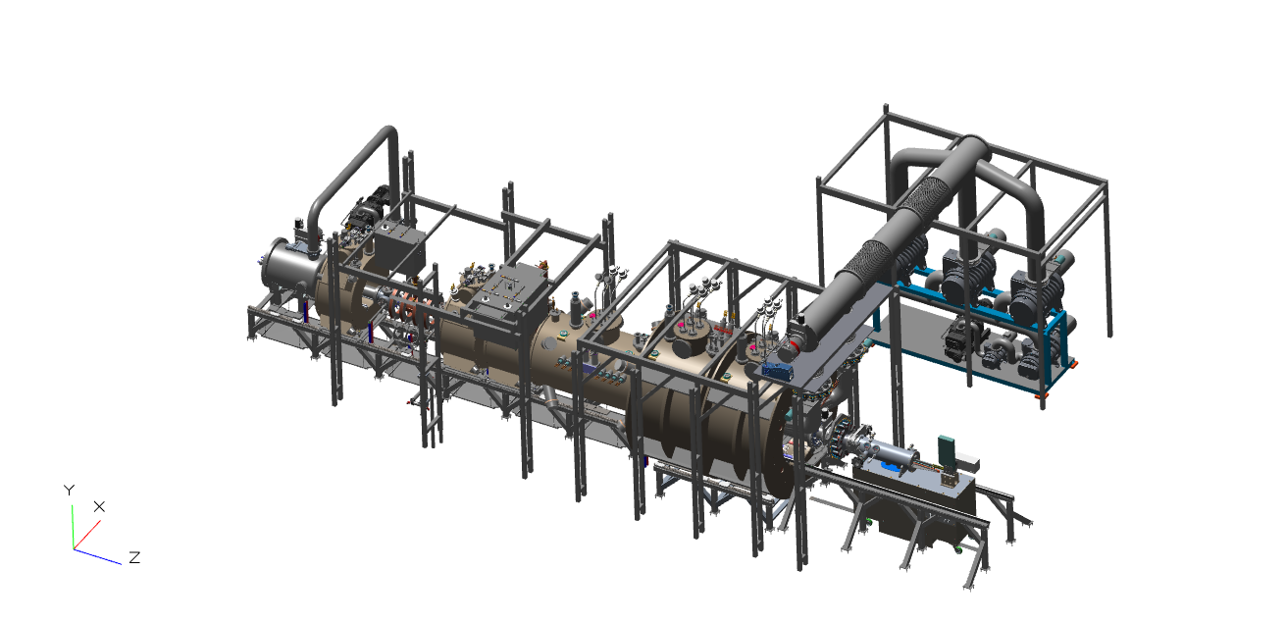

Figure 2‑1. Preliminary design CAD model of MPEX device.

### Plasma source and heating system

If the superconducting magnets are removed, the components of the plasma source and heating as well as the vacuum system components can be seen in Figure 2‑2. The plasma source and heating system consists of the helicon antenna, the electron cyclotron heating system and the ion cyclotron heating system. The helicon antenna (13.56 MHz) is used to produce high density low temperature plasmas as a target for further heating of the electrons and ions by other means. The helicon antenna is mounted ex-vessel on a water-cooled cylindrical window. The electrons are heated in the microwave frequency range (70 GHz or 105 GHz). The baseline heating scenario is heating the electrons with Electron Bernstein Waves. Additionally, Upper Hybrid heating and Whistler Wave heating is possible. Potentially, standard Electron Cyclotron Resonance Heating is possible. The waves are launched with a focusing mirror into the plasma. The ions are heated in the Ion Cyclotron Resonance frequency range of 6-12 MHz. Similar to the helicon antenna the ICH antenna is mounted ex-vessel on a water-cooled cylindrical window. More description of these systems is given in details in Chapter 4.

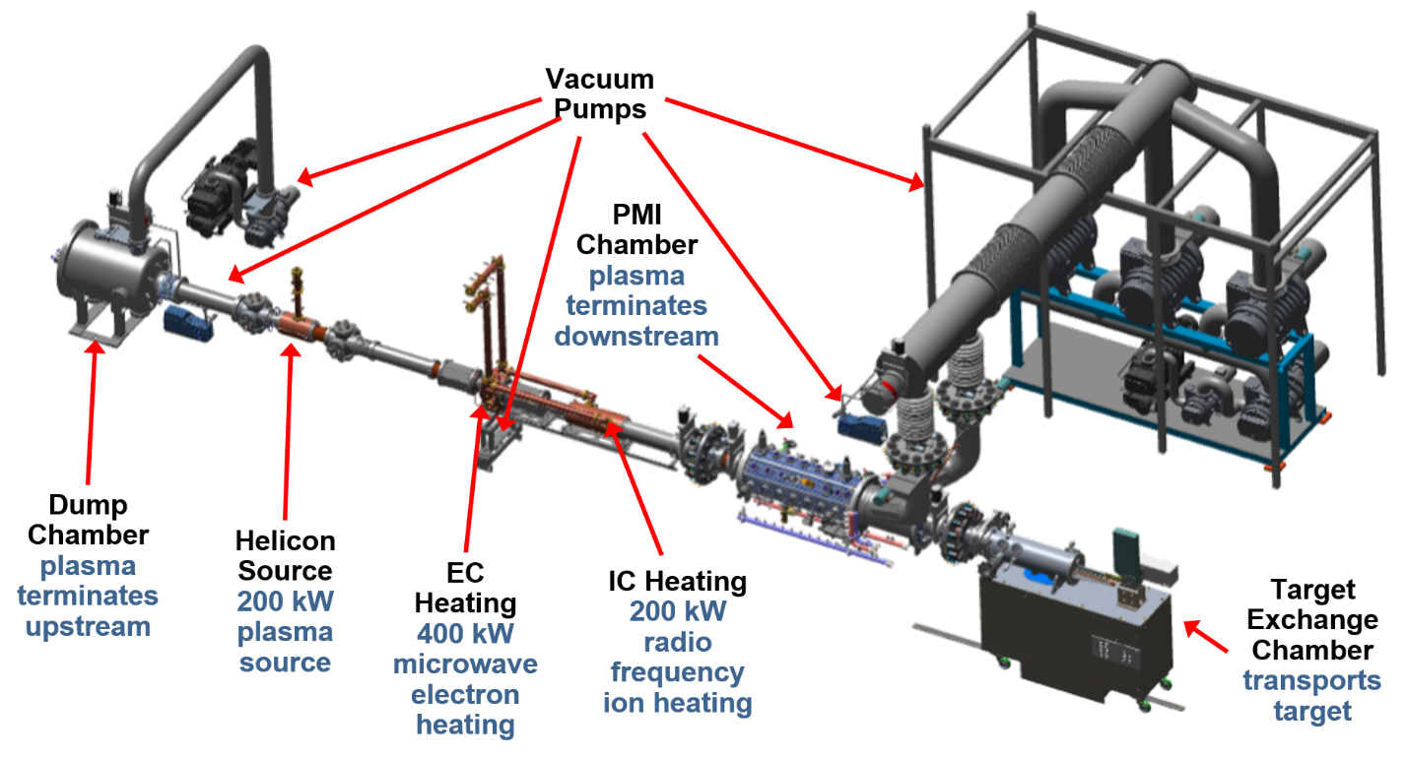

Figure 2‑2. Plasma source and heating components and vacuum systems components.

### Magnet system

The MPEX magnet system consists of a set of superconducting magnets in a linear arrangement for radially confining the plasma and transporting it along the magnetic field to the target. MPEX will have 21 coils in 7 separate cryostats as shown below in Figure 2‑3. The conductor of the coils will be conventional NbTi. The strength of the magnetic field coils depends on the requirements of the plasma source and heating system and the magnetic field relevant for the plasma material interactions at the target. The cryo-system provides vacuum for the coil system and provides the low temperature for the low-temperature superconductors with temperature controlled liquid helium supply. The magnetic field requirements for the magnets, along with the details for the conceptual design, are given in Chapter 5.

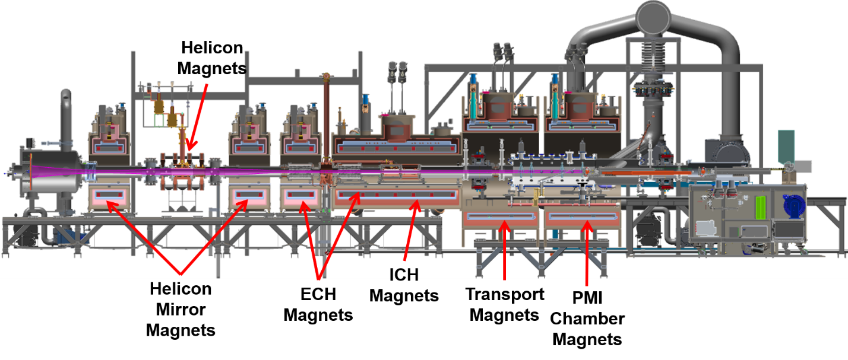

Figure 2‑3. MPEX magnet system, shown with the device in cross-section.

### Vacuum system

The vacuum system consists of first of all the vacuum vessel and all auxiliary systems related to providing vacuum in MPEX as well as the gas introduction systems. The vacuum vessel system provides:

* The vacuum boundary of the plasma vacuum
* A contamination confinement barrier for seeded and chemically produced gases as well as hazardous materials (e.g. liquid metals and activated materials).
* Structural support for the in-vessel components, such as limiters, skimmers, targets etc.

The vacuum chamber is water-cooled to cope with excess heat from the plasma and non-absorbed microwaves and rf-power during steady-state operation. Most of the chamber components are simply cooled by welded cooling pipes. Higher heat flux sections are double-walled. The vacuum chamber will allow access for plasma heating, fueling, diagnostics and in-vessel component services. The vacuum chamber is terminated by a dump tank on the upstream end of the linear device and the target system at the business end of the linear device. The vacuum chambers in between can be subdivided into (a) helicon section, (b) EC heating section, (c) IC heating section, (d) transport section and (e ) the PMI chamber. The PMI chamber can be un-docked from the main plasma device for maintenance purposes. Furthermore a target exchange chamber is docked to the PMI chamber to introduce the target system. This target exchange chamber can be moved (after un-docking) to a specific surface analysis station as shown in Figure 2‑4. More description of these systems is given in Chapter 6.

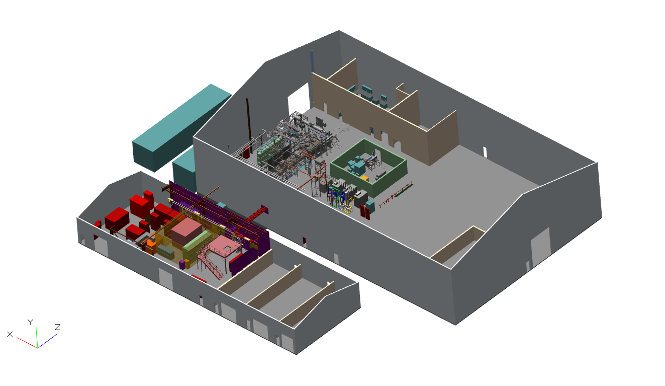

Figure 2‑4. Preliminary design model of MPEX shown in building location.

### Cooling system and in-vessel components

The in-vessel components control the power exhaust and particle flow in the vacuum chamber. The in-vessel components consist of:

* The target system is the business end of the linear device. The target should be able to be exposed to plasmas in the PMI chamber. The angle of the target to the magnetic field should be variable between 90 degrees (normal incidence) and a few degrees for shallow oblique target exposures.
* The dump plate, which is an actively cooled high-heat flux component. The dump plate is located at the opposite side of the business end of the linear device. Its main purpose is to exhaust heat without releasing impurities into the plasma.
* The limiter, which is an actively cooled high-heat flux component. The limiter is located downstream of the helicon window. Its main purpose is to determine the outer dump to target magnetic field line and to exhaust heat without releasing impurities into the plasma.
* Multiple skimmers to ensure the differential neutral pressures necessary between the different sections of the linear device. The neutral pressure should be lowest in the EC and IC heating sections, while there are highest in the helicon antenna region and at the target. The skimmers control the particle flow but are not high-heat flux components.
* A microwave absorber in order to catch stray power from the electron heating system.

The cooling water system removes heat from MPEX components and rejects it to the environment. More description of the in-vessel components and the water cooling system are described in Chapter 7.

### Instrumentation and control

The instrumentation and control includes the (a) access control and security system, (b) the central interlock system, (c ) the plasma and heating control system and (d) the central safety system. More description of the instrumentation and control system are described in Chapter 8.

### Diagnostics

The diagnostic systems cover all diagnostics for the scientific exploration of MPEX. They also include diagnostics which are needed for machine protection and basis and advanced machine control. More description of the diagnostic system are described in Chapter 9.

### Infrastructure

Infrastructure includes all systems and components to support the device within the buildings, including the support structures, the electrical, water, and gas services, and the radiation protection systems. More description of the MPEX infrastructure are given in Chapter 10.

## References for Chapter 2

Barabash et al., V. 2000. J. Nucl. Mater., 383–387 (2000) 138.

Barabash et al., V. 2003. J. Nucl. Mater., 417 (2003) 42.

Behrisch, R., et al. 2003. J. Nucl. Mater., 313–316 (2003) 388.

Behrisch, R., et al. 2003. J. Nucl. Mater., 313–316 (2003) 388–392.

Bonitz et al., M. 2010. Rep. Prog. Phys., 73 (2010) 066501.

Brooks, J. N. 1990. Phys. Fluids B, 2 (1990) 1858.

Bystrov et al., K. 2011. J. Nucl. Mater., 415 (2011) S149.

Cottrell, G. A. 2003. Fus. Eng. Des., 66–68 (2003) 253.

EURO. 2008., “R&D Needs and Required Facilities for the Development of Fusion as an Energy Source,” ISBN 978-92-79-10057-4, European Communities, 2008, <http://ec.europa.eu/research/energy/pdf/978-92-79-10057-4_en.pdf>.

Fujisuka, M., et al. 2000. J. Nucl. Mater., 283–287 (2000) 1148.

Greenwald Panel. 2007. FESAC Report, October 2007.

Hirooka, Y., et al. 1990. J. Vac. Sci. Technol., A8(3), May/Jun (1990) 1790–1797.

Ogorodnikova, O. V., et al. 2008. J. Appl. Phys., 103 (2008) 034902.

Ohno et al., N. 2009. J. Nucl. Mater., 390–391 (2009) 61.

Ohno, N., et al. 2009. J. Nucl. Mater. 390–391 (2009) 61–64.

Ohya, K. 2011. J. Nucl. Mater., 415 (2011) S10.

Ohya, K. 2011. J. Nucl. Mater., 415 (2011) S10–S18.

R.A. Pitts, R. A., et al. 2011., J. Nucl. Mater. (2011)

Rapp, J., et al. 2009. Nucl. Fusion, 49 (2009) 095012.

Rapp, J., et al. 2010. Fus. Eng. Des., 85 (2010) 1455.

Rapp, J., et al. 2012. Nucl. Fusion, 52 (2012) 122002.

RENEW., 2009. “Research Needs for Magnetic Fusion Energy Sciences – Report of the Research Needs Workshop (ReNeW),” 2009, <http://burningplasma.org/web/ReNeW/ReNeW.report.web2.pdf>.

Rieth, M. 2001. “International tungsten development efforts and the gas cooled divertor design,” ICFRM‑15, Charleston, SC, USA, October 16–22, 2011.

Rieth, M. 2009. EFDA Technical Meeting on DEMO, Garching, Germany, September 29–30, 2009.

Rosner et al. 2013. “Report of the FESAC Subcommittee on the Priorities of the Magnetic Fusion Energy Science Program,” <http://science.energy.gov/~/media/fes/fesac/pdf/2013/Final-Report-02102013.pdf>.

Roth, J., et al. 2004. Nucl. Fusion, 44, L21 (2004).

Roth, J., et al. 2009. J. Nucl. Mater., 390–391 (2009) 1–9.

Shimada, M., et al. 2011. J. Nucl. Mater., 415 (2011) S667.

Stangeby, P. C. and Leonard, A. W. 2011. Nucl. Fusion, 51 (2011) 063001.

Stangeby, P. C., et al. 2000. The Plasma Boundary of Magnetic Fusion Devices, Taylor & Francis Group, LLC, New York.

' T Hoen, M.H.J., et al. 2012. Nucl. Fusion, 52 (2012) 023008.

Tanno, T., et al. 2009. J. Nucl. Mater., 386–388 (2009) 218.

Tyburska, B., et al., 2009. J. Nucl. Mater., 395 (2009) 150.

Wampler, W. R. and Doerner, R. 2009. Nucl. Fusion, 49 (2009)115023.

Whyte, D. G., et al. 2012. Fus. Eng. Des. doi:10.1016/j..fusengdes.2011.12.011 (2012).

Wright, G. M., et al. 2010. Nucl. Fusion, 50 (2010) 075006.

Zinkle et al. 2012. DOE/SC-0149, <http://science.energy.gov/~/media/fes/pdf/workshop-reports/20120309/FESAC-Materials-Science-final-report.pdf>.

# PHYSICS BASIS

The physics basis has two goals. It first must demonstrate that MPEX can achieve the UPP scenarios outlined in Table 2-6. The physics basis should also show at a high level, what engineering parameters are necessary to achieve the UPP scenarios. In this chapter, Proto-MPEX experimental results, and Proto-MPEX and MPEX modeling results are shown. Detailed modeling using two-point models, B2-EIRENE, and EMC3-EIRENE are used to obtain desired source parameters. Proto-MPEX experimental and modeling results are used to demonstrate that the helicon source, ECH electron heating, and ICH ion heating can mee these desired source parameters and therefore achieve the desired UPP scenarios. The physics basis sets high-level values for the magnetic field, RF power, RF frequency, neutral pressure, and component heat flux in the helicon, ECH, ICH, and target regions. This chapter outlines the physics basis for these engineering requirements. The detailed engineering requirements are outlined in later chapters.

## Plasma modeling for sizing the systems

### Description of modeling tools

###### 2-point model

Magnetized plasma tubes limited on either end by a target, similar to divertor scrape-off-layers, are often simply modeled by a so-called two-point model (Stangeby, 2000). The two points describe the plasma parameters at the so-called “upstream” location, where the sources of heat and particles fluxes are, and at the so-called “downstream” location close to the target. The target conditions are then either determined by the sheath in front of the target (negligible temperature gradients along the field line: sheath-limited regime) or heat conduction (strong temperature gradients along the field line: conduction-limited regime). In our case, we are in the conduction-limited regime, or even partially detached regime. For the conduction-limited regime, the density at target can be simply evaluated by (Stangeby, 2000)

, (3‑1)

where *nu* is the upstream density, *nt* is the target density, *q* is the parallel heat flux, and *L* is the connection length between the upstream and downstream location. This shows the strong dependence of the target density on the upstream density and weaker dependence with the length and almost inversely linear dependence on the heat flux, suggesting that a high upstream density is the most effective way to achieve high target densities. Otherwise the device length would have to be increased significantly. The heat flux can be reduced by impurity seeding. This simple model assumes constant pressure along field lines. In the high-density case, however, where the target electron temperature will be reduced below 3 eV, momentum loss will take place due to charge exchange and possibly even 3-body recombination. This effect can be taken into account in the 2-point model by introducing a power loss factor *fpower* and a momentum conservation factor *fmom*. Both factors depend strongly on atomic physics and are strong functions of the electron temperature as well as the neutral density and impurity density. The dependence of the target density on these factors is then given by

 , (3‑2)

where *fcond*is the fraction of power transmitted by conduction. If by increasing the radiated power the electron temperature is reduced, then *fmom* is reduced, almost cancelling out the effect on the density increase. Because the momentum loss and the radiated power depend strongly on plasma parameters, particle transport, and atomic physics, it is necessary to “calibrate” those parameters from plasma-neutrals modeling.

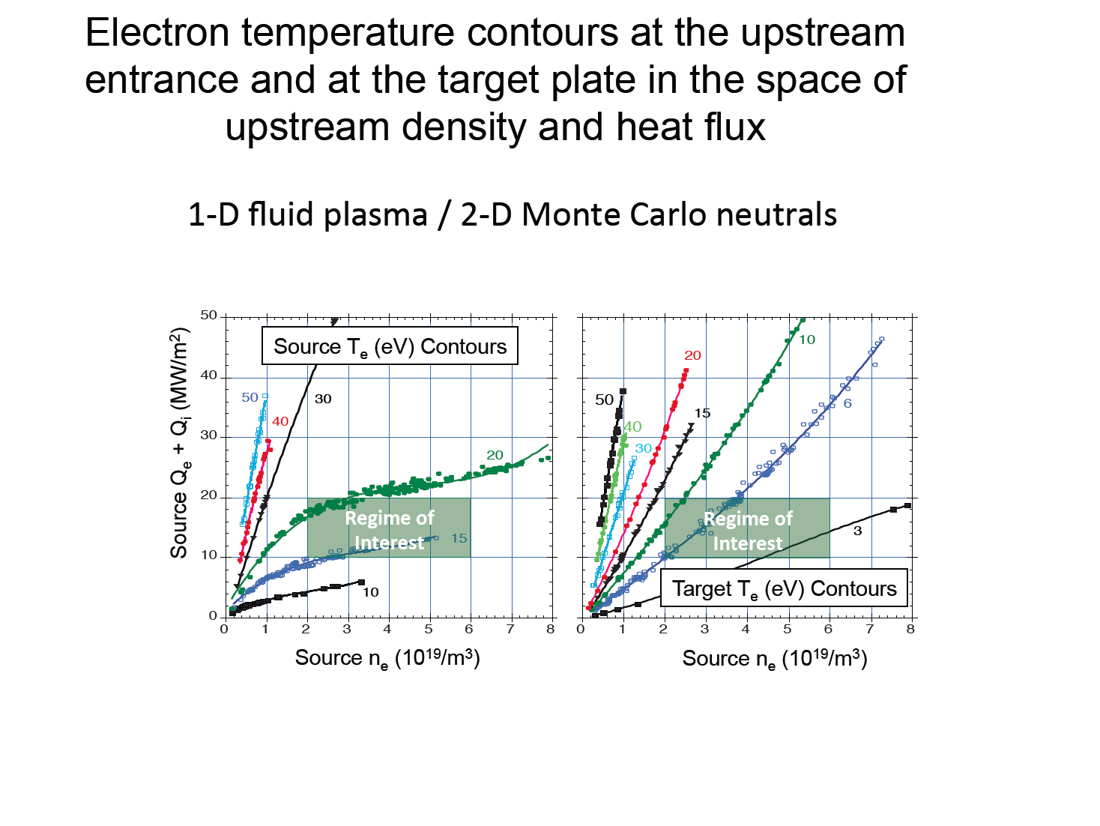

Figure 3‑1. Contours of the calculated source and target temperatures as a function of the density and parallel heat flux output by the plasma source.

###### 1D model

An initial scoping study has been performed to demonstrate that the desired range of parameters at the target can be produced given the achievable density and power levels from the RF sources. In these studies, the plasma was assumed to have a diameter of 10 cm and a length of 3.25 m. A 1D fluid plasma model was developed and coupled to 2D kinetic Monte Carlo simulations of the neutral particle recycling and transport. Concentric cylindrical flux tubes were assumed with cross-field transport between the tubes only via neutrals. With the particle and heat fluxes produced by the helicon/RF source input as boundary conditions in the code, the target plasma parameters were solved for [assuming the standard Bohm sheath boundary conditions at the target (Stangeby, 2000): M=1, i = 3.5, e=4]. At the upstream entrance, Gaussian profiles are assumed for the parallel ion and heat fluxes. For the target, a carbon plate normal to the magnetic field lines is assumed.

These results (Figure 3‑1) show that for a source plasma density ranging from ~2–8´1019m-3 and parallel heat flux of ~15–40 MW/m2, MPEX would produce the needed plasma temperatures in the range of ~1–15 eV. In the planned range, the plasma temperature at the source is much higher than at the target, indicating that parallel transport is in the conduction-limited regime (Stangeby, 2000).

###### 2D plasma fluid/kinetic neutral model

System optimization studies in strongly coupled, reactor-relevant plasma conditions require the predictive modeling capabilities of the B2-Eirene (or SOLPS, Scrape-Off Layer Plasma Simulation) code (Schneider et al., 2006).

B2-Eirene is a sophisticated and widely used edge plasma simulation code for interpretative analyses of data from existing toroidal fusion experiments (Schneider et al., 2006), linear devices (Kastelewicz and Fussmann, 2004; Baeva et al., 2007), as well as predictive calculations for machines such as ITER (Kukushkin et al., 2003; Kotov, Reiter, and Kukushkin, 2007). A significant development effort was made in order to generalize the SOLPS5.0-package so that it could be used to model RF-driven linear devices (in this case the PhIX device). Previously other B2-Eirene versions were used for the modeling of linear devices (Kastelewicz and Fussmann, 2004; Baeva et al., 2007). In this work additional capabilities were added, including the option for specifying separable (in the axial and radial coordinate) forms for the RF electron and ion heating powers. The B2-Eirene code solves coupled conservation equations for the density of each charge state, the parallel momentum of each charge state, the electron energy, the ion energy and the charge. Parallel (axial) transport is classical along field lines with flux limiters on electron, ion, and momentum transport in order to simulate kinetic effects. Radial transport is anomalous, assumed to be diffusive, and described by anomalous particle and heat diffusivities, D, e and i taken from the literature or from other linear plasma generators. The transport of neutral species is calculated with the 3-D kinetic Monte Carlo code Eirene. **E**x**B** and grad B drift effects are neglected in the simulations here.

Boundary conditions for linear plasma configurations in which the source is not explicitly included (only the transport cell) must include assumptions about the plasma parameters at the source end of the cell. The radial profiles for the source parallel ion flux and for the electron and ion parallel power fluxes are typically assumed. Alternatively, density and/or temperature profiles can be prescribed. At the target end, Bohm sheath conditions are imposed. Typically pumping in the form of a sticking coefficient for neutrals is imposed on the end plate behind the target (and behind the dump if the source is included in the simulation domain). The effects on target plasma parameters and on the neutral density in the source regions are investigated by varying gas fueling rates and axial locations. Likewise, effects on the pumping efficiency for pump positions, varied relative to fueling and recycling locations and relative to baffles or plasma limiters, need to be determined and are investigated.

###### 3D plasma fluid/kinetic neutral model

While most aspects of the MPEX geometry can be modeled using SOLPS, a tilted target plate, a currently envisioned capability that mimics the ITER geometry, cannot be directly implemented in a 2D code. Modeling of a tilted target is critical to assess the design goals of MPEX, as the erosion and re-deposition processes are highly sensitive to the target angle. In addition, a tilted target is required for operation with neutron-damaged samples, to increase the prompt re-deposition of the target material and hence reduce device contamination to acceptable levels. It is expected that the tilted target has an impact on the plasma conditions in front of the target, since the power density to the target will be lower and the recycling will be different, most likely reducing the density in front of the target.

One of the most advanced and prominent 3D transport codes is the EMC3-EIRENE code package (Feng, Sardei, and Kisslinger, 1999). EMC3-EIRENE solves the transport equations for fluid plasma and kinetic neutral particles for general 3D magnetic fields and plasma-facing component geometries. It is possible to use EMC3 to model the MPEX geometry with high fidelity, including a tilted target plate.

### Length of the device

###### B2-Eirene results of simple cylindrical geometry

In order to investigate the dependence of target plasma parameters upon assumed source parameters and pumping/fueling configurations, and to obtain an estimate of the momentum loss as well as the power loss fraction in the plasma jet, B2-Eirene simulations in simple cylindrical geometry were carried out. The geometry for this model is given in Figure 3‑2.. For the parameter scans the source ion flux was varied between 2 × 1020 to 2 × 1021 s-1. The source power flux was varied between 100 and 500 kW. The heating was assumed to be 90% into electrons and 10% into ions. The source profiles are assumed to be Gaussian. At the outermost magnetic field lines the profile boundary conditions are defined by either the radial decay length n=Te=Ti=0.005 m or the radial particle and energy fluxes being zero. Pumping was imposed on an annulus at either the source end or the target end or along the side of the vacuum wall. The pumping locations were varied as well as the reflection coefficient (alternatively: sticking coefficient) of the particles.

In the following section, emphasis is placed on the maximum achievable density and temperature in front of the target, since this is the challenge of present-day linear plasma generators. In the Figure 3‑3. an example of an axial electron density profile is shown. The electron density increases from the source to the target as expected in a high recycling conduction limited transport regime. The density peaks a short distance in front of the target and then falls off to approximately half the peak value as the flow Mach number increases to M=1 at the sheath edge. In the following those two densities are distinguish by the peak density in front of the target and the target density.

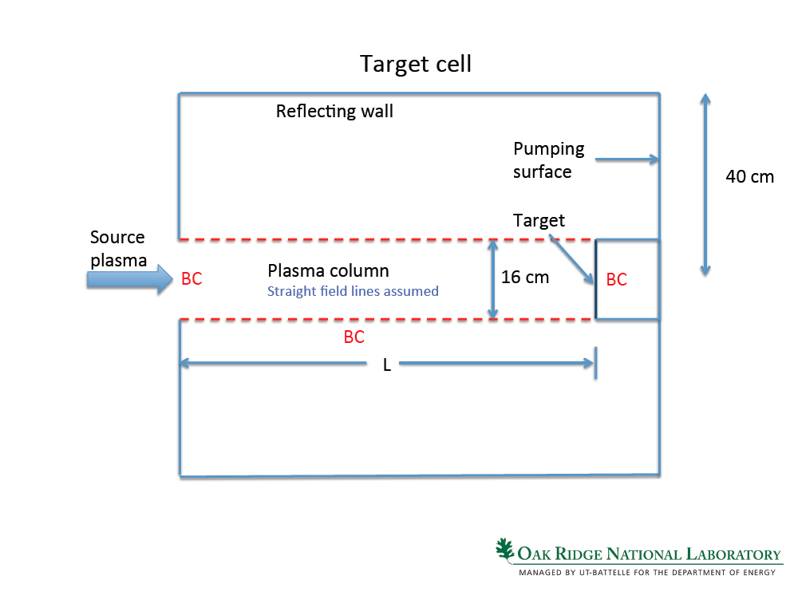

Figure 3‑2. Schematic geometry used for plasma-neutrals modeling of MPEX.

|  |  |
| --- | --- |
|  |  |
| Figure 3‑3. Example of an axial electron density profile with source at z=0 and target at z=3m, shown in metric coordinates (left) and axial mesh coordinates (right). | |

Figure 3‑4.. shows the assumed upstream (source) ion flux profiles and heat flux profiles. With these choices for the upstream boundary conditions, the source density and temperature are computed equilibrium quantities. In Figure 3‑5 the equilibrium ne profiles at the source end of a 4 m long device are shown for values of source ion flux and heat flux. The positive gradients of the source ion flux and source electron density at large radii are a result of the imposed zero flux boundary condition at the outermost flux tube.

|  |
| --- |
|  |
| Figure 3‑4. Source ion flux profiles for different total ion source fluxes and source heat flux profiles for different total source power. |

|  |  |
| --- | --- |
|  |  |
|  |  |
| Figure 3‑5. Upstream electron density profiles (at the source) for a 4 m long device: (a) 200 kW, (b) 300 kW, (c) 400 kW, (d) 500 kW. The total ion fluxes are parameterized. | |

It is seen that the source electron temperature depends most strongly on the source power as the source ion flux (density) and heat flux are varied (Figure 3‑6.).

As seen in Figure 3‑7., densities of 1021 m-3 (peak value) at the target require (peak value) very high plasma source densities. However, as indicated before, the simulations here are limited to cases with target electron temperatures of 2–3 eV minimum, rather than electron temperatures in the ~1 eV range.

Figure 3‑8. shows that, for a given source density, doubling the length from 2 to 4 m will increase the peak density by about a factor of 1.5. This is less than the *L6/7* dependence of the simple 2-point model scaling, since as expected higher densities will have an effect on the momentum conservation.

|  |  |
| --- | --- |
|  |  |
| Figure 3‑6. Contours of constant source electron temperature as function of source electron density and combined heating power density (electron and ions). | |

|  |  |
| --- | --- |
|  |  |
|  |  |
| Figure 3‑7. Contours of constant peak electron density as function of source electron density and combined heating power density (electron and ions) for different device lengths (2, 3, 4, and 5 m). | |

|  |
| --- |
|  |
| Figure 3‑8. Peak electron density in front of the target as function of the upstream electron density (at source): (a) for 2 m long device, (b) for 4 m long device. |

###### Parameterization of B2-Eirene results

The results from the B2-Eirene simulations shown in Section 3.1.2 were used to parameterize the momentum conservation factor (Figure 3‑9.) and the power loss factor (Figure 3‑10.).

The radially averaged values of the momentum conservation factor depend only weakly on the upstream heat flux and device length. The momentum conservation factor mainly depends on the upstream particle flux and therefore mainly on the upstream density.

|  |  |
| --- | --- |
|  |  |
| Figure 3‑9. Parameterization of the momentum conservation factor fmom with the source ion flux, upstream electron density, and the device length. | |
|  |  |
| Figure 3‑10. Parameterization of the power loss fpower with the source ion flux. | |

The radially averaged power loss factor also depends only weakly on the device length and the upstream power density. Like the momentum conservation factor, the power loss depends mainly on the upstream particle flux and hence the upstream density.

As expected, the momentum conservation factor is low at low target electron temperatures (high upstream plasma density) and even at high electron temperatures it does not exceed 0.7. When compared to simple scaling laws (Stangeby, 2000), the momentum conservation is about 30% lower for all temperatures (see Figure 3‑11. and Figure 3‑12.).

This is likely due to viscosity effects, which are usually neglected in the basic and extended 2-point models. The effect of the viscosity on plasma transport in these linear systems is discussed in Section 3.1.2 more extensively.

Figure 3‑11.b shows the power lost as a function of the target electron temperature. The power loss is about 30% at high electron temperatures and increases up to 60% in low-temperature, high-density cases. It should be mentioned that no impurity radiation has been taken into account here. The power loss originates from hydrogen only.

|  |  |
| --- | --- |
|  |  |
| Figure 3‑11. Parameterized momentum conservation factor and parameterized power loss factor shown as function of target electron temperature. | |

|  |  |
| --- | --- |
|  | Figure 3‑12. Momentum conservation factor from literature (Stangeby, 2000) taking into account molecular effects, but not volume recombination. |

###### Device length from 2-point model

The device length investigations in this section are based on the parameterization of the momentum conservation factor *fmom* and power loss factor *fpower* derived in the previous section. Due to the large uncertainties at very low electron temperatures, all cases are limited to Te = 2 eV and above.

For a fixed power flux from the source at the upstream location *Qsource* and a fixed upstream density *nsource*, the dependence of the plasma parameters on device length *L* is strongly affected by the dependence of *fmom* and *fpower* on *L*. In Figure 3‑13. this relation is shown for impurity radiation fraction *frad=0*.

|  |  |
| --- | --- |
|  |  |
| Figure 3‑13. Parameterized momentum conservation factor and parameterized power loss factor shown as a function of device length (left); source (upstream) electron temperature as function of device length (right). | |

In Figure 3‑14. the dependence of the target density as well as maximum density in front of the target is shown for the envisioned largest possible source power flux (500 kW) and the largest expected upstream density of 6 × 1019 m-3 for different values of *frad.*

|  |  |
| --- | --- |
|  |  |
| Figure 3‑14. Target density (left) and peak density (right) as function of the device length for radiative power loss factors using parameterized momentum conservation and power loss factors, source electron density 6 × 1019 m-3. | |

Due to the L-dependence of *fmom* and *fpower*, the variation of *ntarget* as well as *npeak* is weaker than L6/7. The target density and peak density in front of the target are limited to about 1–2.5 × 1020 m-3, respectively, for a device length of 5 m. However, as already mentioned above, the case studies are limited to target plasmas with electron temperatures above 2 eV. A temperature of 2 eV is reached with radiative power fractions of 0.3, as shown in Figure 3‑15. for a device with a length of 5 m. Without additional impurity radiation plasma, parameters of 2 x 1020 m-3 and 5 eV are reached in a 5 m long device. Those parameters are close to the ITER divertor plasma parameters for the maximum power flux to the target (see Table 2‑2: 5 × 1020 m-3, 7 eV). Lowering the source densities below the 6 x 1019 m-3 will increase the target electron temperatures.

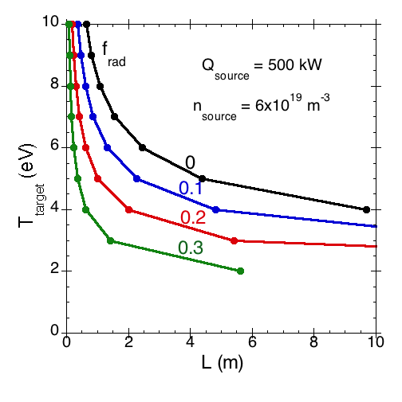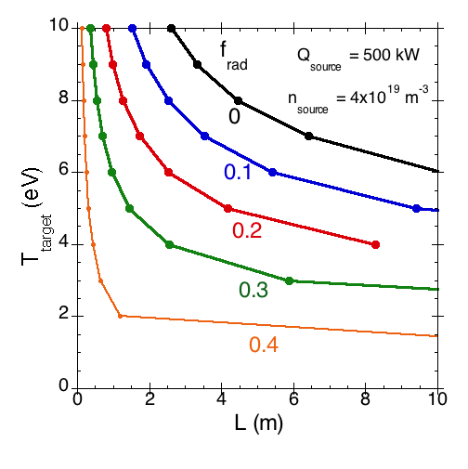

Figure 3‑15. Target temperature as function of the device length using parametrized momentum conservation and power loss factors for a source electron density of 6 x 1019 m-3 (left) and 4 x 1019 m-3 (right).

With source densities of 4 × 1019 m-3(Figure 3‑16), target electron temperatures of 8 eV are possible. In this case the peak density in front of the target is lowered to 1 × 1020 m-3. This almost matches the high-temperature case of the ITER divertor plasma deep in the SOL along the vertical target (see Table 2‑2: 1 × 1020 m-3, 10 eV).

Figure 3‑17 shows that for a source ion flux of 1 × 1021 s-1 the source density for a 5 m long device remains within the source capabilities over the projected range of available input power, meaning less than 6 × 1019 m-3.

|  |  |
| --- | --- |
|  |  |
| Figure 3‑16. Target density (left) and peak density (right) as function of the device length for radiative power loss factors using parameterized momentum conservation and power loss factors, source electron density 4 × 1019 m-3. | |

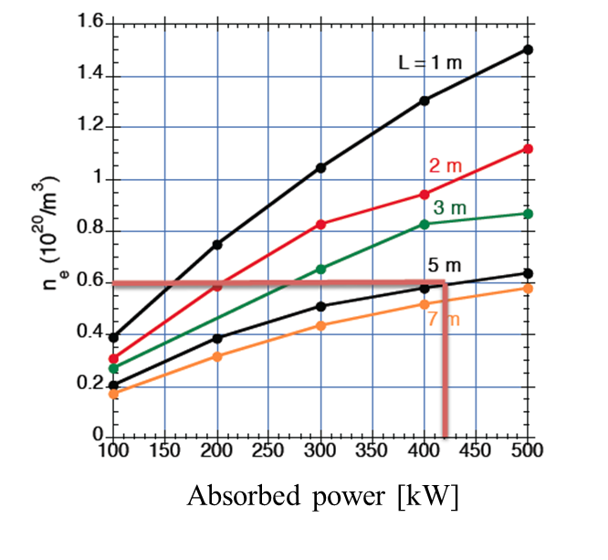

Figure 3‑17. Source electron density as function of source heat flux for different device length.

###### B2-Eirene simulations for MPEX with realistic magnetic geometry

All the above simulations assume an upstream source and downstream target in a simple strictly linear cylinder-symmetric geometry. However, in reality, the magnetic field lines are terminated on two sides. In following we define the termination of the magnetic field lines at the wall, where the PMI experiments will be carried out, the target. On the opposite side the magnetic field lines are terminated at the plasma dump. The requirements of the plasma in front of the dump are different from those in front of the target. While the plasma parameters in front of the target are driven by the experiments, the conditions in front of the dump should basically minimize the heat flux and minimize the erosion of the dump plate. This can be partly achieved by tailoring the magnetic field in front of the dump (flux expansion). However, as we will see later, the conditions at the dump might have an influence on the plasma conditions in front of the target. This interplay has to be understood by modeling. For this reason, the device MPEX was modeled as a whole with B2-Eirene, including a reasonable representation of the vacuum vessel, the magnetic field configuration resulting from all coils and volumetric heat source to simulate the helicon wave plasma production, the electron heating, and the ion heating.

Figure 3‑18 shows the geometry of the MPEX vacuum vessel, later described in this design study. The magnetic field configuration is also shown. This magnetic field configuration is determined by the mirror ratio in the helicon antenna region, the resonance conditions for the EBW and ICRF heating systems, as well as the magnetic field at the target. In the configuration shown here the magnetic field at the target (Zmax-Z=0) is 2 T. Pumping is represented in the simulations with cylinder symmetric rings with the same pumped vacuum boundary areas as the pump ducts. Gas fueling locations are added in the helicon antenna region and at the target.

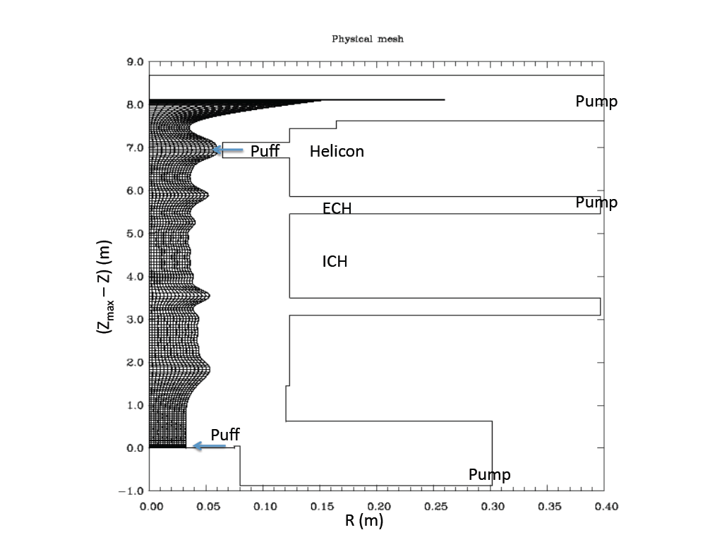

Figure 3‑18. Cylinder symmetric B2-Eirene grid with vacuum boundary for the whole device simulations.

Figure 3‑19. shows the volumetric heating power density; 90% of the heating goes to the electrons and 10% to the ions.

|  |  |
| --- | --- |
|  |  |
| Figure 3‑19. Assumed external heating power: 200 kW helicon antenna, 100 kW EBW, and 200 kW ICRH. | |

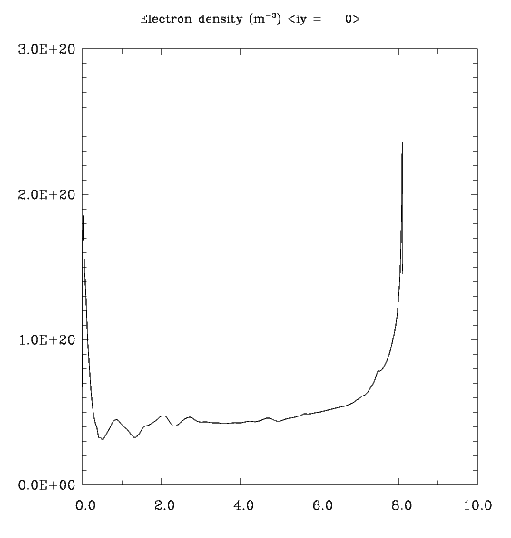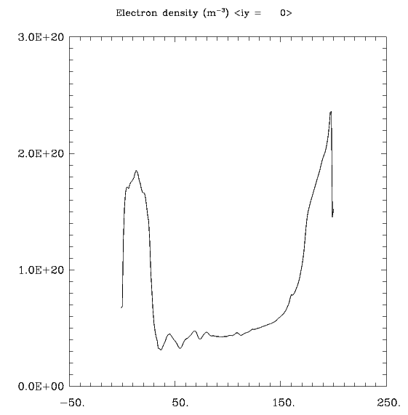

**z[m] Axial mesh #**

Figure 3‑20. Axial electron density profile in metric coordinates (left) and in mesh geometry. The target is at 8 m and the dump is at 0 m.

For puffing at the helicon antenna location, the achievable electron densities at the target are very similar to those calculated with the 2-point model and the simple linear geometry B2-Eirene simulations.

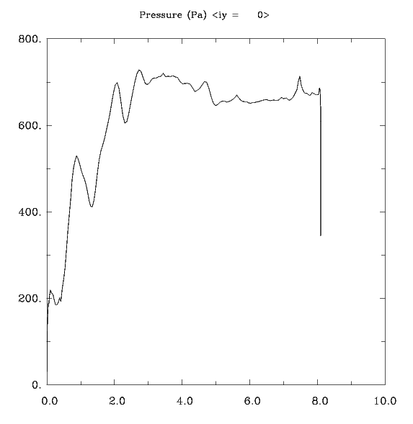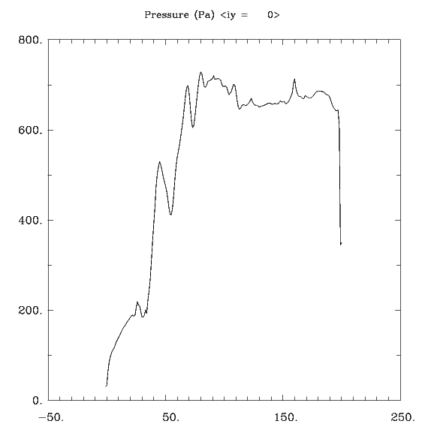

z[m] Axial mesh #

Figure 3‑21. Axial pressure profile in metric coordinates (left) and in mesh geometry (right).

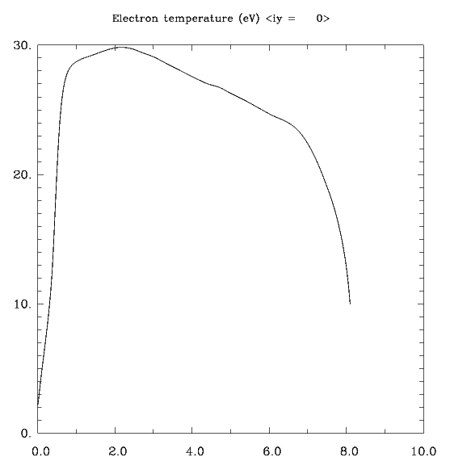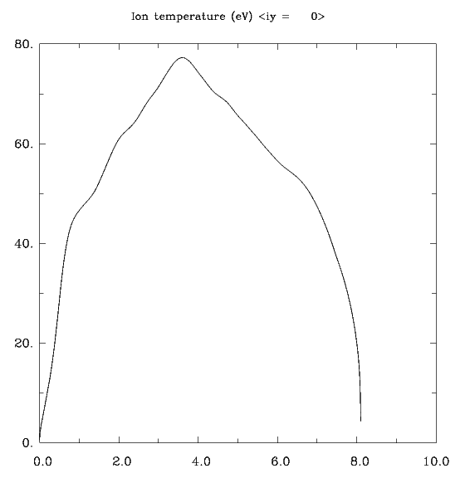

z[m] z [m]

Figure 3‑22. Axial electron temperature (left) and ion temperature (right) profile in metric coordinates.

The electron density (Figure 3‑20) is fairly symmetric. The peak density is about 25% higher in front of the target compared to just in front of the dump plate. The target density is about a factor of 2 higher than the dump plate density. The pressure (Figure 3‑21.) increases from the helicon location at 1 m along the other heating areas (EBW and ICRF) and remains constant along the axis towards the target. The pressure at the dump drops strongly mainly due to the flux expansion in front of the dump plate. The electron temperature (Figure 3‑22.) in front of the target is 10 eV. These are exactly the required parameters for the high-temperature plasma parameters on the ITER target far into the SOL. The ion flux density is 4 × 1024 m-2s-1, and the heat flux is about 35 MW/m2 to the target in these cases.

The full device simulation allows for investigations of the gas fueling and the pump locations. In Figure 3‑23. the axial electron density is shown for gas fueling at the target. In this so-called puff-and-pump scenario, the peak electron density in front of the target reaches values close to 1.6 × 1021 m-3. This is remarkably close to the maximum density to be expected in front of the outer target in the ITER divertor.

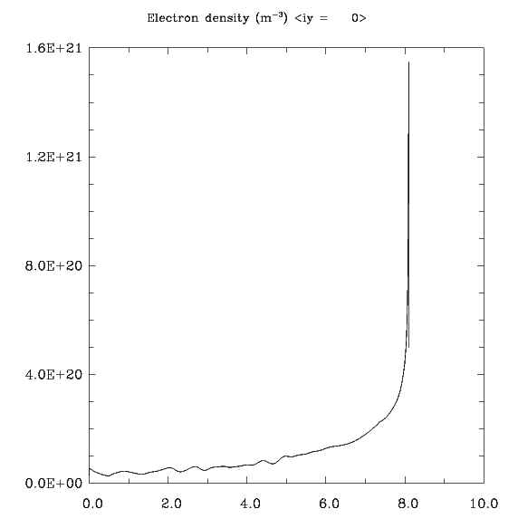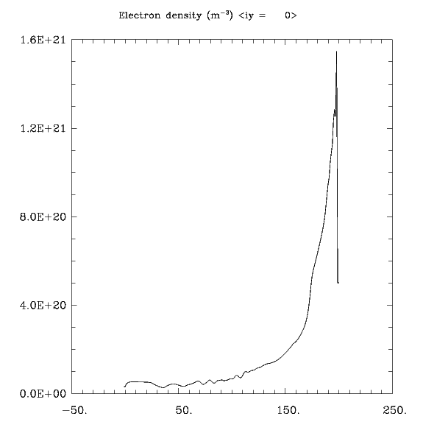

z[m] Axial mesh #

Figure 3‑23. Axial electron density profile in metric coordinates (left) and in mesh geometry (right) for gas fueling at the target.

Figure 3‑24. shows a pronounced increase in the pressure along the axis from the location of the helicon antenna toward the target. The pressure increases by about a factor of 3. This is not easily understood because in most simple models of SOL physics, pressure conservation is assumed (Stangeby, 2000). The increase in pressure seems to be responsible for the high plasma density in the front of the target. The cause of the pressure increase is related to the parallel viscosity term in the Braginskii momentum balance equation. The magnetic ripple due to the magnetic mirrors in the heating sections and the plasma parallel flow from the target to the dump (due primarily to fueling at the target and pumping at the dump) are partly responsible for the strong increase of the pressure and density at the target.

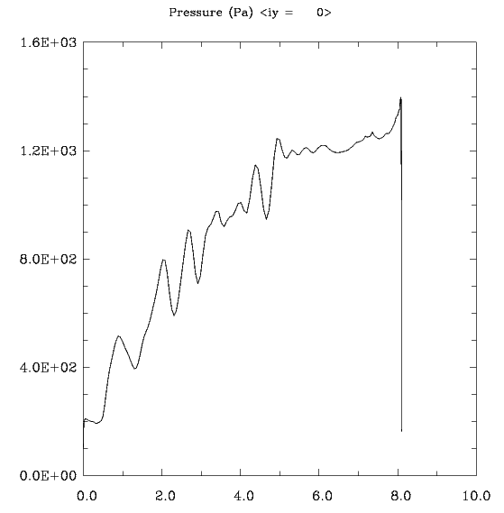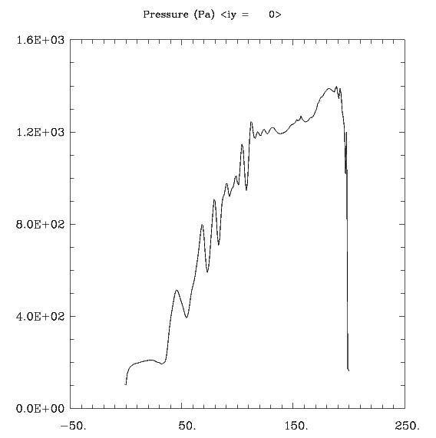

z[m] Axial mesh #

Figure 3‑24. Axial pressure profile in metric coordinates (left) and in mesh geometry (right).

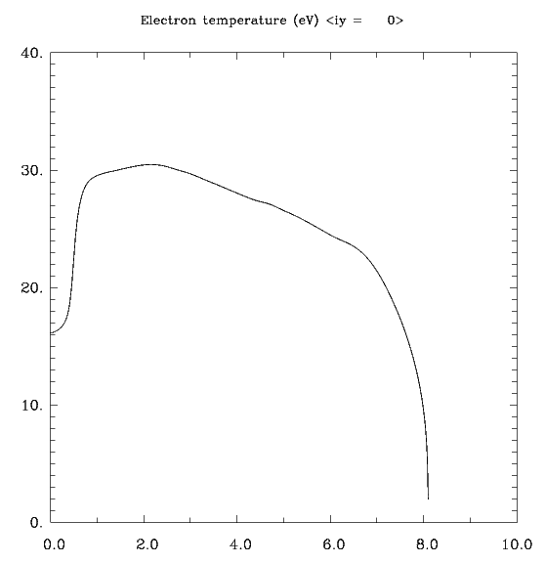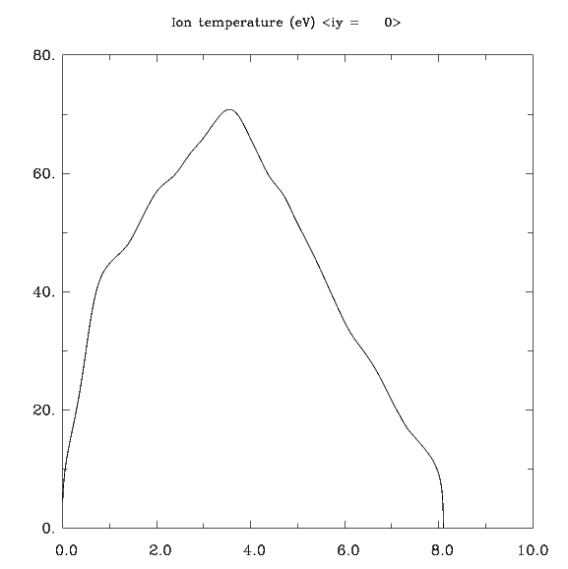

z[m] z [m]

Figure 3‑25. Axial electron temperature (left) and ion temperature (right) profile in metric coordinates.

The temperature profiles (Figure 3‑25.)show a peak in the respective heating section and drop off to both sides—the target and the dump plate. The electron temperatures are reduced to 1–2 eV at the target, as expected for such a high density. The ion temperature drops more strongly, even leading to very cold ions in front of both the target and the dump plate. Larger $T_{e}$ at the dump end results in higher conductive heat flux toward the target. This can be desirable for improving the power split between the target and the dump. On the other hand the higher electron temperature at the dump plate could cause a problem in the puff-and-pump configurations since it could lead to unwanted impurity production at the dump plate, which in turn could be transported along open field lines to the target and spoil the PMI experiments there. Thus, the generation mechanism of the impurities and its transport have to be understood and are being dealt with in the subsequent sections. The ion fluxes are up to 5 × 1024 m-2s-1, similar to the high target electron temperature case. However, due to the strong recycling, the power losses are greater and the parallel heat flux is reduced to about 17 MW/m2.

###### Effect of tilting target to magnetic field

As mentioned above, investigations of erosion and re-deposition must be carried out with targets tilted at a small angle to the magnetic field. In this case the recycling of the impinging hydrogen ions on the tilted target will have a pronounced influence on the density profiles in front of the target. This has been extensively studied in tokamaks. To study this effect the 3D plasma-neutral transport code EMC3-Eirene (Feng, Sardei, and Kisslinger, 1999) was adopted to allow for linear device modeling. Simulations were carried out for a linear geometry terminated at one end with a dump plate positioned normal to the magnetic field and a target on the other side where the angle to the magnetic field was varied. Three hundred kW of power is deposited at the axial center half way between both targets, distributed equally to ions and electrons.

Two cases were investigated: normal incidence target (90 degrees) and shallow angle of incidence (5 degrees). Results are shown in Figure 3‑26.. For the shallow angle the target was rotated, keeping the connection length of the linear system on axis (z-axis) constant. Figure 3‑27. shows the electron temperature and electron density maps in the vertical plane (normal to the tilted target plane and normal to the dump plate plane). As expected, the profiles are symmetric when the target is positioned at 90 degrees. For 5 degrees the electron density and temperature profiles become asymmetric. Like in tokamak divertor target configurations the density peak shifts off the original power flux maximum (in our case the center, axis). The same is true for the electron temperature, only that the maximum of Te shifts in the opposite direction. In the following picture (Figure 3‑27.) the axial dependence of Te and ne is shown. The dump plate is positioned axial position 0 and the target at axial position 4.2 m. Again, the profiles are symmetric when the target is positioned at 90 degrees. When tilted to 5 degrees the density in front of the target on axis is reduced by about 30%. This is true for the peak value in front of the target as well as for the target density. In contrast the temperature is increased on axis. The case shown here is for the high-temperature target plasma case (Te=12 eV, ne ~ 1 × 1020 m-3). This effect might be more pronounced for high-density, low-electron-temperature plasmas.

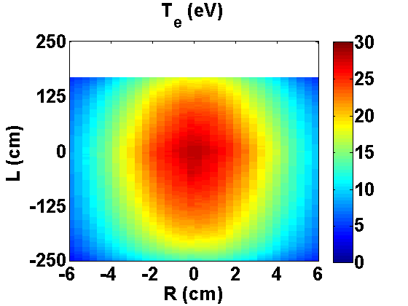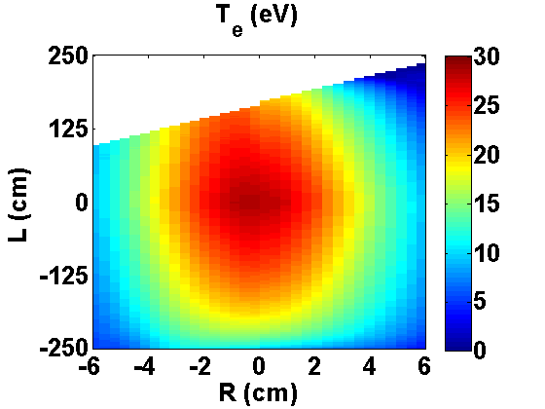

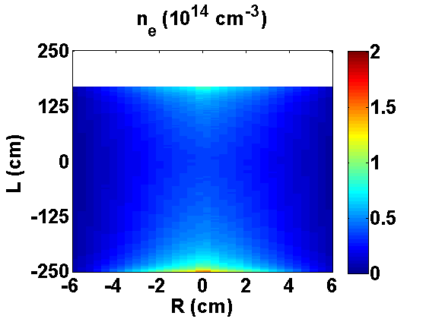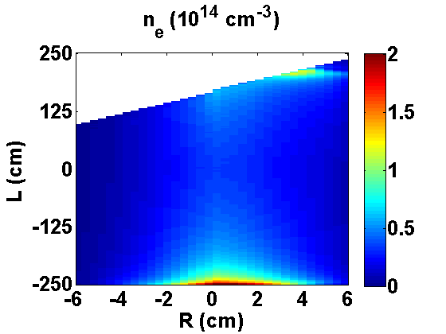

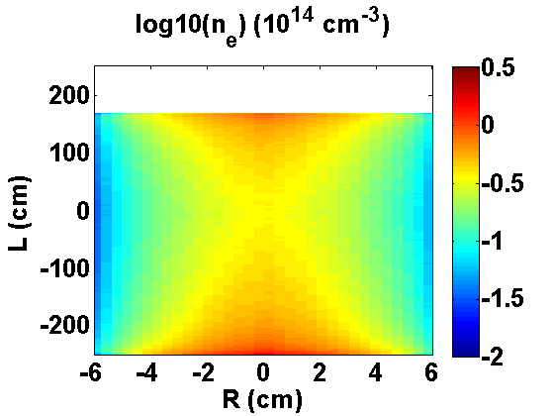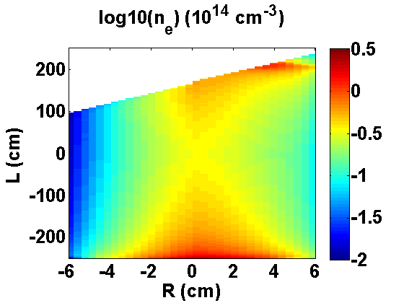

Figure 3‑26. Electron temperature and electron density contour plots for one-half of the plasma. Two target angles were modeled: 90 and 5 degrees.

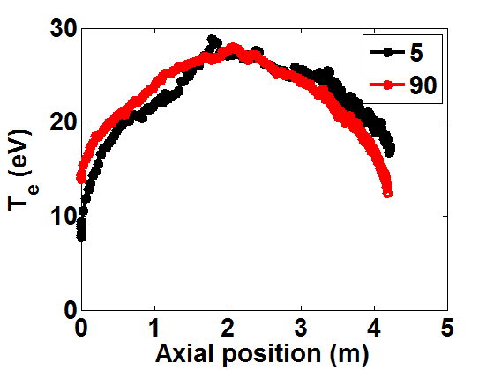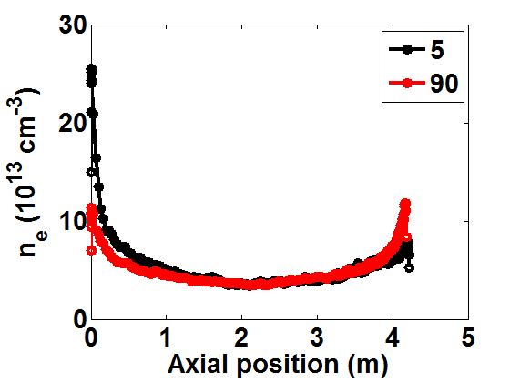

Figure 3‑27. Axial electron temperature and axial electron density for two configurations: 90 degree targets at both ends of the device and 90 degree dump plate in conjunction with a shallow 5 degree target.

###### Discussion of system length

Above it was shown that a length of about 5 m is sufficient to cover the parameter range over a large range, relevant for future fusion reactors. However, the high-density case at low temperatures was not addressed above. B2-Eirene modeling for low-electron-temperature, high-density plasma is difficult due to convergence problems. This is likely due to 3-body recombination and the related detachment. For this special case, one dedicated case was modeled for a 5 m long device. Figure 3‑28 shows the axial profiles for the electron density, electron and ion temperature, ion and heat fluxes. In this case of very low target temperatures, high peak electron densities of about 0.9 × 1021 m-3 are reached. It should be noted though that the target density is only about 0.2 × 1021 m-3. However, reducing the magnetic field by a factor of 5 or more with respect to the magnetic field in ITER or expected in future fusion reactors should bring the dimensionless parameters relevant for the erosion and re-deposition close to the required ones. The parallel ion fluxes and heat fluxes reach the ITER-relevant conditions of 2.5 × 1024 m-2s-1 and 9.5 MW/m2.In Table 3.1, data are compared with the projected MPEX plasma parameters. Almost all parameters can be reached within a factor of 2. This factor of 2 uncertainty is due to the difference in parallel viscosity and particle source due to axial magnetic field and source variations in Figure 3-23 and Figure 3-28. Higher densities might be possible with dedicated puff-and-pump experiments. Puffing at the target and pumping at the dump end will allow increasing the plasma density in front of the target by a factor of 2. On the other hand, configurations with targets tilted to very shallow angles with respect to magnetic field will have lower electron densities in front of the target.

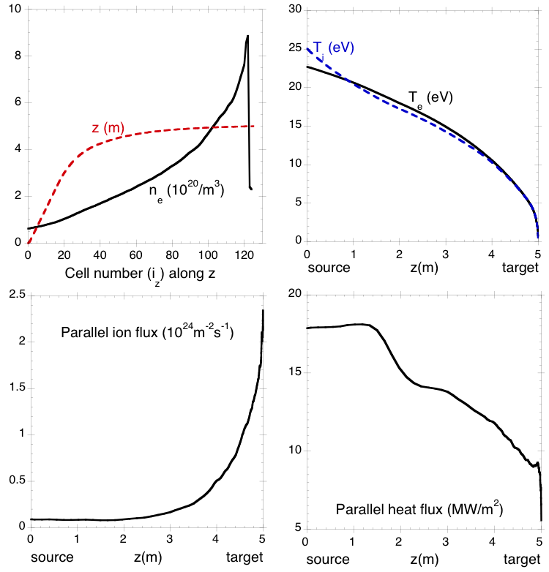

Figure 3‑28. Example results, shown for a 5 m transport section, illustrate typical electron and ion temperature and heat and ion flux evolution along the target section axis. The electron density is plotted versus the cell number.

Table 3‑1. Comparison of ITER and MPEX plasma parameters.

|  |  |  |  |  |
| --- | --- | --- | --- | --- |
|  | **ITER** | | **MPEX** | |
|  | **ne [1020 m-3]** | **Te [eV]** | **ne [1020 m-3]** | **Te [eV]** |
| ITER OSP | 10 | 0.5 | 9.5 | 0.5-1 |
| High ne | 20 | 1–2 | 20\* | 2\* |
| High P | 5 | 6-7 | 2 | 5 |
| High Te | 2 | 10 | 1–2 | 8–10 |

The peak electron density values are very close to the ITER electron densities, assuming that viscosity effects on the plasma transport will have such a pronounced effect in puff-and-pump experiments as indicated above in the full device B2-Eirene simulations.

However, also in the more conservative case, electron densities (peak values) are close to the required ones. For investigations of sheath effects, the target electron densities are more important. Taking the electron densities and temperatures at the target from the parameterized 2-point model results (Section 3.1.2) for a 5 m long device will give the dimensionless parameters important for PMI investigations shown in Table 3‑2. They are compared to the ITER values on the target at high electron temperatures (deep SOL) and high electron density (close to the strike point). The dimensionless parameters for MPEX are calculated for 1 and 2 T. As can be seen the high Te case can be very well reproduced with magnetic fields in the range of 1 to 2 T. In the case of the high density (and consequently low temperatures), a match is more difficult to achieve. But this is mainly due to the atomic physics at low temperatures and the resulting steep gradients in ionization cross sections and recombination rates. Clearly obtaining high density at low electron temperatures, meaning avoiding detachment, is the challenge here.

Table 3‑2. Dimensionless parameters: comparison ITER and MPEX.

|  |  |  |  |  |  |
| --- | --- | --- | --- | --- | --- |
| **Normalized parameters**  **Description** | **Dimensionless quantity** | **ITER high ne** | **ITER high Te** | **MPEX high ne at 2 T / 1 T** | **MPEX high Te at 2 T / 1 T** |
| D ionization MFP | *ei / Lmps* | 684 | 37 | 600 / 300 | 73 / 36 |
| CH4 MFP2 | *CH4 / Lmps* | Transparent1 | 1.5 | 1200 / 600 | 3.3 / 1.6 |
| W ionization MFP3 | *W / Lmps* | 91 | 0.26 | 6 / 3 | 0.43 / 0.21 |
| W gyroradius / W ionization MFP | *W  W* | 0.05 | 15 | 0.6 / 1.23 | 9 / 18 |

### Plasma diameter requirements

The required plasma diameter is determined by the characteristic length scales of ionization mean-free pathes perpendicular to the magnetic field, gyroradii and confinement length scales. For the range of reference plasma scenarios the characteristic length scales for important PMI parameters were calculated and are shown in Table 3.3. It becomes clear that the plasma diameter has to be larger than 3cm for the high ne, high pe and high Te plasma scenarios. Only the low ne plasma scenario requires a plasma of about 10cm. One can compare these values to the relevant system size of a fusion reactor. In this case the system size is the width of the divertor SOL plasma in front of the target. Depending of the assumptions on the flux expansion power scaling width and the spreading of the power due to the partial detachment in the divertor a width of 2 x q is about 5cm (assumptions: q from Eich, 2013, flux expansion of 7 and spread of 1.5mm). This is approximately consistent with before mentioned plasma diameter requirements for MPEX.

Table 3‑3. Important physics length scales on MPEX

|  |  |  |  |  |
| --- | --- | --- | --- | --- |
|  | **high ne** | **high Pe** | **high Te** | **low ne** |
| Ionization MFP of D (cm) | 2.0 | 2.4 | 1.0 | 12.0 |
| MFP of diffusive D (cm) | 0.49 | 2.0 | 0.75 | 10.1 |
| Ionization MFP of CH4 (cm) | 2.5 | 0.096 | 0.047 | 0.48 |
| Ionization MFP of W (cm) | 0.025 | 0.027 | 7.8x10-3 | 0.13 |
| W gyroradius (cm) | 0.27 | 0.74 | 1.9 | 2.4 |
| D gyroradius (cm) | 0.028 | 0.076 | 0.19 | 0.25 |
| Magnetic presheath length (cm) | 0.069 | 0.19 | 0.48 | 0.62 |

### Pumping requirements

The pumping requirements are determined by the necessity to operate in steady state. This depends on the gas fueling into the device, pumping, and the wall conditions. In steady state, for high-density operation and low-power fluxes on the wall, it can be assumed that all wall elements have 100% recycling. However, in low-density operation this might not be the case. For example, experiments on tokamaks in long pulse operation have been shown to have wall recycling coefficients lower than 100%, indicating that the wall equilibration time can be much longer than the pulse length, so that the wall pumps throughout the pulse, even for long pulse discharges.

Recent Proto-MPEX discharges, with optimum sequencing of the power initiation and gas puff, have reached steady state with high-density plasmas. The neutral gas injection is timed relative to the RF pulse in order to achieve breakdown and sustain high-density operation (ne = 6–8 × 1019 m-3 using 100 kW at 13.56 MHz) in long pulses (Caneses et al., 2018) in which the heating is dominated by the fast wave with core power deposition. Proto-MPEX is the linear plasma source used for developing the RF heated plasma source concept for MPEX. Details of the device are provided by Goulding et al. (2017) and Caneses et al. (2018).

During these high-density steady-state discharges with skimmers on either side of the RF section, it has been shown that low pressure (0.01–0.05 Pa) can be sustained in the heating section with minimal external pumping in that section. The pump on the dump end of the device has also been shown to pump very little and is therefore not needed. These recent experimental results from Proto-MPEX indicate that only the target end pump and the strong pumping by the plasma (with perhaps some contingency pumping in the RF section) are needed to sustain high-density long-pulse steady-state operation in MPEX.

###### Heating section

Without the beneficial effects of skimmers in the SOLPS simulations to minimize the neutral flux into the ECH section (Figure 3‑29.), the pump area was varied between 0.066 m2 and 0.613 m2. Depending upon the assumed sticking coefficient (mimicking the pumping speed at the location of the pump duct), the pressure can be varied between 0.023 Pa and 0.083 Pa. This is in the range of the required pressure for optimal operation of the EBW launcher to minimize ionization of neutral gas in the launcher chamber.

The pumping speed was calculated by SOLPS for the plasma parameters at the center of the RF cell in the outermost flux tube (ne = 3.7 × 1018 m-3, Te = 3.5 eV). These particular calculations indicate that pumping speeds in the RF cell of 3–5 m3s-1 are sufficient to meet requirements. However, the latest experiments in Proto-MPEX have shown that only a very small amount of neutrals pumping by the external pump occurs in the RF cell. Apparently, the plasma is a much more effective pump than is the turbo pump in that location, since turning off the external pumping in that cell makes very little difference in the already very low neutral pressure in the duct.

\

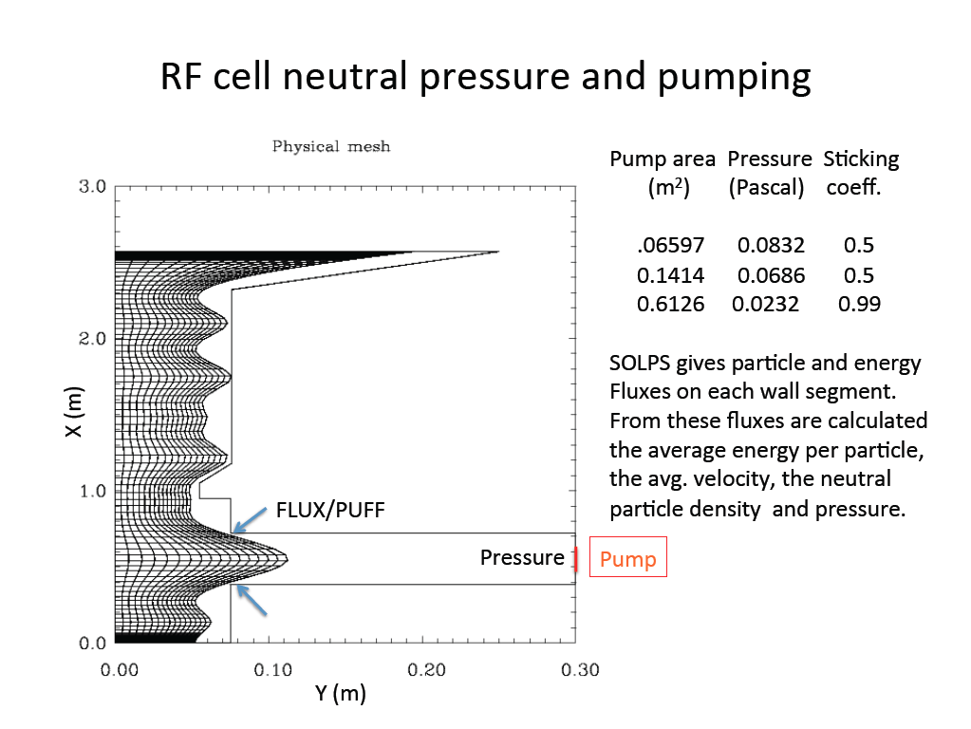

Figure 3‑29. B2-Eirene grid with vacuum boundary for the estimation of the pumping in the ECH section.

### Impurity transport

The transport of tungsten, sputtered from the MPEX target, is investigated at two levels. An example case with hydrogen plasma and tungsten physical sputtering from the MPEX target plate was prepared for the 2D fluid plasma/3D kinetic (Monte Carlo) neutrals transport code SOLPS5.1. Individual charge states of tungsten through W+12 were included and the remainder treated in the bundled charge state model. Objectives of the SOLPS calculations were to determine the flux of physically sputtered tungsten into the target cell plasma resulting from hydrogen ion bombardment of the target plate and to determine the effects of this impurity on the target and source plasma parameters.

The example case chosen for the SOLPS calculations was a full device simulation with 500 kW input power, hydrogen gas puff fueling at the target end, and pumping at the dump end. The sputtering yield was calculated with the modified Roth-Bohdansky formula. With the high recycling conditions required for reactor-relevant PMI studies (electron densities of several × 1020, temperatures approximately 2–3 eV), the physical sputtering yield of tungsten from the target plate was vanishingly small in the high-density low-temperature hydrogen plasma that is incident on the target. (Tungsten self-sputtering was not included in the simulations.) This case is not surprising since the sputtering threshold energy for hydrogen is 447 eV. However, simulating the conditions in a tokamak requires the addition of light impurities (e.g., N, Ne, or Ar), which will then dominate the physical sputtering of tungsten. The electron heating schemes in MPEX should allow for ionization of seeded impurities to multiple ionization degrees. These multiple charged medium-Z impurities will then have sufficient energy at the target for physical sputtering of tungsten. In the frame of this conceptual design, those cases have not been assessed but will be done in more detailed impurity transport studies at a later stage of the design.

At a simpler level, the one-dimensional formalism given by Stangeby (2000) for modeling impurity retention by divertors is used to estimate the near-target retention of tungsten impurities assumed to be ionized to W+1 at a prescribed distance from the sheath edge. It is assumed that the ionization state is frozen and the ions can move only along **B**. The ion velocity at the birth point is taken to be away from the target (the positive direction), along **B**, and is computed as the average velocity of a tungsten atom of temperature TW.

The force on an impurity ion of mass m Z and charge Z can be written as

**** , (3‑3)

where “x” is measured along **B** and positive in the upstream direction away from the target. Trace impurities (pZ=0) are assumed. e = 0.71Z2 and i = 2.6Z2 for tungsten (mZ = 184/mp amu) impurity ions. S is the Spitzer impurity stopping time, given by  S = 1.79 × 1014Ti 3/2/ni for W+ ions in hydrogen plasma with ln☹=15, [eV], and n [m-3]. The first term in Equation 3-3 corresponds to the friction force on impurity ions moving with fluid parallel velocity *vZ* against the background hydrogen ions moving with fluid parallel velocity *vi*. The second term is the electrostatic force due to the presheath electric field. The third and fourth terms are the electron and ion temperature gradient forces that are generally directed away from the target.

In the standard way, Equation 3-3 is written as a first-order differential equation for *vZ* and integrated from the assumed ion birth point either to a stagnation point (where *vZ*=0) or to the upstream boundary. The ion density, the electron and ion temperatures, the electrostatic potential, and the hydrogen ion parallel fluid velocity are taken from SOLPS simulations of a MPEX target cell and are shown in a single flux tube at R=2.75 cm for the near-target region in Figure 3‑30. In the calculations reported here it is assumed that the tungsten atom leaves the target surface, crosses the sheath, and is ionized to W+ at the sheath edge. (Assuming that the first ionization of the W atom takes place further upstream, but still near the target, did not significantly change the retention of the impurity.) In order to span a range of initial W+ velocities, TW values near and much larger than the target plate temperature that is assumed in the simulation are chosen for the initial *vZ* at the ion birth points.

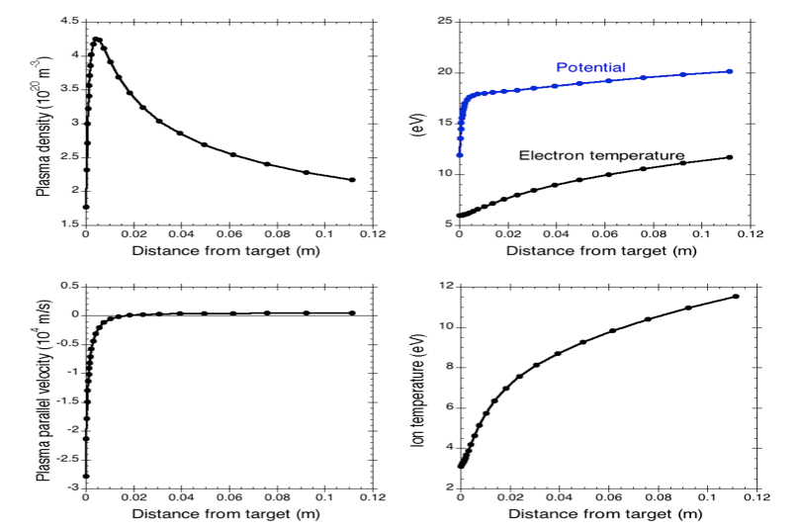

Figure 3‑30. Near-target parameters of the background plasma used for modeling W+ transport parallel to the magnetic field. The flux tube radius is 2.75 cm.

The components of the force (Equation 3-1) on a W+ ion moving in the background hydrogen plasma shown in Figure 3‑30 are shown for the near-target region in Figure 3‑31. The curves are plotted only over the axial distance traversed by the ion with the highest assumed TW+ (10 eV). Positive force components are directed away from the target, and negative components pull the ion back toward the target. It is seen that over most of the range of axial distance the negative electrostatic and friction components are significantly larger than the electron and ion temperature gradient forces. In particular, the friction force is the force component for the given plasma conditions (Figure 3‑30) that is most effective in retaining and re-depositing the tungsten impurities.

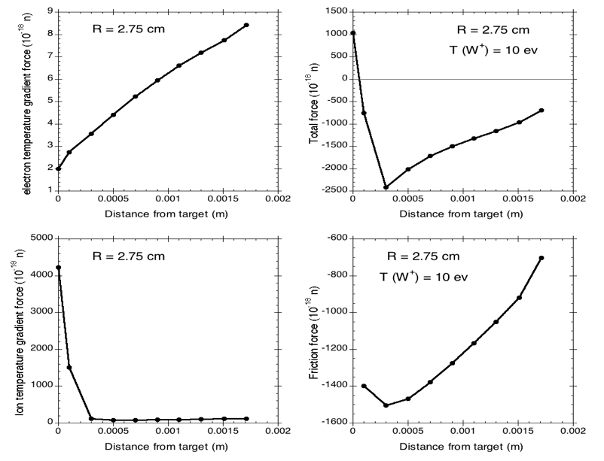

Figure 3‑31. Components of the force, in the direction of the magnetic field, on a W+ ion moving away from the target plate. The friction and total force curves are shown for a 10 eV ion.

The Spitzer stopping time, shown in Figure 3‑32., is only a few microseconds very near the target where the hydrogen ion fluid parallel velocity is greatest. For tungsten ions having TW = Ti, S is the same as the Spitzer parallel collisional diffusion time || defined in Stangeby’s discussion. When *vi* >> *vZ*, small || or large collisionality of the W+ ions with the outflowing hydrogen ions results in a strong retaining force on the impurity ions.

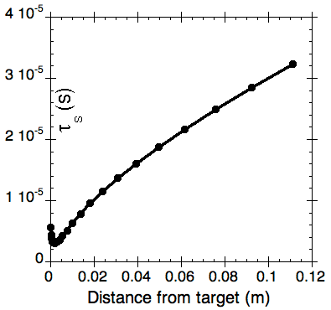

Figure 3‑32. The Spitzer stopping time (same as the parallel collisional diffusion time || for tungsten with TW=Ti) is very small in the pre-sheath region where *vi* is large.

A measure of divertor (or near-target) retention of impurities is the distance from the target at which the ion fluid reaches a stagnation (*vZ* = 0) point and returns to the target. In divertor configurations it is desirable to retain impurities below the X-point so as not to contaminate the core plasma. In MPEX it is likewise desirable to retain impurities to the target region so as not to radiate power in the source region that would otherwise heat the plasma. Figure 3‑33(b) shows that near-target retention of the impurity ions is very good for the plasma conditions shown in Figure 3‑30.

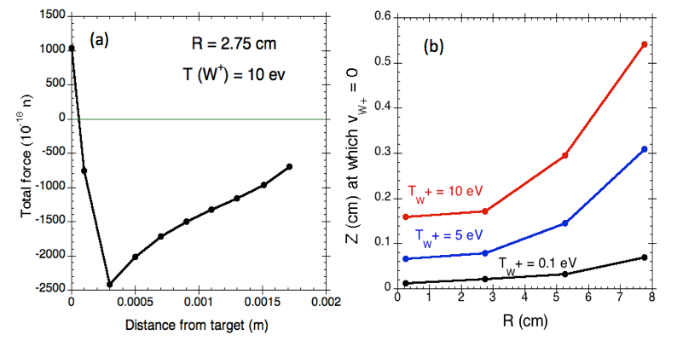

Figure 3‑33. (a) The near-target total force acting on a 10 eV W+ ion born at the sheath edge, 2.75 cm from the axis, is predominantly toward the target in the first 2 mm in front of the sheath. (b) The maximum excursion parallel to the B field of W+ ions born at the sheath edge is shown for three values of the assumed W+ temperature. At larger radii the ions tend to go farther upstream before turning due to decreased friction and electrostatic forces.

### B2-Eirene simulations with Bohm diffusion transport coefficients

In this section, data-constrained B2-Eirene simulations of high-density Proto-MPEX discharges are presented. Proto-MPEX is the linear plasma source used for developing the RF heated plasma source concept for MPEX, and details of the device are provided by Goulding et al. (2017) and Caneses et al. (2018). The discussion will focus on radial transport, for which the choice of the anomalous radial transport coefficients is a central component. Three transport coefficient sets are considered, only one of which (the Bohm diffusion coefficients) is physics based. The other two ad hoc sets are “constant” and “centrally peaked,” with the constant set being spatially constant both radially and axially and the centrally peaked set being axially constant but radially varying.

If Bohm diffusion is assumed for both the electron particle and energy radial transport, then there are only two adjustable parameters, the coefficient  of DBohm = Te/(16|B|) and the ratio of the particle and energy diffusion coefficients. The B2-Eirene simulations presented here show that the Bohm set describes the experimental data quite well, particularly the electron density and temperature profiles in regions with low magnetic field. This is a very fortunate since Bohm diffusion represents a more physics-based approach with a long history of successfully describing transport in a variety of magnetic confinement devices and should significantly improve predictions for transport in MPEX. Also, fewer adjustable parameters describing the particle and energy transport model should expedite the analysis of experimental data.

A second very important ingredient in SOLPS transport simulations is the assumed or calculated heating distribution. Since MPEX will have helicon, electron, and ion heating, each at different axial locations, three heating distributions will be needed for MPEX simulations. The Proto-MPEX results presented here, however, require only the helicon heating distribution since there was no auxiliary electron or ion heating. Figure 3‑34 shows contour, axial, and radial plots of the assumed helicon-absorbed power distributions. The distribution shown is based on the assumption that heating and associated plasma production is mostly fast wave (helicon mode) and occurs at or near the axial location of the helicon.

|  |
| --- |
| Owen OS X:Users:lwo:Documents:Electron heating dist.pdf |
| Figure 3‑34. The contour plot shows the assumed helicon heating distribution. The radial and axial plots are through the maximum of the distribution. Some edge heating-plasma production is included but not enough to give edge peaked profiles. |

Figure 3‑35 shows the radial profiles of the constant, peaked and Bohm (at the axial peak) diffusion coefficients, as well as the axial profile of the Bohm coefficient. The axial variation of the Bohm distribution primarily reflects the magnetic field configuration since Te is relatively more slowly varying. The strong peak in the Bohm coefficient occurs at the low field region under the helicon and leads to significantly greater radial transport of plasma at that axial location.

Figure 3‑36 and Figure 3‑37 show the SOLPS transport calculation fits to the experimental electron density and temperature radial profiles respectively. The measurements at three of the axial locations are from double Langmuir probes and the fourth from Thomson scattering near the target. The results show that the Bohm set gives reasonable fits to the experimental data except Te at spool piece 10.5 where it is about a factor of 2 too high near the axis.

|  |
| --- |
|  |
| Figure 3‑35. (a) The “constant” D is spatially invariant; the peaked D varies radially but not axially, and the Bohm D varies both radially and axially (profile is shown from z~ 1 m). The and are twice D. (b) The on-axis, axial dependence of the Bohm diffusion coefficient primarily reflects the magnetic field configuration since Te is comparatively more slowly varying. |

Figure 3‑38., Figure 3‑39, and Figure 3‑40. show axial distributions (on axis) of the SOLPS fits to the electron density, temperature data, and to the measured D chord data, respectively. These results reinforce that Bohm diffusion adequately describes transport in the Proto-MPEX linear device and should with confidence extrapolate to MPEX. That confidence should be even greater when, for example, comparison is made with the very successful application of the Bohm model in LAPD (Maggs, Carter, and Taylor, 2007) experiments with nonrotating plasmas.

|  |
| --- |
|  |
| Figure 3‑36. Langmuir probe radial profiles of electron density are compared to B2.5-Eirene results for each of the three D- transport coefficient sets. The data from Spool 1.5, 6.5, and 10.5 are from Double Langmuir Probes and the data from Spool 11.5 are from Thomson Scattering. |
|  |
| Figure 3‑37. Langmuir probe radial profiles of electron temperature are compared to B2.5-Eirene results for each of the three D- transport coefficient sets. The data from Spool 1.5, 6.5, and 10.5 are from Double Langmuir Probes and the data from Spool 11.5 are from Thomson Scattering. |

|  |  |
| --- | --- |
|  | Figure 3‑38. The centrally peaked transport coefficients reproduce the probe measurements well except at the dump end, whereas the Bohm model overestimates the density in the helicon region. |
|  | Figure 3‑39. The on-axis temperature data fit quite well with the peaked transport coefficients model and qualitatively using the spatially constant or Bohm models. Each model gives density peaking at the helicon, where ionization of the gas fueling neutrals enter the plasma and where the flow stagnation occurs. |

|  |  |
| --- | --- |
|  | Figure 3‑40. The D chord data from the filterscopes are well reproduced by the transport simulations over the entire plasma column. |

Based on the results of section 31, the combination of 2-point models, B2-EIRENE simulations, EMC-EIRENE, the modeling suggest a range for the parameters at the source. For each of the 4 UPP scenarios in Table 2-6 in the target region, the source requirements are calculated in Table 3-4.

**Table 3-4. Source requirements for MPEX.**

|  |  |  |  |  |
| --- | --- | --- | --- | --- |
| **MPEX Ultimate Performance Parameters** | **ne target [1019 m-3]** | **Te target [eV]** | **ne source [1019 m-3]** | **Te source [eV]** |
| High ne , target 90o | 100 | 1-2 | 4-6 | 25-30 |
| High ne, target 5o | 100 | 1-2 | ~9 | ~30 |
| High Pe , target 90o | 50 | 7 | 4-5 | 25-30 |
| High Pe, target 5o | 50 | 7 | 7-8 | ~30 |
| High Te , target 90o | 20 | 10 | 2.5-3.5 | 20-25 |
| High Te , target 5o | 20 | 10 | 4-5 | ~25 |
| Low ne , target 90o | 1 | 15 | 1 | 15 |
| Low ne , target 5o | 1 | 15 | 1.5 | 15 |

There are caveats to the calculation in Table 3-4. B2-Eirene calculations were done only for high ne case with the target at 90 degrees. EMC3-Eirene calculation only for high Te case with the target at 5 degrees. Given the difference between untilted and tilted targets, a conservative factor of ~1.5 was assumed in the density for all the other tilted target cases based on the EMC3-EIRENCE calculation. The B-2 Eirene and EMC3-Eirene calculations do assume conduction limited regimes and ~5 m between source and target. The calculation for the low ne case uses the two-point model assuming sheath limited regimes. The two-point model was used for scans of the rest of the operation space when necessary.

These source requirements set requirements for the helicon plasma source, ECH electron heating, and ICH ion heating regions. To be conservative, the source and heating systems are designed for electron densities up to 9x1019 m-3, electron heating up to 25 eV, ion heating up to 30 eV, heat flux at target > 10 MW/m2 assuming a length of ~ 5 m from the source and heating systems to the target. This will satisfy all the scenarios.

## Helicon plasma source

The helicon plasma production system for MPEX is based upon the design that has been successfully demonstrated in the MPEX phase 1 and 2 experiments, PhiX and Proto-MPEX, respectively. The design has been operated with coupled RF power levels up to 150 kW with pulses up to 2 seconds and 20 kW with pulses up to 10 seconds. Deuterium plasma densities in the range of $n_{e}=4-15×{10}^{19} m^{-3}$ have been demonstrated in Proto-MPEX. In this section, the main developments on the Proto-MPEX plasma source and on the water-cooled steady-state MPEX plasma source are presented.

### Key contributions from the Proto-MPEX program on plasma production

In what follows, key developments from the Phase 2 experiment (Proto-MPEX) in relation to the helicon plasma system are presented. In this phase, production of plasma densities above $n_{e}=6×{10}^{19} m^{-3}$ has been demonstrated in deuterium with 100 kW RF power at 13.56 MHz. With increasing power up to 150 kW, high-density production > 10x1019 m-3 has been reached using magnetic fields up to 0.15 T. If the magnetic field and RF power is not optimized, low-density edge-power-dominated unstable discharges are produced. With experimental data and modelling, it has been demonstrated that plasma production is dominated by fast-wave power absorption in the plasma core for helicon mode operation while slow-wave edge power deposition is dominant when helicon mode operation is not present. In what follows, fast and slow waves refer to the fast and slow branches of the whistler wave. In cylindrically bounded plasma, like in Proto-MPEX, the eigenmodes formed by these branches (fast and slow) are commonly referred to as “helicon” and “Trivelpiece-Gould” (TG) modes.

In this phase, the most important developments can be summarized as follows:

Production of high-density helicon deuterium plasmas with $n_{e}=4-15×{10}^{19} m^{-3}$ using 150 kW at 13.56 MHz with helicon magnetic fields up to 0.15 T and mirror magnetic fields up to 1.1 T

Demonstration that these discharges are fast-wave dominated with core power deposition

Demonstration of neutral gas control compatible with requirements of auxiliary heating systems

Quantification of the plasma source performance and identification of areas for improvement to maximize plasma production

Characterization of a water-cooled MPEX-like helicon window assembly using CSDX and Proto-MPEX experiments

In what follows, these important developments are described in more detail. Lastly, these results are discussed in relation to the development of the next stage device: MPEX.

### Production of high-density helicon deuterium plasmas

In the Phase 1 experiment (PhiX), production of plasma densities up to $4×{10}^{19} m^{-3}$ was demonstrated. In the Phase 2 experiment (Proto-MPEX), production of high-density plasmas ($\sim 6×{10}^{19} m^{-3}$) was also demonstrated (Goulding et al., 2017); however, this required some development work with the neutral gas injection. Experimentally, it was observed that the neutral gas injection had to be timed relative to the RF pulse in order to achieve breakdown and sustain high-density operation. Details of the neutral gas injection and high-density operation are provided by Goulding et al. (2017) and Caneses et al. (2018). The magnetic field at the plasma source region consists of a low magnetic field section directly under the helicon antenna $≤0.1$ Tesla and two magnetic mirrors on either end at 0.7 Tesla. This can be seen in Figure 3‑41.. The use of magnetic mirrors on either side of the antenna has been motivated primarily by experimental results observed on other light-ion helicon plasma sources, which demonstrated that this non-uniform field enables high-density operation with light-ions (Caneses and Blackwell, 2016; Mori et al., 2004). For the densities and electron temperatures typical of Proto-MPEX, the plasma is very collisional and kinetic mirror effects are not expected; however, *collisional* mirror confinement effects (Logan et al., 1974; Lam et al., 1986) have been measured in Proto-MPEX which increase the confinement time of the plasma in the helicon source region and maximize the plasma density. These collisional confinement effects are believed to be responsible for the need of magnetic mirrors. The recommended mirror ratio for high-density operation can be anywhere between 5 and 15. This is based on observations from Proto-MPEX (Goulding et al., 2017; Caneses et al., 2018) and other high-density light-ion helicon sources (Caneses and Blackwell, 2016).

|  |  |
| --- | --- |
|  | Figure 3‑41. Typical magnetic field geometry in Proto-MPEX illustrating the location of the plasma source and the Target. |

The main results demonstrating the production of high-density deuterium plasmas in Proto-MPEX are shown in Figure 3‑42. The bottom image represents the scaling of the on-axis plasma density as a function of the magnetic field at the plasma source. Plasma densities up to $5×{10}^{19} m^{-3}$ are produced. The plasma density was measured with a Double Langmuir Probe (DLP) (Caneses and Blackwell, 2015) in the Target region. The operating conditions are 95 kW of RF power delivered, 150 ms long RF pulses, 2 SLM deuterium gas flow injected downstream of the RF antenna. The top two images represent the 2D heat flux distribution on the Target plate using Infra-Red (IR) thermography (Showers, 2016; Piotrowicz, Caneses, Showers et al., 2018), and due to the ion and electron magnetization, they represent the 2D distribution of RF power absorption in the plasma. These images are *representative* of the RF power absorption for discharges in the blue and green shaded regions shown on the bottom image. The green-shaded region represents discharges that have core RF power absorption, flat radial electron temperature profiles, are stable, and scale linearly with magnetic field. The discharges in this region are referred to as “helicon-mode” plasmas. The blue-shaded region represents discharges with hollow RF power absorption and electron temperature profiles, are unstable (oscillatory), and do not scale linearly with magnetic field. The error bars in this region are representative of the plasma density oscillations observed during these unstable discharges. The discharges in this region are referred to as “slow-wave” or “TG-mode” plasmas because their power absorption profile is dominated by slow wave excitation.

Both fast and slow wave behavior is observed in the Langmuir probe and IR camera measurements in Figure 3-42 and 3-43. As the RF power to generate the discharge is increased, high-density plasmas can be sustained at higher magnetic fields. If the RF power is too low or the magnetic field is unoptimized, helicon mode cannot be sustained. There is in particular strong correlation between helicon mode operation, high core densities and high core heat flux. Figure 3-44 however shows what can happen if the magnetic field or RF power is not optimized. Substantial heat flux can occur in the edge plasma (Lau et al, 2020). In later paragraphs, this will be identified as slow wave excitation or “TG-modes”.

Operating at higher magnetic fields is important because this has a direct impact on the size of the plasma diameter in the Target section. The plasma radius in the Target section scales $∝\sqrt{B_{H}}$, where $B_{H}$ is the magnetic field under the helicon antenna. According to simple helicon theory (Goulding et al., 2017; Piotrowicz, Caneses, Green, et al., 2018), the plasma density should scale $n_{e}∝{B_{0}k_{z}}/{ωR_{p}}$, where $B_{0}$ is the magnetic field at the source, $k_{z}$ is the dominant wavenumber of the RF antenna, $ω/{2π}$ is the RF frequency, and $R_{p}$ is the effective radius of the plasma column. When this scaling is satisfied, the fast wave forms eigenmodes in the plasma column, slow wave excitation at the edges is suppressed and core RF power absorption is maximized. This scaling is observed in Figure 3-45. The fast wave eignemodes have been measured in Proto-MPEX using RF magnetic probes, and an example is shown in Figure 3-45. These measurements where performed about 10 cm away from the RF antenna. The key characteristics that make this an eigenmode are the $π$ phase change that occurs in the center of the discharge and the bi-modal shape of the magnitude profile of the $B_{z}$ RF field. This structure is *only* observed when the discharge transitions to the high-density mode.

|  |  |
| --- | --- |
|  | **Figure 3‑42. (Bottom) plasma density scaling with magnetic field under the helicon antenna $B_{H}$ measured with a DLP in the target region with 95 kW of RF power. Green-shaded region corresponds to stable, helicon-mode plasmas. Blue shaded region represents discharges with edge power absorption. The top figures represent the IR inferred heat flux on the Target plate and are representative of the green and blue shaded regions.** |
|  | **Figure 3‑43. Plasma density scaling with magnetic field under the helicon antenna for various RF power levels. Plasma density measured at the Target section with a DLP.** |

|  |  |  |
| --- | --- | --- |
|  |  | |
|  | |  |
|  | | Figure 3‑44. Heat flux measurements at various helicon powers and helicon magnetic fields for MPEX. This is a subset of the discharges shown in Fig 3-43. |
|  | | Figure 3‑45. Example of an experimentally measured fast wave eigenmode in Proto-MPEX during a helicon mode discharge. Fast wave eigenmode formation is only observed during the linear scaling observed in Figure 3‑42. |

In Figures 3-42 to 3-45, only helicon power levels up to 100 kW are used. For higher magnetic field operation, higher RF powers are needed. This is shown in Figure 3‑46. for five different magnetic fields with 125 kW of net helicon power and a constant magnetic flux surface shape. As the helicon magnetic field is increased from ~ 0.05 T to 0.15 T, the core plasma density and heat flux increases. The density approximately approaches 15x1019 m-3. If there is sufficient RF powers to get into helicon modes, higher magnetic field is beneficial, which is consistent with the simple scaling of plasma density increasing with increasing magnetic field.

Besides higher helicon magnetic fields, higher helicon magnetic mirror fields is also desired. Figure 3‑47 shows the plasma density production for helicon powers of 80 kW as a function of different magnetic mirror fields on Proto-MPEX. If the magnetic mirror field increases, core density increases. These magnetic mirror fields are necessary in many other light-ion helicon experiments to obtain helicon mode (Caneses and Blackwell, 2016). These magnetic mirror fields are therefore also a requirement to obtain high density helicon modes on MPEX.

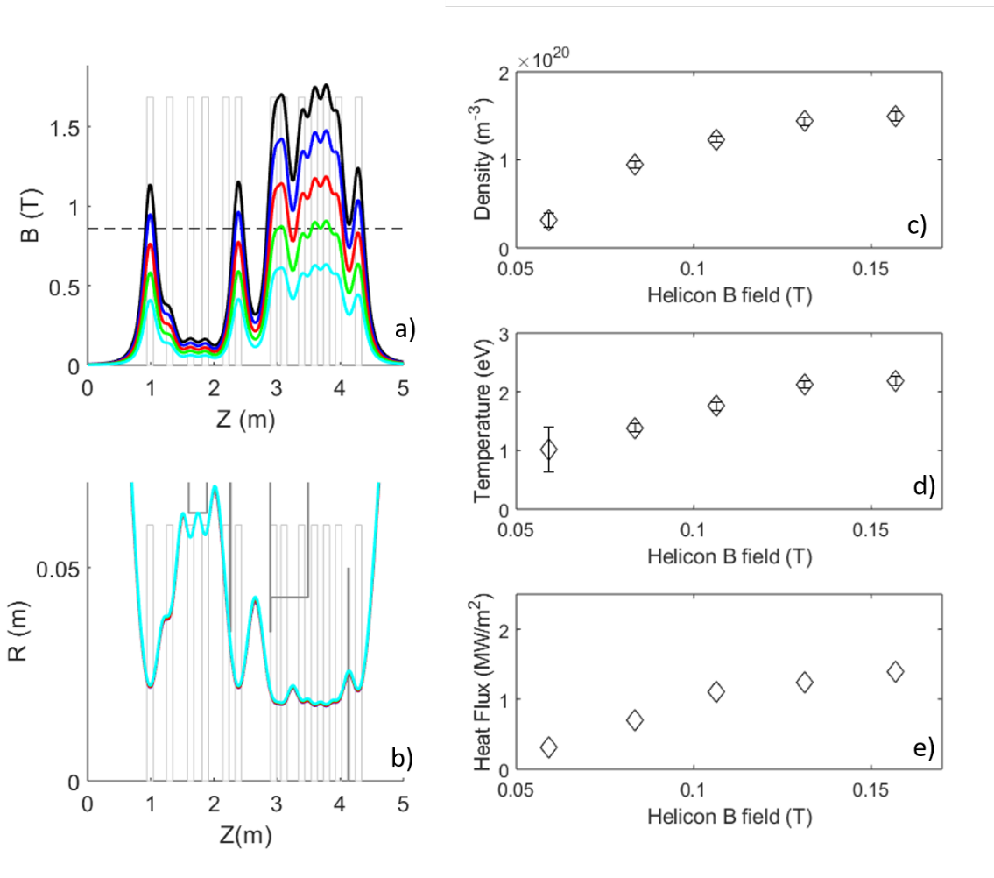

**Figure 3‑46. Helicon plasma production at various magnetic fields for a constant magnetic flux surface shape and constant net helicon power of 125 kW on Proto-MPEX. a) Axial magnetic field profile. b) LUFS. c) Core density as a function of helicon magnetic field. d) Core temperature as a function of helicon magnetic field. e) Core heat flux as a function of magnetic field.**

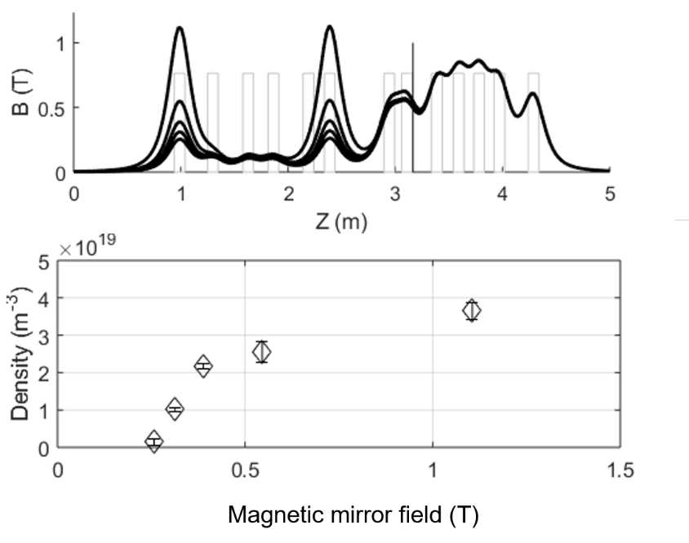

**Figure 3‑47. Helicon plasma production as a function of magnetic mirror field. a) Axial magnetic field profile. b) Core density as a function of magnetic mirror field.**

###### Plasma Startup

The desired MPEX scenarios are steady state but will require a plasma initiation period where the helicon source operates without electron and ion heating before the electron and ion heating is ramped up. This initiation or start-up scenario will have distinguished temporal waveforms for helicon power, ECH power, ICH power, and gas inputs.

For plasma startup on Proto-MPEX, the range of magnetic field strength at the helicon antenna is greater than 0.02 T to get necessary plasmas to startup. From the standpoint of the plasma physics, it is only necessary that this startup |B| value be maintained for a short time, ≤ 10 ms, after which |B| can be ramped higher. Other considerations related to the performance of the magnets themselves will likely require a ramp time longer than this.

The explanation for the required lower bound is as follows: We have empirically determined that for the case of deuterium plasmas, plasma breakdown becomes difficult or impossible for an average |B| > 0.07T, and for some plasma conditions as low as |B| > 0.05T. This magnetic field should be along the entire length of the helicon antenna and helicon window with variation in field along length no greater than 5% based on previous empirical results and a conservative estimate for the variation. This is likely due to the fact that buildup to a high density plasma requires collisional damping of the helicon wave, whose damping length is proportional to the local magnetic field strength (Chen, 1991). It is also necessary to form radial eigenmodes (Shamrai, 1998). Since it is planned to have the capability to operate with hydrogen as well as deuterium plasmas, account must be taken of the differences in ion mass. It can be shown that in order to sustain a given radial eigenmode in a plasma such as MPEX where axial losses dominate, that the magnetic field strength in the helicon region should be scaled proportionally to the ion mass assuming single ionization of any species. Switching from deuterium to hydrogen would then require a factor of two reduction in |B|, and we require 0.02 T rather than 0.025 T to provide a risk conservative estimate for operation with hydrogen plasmas.

###### Light-ion helicon plasma sources

In the next section computational modelling of the wave propagation in the Proto-MPEX helicon plasma source is presented; however, before proceeding, it is important to discuss some key physics to put the computational results into perspective.

###### Background

Most published research in helicon plasma sources has been carried out in low-density ($≤{10}^{18} m^{-3}$), low-RF-power (1–5 kW) discharges with *heavy* ions such as argon. In this context, it is generally accepted that power absorption in the plasma is due to mode conversion of the fast wave into the slow wave[[1]](#footnote-2) at the plasma edge (Arnush, 2000). In other words, power absorption is hollow. Moreover, regardless of where the power absorption occurs, the density profiles in heavy-ion helicon plasmas are typically centrally peaked (Curreli and Chen, 2011). This apparent contradiction is resolved by noting that under these conditions, electrons are magnetized *while the heavy ions are not*. These ions typically have Larmor radii much greater than the plasma radius. Radial transport of unmagnetized ions can lead to centrally peaked profiles. This process is discussed by Curreli and Chen (2011) and Owen et al. (2017). However, there are two main physical mechanisms that make light-ion helicon plasmas, such as those in Proto-MPEX, different from heavy-ion helicon plasmas: (1) both ions and electrons are magnetized and (2) the lower hybrid resonance affects wave accessibility in typical laboratory settings.

###### Ion magnetization and lower hybrid effects

Ion magnetization precludes the transport effects described by Curreli and Chen (2011); therefore, radial plasma density profiles resemble power absorption profiles. Moreover, the Lower Hybrid (LH) resonance restricts the slow-wave propagation to densities less than $<{10}^{16} m^{-3}$, as shown in the dispersion relation plotted in Figure 3-48, thus making the effects of the slow wave observable only at the very edge of the plasma. In this region, magnetic field lines have very short connection lengths; hence, slow-wave-generated plasma is readily lost to the wall and does not contribute significantly to the bulk plasma production. On the other hand, the fast wave can access most of the plasma volume; hence, the bulk plasma is essentially fast wave dominated. To drive plasma production in the core, the fields from the antenna must tunnel through an evanescent layer (Figure 3‑48) and excite a fast wave eigenmode in the core plasma. The exact mechanism responsible for the fast wave absorption is not clear; however, possible absorption mechanisms are collisional damping (Caneses and Blackwell, 2016) and/or non-linear parametric decay of the fast wave into strongly damped electrostatic waves (Lorenz et al., 2005; Akhiezer, Mikhailenko, and Stepanov, 1998).

|  |  |
| --- | --- |
|  | Figure 3‑48. Dispersion relation of the whistler wave with finite ion mass effects (deuterium ions). The perpendicular wave numbers of the slow wave (red) and fast wave (blue) are computed as a function of plasma density. The conditions are , . The Lower Hybrid Resonance (LHR) is represented by the red dotted vertical line and the Fast Wave Cutoff (FWC) by the blue dotted vertical line. |

###### Computational investigation of high-density discharges in Proto-MPEX

A COMSOL-based full-wave model has been developed to numerically study the power absorption process in Proto-MPEX high-density deuterium plasmas (Piotrowicz, Caneses, Green et al., 2018). Lower hybrid effects and Coulomb collisional damping are included in the model. Realistic RF antenna geometry and 2D magnetic field structure are also considered. A more detailed description of the model is provided by Piotrowicz, Caneses, Green et al. (2018). The wave propagation was modelled using conditions typical of the high-density mode deuterium discharges in Proto-MPEX ($n_{e}\sim 2-5×{10}^{19}, B_{0}\sim 0.01-0.1 T$, RF freq. 13.56 MHz). The simulation domain (red rectangle) is shown in Figure 3‑49.

|  |  |
| --- | --- |
|  | Figure 3‑49. Schematic of Proto-MPEX showing the computation domain (red rectangle) used for the full-wave modelling of the plasma source. |

Two-dimensional RF power absorption calculations are shown in Figure 3‑50 for two cases of magnetic field at the helicon antenna: (a) 0.12 Tesla and (b) 0.07 Tesla. In both cases, the peak plasma density is $2.7×{10}^{19} m^{-3}$. The high magnetic field case corresponds to a condition above the “critical” magnetic field observed experimentally (Figure 3‑44), while the low magnetic field case (0.07 T) is at the “critical” magnetic field.

The higher magnetic field case (0.12 T) shows power absorption structures at the edge of the plasma column under the RF antenna and propagating along the magnetic field lines. These can be identified as slow waves due to the field-aligned group velocity. Some absorption in the core is observed, but most occurs at the plasma periphery. Lowering the magnetic field (0.07 T) shows a distinct transition to core power absorption and suppression of edge heating as observed experimentally (Figure 3‑44). From the angle of the group velocity, the power absorption in the core can be associated with the fast wave. The computational results show that above the “critical” magnetic field, core power deposition cannot be sustained and an increase in the edge power absorption is observed. Above the critical magnetic field, the discharge seizes to be fast-wave dominated. Finally, the computational results show that for these conditions, collisional damping is sufficient to absorb the fast wave in the plasma core.

|  |  |
| --- | --- |
|  | Figure 3‑50. Numerical 2D RF power absorption calculations of the Proto-MPEX plasma source for magnetic fields (a) above and (b) below the “critical” magnetic field. The RF antenna location is represented by the thick horizontal red line. |

From the experimental and computational investigation described in the previous two sections, important insight into the physics of the high-density deuterium plasmas in Proto-MPEX has been obtained: (1) fast wave core power absorption is key to producing such discharges, (2) core power absorption leads to edge power suppression, and (3) the stable part of the linear increase in $n_{e}$ with $B_{0}$ is due to fast wave core power absorption, and (4) the unstable part of the $n_{e}\left(B_{0}\right)$ scaling is caused by the inability of the discharge to sustain fast wave eigenmodes, and as a result the slow wave edge power deposition starts to dominate. It has been shown experimentally that the critical magnetic field can be increased by operating at higher RF power.

###### Implications for MPEX

Proto-MPEX has demonstrated the production of high-density deuterium plasmas with up to 150 kW helicon source to the level required for MPEX. In MPEX, this source will need to operate at or below the critical magnetic field in order to achieve the highest plasma densities and plasma diameter at the Target section. To increase the value of the critical magnetic field, operation at higher RF power is required. In Proto-MPEX, 100 kW operation gives an empirical critical magnetic field about 0.06 Tesla. 150 kW operation gives an empirical critical magnetic field about 0.15 T. Assuming the same plasma source performance for MPEX, operation at 200 kW may allow access to operation at 0.2 Tesla. Based on magnetic field flux mapping, at 0.1 Tesla the predicted plasma diameter in the Target section at 1 Tesla is approximately 4 to 4.5 cm. If operation at 0.2 Tesla could be achieved on the MPEX plasma source using deuterium gas, the predicted plasma diameter would be 6 cm in the Target section at 1 Tesla.

Moreover, as it was the case in Proto-MPEX, timing of the neutral gas injection relative to the RF power will be important in establishing high-density discharges in MPEX. To determine the neutral gas flow rate for steady-state operation, the ionization cost and ionization efficiency of the MPEX source are discussed in the next section.

### Neutral gas control and differential pumping requirements for the heating systems

The high-density plasma discharges initially produced in Proto-MPEX (Goulding et al., 2017) demonstrated plasma production to the level required for MPEX; however, the neutral gas pressure in the RF heating section was too high for efficient plasma heating. To reduce plasma production during heating and charge exchange interactions during ion heating, neutral gas pressures in the range of 0.01 to 0.05 Pa are required in the RF heating sections. For efficient plasma production, neutral gas pressures in the range of 1 to 2 Pa are needed in the plasma source. It is evident that differential pumping systems are required to simultaneously satisfy the required neutral gas pressures at the Source and Heating sections. Details of the neutral gas pressure requirements are described by Diem et al. (2018) and Caneses et al. (2018) for electrons and ions, respectively. In what follows, experimental results from Proto-MPEX are presented that demonstrate compatible operation of the high-density plasma source with the heating systems.

Figure 3‑51 presents a diagram of Proto-MPEX showing the location of the conductance-limiting elements (skimmers) used to control neutral gas pressure. The three neutral gas pumping stations used in Proto-MPEX are shown as Pumps 1, 2, and 3, and the pumping speeds correspond to the manufacturer’s specification for nitrogen. The gas injection location is behind the helicon antenna. “LP” refers to a Langmuir probe located in the Target chamber. $P_{H}$ and $P_{T}$ refer to the pressure in the Heating and Target sections, respectively, measured with fast pressure gauges.

Figure 3‑52 presents measurements from a 500 ms long high-density deuterium plasma in Proto-MPEX. For this discharge, the delivered RF power was approximately 80 kW, and the magnetic field at the helicon source was about 0.055 Tesla and 0.7 Tesla in the Target section. The neutral gas was injected upstream of the plasma source and optimized to produce the lowest neutral gas pressures in the Heating section. The most important feature from Figure 3‑49 is the simultaneous production of 4 $×{10}^{19} m^{-3}$ plasma densities at the Target section and neutral gas pressures in the Heating section down to 0.01 Pa. In fact, using this type of discharge electron heating in Proto-MPEX was demonstrated for the first time (Biewer et al., 2018).

Figure 3‑53 presents measurement from a 1 second high-density deuterium discharge in Proto-MPEX. In this figure, both the plasma response and the neutral gas pressure have reached steady state. The conditions are the same as in Figure 3‑52, except that the magnetic field at the Target is about 1 Tesla and leads to plasma densities in the Target up to $7×{10}^{19} m^{-3}$. Figure 3‑53 demonstrates that the skimmers can hold the required pressure difference between the Target and Heating sections and sustain the low pressures (0.01–0.05 Pa) required in the Heating section during a steady-state high-density discharge. Recent experiments using 500 ms long high-density deuterium discharges have demonstrated that a pressure of 1 Pa can be sustained in the Target section while keeping the pressure in the Heating section less than 0.05 Pa. Tests at higher neutral gas pressures in the Target section were not possible due to the neutral gas injector reaching its flow limit. There is still a need to experimentally verify if higher pressures (5–10 Pa) can be sustained in the Target section while keeping the pressures in the Heating sections less than 0.05 Pa.

|  |  |  |  |
| --- | --- | --- | --- |
|  | | Figure 3‑51. Diagram of Proto-MPEX showing the location of the conductance limiting elements (skimmers) used to control neutral gas pressure. Locations of the three neutral gas pumping stations are also shown. The quoted pumping speed is the manufacturer’s specification for nitrogen. Location of the gas injection is also shown. | |
|  | Figure 3‑52. High-density deuterium plasma in Proto-MPEX demonstrating optimized neutral gas control in the heating section. “LP” refers to Langmuir probe measurement in the Target section. and refer to neutral gas pressures measured in the Heating and Target sections, respectively. Pressure in the Heating section is about 0.01 Pa (Black trace). Green traces correspond to cases without plasma and only gas injection. | |
|  | Figure 3‑53. Steady-state conditions reached in 1 second deuterium plasma discharge in Proto-MPEX. Delivered RF power is about 80 kW. and refer to neutral gas pressures measured in the Heating and Target sections, respectively. Black/Green traces correspond to the neutral gas pressure with/without plasma. | |

###### Implications for MPEX

The results from Proto-MPEX have shown that the best fueling location for optimal neutral pressure operation is upstream of the location where the plasma limits the helicon window and the location of the source skimmer. As described by Caneses et al. (2018), the location where the plasma limits on the helicon window serves as an additional conductance limiting element; hence, together with the skimmer they provide enhanced differential pumping between the Source and the low pressure required in the Heating section. Moreover, a conductance-limiting element is also needed between the Target and Heating sections. This process has been demonstrated for quasi-steady-state conditions attained in Proto-MPEX with 1 second pulses. Therefore, neutral gas fueling upstream of the plasma source and the use of conductance limiting elements (such as skimmers) will be requirements for proper neutral gas control and differential pumping in MPEX.

### Quantification of plasma source performance

After demonstrating compatible high-density plasma operation with the heating systems, questions related to the plasma source performance needed investigation:

* How much neutral is converted into plasma?
* What is the energy cost to deliver ions to the target?
* How much plasma is delivered to the target?

Can the plasma source performance be improved?

These questions have been answered experimentally and are described in this section. The experimental setup is the same as in Figure 3‑51, except that an Ion Flux Probe (IFP) is used instead of a Langmuir probe. Moreover, the neutral gas injection was calibrated and set to 5.8 $×{10}^{20}$ deuterium atoms per sec (0.69 SLM). The total delivered RF power was 80 kW. Pump 3 was turned off in order to make neutral particle accounting easier. It was experimentally observed that due to its small size, Pump 3 had no observable effect on the plasma performance. The IFP, located about 30 cm upstream of the Target plate, was used to measure the total integrated ion flux $S_{+}$ flowing toward the Target section. The total integrated ion flux was calculated using Equation 3-4, where $Γ_{+}$ represents the ion flux density in $m^{-2}s^{-1}$. This complete study is reported by Caneses et al. (n.d.). Two key metrics used to quantify the performance of the plasma source are the ionization efficiency $ξ_{IZ}$ (Equation 3-5) and the ionization cost $E_{IZ}$ (Equation 3‑6), where $S_{n}^{D_{0}}$ is the neutral gas flow in deuterium atoms per second and $P_{RF}$ is the delivered RF power.

$S_{+}=\int_{0}^{∞}{Γ_{+}}2πr dr \left[\frac{ion}{s}\right]$. (3‑4)

$ξ_{iz}=\frac{S_{+}}{S_{n}^{D_{0}}}$. (3‑5)

$E_{iz}=\frac{P_{RF}}{S_{+}} \left[\frac{eV}{ion}\right]$. (3‑6)

The most important outcomes from this study are the production of peak ion flux densities of up to $1×{10}^{24} m^{-2}s^{-1}$ while providing the required neutral gas pressures in the Heating section (0.01–0.05 Pa), as shown in Figure 3‑54.. These conditions correspond to the case where the most amount of plasma is delivered to the Target while simultaneously providing the pressures required for the heating systems. The total integrated ion flux was measured to be about $0.52×{10}^{21} s^{-1}$. Given the neutral gas input (5.8 $×{10}^{20} D^{0} s^{-1}$), the ionization efficiency is about 80 to 90%. In other words, 80 to 90% of the input neutral gas gets ionized and arrives at the Target section as ions. Moreover, based on the 80 kW of delivered RF power, the ionization cost is approximately 1 ${keV}/{ion}$. This means that in practice it cost approximately 1000 eV of energy to deliver an ion-electron pair at the Target section in Proto-MPEX. From these metrics it is evident that very good neutral gas utilization has been attained; however, the cost per electron-ion $E_{IZ}$ pair is very high. Next, a brief discussion is provided on the ionization cost and what can be done to reduce it.

|  |  |
| --- | --- |
|  | Figure 3‑54. At top, peak ion flux density 30 cm away from the target plate, (center) peak heat flux at the target plate, and (bottom) neutral gas pressure in the Target and Heating section. |

###### Ionization cost

During plasma production, energy is required to drive ionization, excitation and elastic processes. After accounting for all elastic and inelastic processes, the effective energy required to create an electron-ion pair is called the “ionization cost” $E_{IZ}$ (Hjartarson, Thorsteinsson, and Gudmundsson, 2010). By neglecting transport processes and including only atomic physics, the theoretical minimum for the ionization cost as a function of electron temperature can be calculated. For example, based on Hjartarson, Thorsteinsson, and Gudmundsson (2010), the ionization cost of molecular hydrogen gas in the electron temperature range of 3 to 5 eV is 200 to 80 eV per ion, respectively (Figure 3‑55.). The ionization cost $E_{IZ}$ has been measured in other devices. For example, Pilot-PSI has demonstrated $E_{IZ} \sim 680$ eV per ion using a cascaded arc source operating at 65 kW with H2 gas and producing a total integrated ion flux of $S_{+}=6×{10}^{20} s^{-1}$ (Vijvers et al., 2008). Moreover, the VASIMR helicon source has improved its ionization cost with D2 gas from $E_{IZ} \sim 700 eV$ to $E_{IZ}=250 eV$ by increasing the magnetic field at the plasma source from 0.04 Tesla to 0.14 Tesla (Bering et al., 2006). Similarly, in Proto-MPEX it was observed experimentally that the ionization cost $E_{IZ}$ is improved as the magnetic field under the plasma source is increased as demonstrated by Figure 3‑56. The operating gas in this experiment was deuterium with 80 kW of delivered RF power. In this magnetic field range, the ionization cost appears to scale linearly with magnetic field; however, as the magnetic field of 0.09–0.1 Tesla is approached, it is expected that the slope will flatten. This indicates that the source performance can be improved considerable by operating at higher magnetic fields. As discussed previously, in the current setup of Proto-MPEX operation above 0.06 Tesla requires the use of higher RF power. It is expected that doubling the RF power will enable operation at 0.1 Tesla and improve the ionization cost to about $E_{IZ} \sim 500$ eV per ion.

|  |  |
| --- | --- |
|  | Figure 3‑55. Theoretical ionization cost based on atomic physics for three different gases: argon, atomic hydrogen and molecular hydrogen. |
|  | Figure 3‑56. Ionization cost $E_{IZ}$ measured in Proto-MPEX as a function of the magnetic field $B_{0}$ under the plasma source. The operating gas is deuterium. The RF power is 80 kW delivered. |

###### Role of turbo-pumps

In this section, the role of the turbo-molecular pumps in Proto-MPEX is discussed. The pumping speeds specified by the manufacturer are shown in Figure 3‑51 for nitrogen gas. However, these values are different when using deuterium gas and piping to connect the pumps to the chamber; therefore, the effective pumping speeds in Proto-MPEX have been measured experimentally with deuterium gas. The effective pumping speed of Pump 1 is about 0.75 $m^{3}s^{-1}$ in deuterium. Using this pumping speed and the neutral gas pressure of 0.01 Pa in the Heating section (as shown in Figure 3‑52), the neutral gas throughput of Pump 1 is about 3.6 $×{10}^{18}$ atoms per second by assuming D2 molecules at room temperature. Comparing this value to the total neutral gas input into the system (5.8 $×{10}^{20}$ atoms per second), it can be seen that less than 1% of the total gas load into Proto-MPEX is removed by Pump 1. Moreover, due to the ionizing action of the plasma in the Heating section, the plasma also behaves like a pump. Using the material presented in reference (Caneses et al., 2018) and for conditions typical of the Heating section in Proto-MPEX, the pumping speed of the plasma is about 2.5 $m^{3}s^{-1}$. Therefore, the pumping capacity of the plasma in the Heating section is at least 3 times larger than Pump 1. Based on these estimates of gas throughput and plasma pumping speed, it is concluded that Pump 1 is not needed. The entire neutral gas pumping in Proto-MPEX can be supported by the pump at the Target section (Pump 2). Experimental confirmation of this statement is shown in Figure 3‑57 and Figure 3‑58..

Figure 3‑57 presents the neutral gas pressure in the (a) Source, (b) Heating and (c) Target sections as a function of time for two different pumping scenarios: (red) only Pump 2, (black) both Pump 1 and 2. The blue shading represents the time interval during which the plasma is produced. During the plasma discharge, there is no observable difference in the neutral as pressure for all three sections. This means that the low neutral gas pressure of 0.01 Pa in the Heating section is sustained entirely by the ionizing action of the plasma (red trace). This confirms that Pump 1 is not a significant sink of neutral gas. Experimentation with the neutral gas fueling during high-density discharges has shown that the main contribution of Pump 1 is to reduce the time it takes for the neutral gas pressure to reach 0.01 Pa. For the present conditions, it takes about 150 ms to evacuate the neutral gas from the Heating section. Moreover, the neutral gas pressure in the Target section during the plasma discharge is unaffected by the pumping scenario. Since the neutral gas accumulation at the target is directly related to the plasma flux, this indicates that the amount of plasma delivered to the Target section is not affected by the pumping scenario. This is confirmed by directly measuring the ion flux density at the Target section for both pumping scenarios as shown in Figure 3‑55.. This measurement demonstrates that the amount of plasma delivered the Target section is unaffected by the pumping scenario and consistent with the neutral gas pressure measurements.

The main conclusion from this discussion on the turbo pumps is that provided the helicon plasma source is operated with optimal gas fueling and skimmers as discussed by Caneses et al. (2018; n.d.), practically all the neutral gas injected into the device is delivered to the Target via plasma transport and needs to be removed by the pump in the Target section. This indicates that the most important pumping location in Proto-MPEX is the Target section pump and it should be sized to accept the entire gas load of the device. The pump in the Heating section is of secondary importance and should be sized to *assist* the plasma since in this region the plasma is the main driver of neutral gas removal. Finally, it is emphasized that in this study the pump on the Dump tank was not used (Pump 1). As explained previously, due to its small pumping speed it was experimentally confirmed that its presence or absence had no observable effect on the discharge performance.

|  |  |  |  |  |
| --- | --- | --- | --- | --- |
|  |  | |  | |
| Figure 3‑57. Neutral gas pressure in the (a) Source, (b) Heating and (c) Target sections for two different pumping scenarios. The red traces represent conditions with only Pump 2 operating. The black traces represent conditions with both Pumps 1 and 2 operating. The light blue shading indicates the timing of the discharge. | | | | |
| Figure 1 | | Figure 3‑58. On-axis ion flux density in the Target section for two different pumping scenarios. | |

###### Implications of MPEX

As demonstrated in Proto-MPEX, the ionizing action of the plasma is the prime driver of neutral gas removal in the Heating section and not the mechanical pump. This was ascertained by calculating the effective pumping speed of the plasma and neutral gas throughput of the pump relative to the input neutral gas which indicated that less than 1% of the total neutral gas is removed by the Heating section pump. The main contribution of the pump in the Heating section is to reduce the time it takes the plasma to evacuate the neutral gas. Moreover, it was shown that the small pump (0.2 $m^{3}s^{-1}$) in the Dump tank has little to no effect on the plasma performance. The main message from this investigation is that due to the high ionization efficiency of the plasma, practically all the gas injected in the Source section gets ionized and transported along the magnetic field to the Target section at which point it recombines and delivers all the neutral gas. It is for this reason, that the largest pumping station needs to be at the Target section and sized to accept the entire neutral gas load of the device. The pump in the Heating section should be considered as *supporting* the pumping action of the plasma to maintain low neutral gas pressures. For this to be effective, conductance limiting elements are a requirement on either side of the Heating section. If the ionization efficiency of the plasma source was very low, the conclusions presented here would be very different and more pumping stations distributed along the device would be needed.

The ionization efficiency and ionization cost measured in Proto-MPEX are a good starting point to calculate the neutral gas usage for MPEX in steady-state operation. This calculation has an impact on the total amount of neutral gas pumping needed for MPEX. For example, with 100 kW operation at 0.06 Tesla, the total effective plasma production rate $S_{+}$ is about $0.5×{10}^{21} s^{-1}$ based on Proto-MPEX results. Using an ionization efficiency of 80% (as measured in Proto-MPEX) and letting all the gas be removed at the Target section, the total gas load to be supplied at the plasma source is about 0.7 SLM. Increasing the RF power to 200 kW will double the effective plasma production rate $S_{+}$. In addition, higher RF power will enable operation at higher magnetic fields. It is expected that 200 kW operation will enable operation at 0.1 Tesla. Since the plasma production rate scales linearly with magnetic field, at 0.1 Tesla and 200 kW a plasma production rate of $S_{+}=2×{10}^{21} s^{-1}$ is expected. Using 80% ionization efficiency, this corresponds to about 3 SLM. Adding a 25 % contingency leads to about 4 SLM for the steady-state neutral gas load of MPEX.

### Characterization of a steady-state water cooled helicon plasma source for MPEX

The MPEX plasma source will operate in steady-state at a power level of 200 kW. In order to dissipate the heat loads during plasma production, the source must be actively cooled. The method selected for the MPEX plasma source is water cooling between two concentric dielectric windows and the RF antenna surrounding the assembly as shown in Figure 3‑59.. There are several important engineering questions that need to be addressed such as: (1) What is the RF dielectric loss in the cooling water channel? (2) What are is the distribution and magnitude of the heat loads inside the inner window during 200 kW operation? (3) What fraction of the RF power is lost to the window assembly?

In order to address these questions, two efforts were made. Firstly, a collaboration between ORNL and the University of San Diego California (UCSD) has been established. A MPEX like water-cooled plasma source has been manufactured and successfully installed in the CSDX linear device located at UCSD. Figure 3‑60. shows the manufactured water-cooled MPEX plasma source before installation on CSDX and once installed on CSDX. This plasma source uses an Aluminum Oxide (Al2O3) window brazed to a titanium spacer which is ultimately joined to a stainless-steel flange. This metal-to-ceramic braze concept has been tested under full vacuum load and cooling-water pressure in CSDX. Elastomer seals are avoided in order to prevent introducing impurities into the plasma. Argon helicon plasma discharges have been produced with RF power levels up to 5 kW in steady-state. Initial plasma production, thermal and RF loading experiments have been performed to study the performance of the source and answer key design questions for MPEX. Moreover, studies on preferential erosion of the dielectric window material have been carried out. Secondly, measurements to characterize the helicon window heat flux were made on the Proto-MPEX experiment in deuterium plasmas.

|  |  |
| --- | --- |
|  | Figure 3‑59. Illustration of the water-cooled helicon plasma source for MPEX. |

|  |  |
| --- | --- |
|  | Figure 3‑60. Illustration of the water-cooled MPEX helicon plasma source before installation and once installed in CSDX. |

###### Window material

Initially, the material of choice for the water-cooled steady state plasma MPEX source window was Aluminum Nitride (AlN). Its high thermal conductivity is desirable to minimize thermal stresses during operation. However, there are concerns when using AlN as a window material such as: (1) hydrolysis, (2) preferential erosion of nitrogen leading to reduced RF coupling and (3) uncertainty in the mechanical integrity of brazing AlN with metals. Work done by UCSD demonstrated that preferential erosion under conditions expected for MPEX are not an issue for RF coupling for either AlN or Alumina (Al2O3). Table 3-5 lists the testing conditions for AlN and Al2O3 samples in PISCES A. Figure 3‑58 shows the depletion levels of N and O in the first 30 nm of the ceramic layers. The N depletion occurs in the uppermost 10 nm, and show saturation with time and fluence. The O depletion is within the first 6 nm. However, when the sample is examined post-test, there is a re-oxidation of the first 3 nm from exposure to air. However, if AlN is to be considered, hydrolysis and reduced manufacturing experience are still of concern; hence, Alumina is now considered a better candidate for the window material despite its lower thermal conductivity. This puts additional emphasis on the following areas: (1) higher fidelity thermo-mechanical modelling of the window for operation at 200 kW, (2) mitigation strategies to reduce heat loads on window such as Faraday screens and water-cooled limiters to prevent direct plasma contact with the window.

Table 3‑5. D-plasma PMI testing of ceramics in PISCES A.

|  |  |  |  |  |  |
| --- | --- | --- | --- | --- | --- |
| **Sample** | **Ion** | **Energy**  **(eV)** | **Flux,**  **(1021 m-2s-1)** | **Fluence**  **(1025 m-2)** | **Temperature**  **(K)** |
| AlN IV | D | 60 | 1.5 | 0.7 | 500 |
| AlN III, exposure 1 | D | 60 | 2 | 3 | 600 |
| AlN III, exposure 2 | D | 60 | 1.5 | 12 | 720 |
| Al2O3 I | D | 60 | 1.7 | 2.5 | 520 |

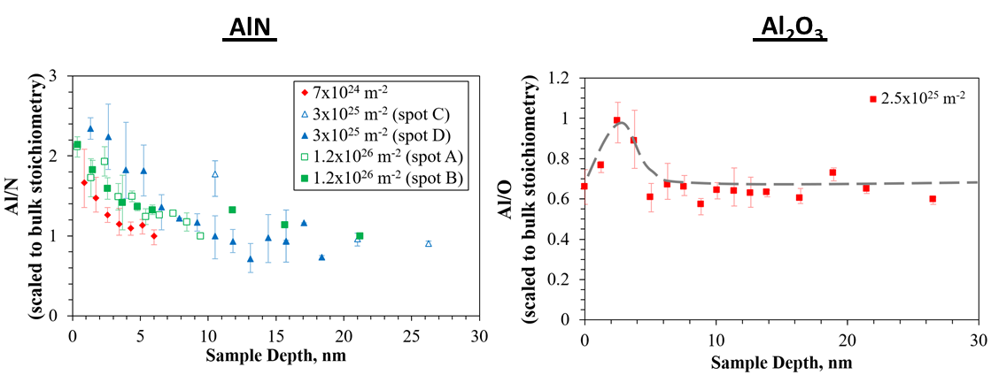

Figure 3‑61. Levels of N and O depletion in ceramics.

###### Performance of water-cooled MPEX plasma source in CSDX

So far, the water cooled MPEX plasma source has been tested up to 5 kW in steady-state in CSDX. A 20-kW experimental campaign is under way to investigate: (1) scaling of heat loads with RF power, (2) effect of plasma limiting location on inner window and (2) extrapolation of heat flux profiles to 100-200 kW operation.

###### Plasma production

In Figure 3‑62., experimental measurements are presented of the plasma density and electron temperature in a 5 kW Argon discharge using the water-cooled metal-brazed MPEX source in CSDX. Measurements with and without cooling De-Ionized (DI) water are shown. The results demonstrate that having a fully-enclosing DI water layer between the RF antenna and the vacuum has no appreciable impact on the plasma production. The vacuum loading and quality factor Q of the resonant circuit were measured to be 0.165 Ohms and Q = 125 in the absence of the cooling water and changes to 0.183 Ohms and Q = 112 when cooling water is applied. Preliminary tests indicate that the presence of the plasma increases the losses incurred in the water to about7% relative to the delivered RF power.

|  |
| --- |
|  |
| Figure 3‑62. Experimental measurements of plasma density and electron temperature in the water-cooled MPEX plasma source installed in CSDX at UCSD for testing. |

###### Infrared thermography

An IR camera is used to diagnose and infer the plasma heat loads on the inner surface of the dielectric window. The IR camera setup in CSDX is shown in Figure 3‑63.. To infer the heat flux from the IR based temperature measurements, a model that describes the transient heat conduction on a semi-infinite medium is used as given by Equation 3-7, where $q_{0}$ is the magnitude of the constant heat flux, $ρ$ is the material’s mass density, $k$ is the thermal conductivity and $c_{p}$ is the specific heat. Given the material properties of the inner window (Al2O3) and the thickness of the window (0.25 in.), the infinite medium assumption is applicable for times less than about 12 seconds. This means the surface heat flux can be extracted by recording the temperature evolution of the inner surface during the first 10 seconds of the discharge and without considering the exact boundary conditions at the water boundary. The heat flux is extracted by plotting the temperature data using Equation 3-8 and fitting a straight line whose slope is linearly related to the surface heat flux $q_{0}$.

$T\left(0,t\right)=T_{0}+\frac{2}{\sqrt{π}}\frac{q_{0}}{b}\sqrt{t} where b^{2}=ρkc_{p}$ (3‑7)

${\left[T\left(0,t\right)-T_{0}\right]}^{2}=Kt where q_{0}=b\frac{\sqrt{π}}{2}\sqrt{K}$ (3‑8)

|  |  |
| --- | --- |
|  | Figure 3‑63. IR cameras setup in CSDX used to measure the plasma-induced heat loads to the inner window of the plasma source. |

The time evolution of the IR inferred temperature at one pixel during a plasma discharge is shown in Figure 3‑64. The start of the RF discharge is indicated by the vertical arrow. The IR camera was calibrated for this measurement. For this discharge 5 kW of RF power was applied and argon was used as the operating gas. The data in Figure 3‑64. is plotted according to Equation 3-8 and yields the result shown in Figure 3‑65. clearly showing a linear scaling with time during the first 10 seconds of the discharge. The linear scaling demonstrates the validity of the semi-infinite medium model used.

The IR camera was located at four 90-degree spaced ports to capture the entire inner surface temperature evolution of the plasma source inner window. The temperature images are homographically reconstructed to plot them on a Cartesian 2D plane (azimuthal angle as the abscissa and “z” location along the window as the ordinate). The heat flux calculation described above is performed on every pixel of the temperature image. Since radial temperature gradients dominate during the transient part of the heat conduction, axial and azimuthal heat conduction was neglected.

|  |  |
| --- | --- |
|  | Figure 3‑64. Time evolution of the IR inferred temperature if the inner window at one pixel during a 5-kW argon discharge in CSDX. |

|  |  |
| --- | --- |
|  | Figure 3‑65. Data from Figure 3‑61. plotted using Equation 3-8 to determine the surface heat flux on the inner window of the plasma source during a 5 kW argon discharge. |

The entire 2D heat flux distribution of the inner window of the plasma source is shown in Figure 3‑66. The RF current paths of the helicon antenna, the high voltage (HV) and ground (GND) connections of the antenna are also shown for reference. The dotted horizontal line indicates the approximate location where the plasma limits on the helicon window. The data indicates that the largest heat fluxes are observed on the HV side of the antenna. This may be indicative of capacitively coupling between the high voltage and the plasma sheath. Further evidence of capacitive coupling is shown in Figure 3‑64 where the location of the HV side of the antenna has been changed. This shows that the largest heat fluxes follow the location of the HV side of the antenna. Additional evidence that strong plasma interaction is occurring at the HV side is shown in Figure 3‑67 and Figure 3-68 where discoloration under the HV side of the antenna that faces the plasma is observed. This photograph during maintenance after weeks of plasma operation at 5 kW.

|  |  |
| --- | --- |
|  | Figure 3‑66. 2D map of the surface heat flux on the inner window of the MPEX source installed on CSDX. Measurements performed with IR thermography. RF power is 5kW and operating gas is Argon. HV stands for the “High Voltage” side of the helicon antenna. GND stands for the “Ground” side of the antenna. |

|  |  |
| --- | --- |
|  | Figure 3‑67. 2D heat flux map of the inner window of the MPEX source installed in CSDX. Case 1 and Case 2 have the location of the HV side of the antenna on opposite sides. The peak peat flux follows the HV side. |

|  |  |
| --- | --- |
|  | Figure 3‑68. Photograph showing the discoloration inside of the ceramic window on the HV side of the antenna. |

These heating marks may be indicative of physical sputtering of the ceramic by plasma ions. This process naturally suggests the use of a Faraday shield to reduce the capacitive coupling at the expense of a small reduction in inductive coupling. This method might be necessary to reduce the thermal gradients generated by the localized heating under the HV side, especially if using Al2O3 as the window material. From a thermo-mechanical point of view, smooth heat flux distributions are desired to minimize thermal gradients. The use of a Faraday shield has yet to be investigated in CSDX and upcoming experiments with additional RF power up to 20 kW will explore how this heat flux scales with RF power. If this is indeed capacitive coupling, it is expected that the heat flux under the HV will scale with the square of the RF power. So far, with up to 5 kW of RF power the scaling of the heat flux under the hottest part of the HV side appears to scale linearly as shown in Figure 3‑69.. The heat flux scaling on the GND side is also shown. The slopes for both cases are shown and indicate that at 200 kW, the heat flux at the hot spot is expected to be about 300 $kWm^{-2}$. This value can be reduced with the use of a Faraday shield.

The scaling of the highest temperature at the HV side with RF power is shown Figure 3‑70. The surface temperatures are taken after 50 seconds of operation with 23 Gallons Per Minute (GPM) of cooling. The data shows a linear scaling of temperature with RF power. If this trend holds for high RF powers, a change in temperature of the inner surface of approximately 20 degrees C at 20 kW and about 200 degrees C at 200 kW operation is expected.

|  |  |
| --- | --- |
|  | Figure 3‑69. Scaling of the inner window surface temperature under the HV side (red) and GND side (blue) as a function of RF power. |
|  | Figure 3‑70. Scaling of the inner window temperature change under the HV side of the antenna as a function of RF power. |

###### Water calorimetry

In addition to IR thermography, the change in temperature of the cooling water was recorded to perform energy balance calculations and determine the total heat removal by the cooling system. By integrating the entire surface heat flux over the surface area of the inner window (Figure 3‑66), the water calorimetry and IR thermography can be directly compared to check the consistency of the energy balance: The total heat removed by the cooling water must be equal to the sum of the integrated surface heat flux plus the RF dielectric loss on the water. The consistency of the energy balance is confirmed as shown in Figure 3‑71. RF absorption refers to dielectric losses in the water and ceramic. Plasma heating refers to the surface integral of the IR inferred heat flux and Calorimetry refers to the power removed by the cooling water. From these calculations, it is observed that total amount of power lost to the plasma source is approximately 20% to 25% of the delivered RF power. There are still open questions such as:

Can the use of a Faraday shield reduce this fraction? If capacitive coupling is present, then Faraday shield will reduce the fraction of power lost to the window. However, this will reduce the inductive coupling.

What is the effect of the ion mass? Using a molecular gas such as deuterium may lead to a large fraction of power lost to the window because ion recombination at the surface will release both the ionization and the dissociation potential.

How does the plasma limiting location affect these estimates?

|  |  |
| --- | --- |
|  | Figure 3‑71. Heat absorption calculations as a function of RF power. RF absorption refers to the dielectric loss on the water and ceramic. Plasma heating refers to the surface integral of the inner window heat flux. Calorimetry refers to the heat removed by the cooling water. |

###### 

###### Helicon window heat flux measurements on Proto-MPEX

Experiments using Infra-Red (IR) thermography have been performed in Proto-MPEX at RF power levels prototypic of MPEX (from 60 to 140 kW) to quantify the surface heat flux incident on inner surface of the dielectric window of the helicon plasma source. Moreover, these experiments investigated the effect of the plasma limiting location on the surface heat fluxes on the dielectric window.

An MPEX-like limiter was installed in Proto-MPEX downstream of the helicon plasma source and the magnetic field profile was adjusted to force the plasma to limit on the MPEX-like limiter as shown in figure 72 below.

|  |  |
| --- | --- |
|  | **Figure 72. Proto-MPEX last uninterrupted flux surface for two magnetic field profiles: one limiting at the helicon plasma source dielectric window (red) and another limiting at the dedicated MPEX-like limiter (black). The strike point for both cases is indicated by the sold red and black circles in contact with the window and limiter surfaces respectively.** |

An optical system consisting of an IR camera, viewing optics and mirror was used to measure the IR emission from the AlN window installed in Proto-MPEX as shown in figure 73. A new and clean AlN window was installed to make the IR measurements and the surface emissivity was experimentally determined to be about 0.9. The IR emission was converted in a time-dependent temperature signal. The temperature temporal evolution was used as an input to a thermal model of the dielectric window and converted into a surface heat flux.

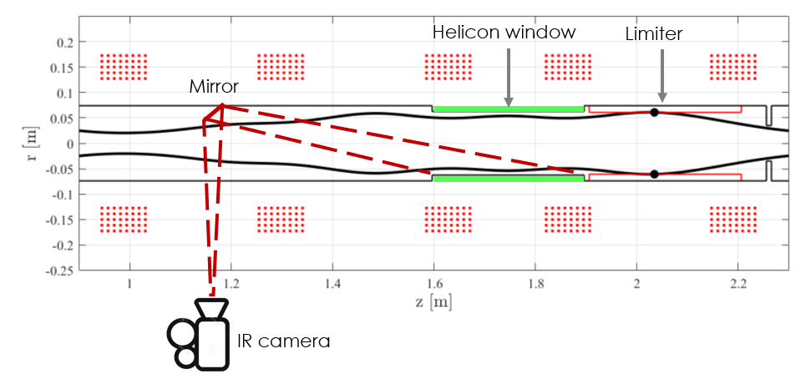

**Figure 73. Optical setup used in Proto-MPEX to measure the IR emission and infer heat fluxes on the inner surface of the AlN window. A Zinc-Selenide window (70% transmission) was used to transmit the IR emission into the IR camera. The spectral band of the IR camera is 6 – 14 microns.**

The surface heat flux distribution over of the inner surface of the dielectric window was measured for the two plasma limiting configurations shown in figure 72 from 60 to 140 kW. These measurements are shown below (figure 74) for 130-140 kW of RF power.

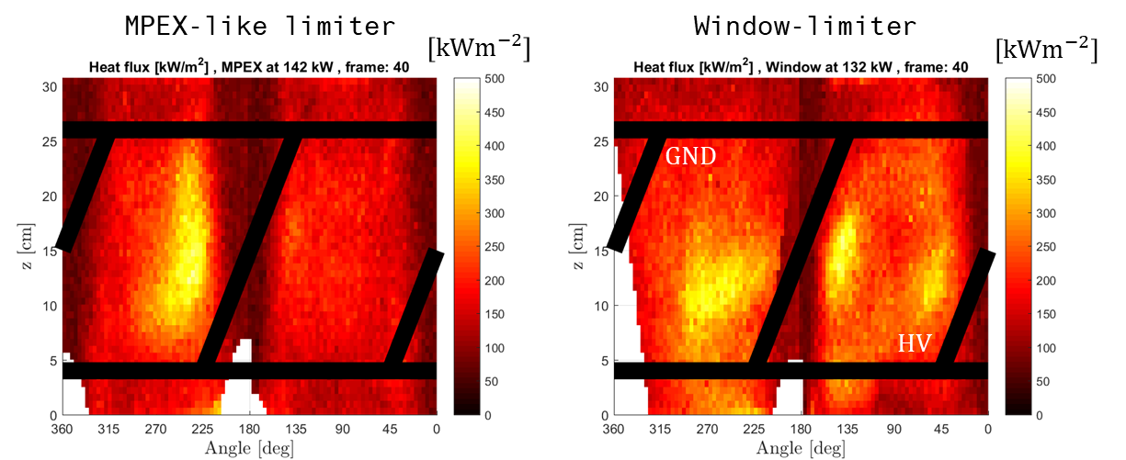

**Figure 74. Surface heat flux distribution on the inner surface of the helicon source AlN dielectric window during the steady-state part of a 500 ms deuterium discharge at 130-140 kW. The black thick lines represent the location of the current straps of the antenna. The High-Voltage (HV) region of the antenna is also indicated.**

Figure 74 indicates that the location where the plasma is limited influences the surface heat flux distribution. The Window-limiter case produces more concentrated “hot” spots. In fact, azimuthally integrating the surface heat flux reveals that the heat distribution for the window-limiter case is concentrated close to the plasma strike point as shown in figure 75.

|  |  |
| --- | --- |
|  | **Figure 75. Azimuthally integrated surface heat flux on the dielectric window for two plasma limiter locations during the steady-state part of 500 ms deuterium plasma discharges at 130-140 kW. The black horizontal lines indicate the position of the transverse current straps of the antenna.** |

Moreover, integrating the surface heat flux over the entire surface area provides the total heat load on the dielectric window. The heat load as a function of RF power is shown in figure 76 where the red and black cases represent data taken on Proto-MPEX with deuterium discharges while the blue trace is from hydrogen data taken on CSDX at the University of California San Diego (UCSD). In the CSDX experiment, the plasma is set to limit on the dielectric window since no MPEX-like limiter was present in the device.

|  |  |
| --- | --- |
|  | **Figure 76. Total heat load incident on the dielectric window of the helicon plasma source as a function of RF power for different plasma limiting configurations.** |

Figure 76 clearly shows that the extrapolation to 200 kW for all the cases is most favorable for the MPEX-limiter case. The experimental data demonstrates that the total heat load on the dielectric window is effectively reduced when setting up a gap between the window surface and the last uninterrupted flux line with the use of a dedicated limiter. Based on these results of reduced heat flux with a MPEX-limiter, a helicon limiter is needed for MPEX, the (radially) last uninterrupted magnetic flux surface shall be determined by the limiter downstream of the helicon antenna. No other in-vessel component (e.g. vacuum chamber, skimmers, docking valves) shall restrict the last uninterrupted flux surface.

The size of this gap was investigated experimentally, and it was found that a 1 cm gap is required to effectively reduce the surface heat flux and eliminate the creation of hot spots as observed during the window-limiter case presented in figure 74. The requirement of a 1 cm gap is most likely related to the plasma decay length outside the last uninterrupted magnetic flux surface. The radial plasma density profile was measured near the plasma source at z = 1.2 m (see figure 71 and 72) using a double Langmuir probe and is presented in figure 77 below. The light-green shaded regions represent radial positions outside the last uninterrupted magnetic flux surface and demonstrates that the plasma density vanishes in about 1 cm away from such surface.

|  |  |
| --- | --- |
|  | **Figure 77. Radial plasma density and electron temperature profiles measured in Proto-MPEX at z = 1.2 m in a deuterium plasma at 120 kW. Light-green shaded regions represent** **radial positions outside the last uninterrupted magnetic flux surface.** |

Therefore, to eliminate the creation of hot spots at the surface of the dielectric window due to plasma strike points and reduce the associated total heat load, a dedicated limiter (other than the window) should be used which produces a gap between the dielectric surface and the last uninterrupted magnetic flux surface no less than 1 cm. Based on the experimentally observed plasma decay length, this requirement causes the plasma density at the window to vanish.

###### Implications for MPEX

The 5 kW argon plasma results in CSDX thus far indicate that the largest plasma-induced heat fluxes follow the HV side of the antenna. Discoloration and surface damage of the ceramic window on the vacuum side directly underneath the HV side indicate signs of plasma sputtering. It is believed that this is caused by capacitive coupling between antenna HV side and plasma. In the context of MEPX, a Faraday shield may be needed to reduce the heat loads on the high voltage side especially if using a low thermal conductivity ceramic like $Al_{2}O_{3}$. Moreover, CSDX experiments indicate that about 20 to 25% of the RF power is lost to the window during these tests. Hence, for 200 kW MPEX operation, this means that 40 to 50 kW of heat needs to be removed from the plasma source in steady-state. Further investigation is needed to determine if these values are the same for deuterium which is a molecular gas.

The preliminary extrapolations from CSDX indicate that surface temperature changes of about 200 degrees C and heat fluxes up to 300 $kWm^{-2}$ on the HV side of the antenna are expected for 200 kW operation. Upcoming experiments with 20 kW in CDSX will provide additional data to improve the extrapolation. Plans are in place to make similar IR thermal measurements in Proto-MPEX with RF power ranging from 40 to 150 kW to supplement the extrapolation to MPEX.

### Conclusions and implications for MPEX

In this section, the most important developments in relation to the plasma production stage of MPEX have been presented. This included: (1) successful production of high-density deuterium plasma using a helicon plasma source with power levels up to 150 kW, (3) demonstration of high-density deuterium plasmas up to 0.15 T helicon magnetic fields (3) demonstration of neutral gas control compatible with heating systems, (4) quantification of the plasma source performance and the contribution of the neutral gas pumps, (5) testing of MPEX-like helicon window for steady-state power levels up to 5 kW on CSDX and pulsed power levels up to 150 kW on Proto-MPEX.

Production of high-density deuterium discharges at the level required for MPEX in Table 3-4 has already been demonstrated. Experimentally, plasma densities in the range of $4-15×{10}^{19} m^{-3}$ have been measured. Based on experimental and computation work, these discharges are understood in terms of fast-wave eigenmode formation and core power absorption. It has been identified that operation at higher magnetic fields requires increasing the maximum plasma density in order to support fast wave core power absorption. This translates to increasing the available RF power to 200 kW and/or improving the ionization cost of the plasma source. Higher magnetic field operation up to 0.2 T can increase the plasma density and/or increase the plasma diameter at the Target section.

It has been demonstrated that high-density operation is compatible with the plasma heating systems for conditions prototypical of MPEX and that the required pressures can be sustained in steady-state based on 1 second discharges in Proto-MPEX. It has been demonstrated that neutral gas control and differential pumping is essential for enabling plasma heating in Proto-MPEX and this will likely be the case for MPEX.

Moreover, the performance of the plasma source at 100 kW operation has been quantified, its ionization efficiency determined (~80-90%) and areas to improve performance identified. The global transport of neutral gas, the pumping effect of the ionizing plasma and the role of the turbo molecular pumps in Proto-MPEX has been described. It has been identified that practically all the neutral gas injected into the device is removed by the Target section pump while less than 1% of the gas exits through the RF heating section. This scenario is likely to be case for MPEX.

The work performed in collaboration with UCSD on the MPEX steady-state water cooled window has been described with RF power levels up to 5 kW in Argon discharges. No appreciable impact of the cooling water on the plasma production process was observed. It was observed that the largest heat fluxes follow the high voltage side of the antenna and identified the use of a Faraday shield as a potential method to mitigate this. Experiments on Proto-MPEX have directly measure the inner window heat flux using IR thermography in Proto-MPEX using RF powers in the range of 40 to 150 kW. CSDX together with Proto-MPEX results will provided the necessary information to design, optimize and validate the water-cooled window design for the MPEX source.

## Electron heating

The electron temperature needs to be as high as 25 eV in the source region. This cannot be achieved with the helicon source discussed in Section 3.2, but it can be achieved with millimeter-wave heating at ~100 GHz frequency range. Four millimeter-wave electron heating schemes have been identified as possibilities: O-X-B electron Bernstein wave (EBW), Upper hybrid (UH), 2nd harmonic X-mode electron cyclotron heating (ECH), and whistler heating. O-X-B EBW is the baseline heating scheme for MPEX ultimate performance parameters in Table 2.5. ECH power, magnetic field and neutral pressure requirements in the ECH region are outlined here. The other three heating schemes are used for possibly lower target density scenarios that lie between the nominal performance parameters and ultimate performance parameters. These schemes are approximately prioritized in this order based on their estimated technical readiness level for MPEX. The schemes have their relative advantages and disadvantages and certain schemes may be better or worse depending on the desired target parameters. The following subsections will summarize the basic theory, simulation, and proof of principle physics experiments (if available) for each of these four heating schemes before concluding with a discussion of technology requirements for the magnetic field, neutral pressure, gyrotron frequency, and millimeter-wave transmission line at the electron heating section to satisfy the MPEX performance goals listed in Table 2‑5.

One important result for successful ECH operation is the transport of electron heated plasma from the ECH source region to the target region. A test-particle Monte Carlo code has been developed and applied to Proto-MPEX to understand how the magnetic geometry in the heating section leads to significant kinetic trapping of the heated electrons and thus reduces the parallel electron transport towards the Target section. This code aims to describe the interaction between: (1) cyclotron resonant heating, (2) kinetic trapping of fast electrons and (3) de-trapping via pitch angle scattering in Proto-MPEX. The MC code is also applicable to ion transport during Ion Cyclotron Heating in Proto-MPEX. Implications on the magnetic field profile will be discussed.

### Physics of O-X-B EBW heating for MPEX

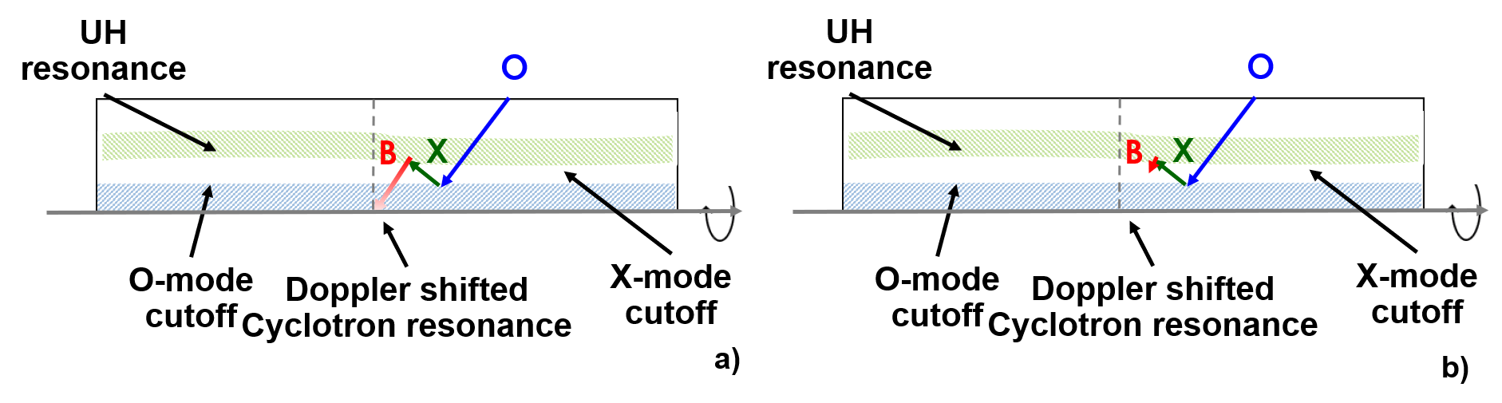

Figure 3‑78. Schematic for O-X-B EBW heating for a linear experiment such as MPEX: a) Bernstein wave damped strongly at the cyclotron resonance b) Bernstein wave damped strongly near the UH resonance.

O-X-B EBW is the baseline electron heating scenario. O-X-B EBW heating is a well-known over-dense electron heating scheme that has been successful in many fusion (Laqua et al., 2003; Shevchenko et al., 2007; Seltzman et al., 2017), and linear plasmas (Yadav and Bora, 2004; Biewer et al., 2018) experiments. The schematic for O-X-B EBW heating is shown in Figure 3‑78.. An ordinary electromagnetic wave (O-mode) is launched outside the plasma, which can then be reflected and mode converted to the extraordinary electromagnetic wave (X-mode) at O-mode cutoff. The X-mode cutoff can then be mode converted to the Bernstein wave at the UH resonance layer. Unlike the O-mode and X-mode, the Bernstein wave can propagate for plasma densities greater than O-mode cutoff density and can ideally damp at the Doppler shifted cyclotron resonance (Figure 3‑78.a). Detailed explanation of the principles of O-X-B EBW heating for fusion experiments is outlined in reference (Laqua, 2007).

In low temperature plasma conditions, however, it is also possible for the Bernstein wave to strongly damp near the UH resonance (Figure 3‑78.b) before it even reaches the cyclotron resonance. This damping could be due to collisions (W7-AS Team ECRH Group et al., 1997), parametric decay instabilities (McDermott et al., 1982), and/or suprathermal electrons (Golovanivsky, Dougar-Jabon, and Reznikov, 1995). An example calculation for Proto-MPEX parameters is shown in Figure 3‑79. using GENRAY-C, which is a ray tracing code that can model the propagation, absorption, and power deposition for O-X-EBW without and with collisional damping (Diem et al., 2018). As observed in Figure 3‑79., the power absorption location can substantially differ without and with collisional damping for similar parameters. From the simulations, it is clear there are two heating mechanisms: one near the Doppler shifted cyclotron resonance and one near the UH resonance. This code does not have the capability to model parametric decay and/or suprathermal electrons, so Proto-MPEX results are necessary as a proof of principle experiment. Demonstration of electron heating and physics understanding at the source and target on Proto-MPEX provides the basis for EBW heating on MPEX.

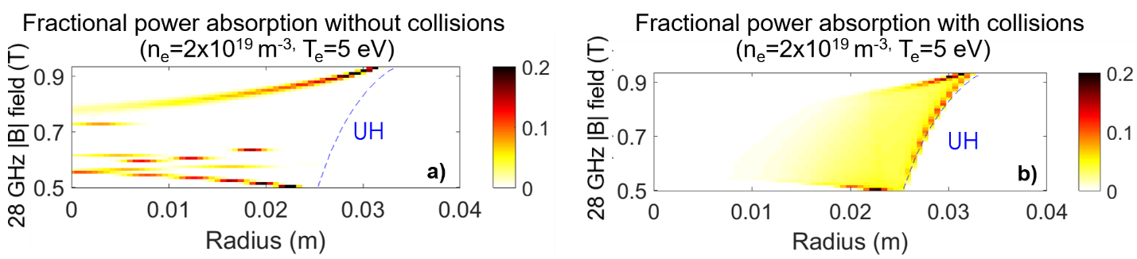

Figure 3‑79. GENRAY-C calculations of power absorption for a) without collisions in the model b) with collisions in the model.

The importance of collisions is highlighted experimentally in Figure 3‑80.. Thomson scattering measurements of the electron temperature without (black) and with (red) approximately 20 kW of 28 GHz power on Proto-MPEX. With increasing neutral pressure or collisionality, the electron temperature drops significantly from 20 to 7 eV. Based on these measurements and GENRAY-C calculations (Biewer et al., 2018), a neutral pressure of approximately less than 0.1 Pa is required. Neutral pressures of approximately 0.01 Pa is desired. These measurements occurred at the microwave heating source location. It is necessary to tailor the axial magnetic field profile for the electron heating to be transported to the desired target location. This is discussed in detail in Section 3.3.5.

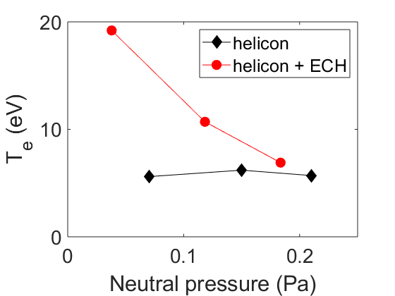

Figure 3‑80. Thomson scattering measurements without (black) and with (red) 28 GHz application.

With the appropriate axial magnetic field profile, electron heating and heat flux can also be observed at the desired target location. This is shown using IR inferred heat flux profiles of the target in Figure 3‑81 without and with 50 kW of 28 GHz power. It is clearly observed that with the application of 28 GHz power, significantly higher heat flux occurs throughout the entire target. There is also a localized hot spot at the bottom of the target near the UH resonance layer where the ECH launcher is located. The UH resonance location is estimated using the density and magnetic field at the 28 GHz source. This is again suggestive of two heating mechanisms: one near the UH resonance and one elsewhere.

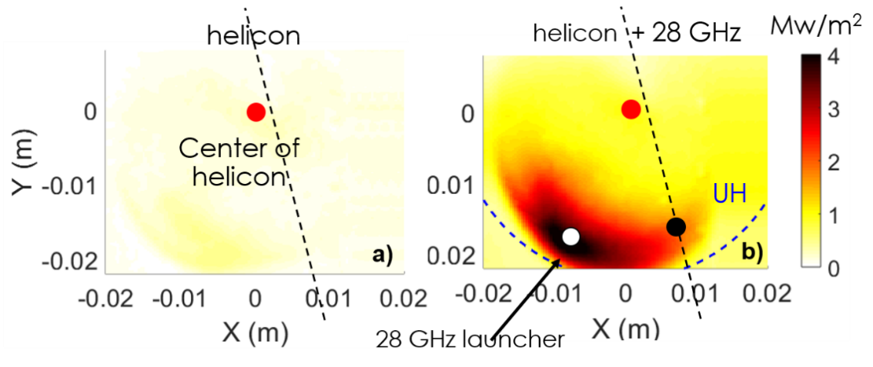

Figure 3‑81. IR inferred heat flux (a) without 28 GHz power and (b) with 28 GHz power. The center of the helicon plasma is noted in the red circles.

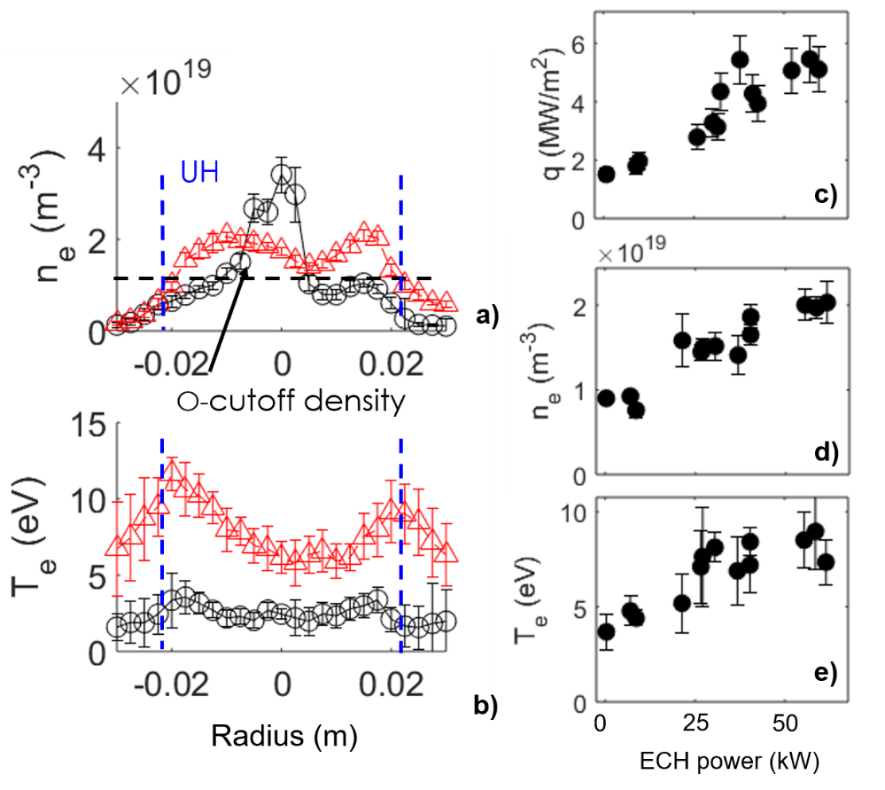

Figure 3‑82. (a) Electron density profile without and with 28 GHz power. (b) Electron temperature profile without and with 28 GHz power. (c) Heat flux as a function of 28 GHz power. (d) Density as a function of 28 GHz power. (e) Temperature as a function of 28 GHz power.

Electron density and temperature profiles measured with Langmuir probes (LP) at the target without (black line) and with (red line) 50 kW of 28 GHz power are shown in Figure 3‑82 a) and b). These profiles occur at the dashed black lines shown in Figure 3‑81 a) and b). Electron heating is clearly observed everywhere in Figure 3‑82b) with the highest temperature near the UH resonance layer, consistent with the measured heat flux. The heating occurs above the O-mode cutoff density in over-dense plasmas and is therefore attributed to Bernstein wave heating. Density modifications are also observed: the density drop in the center of the plasma and rises in this case at the edge of the plasma. A scaling study with different 28 GHz power is shown in Figure 3‑82 c), d), and e). The heat flux in Figure 3‑82c) is measured at the white circle in Figure 3‑81b) and the off-axis density and temperature is measured at the black circle in Figure 3‑72b). The measured off-axis density, temperature, and heat flux all increase approximately linearly with 28 GHz power, suggestive that this will scale well with increasing millimeter-wave power. While not shown here, the on-axis temperature and heat flux also increase with 28 GHz power, but the on-axis density does not. This is likely related to magnetic mirror trapping that is discussed in Section 3.3.5.

One key issue is that the above-mentioned results are very sensitive to the magnetic field at the 28 GHz launcher. The on-axis heat flux, on-axis temperature, peak heat flux, and on-axis density without and with 25 kW of 28 GHz power is shown in Figure 3‑83 as a function of the magnetic field near the 28 GHz launcher. The on-axis heating is only observed at magnetic fields near the 2nd harmonic resonance the 28 GHz launcher (shaded in green) on both the IR camera and LP. The peak heat flux is always observed off-axis near the 2nd harmonic resonance. The peak heat flux is observed at higher fields than the on-axis heat flux, consistent with two different heating mechanisms. On-axis density drop occurs whenever the on-axis temperature increases. Heating is not observed at the fundamental resonance, likely due to substantial absorption in the plasma edge that cannot be observed by these diagnostics. This is because the UH resonance at high magnetic fields is too far out radially and occur at very low densities.

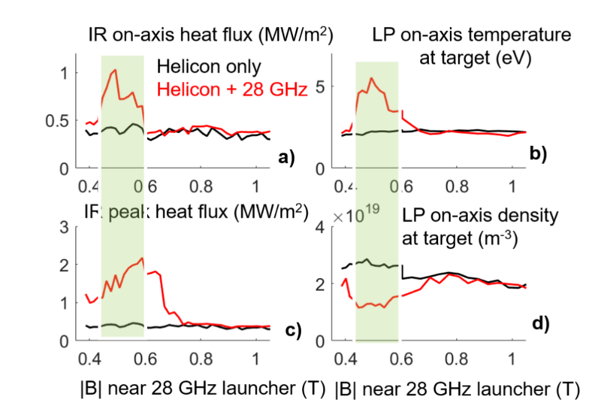

Figure 3‑83. (a) On-axis heat flux without and with 28 GHz power. (b) On-axis density without and with 28 GHz power. (c) Peak heat flux without and with 28 GHz power. (d) On-axis temperature without and with 28 GHz power.

Additional experiments have focused on extrapolating the necessary helicon and ECH power to MPEX through both helicon power and ECH power scans during combined helicon and ECH heating. All the results were achieved using a magnetic field profile shown in Figure 3-84. Note that the target magnetic field is approximately 0.25 T. An example target heat flux measurement is shown in Figure 3-85 without EBW power on the left and with EBW power on the right. With helicon only, the peak heat flux is less than 1 MW/m2. With the addition of EBW power, the peak heat flux is approximately 17 MW/m2. Langmuir probe measurements are made radially on-axis and off-axis as shown in Figure 3-85. We focus on both on-axis and off-axis heating here. While on-axis heating is desired, it is believed that the off-axis heating is largely due to heating near the UH resonance layer. On Proto-MPEX, this is achieved with a 28 GHz gyrotron so the UH resonance density at the second cyclotron harmonic is at approximately 5x1018 m-3. With a 70 or 105 GHz gyrotron at the 2nd cyclotron harmonic on MPEX, the UH resonance density ranges is 4x1019 and 1x1020. This off-axis absorption on Proto-MPEX will likely be much more on-axis for MPEX.

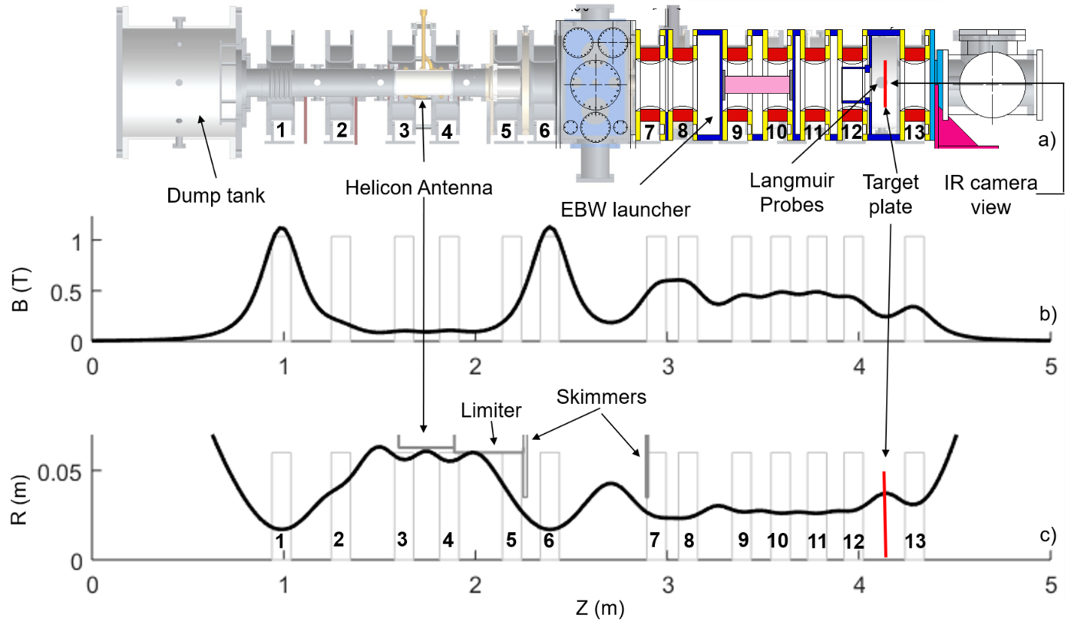

**Figure 3-84. Proto-MPEX geometry and magnetic field geometry for these additional combined helicon and EBW experiment. a) Proto-MPEX geometry. b) Proto-MPEX magnetic field profile. c) Proto-MPEX last uninterrupted flux surface profile.**

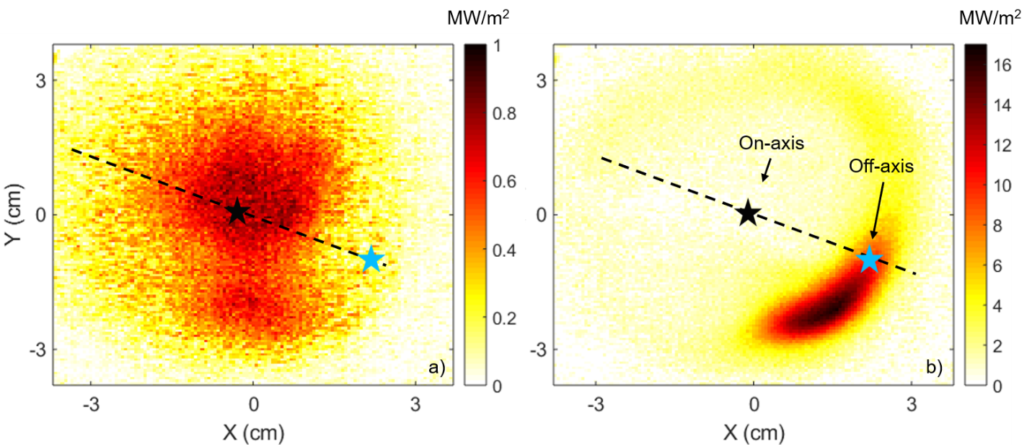

**Figure 3-85. a) Measured target heat flux with helicon only operation. b) Measured target heat flux with combined helicon + EBW operation. Black-star represents on-axis data and blue-star represents off-axis data in later figures. The dashed black line is the location of the radially movable Langmuir probe near the target.**

Figure 3-86 left shows the measured off-axis target electron density, temperature, and pressure as a function of EBW power using a Langmuir probe. Two helicon powers are shown: 80 kW (black symbols) and 120 kW (red symbols). For both helicon powers, it is clear that the electron density, temperature, and pressure increases with EBW power. The black and red lines show a linear fit of the dataset. For 80 kW helicon operation, the linear fit suggests approximately a pressure increase of ~0.37 Pa for every 1 kW of EBW power. For 120 kW helicon operation, the linear fit suggests approximately a pressure increase of ~ 0.63 Pa for every 1 kW of EBW power. Figure 3-86 right shows the peak heat flux, off-axis heat flux and total power on the target for this dataset using an IR camera. The heat flux and total power on the target clearly increases with EBW power. There are therefore clear signs of heating with two independent diagnostics.

|  |  |
| --- | --- |
|  |  |

**Figure 3-86. Off-axis data as a function of EBW power. Measured data is shown in symbols for Langmuir probes in a) to c) and IR camera in d) to f). Dashed lines are extrapolations of the measured dataset. Helicon power = 80 kW in black and helicon power = 120 kW in red. a) Off-axis electron density as a function of EBW power b) Off-axis electron temperature as a function of EBW power. c) Off-axis electron pressure as a function of EBW power. d) Peak target heat flux as a function of EBW power. e) Off-axis target heat flux as a function of EBW power. f) Total target power as a function of EBW power.**

Figure 3-87 left shows the measured off-axis target electron density, temperature, and pressure as a function of helicon power using a Langmuir probe without EBW power (black symbols) and with 55 kW of EBW power (red symbols). Without and with EBW powers, it is clear that the electron density, temperature, and pressure increases with EBW power. The black and red lines show a linear fit of the dataset. From this linear fit, it is clear to see that with EBW power compared to without EBW power, the electron density, temperature, and pressure increases more with increasing helicon power. Without EBW power, the linear fit suggests a pressure increase of 0.015 Pa for 1 kW of additional helicon power. With 55 kW of EBW power, the linear fit suggests a pressure increase of 0.13 Pa for 1 kW of additional helicon power. Figure 3-87 right shows the peak heat flux, off-axis heat flux and total power on the target for this dataset using an IR camera. The heat flux and total power on the target clearly increases with EBW power. There is therefore clear signs of heating with two independent diagnostics.

|  |  |
| --- | --- |
|  |  |

**Figure 3-87. Off-axis data as a function of helicon power without and with EBW power. Measured data is shown in symbols for Langmuir probes in a) to c) and IR camera in d) to f). Dashed lines are extrapolations of the measured dataset. EBW power = 0 kW in black and EBW power = 50 kW in red. a) Off-axis electron density as a function of helicon power b) Off-axis electron temperature as a function of helicon power. c) Off-axis electron pressure as a function of helicon power. d) Peak target heat flux as a function of helicon power. e) Off-axis target heat flux as a function of helicon power. f) Total target power as a function of helicon power.**

Figure 3-88 shows the measured on-axis target electron density, temperature, and pressure as a function of helicon power using a Langmuir probe without EBW power (black symbols) and with 50 kW of EBW power (red symbols). Without and with EBW powers the electron density, temperature, and pressure increases with helicon power. The red lines show a linear fit of the dataset for the case with EBW power. With 50 kW of EBW power, the linear fit suggests a pressure increase of 0.05 Pa for 1 kW of additional helicon power.

|  |  |
| --- | --- |
|  | **Figure 3-88. On-axis data as a function of helicon power without and with EBW power. Measured data is shown in symbols for Langmuir probes Dashed lines are extrapolations of the measured dataset. EBW power = 0 kW in black and EBW power = 50 kW in red. a) On-axis electron density as a function of helicon power b) On-axis electron temperature as a function of helicon power. c) On-axis electron pressure as a function of helicon power.** |

These new experimental data suggests there are complicated dependencies with combined helicon and EBW operation. To project towards the required power for MPEX, extrapolation is required. The goal is to reach the source requirement in Table 3-4 of ne = 9x1019 m-3 and Te = 25 eV. This is an electron pressure of 375 Pa. Magnetic flux expansion needs to be taken into account to compare this Proto-MPEX data to MPEX. On MPEX, the magnetic field at the ECH region is 1.25 T and the magnetic field at this location is 0.25 T. Therefore, the desired density at the Proto-MPEX target is x 9x1019 m-3 = 4x1019 m-3 to reach the desired MPEX density at the ECH source location. The desired Te is still 25 eV and the desired electron pressure at this Proto-MPEX location is 160 Pa.

Using the linear extrapolations in the above figures, the off-axis EBW power scan at helicon power = 80 kW extrapolates to 25 eV and 160 Pa at a EBW power of approximately 400 kW. The off-axis EBW power scan at helicon power = 120 kW extrapolates to 25 eV and 160 Pa at an EBW power of approximately 300 kW. The off-axis helicon power scan at an EBW power = 55 kW extrapolates to a net helicon power of ~ 175 kW. The on-axis helicon power scan at an EBW power = 50 kW extrapolates to a net helicon power of ~ 270 kW.

This extrapolation helps set power requirements for the helicon and ECH systems. To be extremely conservative, the net helicon power should be 270 kW and the EBW power should be 400 kW to reach all the extrapolations above. It should be noted that this may be a significant overestimate; the “off-axis” heating will likely become “on-axis” at higher magnetic fields and frequency. This will be discussed in the later sections, which means that the “off-axis” data may be more pertinent to the extrapolation. The extrapolations become more favorable with increasing helicon or EBW power, so the required power will likely go down. Currently, the EBW system is designed for 400 kW while the helicon system is designed for a net power of 173 kW with the option to upgrade to 270 kW of net helicon power with two different helicon antennas. Even in the on-axis helicon power scan which is the most difficult to accomplish, the MPEX source density will be 6x1019 m-3, which will be sufficient for most scenarios.

Proto-MPEX has demonstrated 2nd harmonic O-X-B EBW heating that appears to scale favorably to high densities, temperatures, and heat flux off-axis. The on-axis density drop due to application of millimeter wave power is concerning in achieving the desired fluence and target density on MPEX (Table 2‑5), but this risk can be mitigated by either UH heating and/or better control of axial magnetic field profile. Discussion of UH heating is in the next section.

### Physics of UH heating for MPEX

The physics basis for UH heating is based on the results of O-X-B EBW heating. From the previous section, the damping near the UH resonance can be strong for MPEX parameters. It therefore may be worthwhile to optimize only for damping near the UH resonance layer rather than trying to optimize for O-X-B damping near the UH resonance and at the Doppler shifted cyclotron resonance. The UH resonance location is given by Equation 3-9 and is a function of launched frequency, electron density, and magnetic field at the 28 GHz launcher. By varying these three quantities (Stenzel and Gould, 1971), it may be possible to modify the radial heating location of the UH heating. This heating scheme has been demonstrated on Proto-MPEX and provides the basis for design on MPEX.

$ω=\sqrt{ω_{pe}^{2}+ω_{ce}^{2}}≅2π\sqrt{81n_{e}+7.84x{10}^{20}B^{2}}$ (3‑9)

UH heating can only occur at densities below the O-mode cutoff density. At these low densities, the heating location does appear to experimentally change due to variations in magnetic field or helicon power. IR camera inferred heat fluxes are shown in Figure 3‑89. and Figure 3‑90. for the millimeter wave only contribution to the heat flux. These images are calculated from a subtraction of the heat fluxes during helicon + 28 GHz and helicon only pulses. Variations of the inferred heat flux are shown at different magnetic fields in Figure 3‑89.. The radial location of the heating goes from the core to the edge for increasing magnetic field, which is consistent with Equation 3-9. A similar trend is observed for variations in helicon power shown in Figure 3‑90.. Helicon power is a proxy for density. For increasing helicon power, the radial heating location again moves outward, consistent with Equation 3-9.

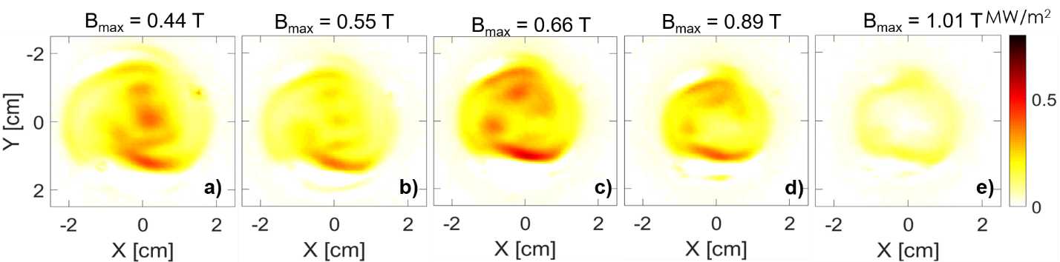

Figure 3‑89. (a–e) IR camera inferred heat flux for 5 different magnetic fields at the ECH launcher region.

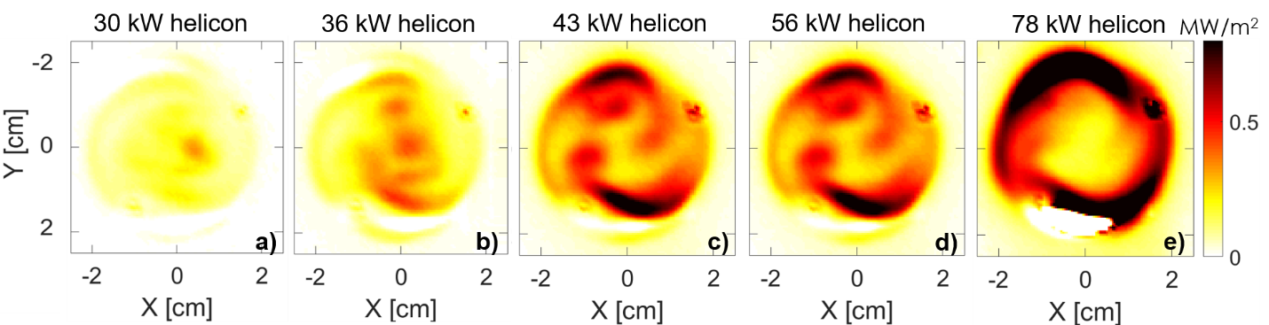

Figure 3‑90. (a–e) IR camera inferred heat flux for 5 different helicon power at the ECH launcher region.

For the case of Figure 3‑89.a), the electron density and temperature at the target is measured by LP and shown in Figure 3‑91 a) and b). As can be observed, there is no significant modification of the density at the target with application of 28 GHz power. The temperature at the core, however, does increase substantially with application of 28 GHz power. There are some theoretical considerations for UH heating that is outlined in (Köhn et al., 2010; Hammond et al., 2018; Lau et al., 2019). Theoretically, X-mode launch is necessary for UH heating. In practice, O-mode launch is also possible for UH heating to due to reflections, mode conversion, tunneling and other possibilities. This is consistent with finite element simulations shown in Figure 3‑91c).

The proposed millimeter-wave launch geometry for UH heating is therefore similar to O-X-B heating, but the initial density and magnetic field needs to be significantly lower. This is one disadvantage of the scheme in that it’s an under-dense heating scheme and cannot heat over-dense plasmas. Based on the limited experiments, the heating efficiency also appears lower than O-X-B EBW. There are two advantages to this scheme compared to O-X-B EBW. The radial heating location can be modified, so the magnetic field and density can be adjusted so that the dominant heat is on-axis rather than off-axis. This more uniform on-axis heating may provide more easier understanding for PMI experiments. The density also does not drop due to the application of millimeter-wave power, which may allow for easier scaling to higher fluence and high-density experiments.

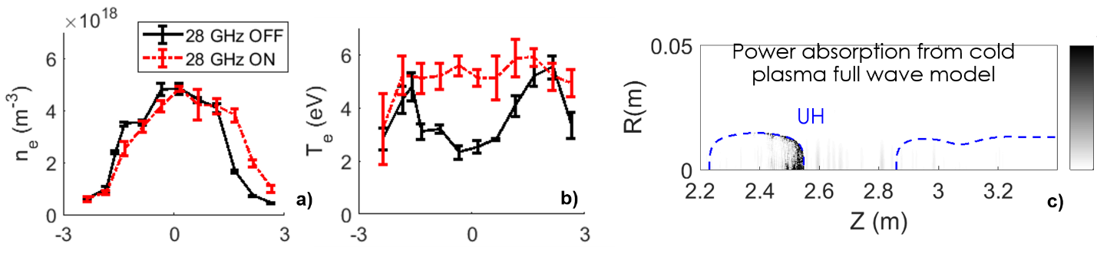

Figure 3‑91. (a) Density without and with ECH power. (b) Temperature without and with ECH power. (c) Finite element method simulation of UH heating.

### Physics of 2nd harmonic X-mode ECH heating for MPEX

2nd harmonic X-mode ECH heating is a commonly used and well understood under-dense heating in fusion experiments such as DIII-D (Stallard et al., 1990) and TCV (Henderson et al., 2003). An X-mode wave is launched outside the plasma and is absorbed at the 2nd harmonic cyclotron resonance layer. This heating scheme is much simpler and well-proven than O-X-EBW and UH in that there are no cutoffs or mode conversion layers. In fusion plasmas, the single pass absorption is close to 100%, so the heating occurs in a single pass across the resonance.

In low temperature plasmas, however, the high single pass absorption does not occur. As shown in the schematic in Figure 3‑92a), there can be many reflections before total absorption after the initial launch. A calculation using theory (Westerhof, 2010) and GENRAY-C of this is shown in Figure 3‑92b) for a chosen magnetic field gradient, chosen density, and variations in temperature. For fusion temperatures of ~103 - 104 eV, the single pass absorption is very near 100%, consistent with the experience in fusion experiments. For MPEX parameters with temperatures from ~ 1-15 eV, the single pass absorption is much lower and can range from ~ 10-3 to 10-1, implying that at least 10–1000 crossings of the resonance are needed for total absorption. For 2nd harmonic X-mode ECH to provide significant heating on MPEX, a cavity-like structure must be used so that the X-mode wave reflects off the walls and crosses the 2nd harmonic cyclotron resonance multiple times. A demonstration of these significant 2nd harmonic X-mode heating for MPEX-like parameters has not been achieved yet.

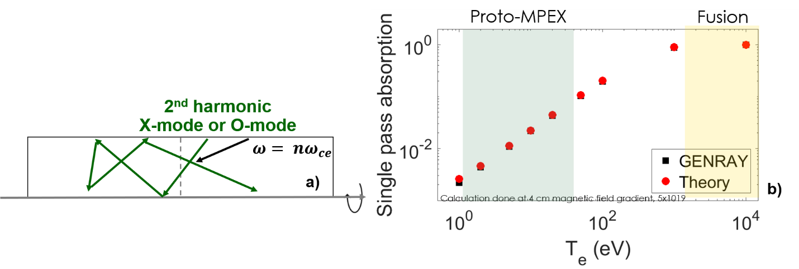

Figure 3‑92. (a) Schematic of 2nd harmonic X-mode heating in a linear device such as MPEX. (b) Single pass absorption calculations for 2nd harmonic X-mode at different electron temperatures.

### Physics of whistler heating for MPEX

Another over-dense heating scheme that is possible is whistler heating. Whistler heating is a high single pass absorption scheme for propagation parallel to the magnetic field. The absorption is at the fundamental cyclotron resonance (Booske et al., 1985). Launch from the high magnetic field side is necessary for heating in over-dense plasmas. Experimental results for whistler density generation were demonstrated on PhiX and shown in Figure 3‑93b) below.

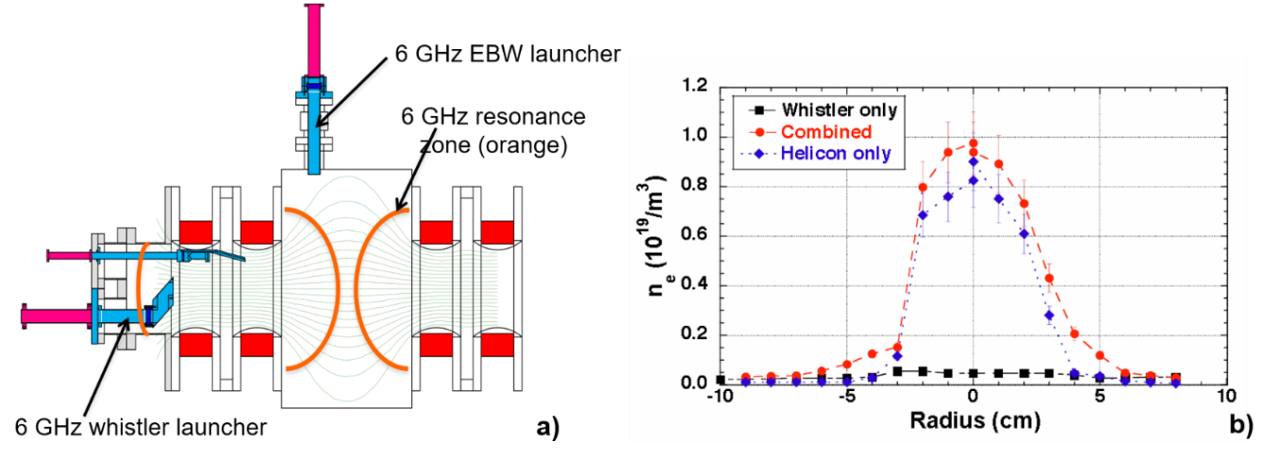

Figure 3‑93. (a) Schematic of whistler launch on PhiX. (b) Density measured for whistler launch.

One possible issue with whistler launch is that the ideal launch location is at the center of the plasma parallel to the magnetic field, as shown by the 6 GHz whistler launcher in Figure 3‑93 a). For MPEX geometry, this is not really possible and the launch location must be located above or below the center of the plasma. In this scenario, most of the power is expected to be absorbed at low densities. Even if the launch location is tilted towards the center of the plasma, GENRAY-C simulations indicate that the wave appears to be significantly refracted and cannot be absorbed at high densities. No experimental demonstration has been achieved for MPEX-like parameters, but whistler heating could still be an attractive scheme to access lower densities on MPEX.

### Effect of magnetic field ripple on parallel electron transport during microwave plasma heating.

Experiments have been performed in Proto-MPEX that demonstrate the efficacy of using 28 GHz microwaves to heat electrons via Electron Bernstein Waves (Biewer et al., 2018). It was observed that the electron temperature in the electron heating section increased from 4 to 20 eV; however, the electron temperature in the Target section was observed to increase only from 2 to 3 eV. It was hypothesized that the magnetic geometry in the heating section leads to significant kinetic trapping of the heated electrons and thus reduces the parallel electron transport towards the Target section.

To develop insight into this process, a test-particle Monte-Carlo (MC) code based on references (Rognlien and Cutler, 1980; Boozer and Kuo‐Petravic, 1998; Chan, Chiu, and Omelchenko, 2002) was developed. This code aims to describe the interaction between: (1) cyclotron resonant heating, (2) kinetic trapping of fast electrons and (3) de-trapping via pitch angle scattering in Proto-MPEX. The MC code is also applicable to ion transport during Ion Cyclotron Heating in Proto-MPEX.

This section is organized as follows. First, the magnetic geometry of Proto-MPEX and the associated scattering mean free paths are described. Secondly, the main parts of the MC code are presented followed by the presentation of calculations and experimental results. Finally, the implication of these results on the magnetic field geometry for MPEX are discussed.

###### Magnetic geometry of Proto-MPEX

The magnetic geometry of Proto-MPEX is composed of a series of interconnected magnetic mirrors. The magnetic geometry used during the heating experiments described in reference (Biewer et al., 2018) is shown in Figure 3‑94 below. The shape of the magnetic field is largely determined by the requirements of the different RF heating systems. The characteristic lengths $L_{m}$ of these mirrors range between 1 meter to 10 cm. In the plasma source region, the mirror length is about 1 meter and in the target section the ripples have a length in the order of 10 cm.

It is instructive to compare these length $L_{m}$ with the expected electron scattering mean free paths $λ_{⊥}$ in order to assess the propensity for kinetic or hydrodynamic transport effects (Lam et al., 1986; Logan et al., 1974; Makhijani et al., 2003). Kinetic transport effects refer to transport affected by the conservation of magnetic moment like in a classic magnetic mirror trap (Ryutov, 1988). Hydrodynamic effects refer to fluid-like collision-dominated transport. The scattering mean-free path $λ_{⊥}$ is the average distance a particle will travel in a background plasma before experiencing a 90-degree pitch angle scattering. The formulas to calculate $λ_{⊥}$ can be found in various sources such as (Spitzer, 2013; Fundamenski, 2007; Hinton, 1983). MC simulations (shown later) indicate that for conditions relevant to Proto-MPEX, two particle populations are present: (a) a low temperature (~4eV) Maxwellian background and (b) a high energy supra-thermal (1e2–1e3 eV) electron population during microwave heating.

|  |
| --- |
|  |
| Figure 3‑94. Magnetic geometry of Proto-MPEX used for the electron heating experiments reported in reference (Biewer et al., 2018). |

In Figure 3‑95, the electron scattering rate $ν_{⊥}^{e}$ and mean free path $λ_{⊥}^{e}$ as a function of energy are presented. In the figure to the right, the mean free paths associated with both the low temperature and the supra-thermal electrons are labelled. Moreover, the length of the mirrors in Proto-MPEX has been highlighted in green. Notice that the low temperature background electrons satisfy the condition ${λ_{⊥}^{e}}/{L_{m}}≪1$ which means that this population is more likely to experience a 90-degree scattering before bouncing between mirrors. Under these conditions, kinetic mirror trapping is minimal, and electrons relax to a Maxwell-Boltzmann distribution. On the other hand, the supra-thermal electrons satisfy the condition ${λ_{⊥}^{e}}/{L_{m}}≈1$ and ${λ_{⊥}^{e}}/{L_{m}}≫1.$ For the low energy part of this population (< ${10}^{2}$ eV), both kinetic mirror and collisional effects are important. The high-energy population, however, exceeds $L_{m}$ by one or two order of magnitudes. These electrons are essentially collision-less and can bounce many times between mirrors leading to kinetic trapping. The distribution function for these electrons is anisotropic and loss cone effects are important. These simple estimates clearly show that the low temperature plasma produced by the helicon source is not expected to experience kinetic trapping effects. However, to understand the effects of resonantly heating electrons in a low temperature background plasma in the presence of pitch angle scattering and kinetic trapping a test-particle MC code has been developed that includes cyclotron resonance interactions via a quasilinear RF operator (Chan, Chiu, and Omelchenko, 2002). The MC code is described in the next section.

The main research questions to be investigated with this tool are: (1) During resonant electron heating in Proto-MPEX, what is the impact of the $B_{0}$ configuration on the electron dynamics? (2) What is the interplay between collisional scattering and perpendicular heating in Proto-MPEX?

|  |  |
| --- | --- |
|  |  |
| Figure 3‑95. (left) 90-degree scattering collision frequency and (right) mean free path for a test electron as a function of energy. The red and black lines correspond to electron-ion and electron-electron collisions respectively. | |

###### Test particle Monte-Carlo code

The complex sequence of magnetic mirrors, resonant heating and particles sources in Proto-MPEX motivates the use of test-particle MC modelling. This code is based largely on references: (Rognlien and Cutler, 1980; Boozer and Kuo‐Petravic, 1998; Chan, Chiu, and Omelchenko, 2002) where test-particle MC modelling has been used to understand transport in Tandem Mirrors (Rognlien and Cutler, 1980), Stellarators (Boozer and Kuo‐Petravic, 1998) and RF heating in Tokamaks (Chan, Chiu, and Omelchenko, 2002). The Proto-MPEX MC code is based on guiding center motion, is 1D in space (along field lines) and 2D in velocity. The term “test particle” indicates that the modelled electrons are only a small fraction of the background plasma which means that interactions are one-directional: test electrons are affected by the background plasma, *but* test electrons do not change the background. Moreover, the density of the test particles is much less than the background plasma; hence, it is assumed that test particles are independent of each other. This simplification allows us to calculate the tendency of a small population of heated electrons subject to kinetic trapping and collisional scattering in the presence of resonant cyclotron heating.

The process of calculating the test particle distribution function is the following:

1. Background plasma conditions are defined: (a) plasma density, (b) electron temperature, (c) magnetic field and (d) ambipolar electric field.
2. The test particles are loaded at the location of the plasma source according to a normal distribution. The initial velocity distribution function of the loaded particles is isotropic and Maxwell-Boltzmann at the background electron temperature.
3. The test particle trajectories are calculated by solving the collision-less equations of motion in a time step $∆t≪ν_{⊥}^{-1}$ where $ν_{⊥}$ is the 90-degree scattering collision frequency (Equation 3-8). The magnetic moment $μ$ is conserved during this calculation.
4. Collisions are applied to calculate (a) pitch angle scattering and (b) energy loss during the time step $∆t$ (Boozer and Kuo‐Petravic, 1998). The pitch angle scattering and energy loss rates are given by Equations 3-10 and 3-11, respectively.
5. Check if any test particle satisfies the cyclotron resonance condition. If so, apply a random change in the magnetic moment $μ$ of the particle according to the RF heating operator described by Equation 3-13 to 3-15 (Chan, Chiu, and Omelchenko, 2002). This introduces wave-induced velocity space diffusion.
6. Test particles that leave the boundary (either end of the device) are re-injected according to step #2 and the calculation process repeats until the final simulation time is reached.

The 90-degree scattering $ν_{⊥}$ and energy loss $ν_{E}$ rates are given below in Equation 3-10 to Equation 3-12 (Fundamenski, 2007; Hinton, 1983), where “a” refers to the test particle and “b” to the background plasma.

$ν_{⊥}^{ab}=ν_{ab}^{0}\left(\frac{Φ\left(x\right)-Ψ\left(x\right)}{x^{3}}\right)$ (3‑10)

$ν_{E}^{ab}=2ν_{ab}^{0}\left(\left(\frac{m_{a}}{m_{b}}\right)\frac{Ψ\left(x\right)}{x}-\frac{Φ^{'}}{2x^{2}}\right)$ (3‑11)

$\begin{matrix}ν_{ab}^{0}=\frac{{n_{b}e}^{4}\ln{Λ}}{2πm_{a}^{2}ϵ_{0}^{2}v_{Tb}^{3}} & x=\frac{v_{a}}{v_{Tb}} & \begin{matrix}Ψ\left(x\right)=\frac{Φ-xΦ^{'}}{2x^{2}} & Φ(x)=\frac{2}{\sqrt{π}}\int_{0}^{x}{\exp\left(-η^{2}\right)dη}\end{matrix}\end{matrix}$ (3‑12)

The RF operator used in this MC code is described by the following equations (Equation 3-13 to Equation 3-15), where $μ$ is the magnetic moment, $E_{⊥}$ is the wave’s electric field perpendicular to the background magnetic field, $τ_{RF}$ is the interaction time between the wave and the test particle, $v_{∥}$ is the test particle parallel velocity, $B$ is the local magnetic field and $R_{M}$ is a uniformly distributed random number between -1 and 1. This RF operator assumes that the parallel wavenumber of the wave is zero.

$∆μ=∆μ_{RF}+R_{M}\sqrt{2μ∆μ_{RF}}$ (3‑13)

$∆μ_{RF}=\frac{1}{2}\left(\frac{e^{2}}{m_{e}B}\right){\left|E_{⊥}\right|}^{2}τ_{RF}^{2}$ (3‑14)

$τ_{RF}^{2}≈2π\left(\frac{m_{e}}{e}\right)\frac{1}{v_{∥}}{\left(\frac{dB}{dz}\right)}^{-1}$ (3‑15)

Once the process has been completed, the data is post-processed to calculate the test particle distribution function $f\left(z,v_{∥},v_{⊥}\right)$, electron energy distribution function and identification of trapped and passing particles. This calculation is equally applicable to ion transport and Ion Cyclotron Resonant Heating (ICRF) in Proto-MPEX.

###### Microwave heating in a magnetic well

In this section, results from the MC code are presented using a plasma scenario relevant to the experiments described in reference (Biewer et al., 2018). The magnetic field geometry and 28 GHz injection location used in this simulation are those shown in Figure 3‑94. This corresponds to microwave heating inside a magnetic well. The background plasma density, electron temperature and ion temperature are assumed to be uniform in space with values of $n_{e}=1×{10}^{19} m^{-3}$, $T_{e}=T_{i}=4 eV$. The ambipolar electric field is set to zero, the wave electric field is set to 10 kV/m based on AORSA 1-D calculations (Jaeger, Berry, and Batchelor, 2000). The microwave power is applied at the 2nd harmonic resonance location (0.5 Tesla) since this is the location where cyclotron damping of the EBWs happens in Proto-MPEX (Diem et al., 2018).

The main results of the simulation are show below in Figure 3‑96. The top figure shows the distribution of test electrons along the device. The location where the microwave is injected is represented by the vertical red line. The distribution shows that there is accumulation of particles in both the plasma source and heating magnetic well. However, inspection of the velocity distribution function reveals that there is an accumulation of high energy particles *only* in the heating section magnetic well. This shows that kinetically trapped electrons are to be found in the well where the 28 GHz is applied. These electrons are kinetically trapped, and most do not reach the target region as evidenced by the low energy electrons in the target region.

The electron energy distribution function (EEDF) in the plasma source region, heating and target section are shown in Figure 3‑97., where $E_{t}$ is the energy of the test electrons and $T_{b}$ is the temperature of the background plasma. The EEDF in the plasma source region develops into Maxwellian distribution. The EEDF in the target section also develops into a Maxwellian but with a small fraction of fast electrons in the range of ${10}^{0}T_{b}$ to ${10}^{2}T_{b}$. These electrons originated most likely in the heating well and escaped confinement via 90-degree scattering collision. However, the EEDF in the heating section develops a distinct high energy tail extending from ${10}^{0}$ to ${10}^{4} T_{b}$. For a well length $L_{m}=0.5 m$ in the heating section, the population of electrons satisfying $E_{t}>{10}^{2}T_{b}$ become kinetically trapped because their 90 degree mean free path becomes much larger than $L_{m}$. To reduce kinetic trapping, the symmetry of the well can be broken and the location of the cyclotron resonance relative to the well minima changed. These aspects (well asymmetry and location of cyclotron resonance) are discussed in the next section.

|  |  |
| --- | --- |
|  | Figure 3‑96. Simulation results with microwave injection in a magnetic well in Proto-MPEX. (Top) probability distribution of test electrons as a function of space along the device. (Center) parallel and (Bottom) perpendicular velocity distribution function of test electrons. $v_{Te}$ is the thermal velocity of the background electrons. |

|  |  |
| --- | --- |
|  | Figure 3‑97. Electron Energy Distribution Function (EEDF) in the plasma source (black), heating (blue) and target region (green) for the results presented in Figure 3‑96. |

###### Electron trapping and magnetic well asymmetry

Well asymmetry is explained with the use of Figure 3‑98.. In this context, the well asymmetry is determined by the value and algebraic sign of $∆B$. When this value is zero, the well is symmetric. When it is positive/negative, the well is referred to as having a positively/negative asymmetry. From the perspective of a test particle, the location of the cyclotron resonance inside a magnetic well can be considered a turning point. This is because resonant interaction of the electron with the microwave significantly increases the particle’s magnetic moment in a region of magnetic gradient. This RF “kick” causes the particle to turn around. The parallel velocity of the particle, after the RF “kick”, can be described by the following equation (Equation 3-16), where “ $s$” is the path length along the field line, $"a"$ represents the strength of the RF “kick” relative to the initial parallel velocity and $∆B=B_{0}-B\left(s\right)$

$v_{∥}^{2}\left(s\right)=v_{∥0}^{2}\left(1+a^{2}\frac{∆B}{B_{0}}\right) where a≈\frac{∆v_{⊥}}{v_{∥0}}$ (3‑16)

When the RF “kick” is strong ($a≫1$), the parallel velocity can be expressed as in Equation 3-17. This indicates that for positive $∆B$, the parallel exit velocity of the heated electron becomes a fraction of the perpendicular velocity imparted by the cyclotron resonance interaction with the microwave. In other words, in a magnetic well with positive asymmetry heated electrons can escape the well and convert a fraction of the perpendicular energy into parallel energy.

(3‑17)

|  |  |
| --- | --- |
|  | Figure 3‑98. Diagram of a magnetic well showing the location of the cyclotron resonance and the definition of $∆B$. |

calculations using the MC code are now presented, where the effect of magnetic well asymmetry is explored. The conditions used for the MC calculations are the following: $n_{e}= 4×{10}^{19} m^{-3}$, $T_{e}=Ti=$ 4 eV. Two magnetic field geometries with negative and positive $∆B$ have been used as shown in Figure 3‑99. They are referred to as “Overhill” and “Downhill” configurations. They represent two cases of well asymmetry, where one is expected to release electrons to the target region (Downhill). The microwaves are injected at a new 0.5 Tesla cyclotron resonance for 2nd harmonic ECRH. This new heating location corresponds to the upgraded microwave heating chamber in ProtoMPEX. The electric field of the wave has been calculated using AORSA 1-D (Jaeger, Berry, and Batchelor, 2000) for a beam power of 50 kW and set to $10{kV}/m$. The results of the calculations are presented in Figure 3‑100.

|  |  |
| --- | --- |
|  | Figure 3‑99. Magnetic field geometries used to explore the effect of magnetic well asymmetry. Cyclotron resonance location is indicated by the red vertical arrow. Red and black magnetic fields are referred to as “Overhill” and “Downhill” configurations, respectively. |

In Figure 3‑100, the velocity distribution functions for the “Overhill” and “Downhill” configurations are shown. The cyclotron resonance location is indicated by the red squares. In Figure 3‑100b, it can be observed that with the “Overhill” configuration there is significant kinetic trapping of electrons. This is evidenced by the population of electrons with very large perpendicular velocities near the cyclotron resonance location. Moreover, some electrons do escape the magnetic well but get trapped in the central chamber and the plasma source region. For the “Downhill” configuration, it can be seen clearly that electrons preferentially diffuse towards the target region showing that heated electrons can escape the magnetic well. This is precisely the process needed to deliver microwave power to the target.

|  |
| --- |
|  |
| Figure 3‑100. Velocity distribution functions along the device for the (a)-(b)“Overhill” configuration and (c)-(d) “Downhill” configuration. Electron cyclotron resonance location where microwaves are injected is represented by the red squares. |

The energy distribution functions in the plasma source, heating and target sections are shown in Figure 3‑101 for the “Overhill” and “Downhill” configuration. In the “Overhill” configuration, the formation of a high-energy tail in the heating section is observed extending up to ${10}^{3}{E_{t}}/{T_{b}}$. In contrast, the “Downhill” configuration leads to an energetic population with energies up to ${10}^{2}{E_{t}}/{T_{b}}$ in *both* the heating and target sections. These results indicate that the “Downhill” configuration has a more favorable geometry when it comes to delivering heated electrons to the target section. In the next section, the effect of the cyclotron resonance location relative to the magnetic well minimum for the “Downhill” configuration is discussed.

|  |
| --- |
|  |
| Figure 3‑101. EEDF for the (a) “Overhill” and (b) “Downhill” configurations. The EEDFs are associated with the data presented in Equation 3-18. |

###### The effect of the cyclotron resonance location

In the previous section, it was observed that magnetic geometries with asymmetries are a good choice for enabling better parallel electron transport to the target section. In this section, the “Downhill” configuration is used to describe the effect of the cyclotron resonance location relative to the magnetic well minimum. Figure 3‑102. describes how the cyclotron resonance location is systematically changed from location A to E in an asymmetric well. Recall that the cyclotron resonance location can be considered a turning point, hence, moving from point A to point E is effectively moving from a positive asymmetric well to a negative asymmetric well. The simulation conditions are identical to those in the previous section.

|  |  |
| --- | --- |
|  | Figure 3‑102. “Downhill” magnetic field geometry used to systematically change the electron cyclotron resonance location along the magnetic well. |

To present the results, the EEDF for all the points A to E are presented. The mean interaction time $〈τ_{RF}〉$ and the mean change in perpendicular energy $〈∆E_{⊥}〉$ during a *single* cyclotron interaction (Equations 3–18) are also presented. The term $〈∆E_{⊥}〉$ essentially represents the amount of energy an electron gains due to an “RF-kick” as it traverses the cyclotron resonance region. The results are shown in Figure 3‑103.. First, notice that the interaction time for all cases is within the range of 4 ns to 8 ns. The mean change in perpendicular energy per cyclotron interaction ranges between 100 eV and 300 eV. However, the range of energies observed in the heating section by moving from location A to E increases from 100 ${E_{t}}/{T_{b}}$ to values greater than ${10}^{4} {E_{t}}/{T_{b}}$. This corresponds to a two order of magnitude change in energy. Since the energy change per interaction is approximately the same for all cases (100 – 300 eV), this indicates that the high energies (${10}^{3}-{10}^{5}{E_{t}}/{T_{b}}$) must have been produced by multiple cyclotron resonance interactions. This occurs when electrons become kinetically trapped and experience multiple bounces in the well with each bounce gaining perpendicular energy. This is observed to happen for locations D and E. In contrast, for cases with the cyclotron resonance at location A to C, the change in perpendicular energy is comparable to the change in perpendicular energy for a *single* cyclotron interaction. This indicates that for location A to C, electron heating is occurring via *single “kick”* cyclotron interaction. Moreover, from the mechanism described in Figure 3‑98., the higher the value of $∆B$, the higher the conversion of gained perpendicular energy to parallel energy.

(3‑18)

|  |  |
| --- | --- |
|  | Figure 3‑103. Electron energy distribution function for different cyclotron resonance locations as shown in Figure 3‑102. for an asymmetric well. |

Using this Monte-Carlo method, new calculations have been done for MPEX-relevant magnetic field profiles and the use of a 70 GHz 2nd harmonic Electron Bernstein Wave (EBW) heating scheme. Electron pitch-angle scattering and slowing down is modelled with a Fokker-Planck collision operator. The background plasma density is taken to be $9×{10}^{19} m^{-3}$ and the electron temperature 16 eV. RF heating is modelled with a quasilinear RF operator acting at the 2nd harmonic resonance (1.25 T) near z = 0 m. Genray-C modelling shows that microwave power travelling in the plasma is absorbed fully near the 2nd harmonic EC resonance at z = 0 m; hence, the 2nd harmonic resonance at z < 0 m is ignored. The magnetic field profile of MPEX is shown in figure 3-104 (red solid line).

The strength of the RF electric field has been chosen to provide a total absorbed RF power of about 150 to 200 kW in a plasma domain of 9 m of length, 2 cm in width and 1 cm in height. This computation domain is intended to represent the region of magnetic flux lines in MPEX that have a direct connection to the microwave absorption region based on Proto-MPEX experimental measurements of EBW absorption profiles.

The Fokker-Planck code calculates the distribution of electron $f\left(u_{⊥},u_{∥},s,t\right)$ in both velocity and position $s$ along magnetic flux surfaces as a function time. This enables estimation of the parallel transport along magnetic flux surfaces in the presence of finite magnetic wells and the distribution of electron kinetic energy in the presence of RF heating and Coulomb collisional relaxation with a background Maxwellian plasma (Caneses et al, 2020).

Two Fokker-Planck calculations are presented next which differ only on the magnetic field ripple to the right of the 2nd harmonic EC near z = 0 m (figure 3-104a and 3-104b). This was done to explore the effect of a finite-sized magnetic well adjacent to the EC heating section. For both cases, there are no 2nd turning points relative to the 2nd harmonic EC resonance at z = 0 m, so in principle adiabatic trapping of electrons is minimized. This represents the magnetic field profile that maximizes electron parallel transport towards the target region during microwave heating. In previous work, it has been shown numerically that the presence of 2nd turning points along the trajectory of electrons relative to the cyclotron resonance leads to adiabatic trapping and thus a reduction in parallel transport of both particles and energy.

|  |
| --- |
|  |
|  |
| **Figure 3-104, PDF of electrons in MPEX as a function of device length obtained with Fokker-Planck calculations during electron heating for two different magnetic well depths at z = 0.05 m: (a) 0.99 T and (b) 1.1 T. Red vertical dashed line represents the 2nd harmonic resonance location (zero doppler-shifter) that is taken to be responsible for the microwave power absorption. Target location is represented by green vertical line at z = 5 m.** |

In both calculations, the microwave absorption leads to the creation of a fast electron tail for z $>0$ m which thermalizes as it approaches the target plate at z = 5 m. The performance of the particle and energy transport towards the target for both cases is similar, except possibly for the increased high energy particles that get trapped in the finite magnetic well near z = 0 m for case (a). This trapped population is created via pitch angle scattering of fast electrons into the finite-sized well and the smaller the depth of the well the lower the probability of accumulating particles.

For both cases, about 70% of the absorbed RF power results in ballistic fast electrons that impact the target plate, 25% gets absorbed by the background plasma via thermalization of fast electrons and about 5% reaches the Dump plate via ballistic fast electrons. The modeling therefore does not suggest significant differences with the two different cases for MPEX.

###### Comparison with experimental results

In Proto-MPEX, electron heating experiments were performed by changing the magnetic field configurations from “Overhill” and “Downhill” configurations (Figure 3‑105.). The location of the cyclotron resonance is also indicated. Using IR thermography, the peak heat flux (MWm-2) and the total heat (in kW) delivered to the target were measured. These measurements are shown in Figure 3‑106. as a function of the magnetic field at the target. The magnetic fields corresponding to the “Overhill” and “Downhill” configurations are labelled. It can be seen that both the total heat and peak heat flux vary as a function of target magnetic field and both have a maximum value for the “Downhill” configuration and monotonically decrease as the “Overhill” configuration is approached. The most important measurement is in fact the total heat to the target, because by changing the magnetic field at the target, the cross-sectional area is changed which affects the peak heat flux. Therefore, based on the total heat alone, It can be seen that the total heat transported to the target is maximum for the “Downhill” configuration and it is about *twice* the value of that observed during the “Overhill” configuration. This is *not* the case for the helicon-only plasma conditions. These observations indicate that the “Downhill” configuration is more favorable in delivering heat to the target during application of the microwaves. The interpretation is that this heat is delivered by the increased parallel transport of cyclotron heated electrons. This interpretation is consistent with the test-particle MC simulations which indicated that the “Downhill” configuration provided improved transport to the target.

|  |  |
| --- | --- |
|  | Figure 3‑105. Magnetic field configurations used in Proto-MPEX during heating experiments to test the effect of magnetic well asymmetry. |

|  |  |
| --- | --- |
|  | Figure 3‑106. (Top) total heat and (bottom) peak heat flux delivered to target measured using IR thermography during electron heating experiments in Proto-MPEX using the magnetic field configurations shown in Figure 3‑105. |

The main conclusions that can be drawn from this study on magnetic transport are the following:

The low-temperature high-density helicon generated plasma in Proto-MPEX is not expected to experience kinetic trapping effects; however, upon injection of microwaves, energetic particles can be generated which are prone to trapping due to the magnetic mirrors in Proto-MPEX.

Trapping of cyclotron heated electrons can be controlled with the shape of the magnetic ripple and the location of the cyclotron resonance relative to the well’s minimum.

Generation of electrons with energies well above $〈∆E_{⊥}〉$, requires the use of magnetic wells for multi-pass RF “kicks”. This process leads to deep kinetic trapping and adversely affects electron parallel transport.

Parallel transport of cyclotron heated electrons can be improved substantially by introducing asymmetries in the magnetic wells.

Improving electron parallel transport via asymmetric magnetic wells effectively leads to *single-pass* electron heating. This implicitly suggests that a magnetic well is not needed to this heating process.

In the context of MPEX, the results from this study suggest that a “Downhill” magnetic configuration is desired such as the one shown in Figure 3‑102. with a cyclotron resonance located near points A and B in order to reduce kinetic trapping. Under these conditions, the heating process would effectively be a single “kick” cyclotron interaction between the passing electron and the wave. Under these circumstances, the single “kick” heating could be improved by increasing the wave electric field; which can be done by increasing the launched RF power and/or focusing the beam. In addition, for a given wave electric field, the interaction time can be increased by reducing the slope of the magnetic field (reducing ${∂B}/{∂z}$) at the cyclotron resonance location. Moreover, as the plasma gets hotter it may be desirable to increase the interaction time via the magnetic field gradient in order to compensate for the reduction in interaction time due to faster electrons (see Equation 3–17).

###### Open questions

This study provided some important insights into the physics of the parallel electron transport during electron heating in Proto-MPEX; however, it is important to reiterate the simplifying assumptions in the model. For example, the contribution of the parallel wavenumber during the EBW heating process is not included, the ambipolar electric field is not self-consistently calculated nor the background plasma modified due to the action of heated particles. The following are some questions that could be answered in future work:

How does the inclusion of the self-consistent ambipolar field affect the results? This should help relax the strong accumulation of deeply trapped particles such as in Figure 3‑100b.

Can deeply trapped electrons collisionally heat passing particles? This would require self-consistent calculations where the test particles affect the background plasma.

What is the effect of including the parallel wavenumber in order to better model the EBW heating process? At the very least, this would broaden the resonance zone within a magnetic well.

###### Conclusions

Based on these electron heating results, there are specific high-level requirements for magnetic field, RF power, RF frequency and neutral pressure. The neutral pressure needs to be less than 0.1 Pa and ideally be as low as 0.01 Pa. 400 kW of power is needed from the extrapolation for EBW power. The magnetic field at the EBW launcher location needs to be at the 2nd harmonic cyclotron resonance and greater than the target magnetic field of 1 T to ensure “downhill” transport. In the transport, ICH, and PMI region, the magnetic field needs to have minimal ripples to increase plasma transport from the source to target. The magnetic field needs to satisfy all 4 potential electron heating scenarios. The RF frequency needs to be at a frequency that is purchasable in industry. As will be discussed in the next chapter, this suggests a dual frequency gyrotron at 70/105 GHz for a magnetic field ranging from 1.25 to 2.5 T a the EBW launcher location.

## Ion heating

### Introduction

Direct ion heating is expected to increase ion temperatures on the Prototype Material Plasma Exposure eXperiment (Proto-MPEX) to values of 30 eV or more (Rapp et al., 2016). In this regime, Proto-MPEX can simulate the effects in a fusion reactor divertor, in which ion temperature is expected to play an important role in the plasma-material interaction physics (Stangeby, 2012). Ion heating on Proto-MPEX will be accomplished by launching a left-hand polarized shear Alfvén (“slow”) wave from a region of high magnetic field |B| to a region of decreased |B| where the wave encounters the ion cyclotron resonance, and it is expected to be absorbed by the ions via fundamental cyclotron damping (Lehane and Paoloni, 1970; Yasaka et al., 1988). This ion heating technique is well known and is referred to as “beach heating”. Beach heating has been demonstrated to heat ions efficiently on several devices including the B-66 mirror machine in the 1960s (Stix and Palladino, 1960), later on tandem mirrors such as Phaedrus (Roberts and Hershkowitz, 1992) and Tara (Golovato et al., 1988), and more recently on VASIMR VX-50 (Bering et al., 2010). The high electron density (*ne*) of Proto-MPEX make this a novel environment for beach heating. It is a factor of 3 or more higher than in other devices that have investigated slow wave beach heating for single ion species. Thus, demonstrating the concept in this regime was essential to the design for MPEX.

### Theory

Assuming knowledge of the parallel wavenumber, the solution of the Helmholtz equation is shown in equations 3-19 and 3-20 as the dielectric tensor can be approximated by two roots, which are known as the fast wave (FW) and slow wave (SW).

|  |  |
| --- | --- |
|  | **Fig 3-107. Dispersion relation for FW and SW for Proto-MPEX ICH parameters** |

Figure 3-107 shows the FW (blue line) and SW (red line) dispersion relation as a function of density for relevant Proto-MPEX ICH parameters. The magnetic field is 0.9 T, electron temperature is 10 eV, ion temperature is 10 eV, antenna frequency is 6.5 MHz, and antenna parallel wavenumber is 20 m-1. Studies of the shear Alfvén wave have been performed on the LAPD device (Gekelman, Vincena, and Leneman, 1997; Kletzing et al., 2003; Gekelman et al., 2011; Vincena, Gekelman, and Maggs, 2001).This wave propagates on the slow wave branch of the dispersion relation. The dispersion relation has two limits depending on whether the wave phase velocity is much greater than or less than the electron thermal velocity. In the former limit it is known as the “inertial Alfvén wave (IAW)”, and in the latter, the “kinetic Alfvén wave (KAW)”. The dispersion relation in these limits is given by Equation 3-21 to Equation 3-22 below for the IAW and KAW respectively:

${k_{⊥ }}^{2}\sim -\frac{{ω_{pe}}^{2}}{ω^{2}} \frac{{k_{0}}^{2}S-{k_{∥}}^{2}}{S} , v_{A}≪\frac{ω}{k_{∥}v_{te}}$ (3‑21)

${k_{⊥ }}^{2}\sim \frac{{{2ω}_{pe}}^{2}}{{k_{∥}}^{2}{v_{te}}^{2}} \frac{{k_{0}}^{2}S-{k_{∥}}^{2}}{S} , v_{A}≫\frac{ω}{k_{∥}v_{te}}$ (3‑22)

Where $k_{⊥\left(∥\right)}$ is the perpendicular (parallel) wavenumber of the Alfvén wave, (the directions are with respect to the background magnetic field), $ω_{pe}$ is the electron plasma frequency, *w* is the driving frequency, *k*0 is the free space wavenumber, $v_{te}$ is the electron thermal velocity, and S is the Stix notation for the corresponding component of the plasma dielectric tensor, which is discussed further below (Chen and Hasegawa, 1974). It can be noticed that there is a sign change between the two equations, and as a result the wave propagates (*k*^ is real) for *k*||2 > *k*02S for the IAW, and *k*||2 < *k*02S for the KAW. At *k*||2 = *k*02S , the Alfven resonance occurs and mode conversion can take place between the FW, IAW, and KAW. *k*|| is determined by the antenna vacuum spectrum, with peaks in the spectrum located at $k_{||}=±\frac{2πn}{l}$ where $l$ is the antenna length. The main peak is at n=+/-1. The sign depends on helicity for a helical antenna and is negative for a left-handed antenna that efficiently excites shear Alfvén waves.

Proto-MPEX can operate in a regime where the FW, IAW and the KAW propagate for magnetic field configurations where the driving frequency is near the ion cyclotron frequency (*ω*/*ωci* > 0.7). Proto-MPEX typically operates with an electron temperature between Te = 1 and 6 eV such that the electron thermal velocity is approximately equivalent to the expected parallel phase velocity of the wave vthe ≈ ω/k∥. S increases with *ne*, and the electron density gradient across the plasma column is such that the IAW wave propagates at the periphery of the plasma, and the KAW propagates in the core plasma.

For low densities where $S≪ n_{||}^{2}$ representative of a region near the ICH antenna, the IAW propagates at physically relevant perpendicular wavenumbers. This propagation occurs nearly parallel to the magnetic field line because the IAW group velocity is nearly parallel to the magnetic field, which is in the axial direction on Proto-MPEX (Piotrowicz 2019). It therefore takes appreciable parallel distances for the IAW to propagate into the core region. The FW is evanescent for densities below the FW cutoff density, which is approximately 1.3x1018 m-3 for these parameters. On Proto-MPEX, the ICH antenna is approximately 4.2 cm radially from the center of the plasma, so if any FW is launched from the ICH antenna, the radial distance of the evanescent layer is at most a few cm and the significant fast wave electric field may be able to tunnel through the evanescent layer and propagate to the core. At higher magnetic fields, the FW cutoff density increases so the radial FW evanescent layer distance increases. The FW group velocity is also known to be nearly perpendicular to the magnetic field line so it can propagate to the core in relatively short parallel distances.

As the density is just below the Alfven resonant density or $S$ slightly less than $n_{||}^{2}$, a confluence occurs between the FW and SW near the Alfven resonance. In principle, as the density increases, the IAW can transition to the KAW or mode convert to the FW. The FW can also mode convert to the KAW. The Proto-MPEX core plasma is estimated to be between 1x1019 m-3 and 3x1019 m-3 so this is expected to be in the region $S> n_{||}^{2}$ where the FW and KAW propagates. Given that the goal of the ICH antenna is to heat ions at the ion cyclotron resonance in this core region, the FW is not important in this region. This is because the ion absorption efficiency of the FW at the fundamental ion cyclotron resonance is negligible because the polarization is in the opposite direction. The ion absorption efficiency of the KAW at the fundamental ion cyclotron resonance is large because the polarization is in the right direction. Given the experimental results described in this paper, the KAW is therefore the desired and likely wave to heat ions in Proto-MPEX core plasmas.

One interesting note from this dispersion analysis is that is unclear if it is the launched IAW transitions or the evanescent fast wave mode converts into the KAW. There is also a lower *ne* limit at the left-hand cutoff given by the condition *n*||2=L, where L is another Stix component (Chen and Hasegawa, 1974) and variations with magnetic field and frequency. ANTENA and COMSOL simulations are illuminating. ANTENA simulations are also carried out to optimize antenna lengths, n|| spectrum and other parameters.

###### ANTENA Simulations

First, the wave coupling from the antenna to the IAW in MPEX is calculated. In order to do this, the ANTENA code (McVey, 1984) is used, which allows arbitrary radial variation of parameters, and can model the effects of various antenna geometries, but assumes that the plasma parameters and magnetic field are non-varying in the axial direction. The antenna is a modified Nagoya Type III with the axial connections twisted into helices spanning 180° of azimuthal angle. It is very similar to the helicon antenna, except that it has a left-handed rather than right-handed helix. In order to maximize the amount of power that can be coupled, two antennas are used. Figure 3‑108 shows the present design of the actual antennas. The model does not include the antenna leads and treats the conductors as flat sheets having zero thickness.

Figure 3‑109. shows both vacuum and plasma spectra calculated for single antennas having two different lengths, for plasma parameters *ne* = 5.5 ´ 1019 m-3on axis, and |B| = 1.5 T. These spectra are for the RF magnetic field component ${\tilde{B}}_{z}$ for radius *r* = 0. Nearly identical results are obtained for the radial component ${\tilde{B}}_{x}$, which is nonzero on axis for this antenna geometry. It is noted that for this calculation and all ANTENA results that follow, only the m=-1 azimuthal mode was included. Inclusion of all azimuthal modes led to much higher predicted loading, while including only the m=-1 mode gave better agreement with data, as discussed below. It can be seen that a large magnitude peak is seen in the spectrum with plasma for the 30 cm long antenna. This peak is approximately within the propagating wave region S ≪ *n||2* ≪ L, and is near the peak in the vacuum spectrum, so that it is strongly excited. On the other hand, the 60 cm long antenna has a null in the vacuum spectrum in the same region. There is a peak in the plasma spectrum for it in the same region as the vacuum peak for that antenna, but in this case *n||2*≪ S, and the plasma peak is much smaller. It is important to choose an antenna length that will efficiently excite the plasma over the range of expected plasma parameters, and this issue is discussed further later in this section.

|  |  |
| --- | --- |
|  |  |
|  | Figure 3‑108. (a) ICH antennas, (b) Cutaway showing coaxial structure of vacuum window, (c) antenna in vacuum chamber. Note: leads and interface with coax will be modified from what is shown. |

|  |  |
| --- | --- |
|  | Figure 3‑109. Comparison of vacuum and plasma spectrum for antennas of length 30 cm and 60 cm. |

As mentioned previously, MPEX will utilize two antennas that are separated axially. In this case, if the antennas are phased properly, the RF fields at the main spectral peak will be in phase, and by superposition are expected to sum linearly. This is in fact what is seen in the ANTENA model, as shown in Figure 3‑110a. In this figure, both spectra, again of ${\tilde{B}}_{z}$ at *r* = 0, are multiplied by the same normalization factor, chosen so that the maximum for the single antenna spectrum = 1. Another effect of having two phased antennas is that the width of the spectral peaks is reduced, as can be seen in Figure 3‑110b. Since the power deposition is proportional to the square of the field magnitude, it would be expected that if the antenna length is chosen correctly so that the maximum possible plasma absorption occurs in the vicinity of the primary spectral peak, that the power deposition (for equal antenna currents) and hence the loading would be increased by roughly a factor of 4. This is in fact what the ANTENA modeling shows. Figure 3‑111a is a contour plot of ${\left|{\tilde{E}}_{+}\right|}^{2}$ over a wide range of *ne* and frequency for a single antenna. This field component rotates in the direction of the ion gyromotion and so couples to the them. The quantity ${\left|{\tilde{E}}_{+}\right|}^{2}$ is proportional to the power absorbed by the ions. Figure 3‑111b is a similar plot for a pair of antennas, where for each the magnitude of the current is the same as for the single antenna. The second antenna is rotated azimuthally by -90º with respect to the first. The current in this antenna is phased by 120º with respect to the first, which produces the maximum possible power coupling. Figure 3‑111c shows a comparison between the two cases where ${\left|{\tilde{E}}_{+}\right|}^{2}$ is plotted as a function of frequency for a single density value. It can be seen that this quantity increases by more than a factor of 3 for the case where two antennas are used. This quantity is determined through integration over all *k*|| values, and so is not a factor of 4 greater than that for a single antenna, as would be the case for the single *k*|| value at the peak of the vacuum spectrum.

|  |
| --- |
|  |
| Figure 3‑110. Comparison of vacuum spectra for 1 vs. 2 antennas: (a) actual magnitudes, (b) magnitudes scaled to show difference in peak widths. |

|  |  |
| --- | --- |
|  |  |
|  | Figure 3‑111. Comparison of |E+|2 values for 1 vs. 2 antennas: (a) |E+|2 for one antenna with length = 30 cm, |B|= 1.2 T, (b) |E+|2 for two antennas, each 30 cm long, separated by 5 cm, note color scale is different than for previous plot, (c) |E+|2 for 1 and 2 antennas for fixed density ne = 3.1 ´ 1019 m-3. |

Figure 3‑112a and b show contours of absorbed ion power near the axis for the same range of quantities as for Figure 3‑111a and b. The calculation does not provide accurate absolute values, since the value for |B| is chosen to be that occurring under the antenna. This is higher than the value at which cyclotron damping occurs. However, the relative power absorption for one and two antennas should be more accurately calculated, and it can be seen that again, the value with two antennas is more than three times as great as that with one.

The resistive loading for one vs. two antennas is compared in Figure 3‑113a and b. It can be seen that the maximum loading for the paired antennas is ~1.7 times greater than that for a single antenna. Thus, if the current is unchanged, the total power is 3.4 times that for the single antenna. Of course, in actual practice, unless there is a limitation in power handing due to encountering a voltage or current limit, it is the power that is fixed rather than the current. In that case, if the pair of antennas each carry the same power as the single antenna, resulting in double the total power, the current and voltages in each will be 1/sqrt(1.7) of the value for the single antenna, which is a reduction of 23%.

|  |  |
| --- | --- |
|  |  |
| Figure 3‑112. Absorbed ion power for (a) one antenna and (b) two antennas, for the same parameters as in Figure 3-111. Note: color scales differ between plots. | |
|  |  |
| Figure 3‑113. Antenna resistive loading for (a) one antenna and (b) two antennas, for the same parameters as in Figure 3-111. For the two-antenna case, loading for the first antenna is shown. Loading for the second antenna is similar. Note: color scales differ between plots. | |

Figure 3‑114a through Figure 3‑114d show contours of ${\left|{\tilde{E}}_{+}\right|}^{2}$ for differing antenna phasings. The current values on the y axis are proportional to |B| under the antenna. For the four phase values shown, the minimum values occur for an antenna phasing 180º from that giving the maximum values. If the downstream antenna is rotated +90º degrees azimuthally relative to the first, rather than -90º, then the behavior is exactly the same (figures 3-114e through 3-114h), if the antenna current phasing for each case is incremented by 180º. Thus, in MPEX the rotation between the two does not have to be in a specific direction. As could be anticipated, the reason for the dependence of ${\left|{\tilde{E}}_{+}\right|}^{2}$ on the frequency and *ne* is the same as the reason for the peaking at a certain value of *k*|| of the plasma spectrum shown in Figure 3‑109.. In Figure 3‑115a through Figure 3‑115c a set of contour plots of that quantity are shown, again as a function of frequency and *ne*, for different values of |B| and antenna length. In each case, the contours having the highest values are located between lines of constant *n*|| = S and *n*|| = L (shown as curved white lines in the figures), where *n||* is the constant value corresponding to the main spectral peak for the particular antenna length. There is a secondary local peaking of ${\left|{\tilde{E}}_{+}\right|}^{2}$ for the second spectral peak having a value of *n*|| twice as high. Loading values are also shown for these combinations in Figure 3‑115d through Figure 3‑115f. The implications of this result are significant. They suggest that indeed the power coupling is determined by the behavior of the IAW, and that it in turn can be understood by simply calculating the *k||*values for theAlfvén resonance and left-hand cutoff based on the parameters *ne*, |*B*|, and *w*, using Figure 3‑109.. In practice, the design may start by calculating *w* from the |*B*| value at the ion cyclotron resonance, determined by other considerations (e.g., it must be higher than the value at the target). Next the |*B*| value at the antenna is chosen, again determined by other considerations (e.g., it must be between the values corresponding to the 2*wce* and *wci*). Then the desired operating density gives an optimum antenna length.

Figure 3‑116.a and b are summary plots of |B| values under the antenna where *n*|| = S and *n*|| = L as a function of *ne*, provided for frequencies in the range 6-8 MHz. The |B| values where *w* = *wci* are also provided in the plots. It can be noted that for a given |B| at the antenna, the highest densities are accessible at the lowest frequencies, also requiring the lowest values of |B| at the resonance. By comparing the two figures, it can be noted that for a given frequency and |B| combination, the wave accessibility for the shorter antenna is over a higher range of densities. Since the accessible densities decrease with increasing *w*, a shorter antenna then allows a given density to be accessed at a higher frequency, and ion cyclotron resonant field. However, there is a disadvantage in pursuing this strategy, since the plasma loading is reduced as the antenna length is reduced. Because the antenna loading is already likely to be low due to the small plasma diameter, **it has been decided to use a 30 cm antenna length in the baseline design**. It will have less impact on the overall MPEX design, if indicated by further modeling, to shorten the antenna rather than lengthen it. In order to provide efficient heating over the widest possible range of densities, it is planned that the system will be operable over the full 6-8 MHz frequency range shown in Figure 3‑116..

A final word on this subject is that some spectral shift can be achieved by altering the relative phasing between antennas, rather than their length. However, this acts by shifting the *k||* values of the peaks in the antenna array factor. This factor is superimposed over (it multi­plies) the single antenna spectrum and shifts these peaks away from the peak in that spec­trum. This reduces the magni­tude of *E+* for fixed antenna current be­low its maximum value, as can be seen in Figure 3‑114, and hence the plasma load­ing. There is experi­mental support for the approach of using the IAW behavior in design guidance that is obtained from data on ICH performance during a sweep of the magnetic field strength un­der the antenna in Proto-MPEX for f = 6.5 MHz. Figure 3‑117a-d show respec­tively the net RF power (which remains ap­proximately constant), the antenna loading, the integrated heating power at the target, and the central heat flux to the target as a function of the magnetic field under the antenna. The electron density during the ICH pulse is believed to be in the range *n­e* = 1-2.5 ´ 1019 m-3 in this region. The vertical lines in the loading, heat to target, and central heat flux plots are at the *n*|| = S and *n*|| = L locations for these values of *w* and |*B*|, for an assumed *ne* = 1.5 ´ 1019 m-3. Both the plasma loading and the target heating appear to peak within these regions.

ANTENA was also benchmarked against the measurements. When a scan of B under the antenna was performed in the code, the result agrees qualitatively with the measurements, with a peaking in loading at the same location. The ANTENA results are given by the magenta curve in Figure 3‑117b. While the results also show a good quantitative match for some field values, it should be cautioned that the calculated results are very sensitive to the value of the edge density. This is believed to be due to the effect of the fast wave because it is cutoff at *n*|| = L and there is evanescent loading. The value giving the best overall fit was used to produce the curve shown in Figure 3‑117b. For the assumed radial *ne* profiles with varying edge density shown in Figure 3‑117e, the calculated loading from ANTENA, with all other parameters held constant, is shown in Figure 3‑117f.

|  |  |
| --- | --- |
|  |  |
|  |  |
|  |  |
|  |  |
| Figure 3‑114. |*E+*|2 as a function of density and magnet current for two antennas with various phasings. Antenna lengths and spacing are the same as for figure 3-111. f = 7.5 MHz. | |

|  |  |
| --- | --- |
|  |  |
|  |  |
|  |  |
| Figure 3‑115. |*E*+|2 vs. *ne* and *f* for (a) |*B|* = 1.2 T, *lant* = 30 cm, (b) |*B|* = 1.36 T, *lant* = 30 cm, (c) *|B|* = 1.36 T, *lant* = 25 cm, and *rp* vs. *ne* and *f* for (d) |*B|* = 1.2 T, *lant* = 30 cm, (e) |*B|* = 1.36 T, *lant* = 30 cm, (f) *|B|* = 1.36 T, *lant* = 25 cm. Dashed white lines are *n|| =* L, and dot-dash white lines are *n|| =* S. | |

|  |  |
| --- | --- |
|  | Figure 3‑116. Left-hand cutoffs (dashed lines), Alfvén resonances (dot-dashed lines), and ion cyclotron resonances (solid lines) as a function of ne and |B| for (a) 30 cm long and (b) 25 cm long antennas. |
|  |

|  |  |
| --- | --- |
|  |  |
|  |  |
|  |  |
| Figure 3‑117. (a) net power, (b) resistive load, (c) power to target, and (d) central heat flux vs. |B| at the ICH antenna, (e) radial *n­e*profiles assumed in ANTENA, and (f) calculated resistive loading. | |

To understand the effect of the fast wave, ANTENA calculations are done. ANTENA can calculate 1-D radial dispersion relations and RF electric field profiles for various different antennas that can preferentially launch fast and/or slow waves. Three cases will be shown: a twisted Nagoya type-III that launches both fast and slow waves and was used on Proto-MPEX, two phased dual half-turn antennas that preferentially launch fast waves, and four phased half-Nagoya antennas that preferentially launch slow waves. The dual half-turn antennas are spaced 11 cm apart axially with a relative phasing of -90 degrees. The half-Nagoya antennas are phased -90 degrees and are spaced 8 cm apart axially. All the antenna dimensions were chosen so that the antenna spectrum peaks around *k*|| = 20 m-1. A 1-D radial dispersion relation calculated by ANTENA is shown in Figure 3-118 right for a type-3 twisted Nagoya antenna. The assumed density profile is shown in Figure 3-118 left. The peak density is 5x1019 m-3. The Left-Hand (LH) cutoff is at 0.016 m and the Alfven resonance is at 0.015 m. For the dispersion relation, a confluence of the fast wave (blue) and slow wave (red) is observed near the Alfven resonance. The fast wave is evanescent for radial regions outside of the LH cutoff but can tunnel into the plasma.

|  |  |
| --- | --- |
|  |  |

**Figure 3‑118. (Left) Radial density profile for ANTENA simulation. (Right) 1-D dispersion relation for the fast wave (blue) and slow wave (red) over the critical radial locations of this density profile. The green lines show the Alfven resonance and LH cutoff.**

For each of the three different antennas, profiles of the RF electric field are shown in Figure 3-119. For both the twisted Nagoya type-3 and dual half-turn antennas, thee electric field propagates into the core plasma. For the four half-Nagoya antennas, there is minimal electric field in the core. This is likely because the antenna excites slow waves. For the twisted Nagoya III antenna and dual half-turn antennas, the RF fields are substantially higher in the core indicating that the RF waves couple to the core with these antennas. These antennas excite the fast wave. The twisted Nagoya III antenna also has noticeably higher electric fields in the SOL because it has some slow wave excitation. Based on the dispersion relation analysis, the most likely explanation is that the antenna excites FW, which mode converts to the KAW in the core plasma. ANTENA is limited by axially homogeneous magnetic fields so it cannot resolve the ICH resonance. A more complete treatment will be discussed in more detail in the COMSOL modeling in the next section.

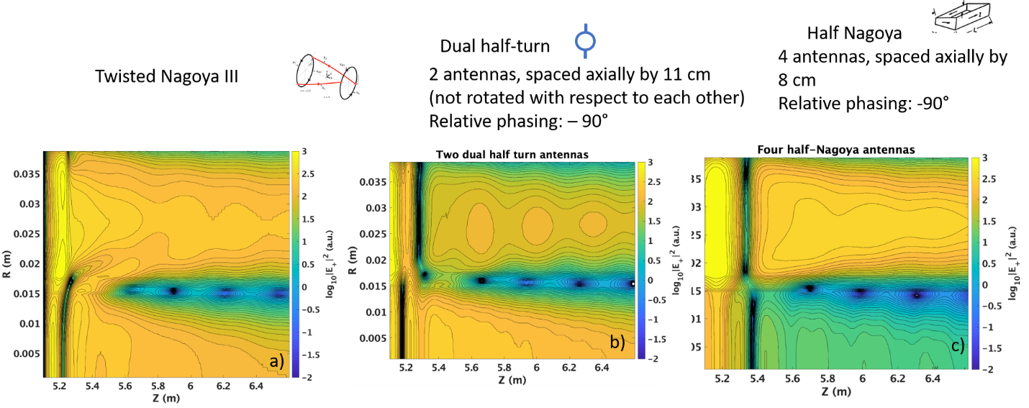

**Figure 3‑119. Profiles of the RF electric field and phase for different antenna geometries. a) Electric field magnitude for twisted Nagoya type-III antenna. b) Electric field magnitude for phased dual half-turn antennas. C) Electric field magnitude for phased half-Nagoya antennas.**

###### COMSOL Simulations

The propagation characteristics of the waves in the ICH region in Proto-MPEX have also been investigated using a 3D full wave model (Piotrowicz et al, 2019) and a 2D full wave model. The model used in the simulation is shown in Figure 3‑120. Since this is a Proto-MPEX ICH model, there is only one antenna. There are plans to perform additional simulations with a pair of antennas in order to confirm ANTENA results for that configuration.

Analysis of the dispersion properties in the ICH region shows that the FW, IAW and the KAW can propagate in the Proto-MPEX plasma (Piotrowicz et al, 2019). However, the IAW cannot couple power into the plasma core due to the narrow-angle of the group velocity and the Alfven resonance restricting its access to the core. This consideration is important for the efficiency of the beach heating on Proto-MPEX since the wave is launched at the periphery of the plasma and cannot access the core if the ion cyclotron resonance is located in close proximity to the antenna as is the case in the current experimental configuration. However, the excitation of the KAW is possible in the temperature regime of Proto-MPEX and opens an avenue for efficient heating of core ions. Modeling this excitation properly requires taking into account the strong axial gradient in |B| in this case, which has been done using COMSOL.

|  |
| --- |
|  |
| Figure 3‑120. Schematic of the ICH geometry used in COMSOL for the simulation. The YZ plane is shown and the ICH antenna, coaxial feed, antenna ground, and antenna feed are labeled. The antenna and feeds are depicted by the gold colored parts in the figure, while the alumina window is dark gray, and the plasma is pink. Vacuum boundaries are indicated by gray lines, outside of which is modeled as perfect electrical conductor. An oblique view of the model is shown at the lower right. |

For a constant magnetic field strength, the Alfvén resonance contour lies across the plasma’s electron density gradient and separates the regions where the FW, IAW and the KAW can propagate, but the layer is not sharply localized in radius since the launched antenna *k*|| spectrum is continuous. The resonance location restricts the propagation of the KAW inside the plasma core and significant electron heating can take place along this contour (Chen and Hasegawa, 1974; Hasegawa and Chen, 1975). Previous authors have described the heating of electrons in this layer due to mode conversion of the shear Alfven wave (slow wave branch) to lower hybrid oscillations (fast wave branch) (Timofeev, 2014, 2015).

Figure 3‑121. shows the contours of RF power absorption by the species present in the plasma. Interpreting these contours reveals the dominant power absorption mechanisms during ICH experiments. The ion power absorption is predominantly located at the fundamental cyclotron resonance location. The electron power absorption seems to occur in the periphery of the plasma column and at the Alfvén resonance. Since electron absorption in Proto-MPEX is not negligible, there is an advantage to keeping the ion cyclotron resonance location in close proximity to the ICH antenna if efficient ion heating is desired. This allows a greater fraction of the wave to be damped on ions as opposed to electrons. It is incorporated to the greatest extent possible in the present design.

|  |  |
| --- | --- |
|  | Figure 3‑121. YZ plane contours of the normalized RF power absorption in the plasma by electrons only (top), ions only (middle), and by both ions and electrons (bottom) for Te= 2.1 eV. Locations of the Alfven resonance are depicted by the red line, while locations of the fundamental ion cyclotron resonanceare depicted by thegreen lines. |

The Figure 3‑122 left side shows the integrated power absorbed in the core plasma, and the division of this absorbed power by each species (electrons and ions) as a function of electron temperature. The core ion power deposition increases with electron temperature until *Te* ~ 5 eV where it begins to slightly decline. The core electron power deposition is at its maximum at *Te* ~ 1 eV. This is most likely due to a balance between excitation of the KAW in the core (which is responsible for heating electrons in the core near the Alfven resonance) and a decreasing collision frequency. At electron temperatures of *Te* > 2 eV, RF absorption by the ions dominates the absorption by the electrons, and for an electron temperature *Te* > 4 eV it is calculated that ~80% of the power delivered to the core is absorbed by the ions.

The Figure 3‑122 right side shows the fraction of power in the core plasma coupled to electrons, ions, and both species as a function of edge electron density (${n_{e}}_{edge}$). This figure shows a significant increase in the core power deposition fraction when the edge electron density is increased up until $n_{e_{edge}}≈2×{10}^{18} m^{-3}$, then a slight decrease in coupling is observed. As has been discussed in the ANTENA simulations and will be discussed more later, this is likely due to FW antenna loading, which is evanescent below the L cutoff. Values of edge electron density above $n_{e_{edge}}>{10}^{18} m^{-3}$ begin to affect the propagation characteristics of the KAW in the core plasma and are unlikely to be experimentally relevant. However, the numerical effect of the higher edge electron density on core power deposition is enlightening for understanding the coupling of RF power to the KAW. Below $n_{e_{edge}}<{10}^{17} m^{-3}$ the amount of core power deposition becomes less than 5%, while $n_{e_{edge}}=1×{10}^{18} m^{-3}$ shows ~30% of the total power being coupled to the core.

|  |  |
| --- | --- |
|  |  |
| Figure 3‑122. (Left) Integrated core power deposition for ions and electrons (black squares), ions only (green circles), and electrons only (red diamonds) normalized to total power deposited in the simulation domain as function of *Te*. (Right) Integrated core power deposition plotted as a function of electron density in the edge (ne edge) for Te = 5 eV. | |

The edge electron density profile in Proto-MPEX is not well known, but it seems an important consideration for coupling ICH power into the core plasma. The simulation results show that when the edge electron density is sufficiently high (*ne* > 1 × 1017 m−3), and the electron temperature is increased to where the KAW is expected to propagate (Te > 2 eV), the core power deposition increases significantly (5%–30% of the total power). These numerical results demonstrate that kinetic effects are required to capture the physics of the ICH system on Proto-MPEX. They also importantly show that core power absorption can occur in Proto-MPEX at densities above the *n||2* = S limit due to the transition between the IAW and the KAW occurring at the *n||2* = S surface. Core power deposition has been clearly demonstrated in several experiments on Proto-MPEX. Figure 3‑123a through c shows an example where the central heat flux to the target is significantly increased during ICH.

|  |  |  |
| --- | --- | --- |
|  |  |  |

(a) (b) (c)

Figure 3‑123. Comparison of pulses with and without ICH heating a) and b): 2D heat flux at the target measured with IR without and with ICH respectively, c) black: central heat flux with helicon only, blue: same quantity with ICH between 4.35 and 4.6 s.

Using 2-D axisymmetric modeling, comparison between experiments and COMSOL modeling have been achieved for a magnetic field scan. This is shown in Figure 3-124. Three sets of simulation data are shown for ncore = 2x1019 m-3, 4x1019 m-3 and 6x1019 m-3 in the green, blue, and red lines respectively. The measured results of Figure 3-124 are overplotted by the black dots. For all three different density profiles, the relative power absorption profile as a function of PS2 current or magnetic field is encouragingly similar for both experiments and simulations over the entire PS2 current scan. This suggests that COMSOL can be used to understand the physics of ICH heating on Proto-MPEX. The simulations suggest three different physical regions. The first region occurs at the lowest PS2 current, shaded in blue, when no fundamental ion cyclotron resonance exists in the plasma. No heating is observed in experiments or in the simulations. This is to be expected as without a fundamental resonance, no appreciable ICH heating can occur. The white region is where optimal heating occurs. In this region, a fundamental ion cyclotron resonance heating occurs so heating is expected. For high PS2 currents shown in the red region, the heating unexpectedly decreases with increasing PS2 currents. In the ANTENA simulations, it was suggested that the decrease of the heating may be due to FW evanescent tunneling and reduced antenna loading at the antenna. 2-D axisymmetric simulations can however be used to highlight the role of the launched FW or IAW and gain physical insights.

|  |  |
| --- | --- |
|  | Figure 3‑124. Comparison between experimental measured heat flux and COMSOL modeling for core power deposition as a function of PS2 current or ICH magnetic field. |

Studying the physics of either launched FW or IAW can be accomplished in 2-D axisymmetric simulations by modifying the antenna surface current to launch purely in either the azimuthal or axial directions. Mathematically, this implies an approximately FW launch when $J_{ant}=J_{φ}\hat{φ}$ and approximately IAW launch when $J_{ant}= J_{z}\hat{z}$. The results for $J_{ant}= J_{z}\hat{z}$ is shown in figure 3-125 and $J_{ant}=J_{φ}\hat{φ}$ is shown in figure 3-126.

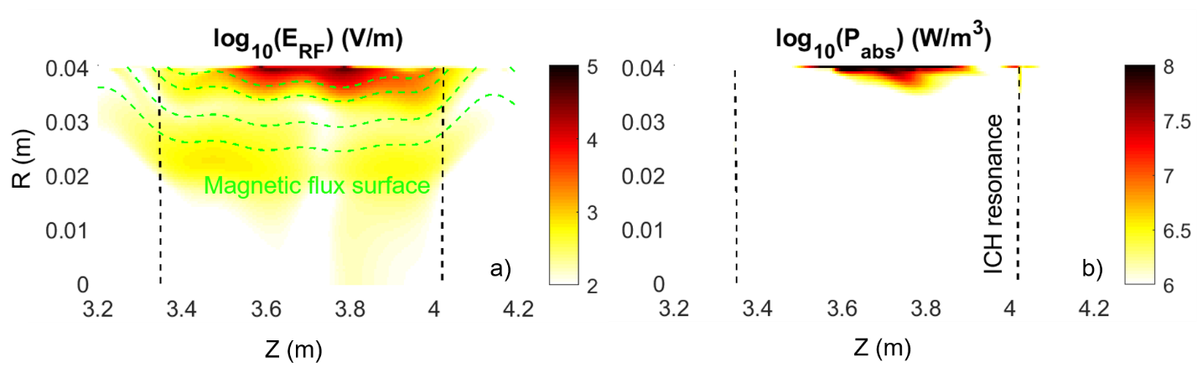

Figure 3‑125. COMSOL modeling assuming an approximately SW launch.

The results for $J_{ant}= J_{z}\hat{z}$ or approximately IAW launch shown in figure 3-125 is quite surprising. Figure 3-125 a) shows that the RF electric fields large near the antenna and small in the plasma core. Moreover, the electric field patterns in front of the antenna appear to mimic the shape of the magnetic flux surfaces (dashed green line). As discussed in the dispersion relation analysis, this is likely because the group velocity of the IAW is nearly parallel to the magnetic flux surfaces so that the IAW is predominantly propagating in the magnetic field or axial direction. There is therefore little propagation of the IAW to the core plasma. Figure 3-125 b) shows that the power absorption is almost all in front of the antenna. Very little if any of the power reaches the core plasma. Moreover, the power absorption does not occur at the ICH resonance layer. This is not only because the propagation is mostly axial; the IAW has significant electron damping and collisional damping (Timofeev,2014, Chen, 1974) because the wave phase velocity is similar to the electron thermal velocity. The IAW therefore can damp strongly in the low density region in front of the antenna.

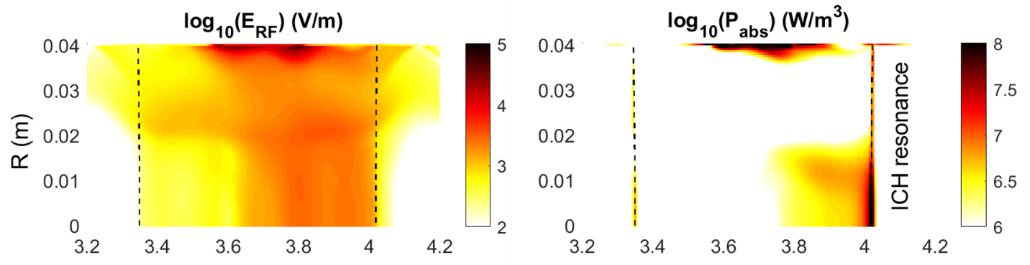

Figure 3‑126. COMSOL modeling assuming an approximately FW launch.

The results for $J_{ant}=J_{φ}\hat{φ}$ or approximately FW launch shown in figure 3-126. While there is still significant electric fields and power absorption in front of the antenna, which needs to be further investigated, significant electric field and power absorption is observed in the core plasma. The core power absorption is predominantly to the ions and at the fundamental ion cyclotron resonance. Given that FW can not directly heat at the fundamental ion cyclotron resonance at this density, this simulation suggests that launched FW are mode converted to the KAW at the Alfven resonance before being absorbed in the core plasma at the fundamental ion cyclotron resonance.

With the understanding of the ICH heating physics and good comparisons to experiments, it is possible to more confidently extrapolate results with increasing ICH power. Figure 3‑127 shows the measured ion temperature and heat flux as a function of ICH power up to ~ 20 kW at different locations. It is encouraging that the measured ion temperature and heat flux increases with ICH power. The ICH power scan shows approximately 5 eV increase in ion temperature for every 15 kW of ICH power. Assuming ne = 1x1019 m-3, this is ~ 8 Pa per 15 kW of ICH power. for this Proto-MPEX discharge Taking into account magnetic flux expansion (times 1.35) and unoptimized magnetic field configuration related to Fig 3-123 (estimated times 1.7), the scaling will translate to approximately 18 Pa per 15 kW of ICH power on MPEX. For MPEX, the desired is 375 Pa increase for ne = ni = 9x1019 m-3 and Ti = 30 eV. This requires a net ICH power of 310 kW. 400 kW of ICH is required to be conservative.

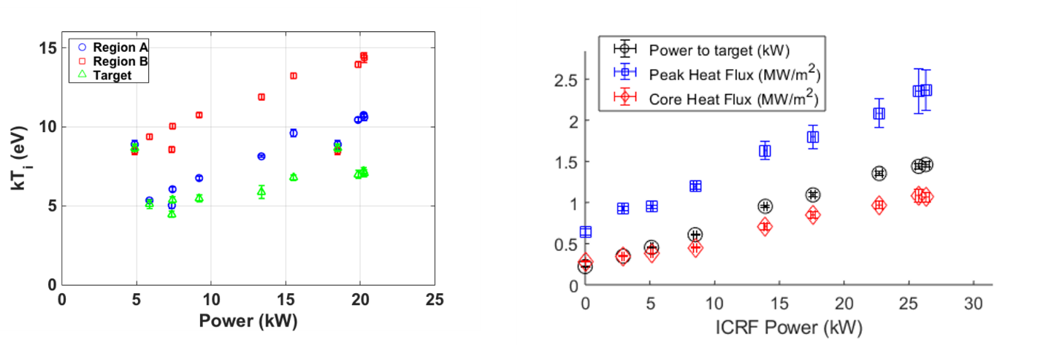

Figure 3‑127. Left. Ion temperature as a function of ICH power. Right. Heat flux at target as a function of ICH power.

### Conclusions

Proto-MPEX is the first device to our knowledge to demonstrate high power ICH beach heating at values of $n_{e}$ greater than the Alfvén resonant value, where only the kinetic Alfvén wave can propagate. Nevertheless, considerable experimental data has been obtained in a fairly short amount of time that together with modeling has produced a large amount of information useful to the design of the ICH system for MPEX.

In summary, the strong correlation between the experimental measurements, ANTENA simulated loading and COMSOL simulated core power absorption suggests that the simulations are reproducing the essential physics of the experiments. The dispersion analysis and simulations suggest that KAW heats the core plasma at the fundamental ion cyclotron resonance. For low magnetic fields or PS2 current, the fundamental ion cyclotron resonance does not exist, so no heating is observed. There exists an optimal magnetic field where the FW is not evanescent and can mode convert to the KAW, which then heats at the ion cyclotron resonance. For larger magnetic fields, the FW is evanescent and needs to tunnel through an evanescent layer to mode convert to the KAW. The ion heating therefore decreases in this region of increasingly large magnetic fields. For a given magnetic field, the edge density near the antenna needs to be large enough to eliminate or at least minimize the radial distance of the fast wave evanescent layer ([Piotrowicz, 2019).

This provides confidence in the choice of antenna length and frequency range of operation. Performance is improved by use of more than one antenna, which results in increased resistive loading, allowing more power to be coupled per antenna, and also produces a more sharply peaked spectrum that can be better optimized to obtain the best performance. The design has converged on a dual antenna version, with currents phased relatively by 90°, and with each strap being 30 cm in length. The loading is predicted to be low but will be maximized by utilizing a relatively small antenna inner diameter of 8.4 cm, together with a coaxial inner window with the inner window having a thickness of only 3mm. Due to the low loading, it may be required to pressurize the feedlines with SF6 in order to achieve the desired power handling. Obtaining a better understanding of the density reduction occurring with ICH will allow better power scaling predictions to be made. Experiments are planned to investigate this density reduction, which also occurs with EBW heating. At the same time, it will be useful to obtain information on heat fluxes at the ICH window through measurements that can be obtained simultaneously All the experimental results were achieved using an ICH antenna that was originally designed to excite the IAW. Any FW excitation is mostly unintentional. In the future, an ICH antenna optimized to launch FW for ion heating will be more optimal to improve core ion heating efficiency.

## Combined heating

Meeting the ITER divertor conditions at near the outer strike point, ne = 1021 m-3 and Te ~ 0.5-2 eV for tilted target (5° and 90°) are required as shown in Table 2‑2. These parameters set some of the most stringent limits for the MPEX ultimate performance parameters in Table 2‑5. To reach these MPEX ultimate performance parameters, extensive transport modeling has been performed in Chapter 3. In Table 3-4, ne = 9x1019 m-3, Te = 25 eV, and Ti = 30 eV is expected to be necessary at the upstream source. In the previous subsections on helicon source, ECH electron heating, and ICH ion heating, power extrapolations have shown that approximately 200 kW of helicon power, 400 kW of ECH power, and 400 kW of ICH power should be able to meet these upstream source parameters.

These RF power requirements are found from 0th order extrapolations from Proto-MPEX experimental data. There are a few caveats to this simple extrapolation. These extrapolations do not account for the fact that RF power is observed to modify multiple parameters. This analysis also assumes that ECH does not drop the core electron density, which has been observed with 28 GHz operation on Proto-MPEX. The density drop is not expected to be significant with 70 GHz operation discussed in Section 3.3.1 and Section 4.2 as well as optimized magnetic geometry in Section 3.3.5. The data is also measured at the Proto-MPEX target and not at the RF source locations.

While helicon, ICH, and ECH can individually satisfy the ne, Te, and Ti source parameters, these parameters are also likely achievable for combined operations. ne , Te , and Ti have not been directly measured for combined operations as a function of input power. However, the heat fluxes have been experimentally shown to be additive for helicon-only, helicon + ICH, helicon + ECH, and helicon + ECH + ICH operations on Proto-MPEX, which makes the combined operation easier to analyze (Rapp et al, 2020). This is shown with core heat flux measurements for 90 kW of helicon-only operation, 90 kW of helicon +35 kW of ECH operation, 90 kW of helicon +25 kW of ICH operation, and 90 kW of helicon +25 kW of ICH +35 kW of ECH operation in Fig. 7. With simple arithmetic, the individual contributions of helicon-only, ICH-only, and ECH-only can be determined and can be calculated to be very close to the simultaneously obtained contribution. An extrapolation from 90 kW helicon, 25 kW ICH, and 35 kW ECH on Proto-MPEX to 100 kW helicon, 350 kW ICH, and 350 kW ECH for MPEX will result in a core heat flux of 19 MW/m2. This will suffice to achieve the minimum requirements of 10 MW/m2 of perpendicular heat flux on the target as required by the mission need (Rapp et al, 2020).

However, this simple extrapolation does not take into account that the magnetic configuration for these experiments on Proto-MPEX is different than what it will be in MPEX. In MPEX, the magnetic field will steadily drop in value axially from the location of wave absorption to the target. In Proto-MPEX, the constraints given by low-frequency gyrotrons mean that the magnetic field at the location of the second harmonic 28 GHz EBW heating is lower than the magnetic field at the location of ICRF absorption for 6 MHz ICRF frequency for the combined operation. It has been found that in the so-called downhill magnetic configuration, where the magnetic field is dropping from the EBW wave absorption region to the target, the heat flux is about a factor of 1.3 higher at the target (Caneses et al, 2020). When taken into account that the magnetic flux in these downhill configurations is increased, normalization to reduced flux expansion would increase the total heat flux by another factor of 1.3 leading to a total normalization factor of 1.7 for electron heating. For ICH heating, it has been found that careful optimization of the magnetic field axial profile can lead to significant improvements in the heat flux to the target (see Figure 3‑124 and discussion in previous section on ICH heating). The combined heating experiments had a magnetic field of just below 1 T under the ICH antenna. Increasing the field to 1.1 or 1.2 T increases the heat flux by about a factor of 1.7. Taking into account the corrections mentioned above for the extrapolation, then combined heating by 200 kW helicon, 400 kW 70 GHz EBW, and 400 kW 7.5 MHz ICH would lead to a power flux of ~37 MW/m2 on target (Rapp et al, 2020).

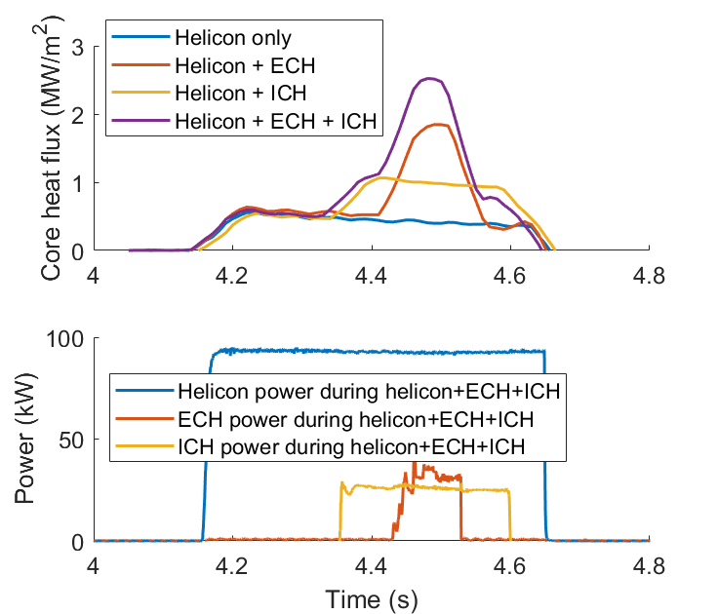

Figure 3‑128. Top: Core heat flux during operation of helicon only, helicon+ECH, helicon+ICH, and helicon+ICH+ECH as a function of time. Bottom: Helicon, ICH, and ECH power as a function of time.

From an extrapolation using Proto-MPEX data, it can be shown that 200 kW helicon, 400 kW ICH, and 400 kW ECH is expected to meet the MPEX source parameters of ne = 9x1019 m-3, Te = 25 eV, Ti = 30 eV at the source and peak core heat flux > 10 MW/m2. This satisfies the most stringent requirements at the source parameters in Table 3-4 and expected to meet all the conditions for the MPEX ultimate performance parameters shown in Table 2-6.

## References for Chapter 3

Akhiezer, A.I., V.S. Mikhailenko, and K.N. Stepanov. 1998. “Ion-Sound Parametric Turbulence and Anomalous Electron Heating with Application to Helicon Plasma Sources.” *Physics Letters A* 245 (1–2): 117–22. https://doi.org/10.1016/S0375-9601(98)00437-X.

Arnush, Donald. 2000. “The Role of Trivelpiece–Gould Waves in Antenna Coupling to Helicon Waves.” *Physics of Plasmas (1994-Present)* 7 (7): 3042–50. https://doi.org/10.1063/1.874157.

Baeva, M., W. J. Goedheer, N. J. Lopes Cardozo, and D. Reiter. 2007. “B2-EIRENE Simulation of Plasma and Neutrals in MAGNUM-PSI.” *Journal of Nuclear Materials*, Plasma-Surface Interactions-17, 363–365 (June): 330–34. https://doi.org/10.1016/j.jnucmat.2007.01.029.

Bering, E. A., F. R. Chang Díaz, J. P. Squire, T. W. Glover, M. D. Carter, G. E. McCaskill, B. W. Longmier, M. S. Brukardt, W. J. Chancery, and V. T. Jacobson. 2010. “Observations of Single-Pass Ion Cyclotron Heating in a Trans-Sonic Flowing Plasma.” *Physics of Plasmas* 17 (4): 043509. https://doi.org/10.1063/1.3389205.

Bering, Edgar, Michael Brukardt, Jared Squire, Timothy Glover, Verlin Jacobson, and Greg McCaskill. 2006. “Recent Improvements In Ionization Costs and Ion Cyclotron Heating Efficiency in The VASMIR Engine.” *44th AIAA Aerospace Sciences Meeting and Exhibit*. https://doi.org/10.2514/6.2006-766.

Biewer, T. M., T. S. Bigelow, J. F. Caneses, S. J. Diem, D. L. Green, N. Kafle, and J. Rapp. 2018. “Observations of Electron Heating during 28 GHz Microwave Power Application in Proto-MPEX.” *Physics of Plasmas* 25 (2): 024501. <https://doi.org/10.1063/1.5018479>.

Biewer, T. M., Lau, C., Bigelow, T. S., Caneses, J. F., Caughman, J. B. O., Goulding, R. H., ... & Proto-MPEX Team. (2019). Utilization of OXB mode conversion of 28 GHz microwaves to heat core electrons in the upgraded Proto-MPEX. Physics of Plasmas, 26(5), 053508.

Booske, J. H., W. D. Getty, R. M. Gilgenbach, and R. A. Jong. 1985. “Experiments on Whistler Mode Electron‐cyclotron Resonance Plasma Startup and Heating in an Axisymmetric Magnetic Mirror.” *The Physics of Fluids* 28 (10): 3116–26. https://doi.org/10.1063/1.865353.

Boozer, Allen H., and Gioietta Kuo‐Petravic. 1998. “Monte Carlo Evaluation of Transport Coefficients.” *The Physics of Fluids* 24 (5): 851. https://doi.org/10.1063/1.863445.

Caneses, J. F., P. A. Piotrowicz, T. M. Biewer, J. B. O. Caughman, R. H. Goulding, N. Kafle, and J. Rapp. 2018. “Differential Pumping Requirements for the Light-Ion Helicon Source and Heating Systems of Proto-MPEX.” *Physics of Plasmas* 25 (8): 083518. https://doi.org/10.1063/1.5001519.

Caneses, J. F., Piotrowicz, P. A., Biewer, T. M., Goulding, R. H., Lau, C., Showers, M., & Rapp, J. (2019). Ion fluxes and neutral gas ionization efficiency of the 100-kW light-ion helicon plasma source concept for the material plasma exposure experiment. *Fusion Science and Technology*, *75*(7), 683-689.

Caneses, Juan F., and Boyd Blackwell. 2015. “RF Compensation of Double Langmuir Probes: Modelling and Experiment.” *Plasma Sources Science and Technology* 24 (3): 035024. https://doi.org/10.1088/0963-0252/24/3/035024.

Caneses, Juan F., and Boyd D. Blackwell. 2016. “Collisional Damping of Helicon Waves in a High Density Hydrogen Linear Plasma Device.” *Plasma Sources Science and Technology* 25 (5): 055027. <https://doi.org/10.1088/0963-0252/25/5/055027>.

Caneses, J. F., Spong, D. A., Lau, C., Biewer, T. M., Goulding, R. H., Bigelow, T. S., ... & Rapp, J. (2020). Effect of magnetic field ripple on parallel electron transport during microwave plasma heating in the Proto-MPEX linear plasma device. Plasma Physics and Controlled Fusion, 62(4), 045010.

Chan, V. S., S. C. Chiu, and Y. A. Omelchenko. 2002. “Radio-Frequency-Driven Radial Current and Plasma Rotation in a Tokamak.” *Physics of Plasmas* 9 (2): 501–10. https://doi.org/10.1063/1.1429633.

Chen, Liu, and Akira Hasegawa. 1974. “Plasma Heating by Spatial Resonance of Alfvén Wave.” *The Physics of Fluids* 17 (7): 1399–1403. <https://doi.org/10.1063/1.1694904>.

Chen, F.F , “Plasma ionization by helicon waves,” *Plasma Phys. Control. Fusion*, vol. 33, no. 4, pp. 339–364, Apr. 1991.

Curreli, Davide, and Francis F. Chen. 2011. “Equilibrium Theory of Cylindrical Discharges with Special Application to Helicons.” *Physics of Plasmas (1994-Present)* 18 (11): 113501. https://doi.org/10.1063/1.3656941.

Diem, S. J., D. L. Green, R. W. Harvey, and Yu. V. Petrov. 2018. “An Electron Bernstein Wave Heating Scheme for the Proto-MPEX Linear Device.”

Eich, T., Leonard, A.W., Pitts, R.A., Fundamenski, W., Goldston, R.J., Gray, T.K., Herrmann, A., Kirk, A., Kallenbach, A., Kardaun, O. and Kukushkin, A.S., 2013. Scaling of the tokamak near the scrape-off layer H-mode power width and implications for ITER. *Nuclear fusion*, *53*(9), p.093031.

Feng, Y, F Sardei, and J Kisslinger. 1999. “3D Fluid Modelling of the Edge Plasma by Means of a Monte Carlo Technique.” *Journal of Nuclear Materials* 266–269 (March): 812–18. https://doi.org/10.1016/S0022-3115(98)00844-7.

Fundamenski, W. 2007. “Comparison of Coulomb Collision Rates in the Plasma Physics and Magnetically Confined Fusion Literature.” EFDA-JET-R(07)01. http://www.euro-fusionscipub.org/archives/jet-archive/comparison-of-coulomb-collision-rates-in-the-plasma-physics-and-magnetically-confined-fusion-literature.

Gekelman, W., S. Vincena, and D. Leneman. 1997. “Experimental Observations of Shear Alfvén Waves Generated by Narrow Current Channels.” *Plasma Physics and Controlled Fusion* 39 (5A): A101–A112. https://doi.org/10.1088/0741-3335/39/5A/011.

Gekelman, W., S. Vincena, B. Van Compernolle, G. J. Morales, J. E. Maggs, P. Pribyl, and T. A. Carter. 2011. “The Many Faces of Shear Alfvén Waves.” *Physics of Plasmas* 18 (5): 055501. https://doi.org/10.1063/1.3592210.

Golovanivsky, Konstantin S., Valery D. Dougar-Jabon, and Dmitry V. Reznikov. 1995. “Proposed Physical Model for Very Hot Electron Shell Structures in Electron Cyclotron Resonance--Driven Plasmas.” *Physical Review E* 52 (3): 2969–73. https://doi.org/10.1103/PhysRevE.52.2969.

Golovato, S. N., K. Brau, J. Casey, J. Coleman, M. J. Gerver, W. Guss, G. Hallock, et al. 1988. “Plasma Production and Heating in a Tandem Mirror Central Cell by Radio‐frequency Waves in the Ion Cyclotron Frequency Range.” *The Physics of Fluids* 31 (12): 3744–53. https://doi.org/10.1063/1.866893.

Goulding, R. H., J. B. O. Caughman, J. Rapp, T. M. Biewer, T. S. Bigelow, I. H. Campbell, J. F. Caneses, et al. 2017. “Progress in the Development of a High Power Helicon Plasma Source for the Materials Plasma Exposure Experiment.” *Fusion Science and Technology* 72 (4): 588–94. https://doi.org/10.1080/15361055.2017.1352429.

Hammond, K. C., R. R. Diaz-Pacheco, A. Köhn, F. A. Volpe, and Y. Wei. 2018. “Overdense Microwave Plasma Heating in the CNT Stellarator.” *Plasma Physics and Controlled Fusion* 60 (2): 025022. https://doi.org/10.1088/1361-6587/aa9a7c.

Hasegawa, Akira, and Liu Chen. 1975. “Theory of Plasma Heating by Nonlinear Excitation of Lower Hybrid Resonance.” *The Physics of Fluids* 18 (10): 1321–26. https://doi.org/10.1063/1.861020.

Henderson, M. A., S. Alberti, C. Angioni, G. Arnoux, R. Behn, P. Blanchard, P. Bosshard, et al. 2003. “Recent Results from the Electron Cyclotron Heated Plasmas in Tokamak à Configuration Variable (TCV).” *Physics of Plasmas* 10 (5): 1796–1802. https://doi.org/10.1063/1.1562167.

Hinton, F.L. 1983. “Collisional Transport in Plasma.” In *Handbook of Plasma Physics*, 147–197. Amsterdam; New York; New York, N.Y.: North-Holland Pub., Elsevier Science Pub.

Hjartarson, A. T., E. G. Thorsteinsson, and J. T. Gudmundsson. 2010. “Low Pressure Hydrogen Discharges Diluted with Argon Explored Using a Global Model.” *Plasma Sources Science and Technology* 19 (6): 065008. https://doi.org/10.1088/0963-0252/19/6/065008.

Jaeger, E. F., L. A. Berry, and D. B. Batchelor. 2000. “Full-Wave Calculation of Sheared Poloidal Flow Driven by High-Harmonic Ion Bernstein Waves in Tokamak Plasmas.” *Physics of Plasmas* 7 (8): 3319–29. https://doi.org/10.1063/1.874197.

Kastelewicz, H., and G. Fussmann. 2004. “Plasma Modelling for the PSI Linear Plasma Device.” *Contributions to Plasma Physics* 44 (4): 352–60. https://doi.org/10.1002/ctpp.200410053.

Kletzing, C. A., S. R. Bounds, J. Martin-Hiner, W. Gekelman, and C. Mitchell. 2003. “Measurements of the Shear Alfv\’en Wave Dispersion for Finite Perpendicular Wave Number.” *Physical Review Letters* 90 (3): 035004. https://doi.org/10.1103/PhysRevLett.90.035004.

Köhn, A., G. Birkenmeier, E. Holzhauer, M. Ramisch, and U. Stroth. 2010. “Generation and Heating of Toroidally Confined Overdense Plasmas with 2.45\hspace0.167emGHz Microwaves.” *Plasma Physics and Controlled Fusion* 52 (3): 035003. https://doi.org/10.1088/0741-3335/52/3/035003.

Kotov, V., D. Reiter, and A. S. Kukushkin. 2007. “Numerical Study of the ITER Divertor Plasma with the B2-EIRENE Code Package.” http://inis.iaea.org/Search/search.aspx?orig\_q=RN:39025830.

Kukushkin, Andrei S, Horst D Pacher, Gianfranco Federici, Günter Janeschitz, Alberto Loarte, and Guenther W Pacher. 2003. “Divertor Issues on ITER and Extrapolation to Reactors.” *Fusion Engineering and Design*, 1st International Workshop on Innovative Concepts for Plasma - Interactive Components in Fusion Devices, 65 (3): 355–66. https://doi.org/10.1016/S0920-3796(02)00380-0.

Lam, K. L., B. J. Leikind, A. Y. Wong, G. Dimonte, A. Kuthi, L. Olson, and H. Zwi. 1986. “Mirror Ratio Scaling of Axial Confinement of a Mirror‐trapped Collisional Plasma.” *The Physics of Fluids* 29 (10): 3433–38. https://doi.org/10.1063/1.865859.

Laqua, H. P., H. Maassberg, F. Volpe, W7-AS Team, and ECRH-Group. 2003. “Electron Bernstein Wave Heating and Current Drive in Overdense Plasmas at the W7-AS Stellarator.” *Nuclear Fusion* 43 (11): 1324–1328. https://doi.org/10.1088/0029-5515/43/11/004.

Laqua, Heinrich Peter. 2007. “Electron Bernstein Wave Heating and Diagnostic.” *Plasma Physics and Controlled Fusion* 49 (4): R1–R42. https://doi.org/10.1088/0741-3335/49/4/R01.

Lau, C., J. F. Caneses, T. S. Bigelow, T. M. Biewer, J. B. O. Caughman, R. H. Goulding, P. A. Piotrowicz, J. Rapp, H. B. Ray, and M. Showers. 2019. “Evidence of Electron Heating at Different Radial Locations on Proto-MPEX.” *Physics of Plasmas* 26 (3): 032503. <https://doi.org/10.1063/1.5083814>.

Lau, C., Caneses, J. F., Piotrowicz, P. A., Showers, M. A., Beers, C. J., Biewer, T. M., ... & Rapp, J. (2020). Heat Flux Analysis From IR Imaging on Proto-MPEX. IEEE Transactions on Plasma Science, 48(9), 3152-3159.

Lehane, J. A., and F. J. Paoloni. 1970. “Hydromagnetic Wave Propagation in Inhomogeneous Magnetic Fields.” *Plasma Physics* 12 (11): 823–830. https://doi.org/10.1088/0032-1028/12/11/001.

Logan, B. Grant, I. G. Brown, A. J. Lichtenberg, and M. A. Lieberman. 1974. “Plasma Confinement in Multiple Mirror Systems. II. Experiment and Reactor Calculation.” *The Physics of Fluids* 17 (6): 1302–13. https://doi.org/10.1063/1.1694882.

Lorenz, B., M. Kramer, V. L. Selenin, and Yu M. Aliev. 2005. “Excitation of Short-Scale Fluctuations by Parametric Decay of Helicon Waves into Ion–Sound and Trivelpiece–Gould Waves.” *Plasma Sources Science and Technology* 14 (3): 623. https://doi.org/10.1088/0963-0252/14/3/027.

Maggs, J. E., T. A. Carter, and R. J. Taylor. 2007. “Transition from Bohm to Classical Diffusion Due to Edge Rotation of a Cylindrical Plasma.” *Physics of Plasmas* 14 (5): 052507. https://doi.org/10.1063/1.2722302.

Makhijani, A., A. J. Lichtenberg, M. A. Lieberman, and B. Grant Logan. 2003. “Plasma Confinement in Multiple‐mirror Systems. I: Theory.” *The Physics of Fluids* 17 (6): 1291. https://doi.org/10.1063/1.1694881.

McDermott, F. S., G. Bekefi, K. E. Hackett, J. S. Levine, and M. Porkolab. 1982. “Observation of the Parametric Decay Instability during Electron Cyclotron Resonance Heating on the Versator II Tokamak.” *The Physics of Fluids* 25 (9): 1488–90. https://doi.org/10.1063/1.863932.

McVey, B. 1984. “ICRF Antenna Coupling Theory for a Cylindrically Stratified Plasma.” PFC/RR-84-12 (1984). MIT Plasma Fusion Center.

Mori, Yoshitaka, Hieki Nakashima, Frederick W Baity, Richard H Goulding, Mark D Carter, and Dennis O Sparks. 2004. “High Density Hydrogen Helicon Plasma in a Non-Uniform Magnetic Field.” *Plasma Sources Science and Technology* 13 (3): 424–35. https://doi.org/10.1088/0963-0252/13/3/009.

Owen, L. W., J. F. Caneses, J. Canik, J. D. Lore, C. Corr, B. Blackwell, X. Bonnin, and J. Rapp. 2017. “B2.5-Eirene Modeling of Radial Transport in the MAGPIE Linear Plasma Device.” *Plasma Sources Science and Technology* 26 (5): 055005. https://doi.org/10.1088/1361-6595/aa6389.

Piotrowicz, P. A., Goulding, R. H., Caneses, J. F., Green, D. L., Caughman, J. B., Lau, C., ... & Ruzic, D. N. (2019). Computational investigation of ion cyclotron heating on Proto-MPEX. *Physics of Plasmas*, *26*(3), 033511.

Piotrowicz, P. A., J. F. Caneses, D. L. Green, R. H. Goulding, C. Lau, J. B. O. Caughman, J. Rapp, and D. N. Ruzic. 2018. “Helicon Normal Modes in Proto-MPEX.” *Plasma Sources Science and Technology* 27 (5): 055016. https://doi.org/10.1088/1361-6595/aabd62.

Piotrowicz, P. A., J. F. Caneses, M. A. Showers, D. L. Green, R. H. Goulding, J. B. O. Caughman, T. M. Biewer, J. Rapp, and D. N. Ruzic. 2018. “Direct Measurement of the Transition from Edge to Core Power Coupling in a Light-Ion Helicon Source.” *Physics of Plasmas* 25 (5): 052101. https://doi.org/10.1063/1.5023924.

Rapp, J., T. M. Biewer, T. S. Bigelow, J. B. O. Caughman, R. C. Duckworth, R. J. Ellis, D. R. Giuliano, et al. 2016. “The Development of the Material Plasma Exposure Experiment.” *IEEE Transactions on Plasma Science* 44 (12): 3456–64. <https://doi.org/10.1109/TPS.2016.2628326>.

Rapp, J., Lau, C., Lumsdaine, A., Beers, C. J., Bigelow, T. S., Biewer, T. M., ... & West, D. (2020). The materials plasma exposure experiment: Status of the physics basis together with the conceptual design and plans forward. *IEEE Transactions on Plasma Science*, *48*(6), 1439-1445.

Roberts, D. R., and N. Hershkowitz. 1992. “Enhanced Slow‐wave Beach Heating of Mirror Plasmas with Two‐ion Species.” *Physics of Fluids B: Plasma Physics* 4 (6): 1475–85. https://doi.org/10.1063/1.860058.

Rognlien, T. D., and T. A. Cutler. 1980. “Transition from Pastukhov to Collisional Confinement in a Magnetic and Electrostatic Well.” *Nuclear Fusion* 20 (8): 1003. https://doi.org/10.1088/0029-5515/20/8/007.

Ryutov, D. D. 1988. “Open-Ended Traps.” *Soviet Physics Uspekhi* 31 (4): 300. https://doi.org/10.1070/PU1988v031n04ABEH005747.

Schneider, R., X. Bonnin, K. Borrass, D. P. Coster, H. Kastelewicz, D. Reiter, V. A. Rozhansky, and B. J. Braams. 2006. “Plasma Edge Physics with B2-Eirene.” *Contributions to Plasma Physics* 46 (1–2): 3–191. https://doi.org/10.1002/ctpp.200610001.

Seltzman, A. H., J. K. Anderson, S. J. Diem, J. A. Goetz, and C. B. Forest. 2017. “Observation of Electron Bernstein Wave Heating in a Reversed Field Pinch.” *Physical Review Letters* 119 (18): 185001. <https://doi.org/10.1103/PhysRevLett.119.185001>.

Shamrai, K. P. (1998). Stable modes and abrupt density jumps in a helicon plasma source. Plasma Sources Science and Technology, 7(4), 499.

Shevchenko, V., G. Cunningham, A. Gurchenko, E. Gusakov, B. Lloyd, M. O’Brien, A. Saveliev, A. Surkov, F. Volpe, and M. Walsh. 2007. “Development of Electron Bernstein Wave Research in MAST.” *Fusion Science and Technology* 52 (2): 202–15. https://doi.org/10.13182/FST07-A1499.

Showers. 2016. “Heat Flux Estimates of Power Balance on Proto-MPEX with IR Imaging.” *Review of Scientific Instruments* 87 (11): 11D412. https://doi.org/10.1063/1.4959953.

Spitzer, Lyman. 2013. Physics of Fully Ionized Gases: Second Revised Edition. Courier Corporation.

Stallard, B. W., D. A. Content, R. J. Groebner, D. N. Hill, R. James, J. M. Lohr, T. Luce, et al. 1990. “Heating and Confinement in H-Mode and L-Mode Plasmas in DIII-D Using Outside Launch Electron Cyclotron Heating.” *Nuclear Fusion* 30 (11): 2235–2258. https://doi.org/10.1088/0029-5515/30/11/003.

Stangeby, P. C. 2000. *The Plasma Boundary of Magnetic Fusion Devices*. CRC Press. https://doi.org/10.1201/9781420033328.

Stangeby, P. C. 2012. “The Chodura Sheath for Angles of a Few Degrees between the Magnetic Field and the Surface of Divertor Targets and Limiters.” *Nuclear Fusion* 52 (8): 083012. https://doi.org/10.1088/0029-5515/52/8/083012.

Stenzel, R. L., and R. W. Gould. 1971. “Upper‐Hybrid Resonance Absorption, Emission, and Heating of an Afterglow Plasma Column.” *Journal of Applied Physics* 42 (11): 4225–35. https://doi.org/10.1063/1.1659758.

Stix, Thomas H., and Richard W. Palladino. 1960. “Observation of Ion Cyclotron Waves.” *The Physics of Fluids* 3 (4): 641–47. https://doi.org/10.1063/1.1706099.

Timofeev, A. V. 2014. “On the Influence of Alfvén Resonance on Ion Cyclotron Resonance Heating.” *Plasma Physics Reports* 40 (1): 1–13. https://doi.org/10.1134/S1063780X14010103.

Timofeev, A. V. 2015. “On RF Heating of Inhomogeneous Collisional Plasma under Ion-Cyclotron Resonance Conditions.” *Plasma Physics Reports* 41 (11): 873–81. https://doi.org/10.1134/S1063780X15110094.

Vijvers, W. a. J., C. a. J. van Gils, W. J. Goedheer, H. J. van der Meiden, D. C. Schram, V. P. Veremiyenko, J. Westerhout, N. J. Lopes Cardozo, and G. J. van Rooij. 2008. “Optimization of the Output and Efficiency of a High Power Cascaded Arc Hydrogen Plasma Source.” *Physics of Plasmas* 15 (9): 093507. https://doi.org/10.1063/1.2979703.

Vincena, S., W. Gekelman, and J. Maggs. 2001. “Shear Alfvén Waves in a Magnetic Beach and the Roles of Electron and Ion Damping.” *Physics of Plasmas* 8 (9): 3884–96. https://doi.org/10.1063/1.1389092.

W7-AS Team ECRH Group, H. P. Laqua, V. Erckmann, H. J. Hartfuß, and H. Laqua. 1997. “Resonant and Nonresonant Electron Cyclotron Heating at Densities above the Plasma Cutoff by O-X-B Mode Conversion at the W7-As Stellarator.” *Physical Review Letters* 78 (18): 3467–70. https://doi.org/10.1103/PhysRevLett.78.3467.

Westerhof, Egbert. 2010. “Electron Cyclotron Waves.” *Fusion Science and Technology* 57 (2T): 214–21. https://doi.org/10.13182/FST10-A9412.

Yadav, Vipin K., and D. Bora. 2004. “Electron Bernstein Wave Generation in a Linear Plasma System.” *Physics of Plasmas* 11 (10): 4582–88. https://doi.org/10.1063/1.1784787.

Yasaka, Y., R. Majeski, J. Browning, N. Hershkowitz, and D. Roberts. 1988. “ICRF Heating with Mode Control Provided by a Rotating Field Antenna.” *Nuclear Fusion* 28 (10): 1765–70. https://doi.org/10.1088/0029-5515/28/10/005.

# PLASMA SOURCE AND HEATING SYSTEMS

## Helicon Plasma Production System

### Overview

Steady-state plasma generation is initiated by a 200 kW helicon antenna operating at a frequency of 13.56 MHz. The antenna is located outside the vacuum space to minimize plasma impurities. Power is coupled through concentric ceramic RF windows. A drawback of this configuration is that 10–20% of the power launched by the antenna is absorbed in the RF windows due to RF plasma-sheath interactions and the production of hot neutral gas; therefore, the window must be actively water cooled (Lumsdaine et al., 2019). The functional requirements are listed in Table 4‑1. The R&D performed for the water-cooled helicon window on CSDX is given in Section 3.2.5 on page 64.

Table 4‑1. Helicon antenna design requirements.

|  |  |
| --- | --- |
| **Functional Requirement** | **Value** |
| Window loss tangent | <1×10-3 |
| Power into antenna | 200 kW |
| Antenna pitch | 90 degrees |
| Antenna/Window lifetime | 5yrs |
| Minimum clearance | 406 mm (16in) |
| Minimum magnetic field along central axis of helicon | 80 mT |
| Maximum magnetic field along central axis of helicon | 200 mT |
| Uniformity of magnetic field along central axis of helicon | <5% |
| Maximum mirror magnetic field upstream and downstream of helicon | 0.7 T |

### Electrical aspects of the helicon plasma source design

An important difference between MPEX and the earlier experiments is that the requirement to operate steady state, given the power deposition of 20 to 30% of the input RF power at the inner surface of the window, requires active water cooling. Furthermore, the window length is required to be at least 30 cm, in order to sufficiently limit the power density and maximum electric field to values allowing 200 kW of power coupling to the plasma. Even if aluminum nitride (AlN) were to be used, this is too long for edge cooling to be feasible, so that the water must be flowed over the window surface, between the antenna and the window. The water channel is formed by adding a larger diameter secondary cylindrical window located coaxially with the first with a narrow gap in between the two.

As the thickness of the window increases, the distance between the antenna and plasma does as well, and the plasma coupling drops. The windows procured for the experiments to date have a 6 mm wall thickness. Manufacturer of windows of the required length and diameter with thinner walls will be difficult but may be possible with a development effort involving suppliers. For the purpose of this study, the electrical performance of two water-cooled windows is studied: one with 3 mm thick inner and outer windows and the second with a 6 mm thick inner window and a 3 mm thick outer window. These have been compared to the existing single 6 mm thick window.

The antenna itself also has a design feature that maximizes coupling. It is composed of flat straps so that RF currents in the helices can travel as close to the plasma as possible. Semicircular channels welded to the straps on the outside carry the water used to cool it. It would be simpler to fabricate an antenna directly out of circular tubing, but in this case the current on the average would be located at a larger radius, reducing the plasma coupling.

The 3-D electromagnetic modeling code CST Microwave Studio (MWS) has been used to examine the three cases described above. For the water-cooled designs there is assumed to be a 1 mm thick water channel between the inner and outer windows. The code has been used to determine the relative loading for these cases and, utilizing that quantity, the input current required to couple 200 kW of RF power to the plasma. The current has then been used in turn to scale the electric fields calculated by MWS for the different configurations. The electric field is the factor that limits the peak power, while power deposition and cooling considerations determine long pulse power limits.

Figure 4‑1. shows the MWS model for case with the 6 mm thick inner window and 3 mm thick outer window. The water channel can be clearly seen, as well as the gap between the outer ceramic and the antenna, which for all cases is taken to be 4 mm. In order to minimize the mesh size, the model assumes as a boundary condition that all regions not containing vacuum (transparent blue region), plasma, or components are filled with perfect electrical conductor (PEC). The antenna is also modeled as PEC. In this model a lossy dielectric is used to model the plasma. The dielectric constant for the two windows is assumed to be the same (=9.5), and the water in the cooling channel is modeled using the dielectric constant and conductivity of pure water.

|  |  |
| --- | --- |
| Labeled_MWS_helicon_model | Figure 4‑1. MWS model of the helicon antenna with double window. |

The input power is determined using the usual formula $P_{in}=1/2 Re\left\{VI^{*}\right\}$, where *V* and *I* are the complex input voltage and current, respectively, and the asterisk denotes that the complex conjugate should be taken. The antenna resistive coupling is then simply $R_{a}={2P_{in}}/{I^{2}}$. The voltage is measured between the inner and outer conductor of the feed at the location indicated by the arrow in the model, and the current is obtained by integrating the tangential RF magnetic field around the circle at the same location. The results are given in Table 4‑2

Table 4‑2. Electrical performance for the three helicon window configurations.

|  |  |  |  |  |  |
| --- | --- | --- | --- | --- | --- |
| **Configuration** | ***V*** | ***I*** | ***Pin*** | ***Ra*** | **|*Emax*|** |
| 6mm | 2.71 + 4.84 i | .230 - .100i | 0.070 W | 2.23 Ω | 1.83 kV/mm |
| 3 mm + 1 mm gap + 3 mm | 2.62 + 4.84 i | .208 - .089i | 0.058 W | 2.26 Ω | 1.83 kV/mm |
| 6 mm + 1 mm gap + 3 mm | 2.55 + 4.91 i | .232 - .101i | 0.048 W | 1.50 Ω | 2.54 kV/mm |

The plasma coupling is virtually identical for the case with the single 6 mm thick window, and that with two 3 mm thick windows and a 1 mm gap in between. If the thickness of the inner window is increased by 3 mm, then the coupling drops by ~30%. It is important to note that only the relative values are important here. Because MWS does not include a plasma model using an isotropic lossy dielectric instead, the absolute value of the loading is not expected to be modeled accurately. In actual experiments with the existing 6 mm thick window, the resistive plasma coupling has been measured to be ~ 6 Ω for both deuterium and helium plasmas, even at relatively low density (Figure 4‑2.). The scaled loading based on the experimentally measured value is then is 6 Ω for the second case and 4 Ω for the third. The scaled peak input current for 200 kW power is then 259 A for the first two cases and 317 A for the third. The maximum electric fields from MWS, using the scaled currents, are also given in Table 4‑2. Figure 4‑3. and Figure 4‑4. show the MWS calculation of electric field magnitude in the vicinity of the antenna feed, where the field is maximum, for the case with a 6mm thick inner window and 3 mm thick outer window. As would be expected, the field peaks in the gap between the antenna and the outer ceramic. For the worst case, the maximum electric field of 2.54 kV/mm is still below but close to the limit in ambient air of ~ 2.7 kV/mm, which suggests it may not be possible to increase the outer window thickness. The development of a water-cooled helicon window will require RF high-voltage testing on Proto-MPEX in addition to an investigation of long-pulse power handling.

|  |
| --- |
| Plasma_loading_he_and_D |
| Figure 4‑2. Measured density (top) and helicon antenna loading (bottom) for He and D plasmas in the Phase 1 experiment (PhiX). |

|  |
| --- |
| Electric field 6+3mm |
| Figure 4‑3. MWS calculation of RF electric field magnitude at the axial location of the field maximum. |

|  |
| --- |
| Electric_field_helicon_closeup |
| Figure 4‑4. Close-up showing electric field magnitude peaking in the gap between the antenna feed and the outer window. |

### Helicon antenna mechanical description

The helicon antenna is located between the dump plate and the ECH chamber positioned 3.05 m from the dump plate and 2.74 m from the ECH chamber. The target is located approximately 8.1 m from the helicon antenna, as shown in Figure 4‑5.

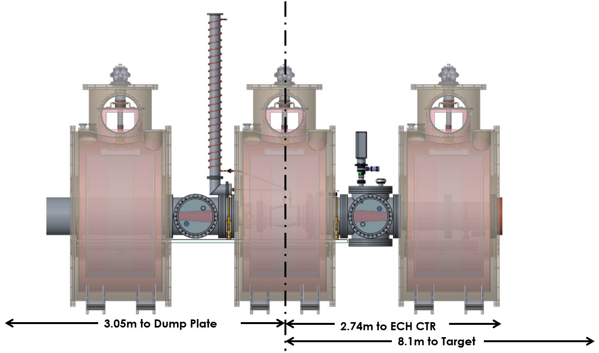

Figure 4‑5. Helicon location.

The helicon antenna has a 90 degree pitch and overall length of 245 mm. The inner window is made from Alumina (Al2O3) ceramic, and the outer window is made from quartz. The inner window is vacuum brazed to the conflat-style end flanges. Elastomer seals are avoided for vacuum boundaries in order to minimize impurities in the plasma. The antenna, outer window, and clamping rings are captured between the end flanges and sealed with elastomeric O-rings after brazing, as shown in Figure 4‑6.

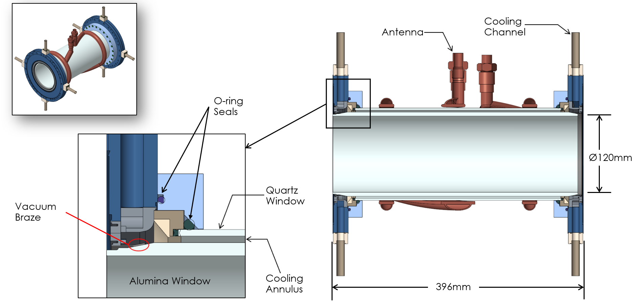

Figure 4‑6. Helicon antenna assembly.

### Helicon antenna thermal / structural analysis

A water-cooled helicon antenna with an uncooled RF window was fabricated and tested on a short-pulsed prototype machine, Proto-MPEX (Lumsdaine et al., 2019). The assembly was configured with an IR camera and a fluoroptic probe and tested at various power levels. The results of the testing were compared with FE analysis. Qualitatively, the results indicate that the heat flux on the window varies from one end of the assembly to the other with more on the ground end. Approximately 20% of the power in the antenna is assumed to be deposited in the window.

As part of the helicon antenna assembly development, FE and CFD analysis was performed for an actively cooled window design (Lumsdaine et al., 2019). The resulting design incorporates machined flanges that induce swirling in the cooling annulus, as shown in Figure 4‑7.

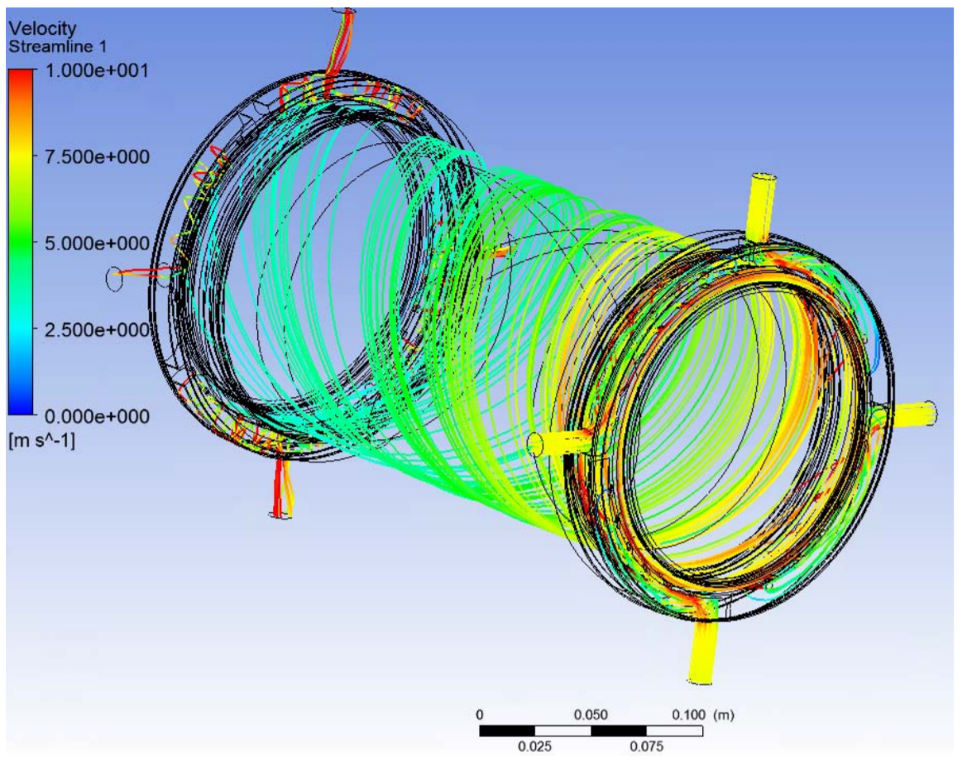

Figure 4‑7. Streamlines for design with machined flanges to induce swirl flow.

The temperature results for uniform heating and spatially varying heating are shown in Figure 4‑8 and Figure 4‑9, respectively.

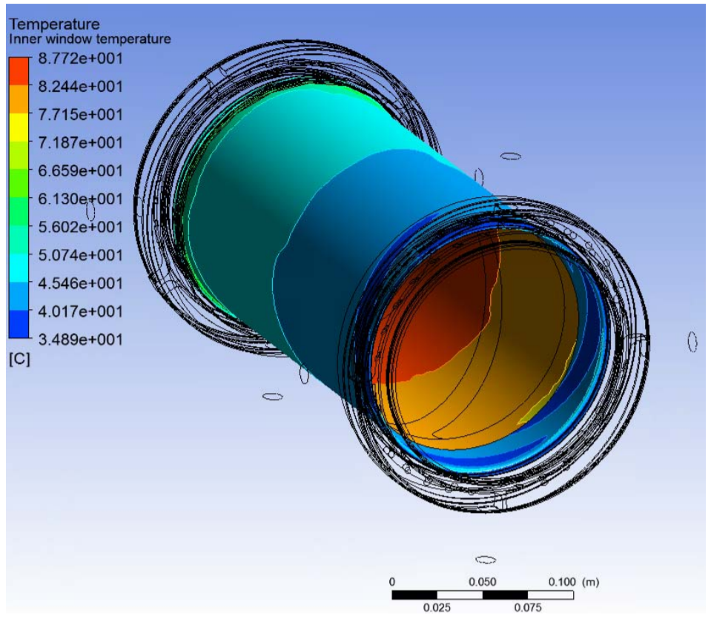

Figure 4‑8. Temperature Contours for uniform heating.

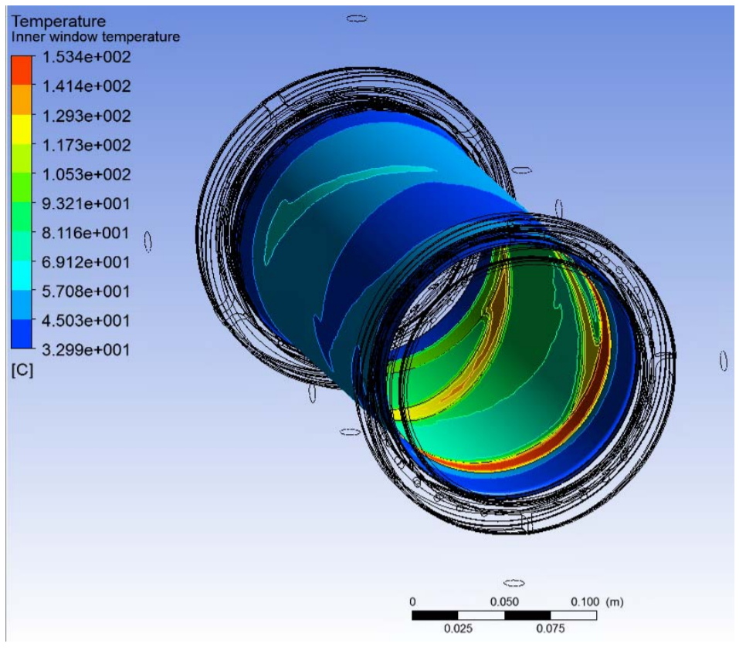

Figure 4‑9. Temperature contours for spatially heating.

Finally, the stress contour is shown in Figure 4‑10. The maximum principal stress is found to be 154 MPa, which is lower than 200 MPa material that is commercially available.

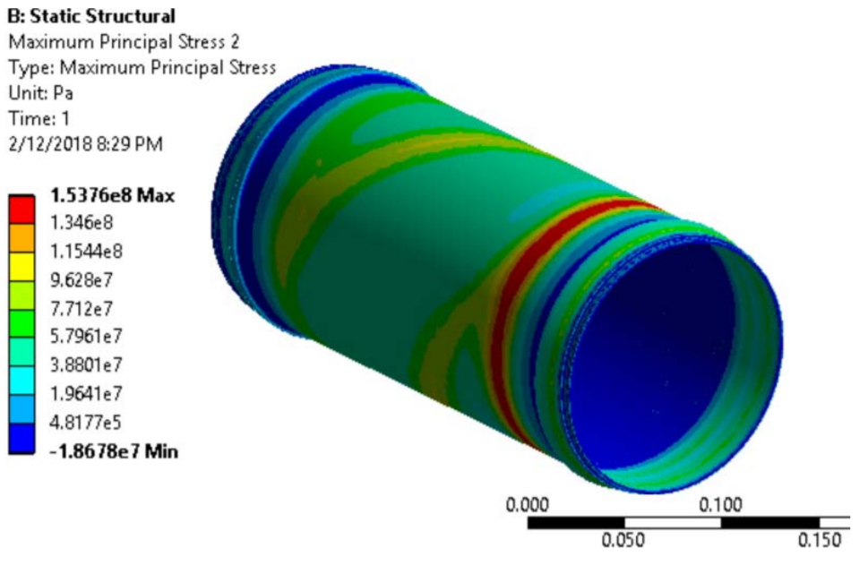

Figure 4‑10. Stress contours for spatially varying heating.

A description of the helicon antenna window development and testing in Proto-MPEX and CSDX is given in Section 3.2.5 starting on page 64. Plans are to validate FE and CFD simulations with the highest power CSDX results (10–20 kW) and extrapolate to planned MPEX power (200 kW).

## ECH heating system

### Overview

Electron heating of the plasma is essential to get into the conduction limited plasma transport regime, the underlying principle of the device. Electron Bernstein Wave heating is planned to be heating scheme, since the ordinary electromagnetic waves in the electron cyclotron range will not propagate in the envisioned density range and magnetic field range planned in MPEX. Electrostatic electron Bernstein waves (EBW) do propagate in those over dense plasmas in which the plasma frequency is larger than the electron cyclotron frequency. In the scenario for MPEX a double mode conversion from an obliquely launched O-mode via the slow branch of the X-mode to the EBW is planned, meaning EM waves in the electron cyclotron frequency domain are launched into a magnetic mirror from the low field side to the electron cyclotron resonance layer in the magnetic mirror (1.6 T) (Rapp et al., 2015).

The functional requirements for the ECH system are shown in Table 4‑3.

Table 4‑3. ECH design requirements.

|  |  |
| --- | --- |
| **Functional Requirements** | **Value** |
| Power transmitted through the ECH waveguide | 90% |
| Total Power | 400kW |
| Pressure in ECH region | 0.0133Pa  (10-4 torr) |
| Antenna pitch | 90 degrees |
| Antenna/Window lifetime | 5yrs |
| Minimum clearance | 406mm (16in) |
| Peak magnetic field upstream of ECH port for heating | 2T |
| Target magnetic field at end of ECH region | 1.5T |

### Technology requirements for all microwave heating schemes

Given the physics basis discussed in Section 3.3, basic technology considerations are discussed here. The technology requirements are prioritized based on the discussion in Section 3.3 but will allow for the possibility of all four heating schemes. O-X-B EBW is the baseline electron heating scheme, so the baseline technology requirements are focused on this heating scheme. However, the design will allow for all four possible heating schemes. The previously discussed proof-of-principle experiments are limited to 6 and 28 GHz at the maximum magnetic field of ~ 1.9 T, but the design for MPEX will allow for choices of gyrotron frequency, magnetic field, millimeter-wave launcher design, and neutral pressure control. Electron heating needs to satisfy the key MPEX performance requirements from Table 2‑5. For this discussion, the more important criteria are the desired density at the millimeter-wave source of ~ 4–6 × 1019 m-3 and the magnetic field at the target of ~ 1 T. In principle, O-X-B EBW heating does not have a maximum density requirement, but there is a minimum density requirement for the O-mode cutoff to exist so that the O-X mode conversion process can occur. Under-dense heating schemes such as Upper-Hybrid (UH) do have a maximum density requirement at cutoffs. Due to magnetic field trapping discussed in Section 3.3.5, the magnetic field at the source is desired to be higher than the magnetic field at the target. For a range of gyrotron frequencies, the key density and magnetic field requirements and cutoffs and resonances are shown in Table 4‑4.

Table 4‑4. Key density and magnetic field requirements for various cutoffs and resonances.

|  |  |  |  |  |  |
| --- | --- | --- | --- | --- | --- |
| **Frequency** | **28 GHz** | **53 GHz** | **70 GHz** | **90 GHz** | **105 GHz** |
| O-mode cutoffs | 9.6×1018 | 3.5×1019 | 6×1019 | 1×1020 | 1.36×1020 |
| 2nd harmonic resonance | 0.5 T | 0.95 T | 1.25 T | 1.6 T | 1.875 T |
| Fundamental resonance | 1 T | 1.9 T | 2.5 T | 3.2 T | 3.75 T |
| UH density at 2nd harmonic | 7.3×1018 | 2.5×1019 | 4.5×1019 | 7.5×1019 | 1.0×1020 |
| X-cutoff at 2nd harmonic | 5×1018 | 2×1019 | 3×1019 | 5×1019 | 6×1019 |

Based on the Proto-MPEX results for O-X-EBW heating in Figure 3‑74, 2nd harmonic EBW is preferred to other harmonics. To satisfy the minimum density requirement for O-X-B EBW, the achievable density must be greater than the O-mode cutoff density. Measured plasma densities at the millimeter-wave source with helicon-only operation on Proto-MPEX is shown by the black symbols in Figure 4‑11. The applicability of O-X-EBW at various frequencies is shown by the shaded boxes. The minimum density limit is shown at the O-mode cutoff. The magnetic field limits are ±20% of the 2nd harmonic resonance based on the core heat flux results in Figure 3‑74. Based on the intersection of the experimental values for helicon-only operation in black symbols and the shaded boxes, achievable helicon densities are possible to satisfy the minimum density requirement at 2nd harmonic heating for 28, 50, and 70 GHz but not for 90 and 105 GHz. For the 2nd harmonic resonance to be higher than 1 T at the source requires that the gyrotron frequency be greater than 56 GHz. These two requirements imply that the gyrotron frequency should be approximately 70 GHz for O-X-EBW heating, which will give a minimum density of approximately 6x1019 m-3 at the source location.

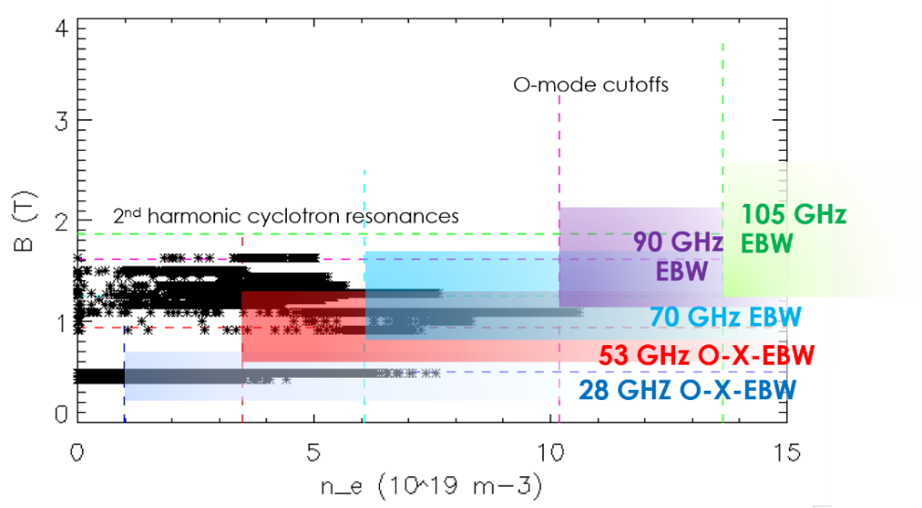

Figure 4‑11. Regions of applicability for O-X-B EBW heating at different frequencies for various density and magnetic field ranges on MPEX.

The 70 GHz choice is also consistent with UH heating. At 1.25 T, the UH resonance density is ~ 4.5×1019 m-3, consistent with the 4–6×1019 m-3 requirement for density at the millimeter-wave source. The 70 GHz source is however not consistent with 2nd harmonic X-mode heating since the cutoff density is 3×1019 m-3 at 70 GHz and less than the required source density. A higher frequency is required so that the X-mode cutoff density at the 2nd harmonic resonance is approximately 4–6×1019 m-3. The 105 GHz would be a preferred frequency for 2nd harmonic X-mode heating. For whistler launch, a lower frequency is preferred to reduce the magnetic field requirement at the fundamental resonance. This is approximately 2.5 T at 70 GHz operation. MPEX is planned to have a maximum magnetic field to be approximately 2.5 T at the millimeter-wave source, so 70 GHz is therefore the preferred gyrotron frequency for three of the four heating schemes and the preferred option for MPEX. The 105 GHz option can be incorporated either with an additional 105 GHz gyrotron or a gyrotron with dual-frequency capability at 70 and 105 GHz. A gyrotron vendor has indicated that they are willing to design and manufacture a steady-state 300 kW gyrotron with dual-frequency capability at 70 and 105 GHz. Power supply vendors for these gyrotrons have been identified.

The 1.25 T capability at the ECH source region is the baseline magnetic field criteria. The 2.5 T maximum magnetic field capability at the millimeter wave source will also satisfy the maximum magnetic field requirement for all four electron heating schemes based on their absorption at the fundamental, second harmonic, and/or UH resonances at 70 or 105 GHz. The axial magnetic field profile requirements due to magnetic mirror trapping of fast electrons is further discussed in Section 3.3.5.

For both gyrotron frequencies, corrugated waveguides (Doane, 1985) are envisioned as the transmission line to minimize the transmission line losses. Corrugated waveguide HE11 mode at these millimeter wave frequencies is widely known to be low loss, have high power-handling capability and relatively large frequency bandwidths, and can easily be used with quasi-optical components such as miter bends. Corrugated waveguide components include straight sections, miter bends, polarizing miter bends, DC breaks, vacuum windows, etc. Some of the waveguide components will need to be water cooled to satisfy the steady-state requirement; an example water-cooled miter bend for the ITER ECH project is shown in Figure 4‑12(a). Copper will likely be used for many of the high-heat-flux components due to its high thermal and electrical conductivity. A longer discussion on water cooling is in Section 7.6. The vacuum window will likely be a low-cost CVD diamond disk. The design of many of these components will likely be leveraged from corrugated waveguide development for the ITER ECH project (Anderson et al., 2018). The large frequency bandwidth of the HE11 mode will allow same transmission line to be used for 70 and 105 GHz operation.

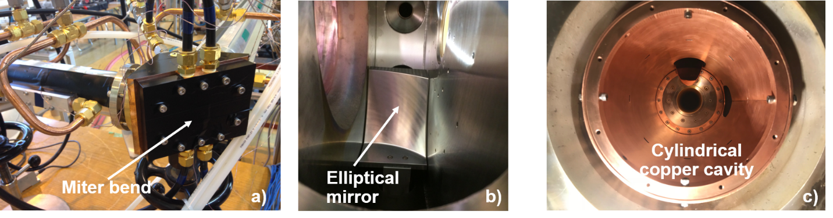

Figure 4‑12. (a) An example corrugated waveguide miter bend; (b) an example elliptical mirror for the 28 GHz system on Proto-MPEX; (c) an example cylindrical copper cavity for the 105 GHz system on Proto‑MPEX.

The millimeter-wave launcher will likely use an elliptical mirror and/or cylindrical copper cavity fed from an open-end corrugated waveguide on the low field side of the magnetic mirror. Examples of the mirror and cavity on the Proto-MPEX experiment are shown in Figure 4‑12(b) and Figure 4‑12(c), respectively. The choice of the millimeter-wave launcher will depend on the electron heating scheme. An elliptical mirror will improve the focusing of the beam; GENRAY-C simulations indicate that O-X-B EBW heating may benefit from focusing (Diem et al., 2018). A cylindrical copper cavity, on the other hand, may be more useful to reduce multiple bounce losses in a low-single-pass absorption such as 2nd harmonic X-mode heating. There will be enough flexibility in the MPEX design so that both mirror and cavity options can be achieved as well as possible launch from the high field side of the magnetic mirror for whistler heating.

As shown in Figure 3‑71., neutral pressure control at the electron heating region is important to maximize the electron heating. Skimmers, vacuum pumps, and differential pumping are required to reduce the neutral pressure << 0.1 Pa in the electron heating section. This has been demonstrated on Proto-MPEX (Caneses et al., 2018) and is discussed in further detail in Section 3.2.3.

The recommendations of this section are summarized here:

70 GHz is the preferred gyrotron frequency for O-X-B EBW electron heating. 105 GHz is an additional option for the gyrotron frequency as an additional option.

1.25 T is the baseline magnetic field at the ECH region for O-X-B EBW heating at 70 GHz. 2.5 T is approximately the maximum desired magnetic field at the millimeter wave source location. The desired axial magnetic field profile shaping is discussed in Section 3.3.5.

Corrugated waveguides will be used as the transmission line. Open-end corrugated waveguide launch into focusing mirrors and/or cylindrical cavity will be used for the transmission line and launch geometry of the electron heating system.

Neutral pressure needs to be kept approximately at 0.01 Pa by using differential pumping techniques.

### ECH chamber mechanical description

The ECH vacuum chamber is located between the helicon and ICH antennas, as shown in Figure 4‑13, and approximately 5.3 m from the target location. There is a nominal 6 in. gap between the ECH and ICH magnets for utilities to be routed from the axial chambers.

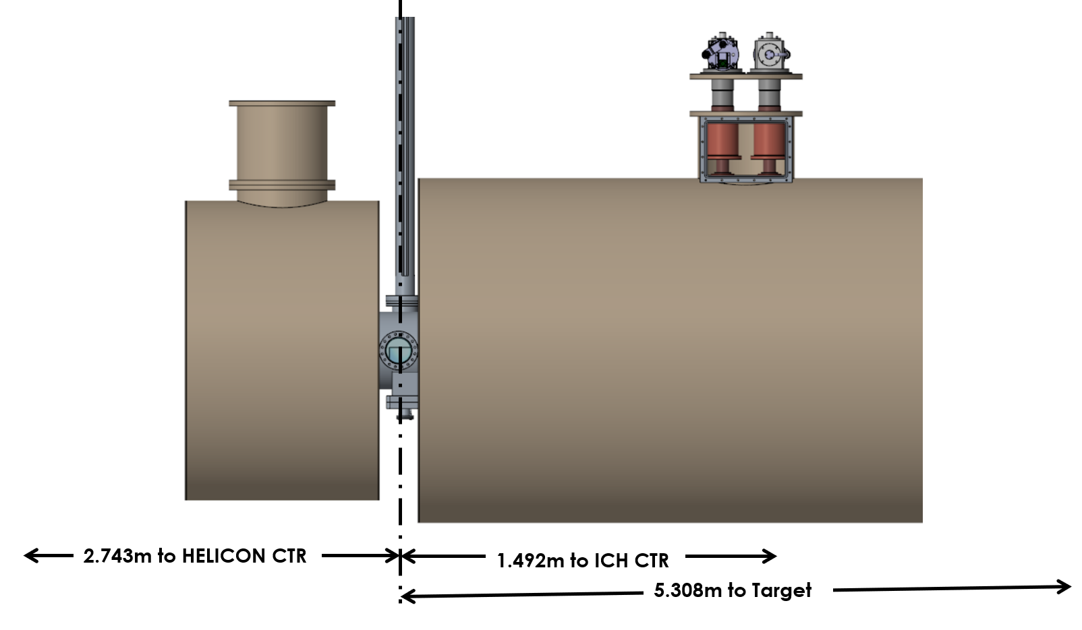

Figure 4‑13. ECH location.

The baseline design requirement is to accommodate one ECH waveguide; however, the current design incorporates the flexibility for two ECH waveguides and mirrors. The waveguide ports are located 25.4 mm (1 in.) “downstream” of the center of the gap between the ECH and ICH magnets and 82.04 mm (3.23 in.) to either side of the centerline of the vacuum chamber, as shown in Figure 4‑14.

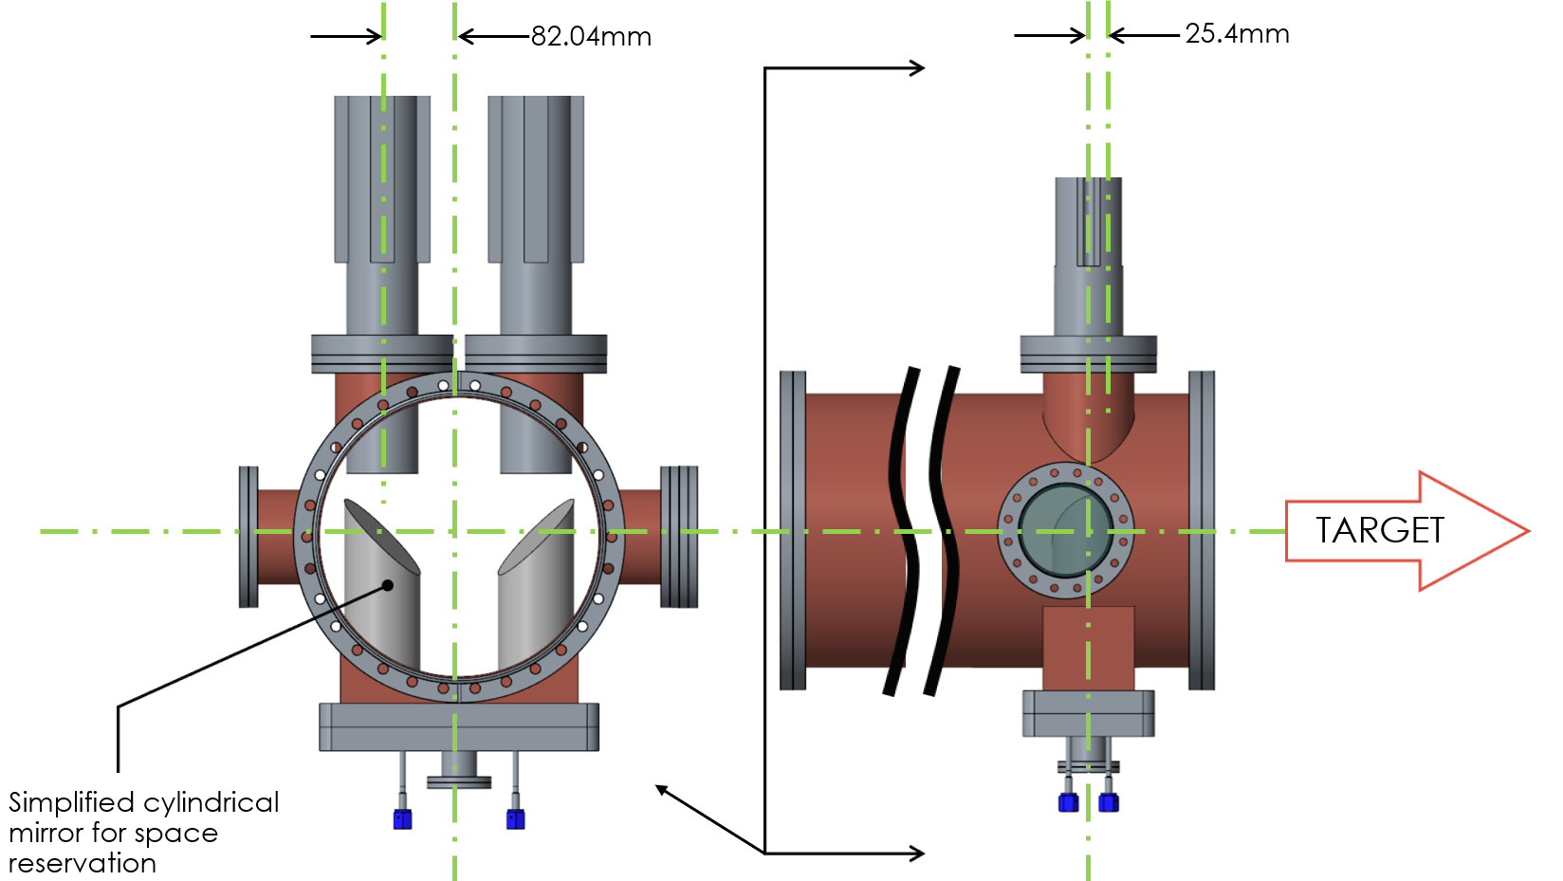

Figure 4‑14. Dimensional layout of the ECH heating system.

## ICH heating system

### Overview

Direct ion heating will be used to increase ion energies in MPEX. This will be accomplished using ion cyclotron heating (ICH). In MPEX, power will be coupled into a helicon generated plasma through two or three ICH antennas with 180-degree pitch similar to the helicon antenna but opposite in helicity. The functional requirements for the ICH system are shown in Table 4‑5.

Table 4‑5. Functional requirements for the ICH system.

|  |  |
| --- | --- |
| **Functional Requirements** | **Value** |
| Window loss tangent | <1×10-4 |
| Total power into antenna(s) | 400 kW |
| Antenna length | 300 mm |
| Antenna diameter | >112 mm |
| Voltage/standoff | 20 kV/30 mm |
| Transmission line | 3–1/8 in. water cooled |
| Outer diameter of antenna mounting flange | 150 mm (6 in.) |
| Clearance for RF coaxial elbow | 102 mm (4 in.) |
| Transmission line standoff | 20 mm |
| Magnetic field at antenna | 1.5T |
| Target magnetic field along central axis of 60 cm antennae length | 1.45 T |
| Maximum magnetic field along central axis of 60 cm antennae length = 1.55 T | 1.55T |
| Minimum magnetic field along central axis of 60 cm antennae length | 1.35T |
| Length of normalization beach area downstream of antennae | 5 cm |
| Target magnet field along central axis of beach normalization area | 1.25 T |
| Neutral pressure | 0.0133 Pa  (10-4 torr) |

### Engineering considerations

###### Antenna Design

As mentioned in Section 3.4, the antennas chosen for ion cyclotron heating are half-turn dual-helix designs. The helicity is that of a “left-hand” antenna (Chen, 1996), coupling to waves that are left-hand circularly polarized, rotating in the direction of the ion gyromotion. The present design for these antennas is shown in Figure 3‑93 in Section 3.4.2. Use of a pair of antennas has been chosen to reduce the power density under the antenna and to reduce currents and voltages on each antenna by increasing the antenna loading, which was modeled in that section. The antennas are water cooled, with water introduced through the center of the inner conductor in the feed coaxial transmission line, which also cools the inner conductor itself. The water is returned through a trace cooling line that cools the outer conductor of the coax. The antenna, window, and cooling lines are all shown in Figure 3‑93.

As in the case of the helicon antenna, the power is transmitted through a coaxial cylindrical vacuum window, with the inner cylinder fabricated from alumina and the outer cylinder from quartz, with a gap between them in which cooling water flows. Following the helicon window design, the inner window will utilize a metal-to-ceramic seal, while the outer one will have an elastomer one. The present geometry of the antenna and window is provided in Table 4‑6. This design may be changed slightly in response to further RF and thermal modeling to be conducted as part of the Preliminary Design process. The inner diameter of the inner window is chosen as a compromise between the reduction in antenna loading that occurs as the radial gap between the antenna the plasma is increased. and the reduction in the heat load obtained as the radial gap between the inner window surface and plasma is increased. These issues are further discussed in later sub-sections.

Table 4‑6. ICH antenna design parameters.

|  |  |
| --- | --- |
| **Parameter** | **Value** |
| Number of antennas | 2 |
| Antenna length | 30 cm |
| Axial gap between antennas | 5 cm |
| Axial gap between antenna ends and neighboring flanges | 2.5 cm |
| Antenna ID | 8.4 cm |
| Outer window OD | 7.4 cm |
| Outer window ID | 6.8 cm |
| Inner window OD | 6.2 cm |
| Inner window ID | 5.6 cm |

There is presently an external ICH antenna on Proto-MPEX that has been operated at net powers up to ~30 kW and pulse lengths up to 0.3 s, utilizing an uncooled alumina window. It has been operated using a very low duty cycle < 1%. Loading data from that antenna has been previously discussed. A drawing and photos of the Proto-MPEX antenna are included in Figure 4‑15. It can be noted that for the maximum loading case (corresponding to the point at |B| = 0.97 T in Figure 3‑102b), the plasma radius is 1.5 cm. The inner radius of the antenna is 4.5 cm, so the gap between the antenna inner radius and the plasma outer radius is 3 cm for this case. This is larger than the planned gap for the MPEX design of only 2.4 cm.

The MPEX antenna is the same length as, and only slightly smaller in radius than, the Proto-MPEX antenna (4.2 cm vs. 4.5 cm). For use in circuit models to be discussed below, it is very accurate to model the MPEX antenna based on measurements of the electrical characteristics of the Proto-MPEX antenna. This antenna can be accurately modeled as a lossless stub that is terminated in a purely resistive load. The characteristic impedance, electrical length, and terminating resistance of the stub with no plasma can be determined by using these quantities as fitting parameters to match the complex impedance vs. frequency of the stub to measured values for the Proto-MPEX antenna. The resistance is small compared to the value with plasma and so is not important, but even it can be fit accurately, the results of which are shown in Figure 4‑16(a) and (b). The input impedance of the antenna with a plasma load at any frequency can then be modeled using this representation and changing the resistance of the termination.

|  |  |
| --- | --- |
|  |  |
|  |  |
| Figure 4‑15. Proto-MPEX external ICH antenna: (a) drawing of antenna, leads, and coaxial feed, (b) side view of antenna and leads, (c) photo of antenna before installation, (d) photo of antenna during installation including alumina vacuum window and vacuum sealing flange. | |

|  |  |
| --- | --- |
|  |  |
| Figure 4‑16. Proto-MPEX ICH antenna impedance measurement vs. frequency and fit to model of antenna as transmission line terminated with a resistive impedance. | |

###### Matching and feed network design

The matching configuration for the ICH system is shown in Figure 4‑17. It allows two antennas to be driven by a single transmitter, with 90° relative phasing, over the 6–8 MHz frequency range. Each antenna will be matched using a two-capacitor “L-match” very similar to the one presently in use on Proto-MPEX, photos and a schematic of which are provided in Figure 4‑18. The capacitance vs. loading required, taking into account the estimated length of transmission line between the antenna and matchbox, is shown in Figure 4‑19 for frequencies 6 MHz and 8 MHz. The capacitors chosen, based on the required range of capacitances and current and voltage requirements discussed in the next section, are the COMET CVMA-450DW/50 and CVMA-250DW/50. Due to the mutual inductance between the antennas, it will be necessary to have a decoupler between the two feed lines connecting the matchboxes to the antennas, as shown in the figure. The decoupler consists simply of a capacitor connected in parallel via a tee to a transmission line that is connected to the two feed lines. The capacitor setting controls the mutual impedance cancellation and is “set and forget”; it does not have to be adjusted during operation. The matching capacitors are adjusted automatically during operation based on signals obtained from the directional couplers located on both sides of the matchboxes. Signals obtained from directional couplers located in the output lines from the matching networks are not commonly used for this purpose, but when used in combination with those from the input side, they greatly improve the likelihood of match convergence from any capacitor starting location and after any type of transient. Further design of the feed and matching circuit, including development of automatic matching controls, will be conducted during the preliminary design phase. The antenna feed lines from the matching networks to the antenna can be seen in Figure 3‑93. Water is introduced into the matchbox and, as mentioned previously, travels through the hollow center of the inner conductor into the antenna, returning from the antenna to trace cooling lines surrounding the outer conductor.

|  |
| --- |
|  |
| Figure 4‑17. Feed and matching network configuration for the Proto-MPEX ICH system. |

|  |  |
| --- | --- |
|  |  |
|  | |
| Figure 4‑18. Matchbox for Proto-MPEX ICH system: (a) matchbox drawing, (b) schematic of matchbox, (c) photo of matchbox. | |

|  |  |  |
| --- | --- | --- |
|  |  | |
| Figure 4‑19. Capacitances required to match vs. loading resistance at (a) 6 MHz and (b) 8 MHz. | |

###### Antenna loading and power limits

The plasma loading for the MPEX ion cyclotron antennas has been estimated using the ANTENA code. The density profile that was used is based on the one that most accurately fit the values measured experimentally on Proto-MPEX, as shown in Figure 3‑102b. The plasma radius is determined by mapping of the largest limited flux tube based on the helicon window ID, the nominal value of |B| at the helicon window of 0.12 T, and the nominal value at the ICH antenna of 1.2 T. This can be calculated approximately as $r_{helicon window} ×{\left(B_{helicon}/B_{ICH}\right)}^{1/2}=5.7 \text{cm} ×{\left(.12/1.2\right)}^{1/2}=1.8 \text{cm}$. It is confirmed by the mapping shown in Figure 4‑20. Based on the benchmarking results for ANTENA shown in Figure 3‑102b, an external density value that is 2% of the central value is used in the calculation. It is assumed to extend out to the window ID. Figure 4‑21 shows plasma loading for two different antenna lengths as a function of $n_{e}$. It can be seen that the 30 cm long antenna is indeed the better choice for most density values. For = 3 ´ 1019 m-3, the loading *Rp* ~ 0.85 Ω. The low value for two antennas is partly due to the fact that the vacuum window has a significantly smaller inner diameter than is the case for the Proto-MPEX one due to the need to incorporate water cooling. Note that the ANTENA model does not include the window itself or the water dielectric in the model, but these should have a small effect on loading.

|  |
| --- |
|  |
| Figure 4‑20. Top: example flux tubes for MPEX; bottom: enlargement of region where ICH antennas are located. |

There are several factors that limit the power that can be coupled through the antenna. These are the electric field between the antenna current straps and the vacuum window, the voltage in the coaxial transmission line between inner and outer conductor, the voltage across the matching and decoupling capacitors, and the current through the matching and decoupling capacitors.

|  |
| --- |
|  |
| Figure 4‑21. Resistive loading vs. $n_{e}$ for antenna lengths of 25 cm and 30 cm calculated using ANTENA. |

The power limits due to these various parameters are determined as follows.

Regarding the limit due to the electric field at the antenna, the electric field present for a given voltage is estimated here using a 2D COMSOL model. Figure 4‑22 shows results. The maximum electric field is 1800 V/m for a voltage of determined at a location slightly above the antenna of 5.2 V. The maximum electric field at the antenna is then very simply given by

$\left|E_{\max{ant}}\right|=\left|E_{COMSOL}\right|\left(\frac{V}{V_{COMSOL }}\right)$, (4‑1)

where the voltage V is calculated using the circuit model of the antenna and feed line used to determine the capacitor settings given in Figure 4‑19, and the power limit due to the electric field *Plim E* is given by the expression

$P_{\text{lim}⁡E}=P{\left(\frac{\left|E_{lim}\right|}{\left|E_{\max{ant}}\right|}\right)}^{2}$, (4‑2)

where *Elim* is the electric field limit to avoid breakdown, which in ambient air is taken to be 2.7 kV/mm.

|  |
| --- |
|  |
| Figure 4‑22. 2D electric field profiles calculated using COMSOL. |

For the coaxial line, the maximum electric field is obtained from the maximum voltage on the line. This is determined based on an assumed power and resistive loading, using the same circuit model. An example plot showing the voltage and current from the grounded end of the antenna to the matchbox, for resistive loading *Rp* = 0.85 Ω, is shown in Figure 4‑23. The maximum voltage for a 3-1/8 in. transmission line can be taken to be the value corresponding to a maximum value of |E|=1.5 kV/mm. This is significantly lower than the ambient air limit and is obtained from experience with coaxial lines. The corresponding voltage is *Vlim* coax = 20.7 kV peak. For the assumed power *P* and with *Vmax* determined from a model such as shown in Figure 4‑23, the power limit due to the coax voltage limit is then simply given by

$P_{lim⁡coax}=P{\left(\frac{V_{lim}}{V_{max}}\right)}^{2}$. (4‑3)

The voltage limit for the capacitor is equal to its peak working voltage. For the capacitors listed in the previous section, this value is given by *Vlim cap*= 30 kV. The current limit is set by the shunt capacitor, since it sees essentially the full circulating current that passes through the antenna, while the series capacitor does not. For the listed capacitor, its limit is given by *Ilim cap* = 419 \* (13.56 MHz / f(MHz))1/2 A rms, assuming the capacitor is water cooled, with a 12 liter/minute flow rate. These limits are then simply calculated as

$P_{\lim{cap} V}=P{\left(\frac{V_{lim⁡cap}}{V_{cap}}\right)}^{2}$, (4‑4)

$P_{\lim{cap }I}=P{\left(\frac{I_{lim⁡cap}}{I_{cap}}\right)}^{2}$, (4‑5)

where *Vcap* and *Icap*can be calculated from a circuit model.The values for these parameters as a function of *Rp* are provided in Figure 4‑24.

|  |
| --- |
|  |
| Figure 4‑23. Voltage and current on transmission line from shorted end of antenna to matchbox. |

The summary for all of these power limits as a function of *Rp* for a frequency of 7.5 MHz is given in Figure 4‑25. Of course, the total power limit is the lowest of all these limits.

It can be seen that for the loading value estimated above from ANTENA of 0.85 Ω, the overall power limit (the calculation is for each antenna) is very low for the assumed gap between the antenna and vacuum window in the COMSOL model of 2 mm. Furthermore, the limiting factors are the electric field at the antenna. However, if it is assumed that |E| is proportional to the gap, and if it is increased from 2 mm to 5 mm, then the power limit due to |E| at the antenna becomes >> 200 kW. Power is then limited by the transmission line voltage. This limit can be increased very significantly by filling the lines with SF6. Transmission lines are routinely pressurized up to 100 kPa gauge. It can be seen from Figure 4‑26 (Moretti, 2005), which pertains to voltages at RF and microwave frequencies, that even at atmospheric pressure, the power handling increases by an order of magnitude, while increasing the pressure up to even 50 kPa gauge increases power handling by a factor of 20. If this approach is used on MPEX, then the voltage limit on the capacitor becomes the limiting factor, and it is ~ 150 kW for these conditions. It is not possible to increase this limit easily. It may be possible to obtain capacitors with somewhat increased peak working voltage. This would be the only possibility.

|  |  |
| --- | --- |
|  |  |
| Figure 4‑24. Voltage and current at the matching capacitors as a function of resistive loading. | |

|  |  |
| --- | --- |
|  | Figure 4‑25. Power limits due to component electric field, voltage, and current limits as a function of resistive loading. Dashed black line is predicted loading for ne = 3 ´ 1019 m-3. |

If it is not possible to use insulating gas, or if it is desired to go to even higher power levels, then a further increase in plasma loading is required. This can be obtained by using a smaller diameter antenna, which could lead to excessive thermal loading on the window. The fallback option would be to add a third antenna, since the loading per antenna will increase approximately as n2, which will dominate over any loss of loading due to the use of shorter antennas needed to avoid increasing the overall length of the heating section. The shorter antennas would also favorably couple to a higher power density.

|  |  |
| --- | --- |
|  | Figure 4‑26. Peak power in transmission line as function of gas pressure for air, N2, and SF6. Source: A. Moretti (2005). |

###### Heat load on the vacuum window

The radial gap between the plasma and the window eliminates any direct convective heat load to the window due to the limited plasma traveling along magnetic field lines. There are several other sources of heat load to the window, however. One possible source is charge exchange. The mean free path for the ions heated by ICH is greater than the plasma radius, so that energetic charge exchange ions created in the core plasma, with a large perpendicular velocity after passing through the ion cyclotron resonance, can easily reach the wall. However, these losses will be limited due to the low neutral pressure planned for this region of ≤ .01 Pa. In addition, the resonance will be located at a position downstream from the window, and so this axial peaking will not occur there. It is necessary to ensure this by requiring operation with a sufficiently high magnetic field under the window to avoid any resonances there. It is particularly important not to have one located in the region of the ceramic to metal seal, which is unlikely to be able to withstand large thermal stresses.

Another possible source of window heating is due to impact on the window of a non-limited “external” plasma, including possibly hot electrons, that can be produced by the electron heating system or the ICH itself. The ICH antenna can not only produce such a plasma, but also heat it, through wave interactions discussed in the previous section, as well as by direct inductive and/or capacitive coupling to the RF near fields. Capacitive coupling has been seen in studies carried out on the CSDX device at UCSD (3.2.5) on the helicon antenna. It can be eliminated through the use of a Faraday shield. The possibility of including one in the design will be considered in the next design phase. If the shield is located on the outside of the window, it will limit the antenna voltage to ~ 16 kV or less. The loading will also be reduced by ~ 20%, increasing the voltage at a given power level by 12%. The ID of the antenna will have to be increased, leading to further losses in loading. An advantage is that it can be fabricated from copper and just cooled at the edges. If a Faraday shield is instead placed inside the window, it will allow a higher antenna voltage limit but will have to be heavily cooled, requiring it to be thicker. It will also be subject to sputtering and so likely will have to be fabricated from tungsten, resulting in additional RF losses. It will still suffer the ~20% loading reduction due to its finite transparency, and possibly more if the same surface-to-plasma gap is maintained. Regarding the possible heat load on the window from ECH-generated plasma and hot electrons, it may be advisable to add some form of “limiter” between the ECH and ICH sections at large radius to eliminate this. It could also help reduce the neutral pressure in the region further. The low neutral pressure in the ICH region should limit heat transfer to the window through any external RF-generated plasma in comparison to the helicon window.

A final source of heating is simply radial ion transport from the limited plasma, which can be enhanced by RF effects such as the creation of convective cells. Power deposition as a result of such modified radial transport in the antenna region is difficult to model. At this time, it is not possible to provide quantitative estimates for this or the other effects (other than charge exchange, discussed in the next section). There is visual access for IR measurements on portions of the ICH vacuum window on Proto-MPEX, and further information on heat flux to the window from all sources will be obtained through measurements to be made there. As long as the ion cyclotron resonance is located outside the window, and if a local limiter is provided to prevent any ECH-produced external plasma from reaching it, it is expected that the maximum and average surface heat flux on the window will be significantly smaller than for the helicon window. The associated thermal stresses will be lower than those for the helicon window both for this reason and because the reduced thickness of the alumina window (3 mm) will lead to lower temperatures on the ceramic inner surface.

###### Charge exchange heat flux estimate

An estimate has been made of the localized power flux at the axial location of the ion cyclotron resonance(s) due to charge exchange. For this worst-case assumption, it is assumed that the resonance is a turning point for all ions so that the hot neutrals travel radially after undergoing charge exchange. The charge exchange power flux is given by the equation

$Q_{cx}=n_{0}{〈σv〉}_{cx}T_{i}\int_{0}^{r_{w}}{n_{e}\left(r\right)rdr/r_{w}}$, (4‑6)

where ${〈σv〉}_{cx}$ is the volumetric charge exchange rate for D ions on $D_{2}$, obtained from ADAS data, and $r_{w}$ is the radius of the inner wall of the vacuum chamber, which is assumed to be the same as that of the window (=4.2 cm). The charge exchange rate is assumed to be constant with radius, as is the neutral density $n_{0}$, assumed to be 100% $D_{2}$, and $T_{i}$. The electron density is assumed to have the radial profile shown in Figure 4‑27(a). The total charge exchange power as a function of $T_{i}$ and $n_{0}$ is shown in Figure 4‑27(b). It is obtained by integrating the power flux from Equation 3-29 over the inner wall surface, and over an axial distance of 5 cm, which is the approximate length of the flat |B| region at which the ion cyclotron resonance is located. It can be seen from the figure why it is necessary to have low neutral pressure. For the highest pressure case shown, there can be appreciable power lost through charge exchange if the ion temperature is increased to levels in the 30 eV range. More important is the concentrated charge exchange power flux, which for this upper bound estimate can reach > 100 kW/m2 at that pressure, as is shown in Figure 4‑27(c). The mean free path for energetic neutrals produced by charge exchange over all energies of interest is on the order of or greater than the plasma radius of 1.8 cm, so that nearly all those created will reach the wall. Note that this is not a heat flux calculation and that some of the energy will be reflected at the wall.

###### ICH power losses at other locations

As discussed previously, there are possibilities for concentrated power losses at the window due to capacitive and inductive coupling by the antenna that generates an external plasma. There are also possibilities for such losses in the region of the ICH resonance. External plasma that does not map to the target can produce increased convective losses at the locations where field lines passing through it intersects with other material surfaces. It is also possible for antenna near fields to induce wall currents, leading to some dissipation. These losses, together with those related to currents in the antenna, transmission line, and matching network, are responsible for “vacuum loading” and can dissipate up to 10% of the input power in total. Aside from these locations, and of course at the target and dump plate, it is not expected that the ICH power will be deposited in concentrated form at any other location, and for the present time it is assumed that all remaining coupled power will be deposited evenly throughout the machine.

|  |  |
| --- | --- |
|  |  |
| Figure 4‑27. (a) Radial density profile used to calculate charge exchange power, (b) charge exchange power as function of *Ti* and neutral pressure, (c) power flux as function of *Ti* and neutral pressure. |  |

###### Power scaling

At the present time, the scaling of the absorbed power in the plasma with ICH power has been determined only through experiment. For all the cases observed, the scaling of the heat flux on the target, assumed to be proportional to the absorbed power, has been seen to be linearly related to the ICH net power. Since the highest power achieved is only~ 30 kW, predicting the level of absorbed power for MPEX requires extrapolation of these results by more than an order of magnitude. As shown in the example in Figure 4‑28, the plasma density is reduced during ICH injection. Since this phenomenon is not yet well understood, it would be difficult to predict scaling at higher power based on modeling. At this point all that can be said is that it appears that the linear scaling observed between ICH net power and absorbed power at the target appears to be robust. Figure 4‑29(a) and Figure 4‑29(b) show results for experiments performed before and after a significant configuration change was made to Proto-MPEX.

|  |  |
| --- | --- |
|  | Figure 4‑28. Example of Te increase (top) and ne decrease (bottom) during ICH injection, from Thom-son Scattering measurement (Beers et al., 2018). |
|  |  |
| Figure 4‑29. (a) Scaling of central heat flux ith ICH power for heating at f = 7.5 MHz, before magnetic field configuration change, note suppressed 0; (b) central heat flux scaling with ICH power for f = 6.5 MHz, after magnetic field configuration change. | |

### Mechanical description

The ICH antennas are located between the ECH and PMI regions, as shown in Figure 4‑30, and approximately 3.8 m from the target location.

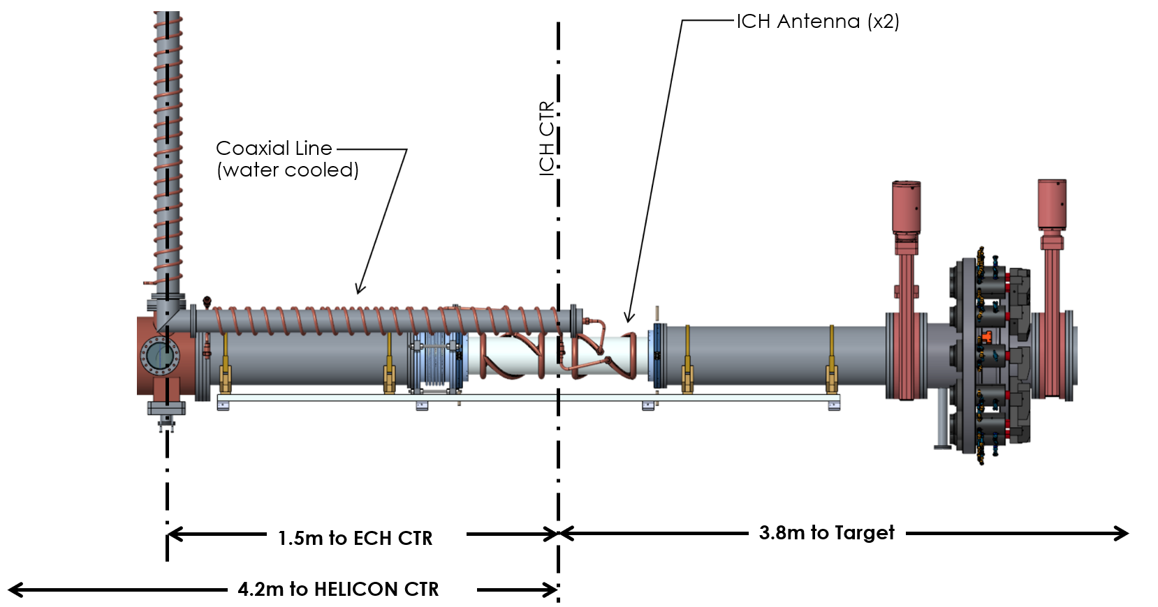

Figure 4‑30. Mechanical layout.

The ICH antennas are actively cooled in series with the coaxial transmission lines, as shown in Figure 4‑31. The ICH dual-antenna assembly consists of two RF windows. An inner alumina window and an outer quartz window. The inner window is vacuum brazed to the end flanges, while the outer window is captured and sealed with an O-ring style configuration. The RF windows are also water cooled in the annular space between the windows, as shown in Figure 4‑32.

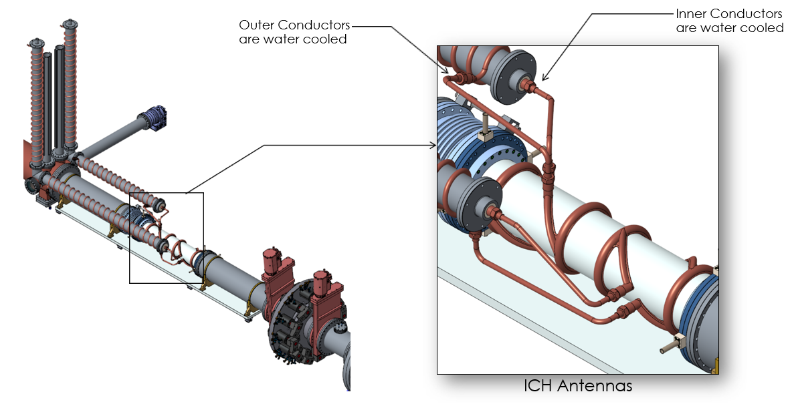

Figure 4‑31. ICH antenna configuration.

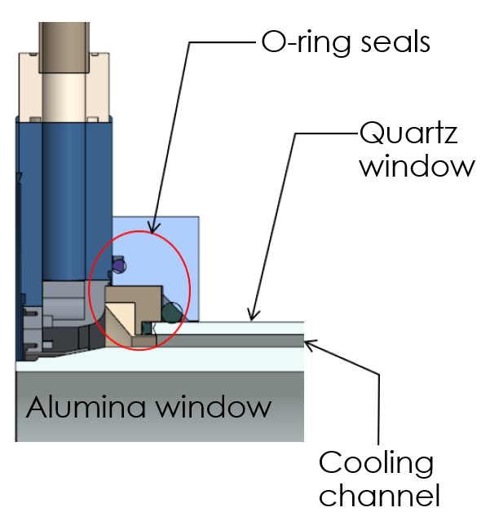

Figure 4‑32. ICH antenna RF windows.

The geometric parameters for the conceptual design of the ICH antenna are shown in Figure 4‑33. The antennas have a 180 degree pitch and are rotated 90 degrees with respect to each other. The final overall length, spacing, and antenna length will be determined during the preliminary design phase of the project.

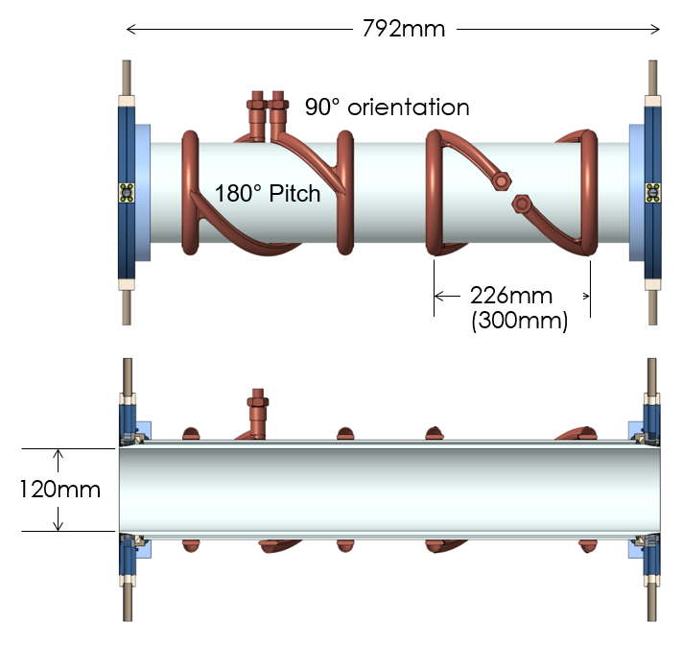

Figure 4‑33. ICH dual-antenna assembly.

## Heal load specifications

The conceptual design level heat load specifications are based on a combination of sources, including the machine performance functional requirements, experimental results from Proto-MPEX and other devices, or analysis. A description of the plasma source and heating systems in Chapter 3 includes a description of the combined heating sources in Section 3.5. Many of these specifications will need to be updated early in the next design phase. This will be done by a combination of particle and plasma modeling, microwave modeling, and Proto-MPEX experiments. The conceptual design heat load specifications are listed below by component.

### Target

The requirements on the MPEX target are based on the CD-0 statement of mission need. The peak heat flux on the target is expected to be 10 MW/m2 with a plasma diameter of 10 cm. If the profile is assumed to be Gaussian with a 10% heat flux at the edge, then the heat flux may be written as:

$q=q_{0}e^{-\left({r^{2}}/{r_{0}^{2}}\right)}$ (4‑7)

Where *q0* is the peak flux (10 MW/m2), *r* is the radial distance from the center of the heat load, and *r0* can be calculated to be 3.295 cm in order to give *q* = 1 MW/m2 at *r* = 5 cm. If this is integrated over the area, the total heat on the target is calculated to be 30.7 kW.

The requirements on the tilted target are based on the expected ultimate performance parameter of 40 MW/m2 parallel heat flux at a smaller diameter of 3.5 cm. For a tilted target, it is expected that the Gaussian profile will be stretched elliptically, and the heat flux may be written as:

$q=q_{0}e^{-\left[{x^{2}+{\left(y\sin{θ}\right)}^{2}}/{r_{0}^{2}}\right]}$ (4‑8)

Where *x* is the direction of the ellipse minor axis, *y* is the direction of the ellipse major axis, and ** is the angle of the tilted target (5 degrees for the more aggressive tilt angle). The peak heat flux for the tilted target can be calculated as:

$q_{0}=q_{∥}\sin{θ}$ (4‑9)

Which yields a *q0* of 3.486 MW/m2 for a 5 degree target. For this plasma to have 10% of the heat flux at *x* = 1.75 cm and *y* = 0, *r0* is calculated to be 1.149 cm. Integrated over the area, the total heat on the target is calculated to be 14.9 kW.

### Dump tank

For the heat loads on the dump chamber, it is assumed conservatively that the worst case would be a fully detached plasma, where the entire ion and electron flux is applied to the chamber walls. In addition B2-Eirene calculations on the ITER divertor (Kotov, V., D. Reiter, and A. S. Kukushkin. 2007) has indicated that, to first order the heat of neutral particles and radiation is equal to that of the plasma flux to the target. In the case of the PMI chamber, if the plasma load to the target of 31 kW is doubled, and uniformly distributed over the surface area (approximately 3 m2) of the PMI chamber in front of the target, a heat flux of 21 kW/m2 results. It is assumed that heat fluxes in the dump tank will be similar to this. A heat flux of 25 kW/m2 can then be conservatively assumed. In the next phase of design, modeling will be performed in order to better estimate this heat load, and its distribution over the interior of the chamber.

It should be noted that a thermal radiation calculation was performed to estimate the heat load on the PMI chamber assuming a target temperature of 3683 K (which is the melting temperature of tungsten). The total heat to the chamber was calculated to be less than 1 kW, and so is negligible in comparison to the heat load assumed above.

### Dump plate

It is assumed that the power to the dump plate will be equal to the power to the target. This is likely a conservative assumption as some of the heating systems are expected to heat preferentially towards the target. Furthermore, it is assumed that the ultimate performance parameter of 40 MW/m2 parallel heat flux at the target is achieved in a 10 cm diameter plasma (rather than the 3.5 cm requirement). This would produce a total power of 120 kW. If the dump plate is located at a position in the dump tank such that the plasma diameter is 31.6 cm (which will occur where the field is 10% of the field required for a 10 cm diameter), and the heat is distributed in a Gaussian profile, then the peak heat flux on the plate will be 3.9 MW/m2. These extremely conservative assumptions will make allowances for the possibility of a more focused plasma if the field at the dump plate is higher than this design point. In the next design phase, a more precise heat flux will be calculated. Additionally, the range of possible field strengths at the dump plate will be considered in order to examine the worst-case heat flux (for the highest field of the helicon magnet mirror ratio) and the worst case plasma diameter (for the lowest field of the helicon magnet mirror ratio).

### Helicon window and limiter

Based on experimental results in Proto-MPEX, it is anticipated that 40% of the applied power to the helicon antenna will be deposited on the window and limiter. If it is assumed that this power is divided evenly between these two components, then each will be loaded with 40 kW.

### Skimmer

In Proto-MPEX the skimmer was estimated to receive a load of 0.22 kW for a 101.3 kW power to the helicon antenna. A 1.33 kW total heat load on the skimmer is applied in order to account for the additional helicon power in MPEX (factor of 2) and the power from the other heating sources (conservatively, a factor of 3). This heat is applied primarily to the inner face (the plasma facing region) of the skimmer, with a 100 kW/m2 heat flux, with another 35 kW/m2 applied to the “flange” face of the skimmer.

### Vacuum chamber upstream of helicon

There will be a heat load where the gas is injected upstream of the helicon from hot neutrals, charge exchange and recombination in this region. Previous accounting makes the following assumptions for the 200 kW power to the helicon antenna:

* 15% to the target (30 kW)
* 15% to the dump (30 kW)
* 40% to the window and limiter (80 kW)
* 10% lost in Ohmic losses, reflection, and absorption to the cooling water

This leaves 20%, or 40 kW remaining. It is conservatively estimated that all of this power will be deposited on the chamber upstream of the helicon. Experiments will be performed in the next phase of the design in order to better quantify the expected heat that will come from this source.

### Microwave absorber

400 kW of launched EBW power is expected into MPEX. For specifying the heat loads on various components, a worst-case assumption is made here that none of the power is absorbed in the plasma. In this case, the 70 GHz microwave power will like around the vacuum vessel.

The reflectivity, $R$, of microwaves on a material can be estimated as(Serov, Parshin, and Bubnov, 2016):

$R= {\left|\frac{ε^{1/2}-1}{ε^{1/2}+1}\right|}^{2}$ (4‑10)

where $ε$ is the dielectric permittivity of a material. The permittivity is proportional to the electrical conductivity in equation (1). A simple calculation can show that the reflection losses (1- $R$) scale inversely with the square root of the conductivity and are proportional to the square root of the frequency. The reflection losses are therefore higher at higher frequency and lower electrical conductivity. The ECH chamber will be stainless steel plated with copper. The skin depth of Copper at 70 GHz is approximately microns so copper will be used as the material in this calculation. Based on Serov, Parshin, and Bubnov (2016) and using the conductivity of copper as 5.96x107 S/m, the reflectivity at 70 GHz is estimated to be 7x10-4. This implies ~1500 reflections before the ECH power is fully absorbed if the entire ECH chamber is copper. Without a high heat flux microwave absorber, the microwave power will likely bounce throughout the entire vacuum vessel. A high heat flux microwave absorber will greatly reduce the heat loads throughout the rest of the vacuum vessel.

This high heat flux microwave absorber will be located on both the dump and target side of the copper plated stainless-steel chamber. The microwave absorber will require high heat flux handing capability and low electrical conductivity so as to increase the reflection losses in equation (1). Options could include graphite, stainless steel, and/or stainless steel coated with silicon dioxide. Graphite is the preferred option due to both its low conductivity and high heat flux handling capability. While there may be some concern of chemical erosion affect the target, the low neutral pressures at the ECH region will likely prevent any graphite from reaching the target. Graphite is strongly anisotropic and has an estimated electrical conductivity of 2x105 S/m parallel to the basal plane and 3x102 S/m perpendicular to the basal plane, stainless steel has an estimated electrical conductivity of 1x106 m-3. Silicon dioxide is a great microwave absorber, but there could be some concerns that the coating may not last during long pulse operation.

Since graphite is strongly anisotropic, it is difficult to estimate the reflectivity without a full simulation that accurately captures parallel and perpendicular propagation off the graphite walls. This has not been done for this conceptual design review but is planned for the preliminary design review. There is some experimental data from fusion tokamak experiments. On the DIII-D tokamak, a reflectivity of 0.76 was measured for frequencies between 150 and 300 GHz on their graphite tiles (Austin, Ellis, and Luce, 1997). Using this reflectivity or 24% reflection loss and scaling to a lower frequency of 70 GHz on Proto-MPEX would imply approximately 5-10 reflections off graphite before total absorption. Relative to the 1500 reflections needed for copper and taken into account the relative surface area between the graphite and copper on ECH chamber of MPEX, we conservatively estimate that at most 40 out of the 400 kW will be absorbed in the copper in the ECH chamber. This would give an average heat flux of ~30 kW/m2 on the copper. The heat flux on the copper will likely be very uniform given the large number of reflections. For this conceptual design review, this analysis assumes a negligible amount of power escapes the ECH chamber and impacts the walls of other chambers. Even if a small amount of power escapes, it will likely be uniformly spread over a very large surface area due to the large number of reflections.

Assuming a scenario of all 400 kW absorbed equally on the target or dump side graphite microwave absorber would imply an average heat flux of ~ 3.6 MW/m2.

### ICH heating

The accounting of the ICH antenna is as follows:

* 25% is lost to the ICH antenna, transmission line, reflection, and water cooling (100 kW)
* 20% is lost to the ICH window (80 kW)
* 10% is lost in the ICH chamber
* 10% is transported to the helicon chamber (40 kW)
* 10% is loss in the transport region (40 kW)
* 35% is lost in the PMI chamber (140 kW).

110% of the power is accounted for to be conservative. This estimate is from analytical calculation of hot neutrals and particularly charge exchange, which dominate the losses for hot ions. Areas of high neutral pressure will therefore see strong absorbed power loads. It is assumed for the PMI chamber that the heat flux in front of the target is twice that behind the target, which yields 50 kW/m2 in front and 25 kW/m2 behind. Experiments and modeling will be performed in the preliminary design in order to better quantify this expected heat flux.

### Summary of heat load specifications

A summary of the heat load specifications is given below in Table 4‑7.

Table 4‑7. Conceptual design heat load specifications.

|  |  |  |
| --- | --- | --- |
| **Component** | **Heat load (kW)** | **Peak heat flux (kW/m2)** |
| Target (90°) | 31 | 10,000 |
| Target (5°) | 15 | 40,000 |
| Dump tank | 70 | 25 |
| Dump plate | 120 | 3,900 |
| Helicon chamber | 40 | 70 |
| Helicon window | 40 | 250 |
| Helicon limiter | 40 | 1,000 |
| ECH microwave absorber | 400 | 3,600 |
| ECH chamber | 40 | 40 |
| ICH chamber | 40 | 40 |
| ICH window | 80 | 250 |
| ICH antenna loading | 120 | 375 |
| Transport chamber | 50 | 70 |
| PMI chamber | 140 | 50 / 25 |

## References for Chapter 4

Anderson, James Paul, John Doane, Howard Grunloh, Michael Brookman, and David Su. 2018. “Wideband Polarizers, Switches and Waveguide for Overmoded Corrugated Transmission Lines.” *Fusion Engineering and Design*, December. https://doi.org/10.1016/j.fusengdes.2018.11.023.

Austin, M. E., R. F. Ellis, and T. C. Luce., 1997, *Determination of wall reflectivity for ECE frequencies in DIII-D*. No. GA-A22581; CONF-970405-2. General Atomics, San Diego, CA (United States).

Beers, C. J., R. H. Goulding, R. C. Isler, E. H. Martin, T. M. Biewer, J. F. Caneses, J. B. O. Caughman, N. Kafle, and J. Rapp. 2018. “Helicon Plasma Ion Temperature Measurements and Observed Ion Cyclotron Heating in Proto-MPEX.” *Physics of Plasmas* 25 (1): 013526. <https://doi.org/10.1063/1.4994541>

Chen, F.F. 1996. “Physics of Helicon Discharges.” *Physics of Plasmas* 3 (5): 1783–1793.

Diem, S. J., D. L. Green, R. W. Harvey, and Yu. V. Petrov. 2018. “An Electron Bernstein Wave Heating Scheme for the Proto-MPEX Linear Device.” *Physics of Plasmas* 25, 072124; doi: 10.1063/1.5033334

Doane, J. L. 1985. “Propagation and Mode Coupling in Corrugated and Smooth-Wall Circular Waveguides.” In 13:123–70. <http://adsabs.harvard.edu/abs/1985imw....13..123D>.

Kotov, V., D. Reiter, and A. S. Kukushkin. 2007. “Numerical Study of the ITER Divertor Plasma with the B2-EIRENE Code Package,” (Juel--4257). Germany.

Lumsdaine, Arnold, Meitner, Steve, Goulding, Richard, Caneses, Juan, McGinnis, Dean, Rapp, Juergen and Burnett, John. 2019. “Design and Analysis of an Actively Cooled Window for a High-Power Helicon Plasma Source,” *IEEE Transactions on Plasma Science*, vol. 47, no. 1.

Moretti, A. 2005. “Breakdown in Waveguides and Components,” ILC Snowmass Workshop, August 16, 2005, <http://www.slac.stanford.edu/econf/C0508141/proc/pres/ILCAW0216_TALK.PDF>.

Rapp, J., T.M. Biewer, T. Bigelow, J.B.O. Caughman, R. Duckworth, D. Giuliano, R. H. Goulding, D. L. Hillis, R. Howard, R. J. Ellis, T. Lessard, J. D. Lore, A. Lumsdaine, E. Martin, W. D. McGinnis, S. J. Meitner, L.W. Owen, H. Ray, G. Shaw, V. Varma. 2015. “The Material Plasma Exposure eXperiment MPEX: pre-design, development and testing of source concept,” IEEE 26th Symposium on Fusion Engineering (SOFE).

Serov, Evgeny A., Vladimir V. Parshin, and Grigoriy M. Bubnov., 2016, “Reflectivity of metals in the millimeter wavelength range at cryogenic temperatures.” *IEEE Transactions on Microwave Theory and Techniques* 64.11 3828-3838.

# MAGNET SYSTEMS

## Overview of MPEX Magnet System

The solenoid magnets perform two essential functions for MPEX. First, they provide the background magnetic fields that confine the plasma as it moves from generation to target. Second, they provide specific magnetic field profiles to enable the specific RF heating modes that are responsible for plasma generation, electron heating, and ion heating. The central, axial magnetic field values within the solenoids vary along the length of MPEX from 0.1 T to 2.5 T.

The conceptual design for the MPEX magnet system was based on the use of superconducting magnets housed in cryostats in five distinct areas: Helicon Magnets, Electron Cyclotron Heating (ECH) Magnets, Ion Cyclotron Heating (ICH) Magnets, Transport Magnets, and Target Magnets. Requirements for the magnets, as well as a design concept that meets the requirements are presented below. In addition to the magnets and cryostat, the supporting systems such as cryogenic refrigeration, quench protection, and magnet power supplies were developed for the MPEX magnet system (Figure 5‑1. and Figure 5‑2.).

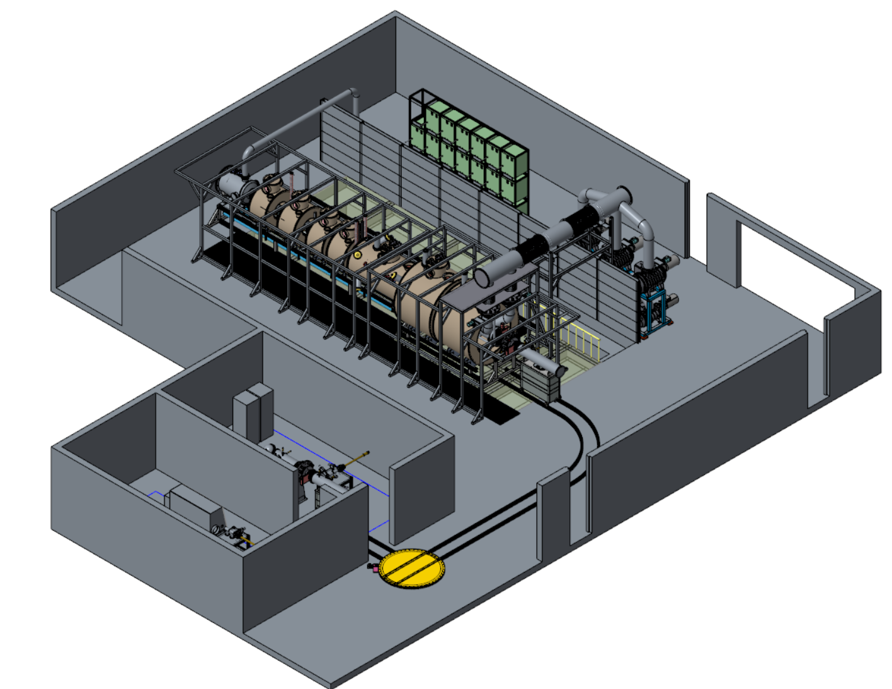

Figure 5‑1. The MPEX magnet system relative to location of other MPEX systems.

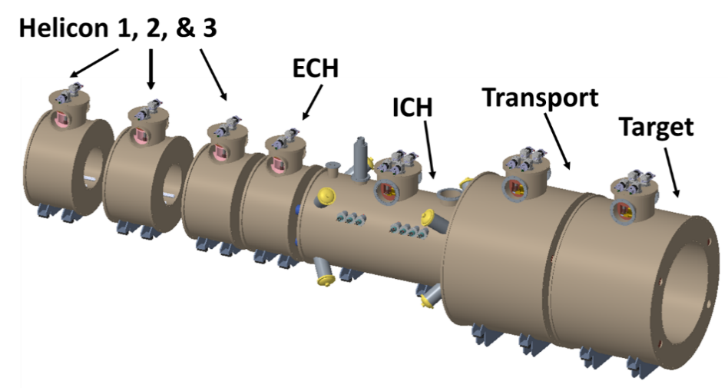

Figure 5‑2. Conceptual design MPEX magnet system with relative locations of cryostats that house superconducting magnets for each area.

## Requirements

### General requirements

The MPEX solenoid magnets and their supporting subsystems are designed to meet a complex magnetic field profile along the length of MPEX as the plasma moves from generation to target. The requirements were defined so that the deliverables would enable the RF heating modes under consideration to meet the physics goals of the experiment. The requirements are summarized below.

Because of the combination of the magnitude of the magnetic field and the clearances that are needed for each part of MPEX from plasma generation to target area, the magnet windings are solenoid magnets that are made from NbTi superconducting wires and cooled with a liquid helium (LHe) recondensing system. The ability to independently power each solenoid separately was desired to maximize flexibility of the magnetic field profile relative to different RF heating scenarios under consideration. Within this flexibility, proto-MPEX has provided the necessary information to define a baseline and maximum operating field scenario for each area of the MPEX magnets and permitted an effective conceptual design to be completed.

### Magnet operating requirements

Each solenoid magnet performed a different function relative to the section of MPEX and has a unique field profile. While the RF heating specifics were covered in the previous chapter for the helicon, ECH, and ICH, the magnetic field requirements for these areas as well as the remaining areas of MPEX are summarized below with specific requirements listed in Table 5‑1.

###### Helicon magnetic field requirements (HM)

As stated in the previous section, the helicon is the plasma source as it couples electromagnetic waves to either hydrogen or other gas species at a frequency of 13.56 MHz. This is done with helicon antenna that are attached to a water-cooled window that placed into a region with an axial magnetic field of 0.1 T with a variation of less than 5% along the antenna length. The variation is required to prevent secondary harmonics from decreasing the plasma generation frequency. In addition, the upstream and downstream axial magnetic field from the helicon antenna should have a mirror ratio of at least 6 relative to the axial magnetic field in the helicon is needed.

###### Electron Cyclotron Heating (ECH) Magnets

Based on the results from ECH heating experiments on MPEX, there are different options under consideration. The baseline configuration for ECH is the 2nd harmonic 70 GHz electron Bernstein wave heating, which requires an axial field within the ECH region of 1.25 T. This heating needs to occur in a downhill configuration so the maximum axial field should be 1.35 T and this field should be upstream of where the waveguides and windows introduce ECH into the region. For the other heating under consideration, the maximum axial field could grow to 2.5 T for 70 GHz fundamental O-mode Whistler ECH and the implications for this option at 2.5 T will be discussed in the context of the baseline design in a separate section (5.3.5).

###### Ion Cyclotron Heating (ICH) magnets

The ICH follows the ECH heating through the use of two modified Nagoya Type III antennae over a length of 60-cm that single pass damping of slow electromagnetic waves to heat the ions in the plasma. This approach is similar to others that have been successfully demonstrated for single ion species. The ICH heating required a 1.2 T axial magnetic field over the 60-cm antennae length followed by a 5-m length of axial length of 1.1 T to accommodate “beach heating” for normalized the energy of ions prior to moving toward the target. A minimum distance of 20-cm at 1.2 T was needed between these two areas.

###### Transport magnets

The magnetic field within the transport magnet region served as a bridge between the ICH region and the target region. The axial magnetic field is required to stay between 1.0 T and 1.1 T in order to avoid any disruption or losses in the plasma as it moves from the ICH to the target.

###### Target magnets

Finally, target region required an axial magnetic field region of 1.0 T over a length and within sufficient long bore to accommodate the target exchange chamber and the additional instrumentation and controls.

Table 5‑1. Magnetic field requirements for each area of MPEX magnet system.

|  |  |  |  |  |
| --- | --- | --- | --- | --- |
|  | **Maximum Axial Magnetic Field [T]** | **Minimum Axial Field**  **[T]** | **Minimum warm bore diameter**  **[m]** | **Additional requirements of note** |
| Helicon | 0.7 | 0.1 | 0.66 | Axial magnetic field of 0.1 T on center with less than 5% variation along 30.2 cm antenna length  Upstream and downstream mirror ratio of 6-7 relative to axial magnetic field at helicon |
| ECH | 1.35 | 1.1 | 0.66 | 1.25 T upstream of electron Bernstein wave introduction & possible accommodation of 2.5 T axial magnetic field capability upstream of ECH center |
| ICH | 1.2 | 1.1 | 0.66 | Axial magnetic field of 1.2 T with less than 5% variation along 60-cm ICH antennae length  Beach normalization region with axial magnetic field of 1.1 T over 5-cm length downstream of ICH antennae |
| Transport | 1.1 | 1.0 | 1.50 | Maintain axial field between 1.0 T and 1.1 T along length between ICH and Target areas  Space to accommodate services and diagnostics |
| Target | 1.0 | 0.9 | 1.50 | Axial magnetic field of 1.0 T with variation less than 5% over 60-cm length |

## References for Chapter 5

Bottura, L., *A Practical Fit for the Critical Surface of NbTi*, Large Hadron Collider Project, Report No. 358, 1999.

Bruker Corporation, <https://www.bruker.com/fileadmin/user_upload/8-PDF-Docs/BEST/DataSheets/LTS.pdf>, 2018.

Cryomech, Inc. AL 125, <https://www.cryomech.com/wp-content/uploads/2018/11/AL125_cc.pdf>, 2019.

Cryomech, Inc. PT 415, <https://www.cryomech.com/wp-content/uploads/2018/11/PT415-CPA1110-Capacity-Curve.pdf>, 2019

Dotesnko, V.I., Kislyak, I.F., and Chaykovskaya, N.,M., *Experimental study of thermomagnetomechanical instabilities in superconducting composites. Part 2: dynamics of normal zones,* 29, 16, 1989, <http://dx.doi.org/10.1016/0011-2275(89)90005-2>.

Duckworth, R., Lumsdaine, A., Rapp, J., Bjorholm, T., Demko, J., McGinnis, D., Caughman, J., and Goulding, R., *Progress in magnet design activities for the material plasma exposure experiment*, Fus. Engr. Des. 124, 211, 2017; <http://dx.doi.org/10.1016/j.fusengdes.2017.05.137>.

Edeskuty, F.J. and Stewart, W.F., *Safety in the Handling of Cryogenic Fluids*, New York, Plenum Press, 1996.

FlexPDE, version 7.12, PDE Solutions, Inc., [www.pdesolutions.com](http://www.pdesolutions.com).

Green, M.A. and Chouhan, S.S, *A Cyclotron Magnet Case Study: Would Replacing the LTS Coils with HTS Coils Make Sense?,* IEEE Trans. Appl. Supercon., 26, 4900205, 2016, <http://dx.doi.org/10.1109/TASC.2016.2515262>.

Hassenzahl, W. and Muratore J., *Quench User’s Manual Ve3c,* 2019.

Ishiyama, A., Sato, Y., Tsuda, M., *Normal-zone propagation velocity in superconducting wires having a CuNi matrix*, IEEE Trans. Magn. 27, 2076, 1991

Iwasa, Yukikazu. *Case Studies in Superconducting Magnets: Design and Operational Issues 2nd ed*. New York: Springer, 2009.

Leung, E.M., Fast, R.W., Hart, H.L., and Helm, J.R., *Techniques for Reducing Radiation Heat Transfer Between 77 K and 4.2 K*, Adv. Cryo. Engr. 25, 489, 1980.

Luongo, C., private communication email to Duckworth & Lumsdaine, October, 1, 2015.

Lvovsky, Y., Stautner, E.W., and Zhang, T., *Novel technologies and configurations of superconducting magnets for MRI,* Super. Sci. Tech., 26, 093001, 2013, http://dx.doi.org/10.1088/0953-2048/26/9/093001.

McFee, Richard, *Optimum Input Leads for Cryogenic Apparatus,* Rev. Sci. Inst. 30, 98 ,1959; <https://dx.doi.org/10.1063/1.1716499>.

Muratore, J., Anerella, M., Joshi, P., Kovach, P., Marone, A., and Wanderer, P., *Design and Fabrication of the 1.9 K Magnet Test Facility at BNL, and Test of the First 4-m-Long MQXF Coil,* IEEE Trans. Appl. Supercond., 28, 9500104, 2018, <http://dx.doi.org/10.1109/TASC.2017.2781246>.

Parizh, M., Lvovsky, Y., and Sumption, M., *Conductors for commercial MRI magnets beyond NbTi: requirements and challenges,* Supercond. Sci. Tech., 30, 014007, 2017, http://dx.doi.org/10.1088/0953-2048/30/1/014007.

Ray, R. and Glenzinski D., *Mu2e Conceptual Design Report*, Fermi National Laboratory, Fermilab-TM-2545, 2012.

Steinmeyer, F., Retz, P.W., White, K., Lang, A., Stautner, W., Smith, P.N., and Gilgrass, G., *Towards the invisible cryogenic system for Magnetic Resonance Imaging,* AIP Conference Proceedings 613, 1659, 2002, http://doi.org/10.1063/1.1472203.

Timmerhaus, K.D., Conductive Heat Transfer in *Heat Transfer at Low Temperatures,* W. Frost (ed.) Ch. 2, New York: Plenum Press, 1975.

Vysotsky, V.S. and Tsikhon, V.N., *Normal zone origination and propagation in superconducting wire with fast changing current*, IEEE Trans. Magn., 30, 1998, 1994, http://dx.doi.org/10.1109/20/305658.

Willen, E., Kelly, E., Anerella, M., Escallier, J., Ganetis, G., Ghosh, A., Gupta, R., Jain, A., Marone, A., Morgan, G., Muratore, J., Prodell, A., and Wanderer, P., *Construction of helical magnets for RHIC*, Proc. of 1999 PAC, 3161, 1999, <http://dx.doi.org/10.1109/PAC.1999.792236>.

Willen, E., Anerella, M., Escallier, J., Ganetis, G., Ghosh, A., Gupta, R., Harrison, M., Jain, A., Luccio, A., McKay, W., Marone, A., Muratore, J., Plate, S., Roser, T., Tsoupas, N., and Wanderer, P., *Superconducting Helical Snake Magnet for the AGS,* Proc. of 2005 PAC, 2935, 2005, http://dx.doi.org/10.1109/PAC.2005.1591319.

Wilson, M.N. *Computer simulation of the quenching of a superconducting magnet*, Rutherford

High Energy Laboratory, internal report RHEL/M151, 1968.

Wilson, Martin. *Superconducting Magnets*. Oxford: Oxford University Press, 1983.

Yang, S.Q., Green, M.A., Lau, W.W., Senanayake, R.S., Strauss, B., and Witte, H., *The Cold Mass Support System and the Helium Cooling System for the MICE Focusing Solenoid*, IEEE Trans. Appl. Supercond. 17, 1251, 2007.

# VACUUM SYSTEMS

## Introduction

To estimate the amount of neutral gas pumping in MPEX, an estimate the amount of gas required to fuel the device in steady-state is needed. This calculation depends directly on how much plasma is to be generated and the ionization efficiency of the source. This section reviews the latest results from Proto-MPEX where the total amount of plasma generated has been determined experimentally. Results are then extrapolated to 200 kW and higher magnetic field (~0.1 Tesla) operation and the plasma generation rate and neutral gas load requirements are computed for MPEX.

### Results from Proto-MPEX

Experiments have been performed in Proto-MPEX to measure the total plasma production rate and quantify the ionization efficiency of the source. The ionization efficiency in this context is defined as the ratio of total integrated ion flux $S_{+}$ reaching the target to the neutral gas flow rate $S_{n}^{D_{0}}$ supplied to the plasma source in atoms per sec. Notice that when suppling molecular gases such as deuterium, there are two atoms per D2 molecular. The expression for the ionization efficiency is given in Equation 6-2 below. The total integrated ion flux is given by Equation 6-1 and requires knowledge of the radial variation of the ion flux density $Γ_{+}$. This calculation assumes that the plasma is azimuthally symmetric.

$S_{+}=\int_{0}^{∞}{Γ_{+}}2πr dr \left[\frac{ion}{s}\right]$ (6‑1)

$ξ_{iz}={S_{+}}/{S_{n}^{D_{0}}} \left[\frac{ion}{atom}\right]$ (6‑2)

The ionization efficiency in Proto-MPEX was directly measured by collecting ion flux arriving at the Target using a radially-scannable ion flux probe. The measurement was performed as a function of RF power, magnetic field and input D2 gas flow rate to find the highest ionization efficiency. For these experiments, neutral gas pumping was performed at the Target and RF heating section only. There was no neutral gas pumping at the Dump tank. The best results yielded a maximum ionization efficiency of 80%-89% and an integrated ion flux of $0.52×{10}^{21}$ ions per second when operating at 100 kW RF gross power (80 delivered, 20 reflected) and 0.05 Tesla at the helicon plasma source (Caneses et al.,2019). For these conditions, it was found that less than 1% of the input gas was removed by the turbo-molecular pump at the RF heating section. This was explained via the ionization action of the plasma acting as a neutral gas pump in the RF heating section. In Figure 6‑1., the radial variation of the ion flux density near the target in Proto-MPEX is shown. The operating conditions are those that yielded the best ionization efficiency and highest ion flux to the target. The magnetic field at the plasma source and measurement point was approximately 0.05 Tesla and 0.7 Tesla respectively, the neutral deuterium gas flow into the plasma source was $5.8×{10}^{20} D_{0}$ atoms per second which corresponds to 0.69 SLM (D2 gas).

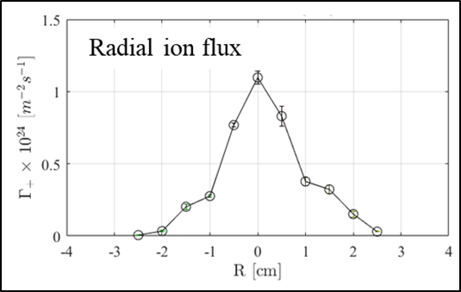

Figure 6‑1. Radial distribution of the ion flux density measured 30cm in front of the target plate.

### Gas load requirements for MPEX

By increasing the RF power at the plasma source from 100 kW to 200 kW gross power, it is expected that the total ion production rate will double for the same magnetic field at the plasma source (0.06 Tesla); that is, the total integrated ion flux to the target will be $1.04×{10}^{21}$ ions per sec. Moreover, operation at higher RF power will enable us to operate at higher magnetic fields at the plasma source. This will have the effect of increasing plasma production for a given RF power. Provided enough RF power is supplied, the plasma production scales linearly with magnetic field at the plasma source. This effect has been observed experimentally in Proto-MPEX (Goulding et al., 2017) and many other helicon sources (Caneses and Blackwell, 2016). It is assumed that 200 kW operation will allow access to magnetic fields up to 0.1 Tesla at the plasma source. For these conditions, it is expected that the total integrated ion flux $S_{+}$ reaching the target will increase from $1.04×{10}^{21}$ to $2.08×{10}^{21}$ ions per sec. Since plasma recombination between the plasma source and the entrance of the target section is not expected, the total integrated ion flux can be equated to the source’s effective plasma production rate. the term “effective” refers to the amount of plasma that comes out of the plasma source and reaches the Target section.

Based on this effective plasma production rate ($2.08×{10}^{21} s^{-1}$) at 200 kW and 0.1 Tesla operation, the amount of gas flow needed to sustain the plasma source during steady state operation will depend in the ionization efficiency of the source and how the neutral gas at the Dump tank is removed. In Proto-MPEX, the ionization efficiency of the source was measured to be about 80%-89%. This was measured without neutral gas pumping at the Dump tank. This means that the neutral gas produced at the Dump tank, through plasma surface recombination, recycles many times in the source volume until it exits towards the Target section. This strong recycling has the effect of fueling the plasma source. If this same pumping setup is implemented in MPEX (no neutral gas pumping at the Dump tank, only at the Target and RF heating sections), based on the performance of Proto-MPEX an ionization efficiency of 80% is used for MPEX. Therefore, the total neutral gas load becomes $2.08×{{10}^{21}}/{0.8}=2.6×{10}^{21}$ neutral deuterium atoms per second, which corresponds to $1.3×{10}^{21} D_{2}$ molecules per second. This value corresponds to 3.11 SLM if input gas. Adding a 25% contingency on top, the *total* gas load during steady state operation of MPEX with no pumping at the Dump tank, pumping at the Target chamber and RF heating section will be 3.89 SLM.

How much of that gas can be expected to arrive at the Target chamber? Based on the experiments described in (Caneses et al., 2019), less than 1% of the total gas injected into Proto-MPEX is removed by the pump in the RF heating section. The pressure in the RF heating section is about 0.01 Pa and with an effective pumping speed of 0.75 $m^{3}s^{-1}$; hence, the neutral gas removal rate in the RF heating section becomes 0.005 SLM. Therefore, it can be safely assumed that all the gas injected into the plasma source is removed by the Target section pump. In the context of MPEX, this means that 3.89 SLM of D2 neutral gas must be removed from the Target section.

The neutral pressure in the Target section will range between 1 and 10 Pa. To calculate the pumping requirements in the Target chamber, equation 6-3 is used, where $S$ is the pumping speed in $m^{3}s^{-1}$, $\dot{N}$ is the gas flow rate in molecules per second, $P$ is the required chamber pressure at the pump inlet in Pa, $T$ is the gas temperature in Kelvin and $k_{B}$ is Boltzmann’s constant.

$S=\frac{\dot{N} k_{B}T}{P}$ (6‑3)

The highest pumping speed occurs at the lowest inlet pressure; therefore, using a gas load of 3.89 SLM and an inlet pressure of 1 Pa the highest pumping speed becomes $S=$ 6.73 $m^{3}s^{-1}$ which corresponds to 24,230 ${m^{3}}/{hr}$.

## Vacuum System Overview

The vacuum system includes the dump region, helicon region, electron heating (ECH) region, ion cyclotron heating (ICH) region, plasma material interaction (PMI) region, target exchange chamber (TEC), pumping trains and the axial vacuum chambers that connect the different regions of the machine. Figure 6‑2 shows an elevation view of MPEX with and without the SC magnets delineating the vacuum regions. Skimmers and a limiter allow for differential pumping of the sections, see Figure 6‑3. And Figure 6‑4. shows the 3 pumping trains required to achieve the MPEX pressure profile. Each region of the vacuum system has different requirements based on its function. The operational pressure requirements for each region are shown in Table 6‑1 and the heat flux on the chambers is given in Table 6‑2.

Table 6‑1. MPEX operational vacuum requirements.

|  |  |
| --- | --- |
| **Region** | **Pressure (Pa)** |
| Dump | 1-10 |
| Helicon | 1-10 |
| ECH | 10-2 |
| ICH | 10-2 |
| PMI | 1-10 |
| TEC | 10-4 |

Table 6‑2. Thermal loads on vacuum chambers.

|  |  |
| --- | --- |
| **Component** | **Heat Flux (kW/m2)** |
| Dump tank | 25 |
| PMI chamber | 25 (50 peak) |
| Axial chambers | 10 |
| ECH region | 25 |

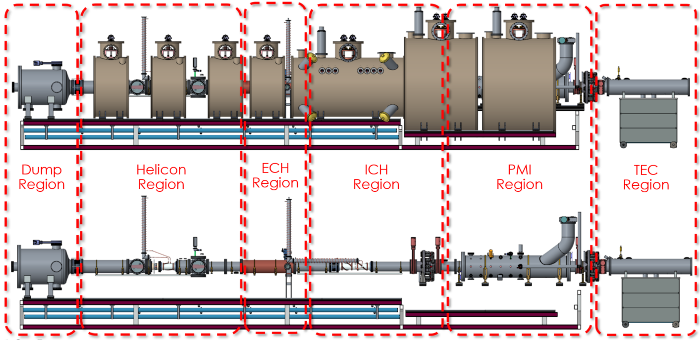

Figure 6‑2. MPEX vacuum regions.

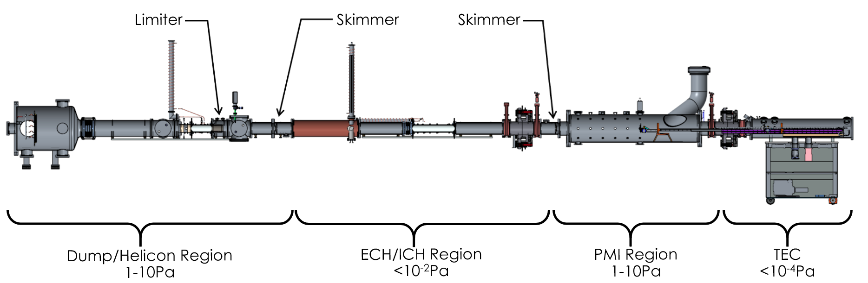

Figure 6‑3. MPEX vacuum system components.

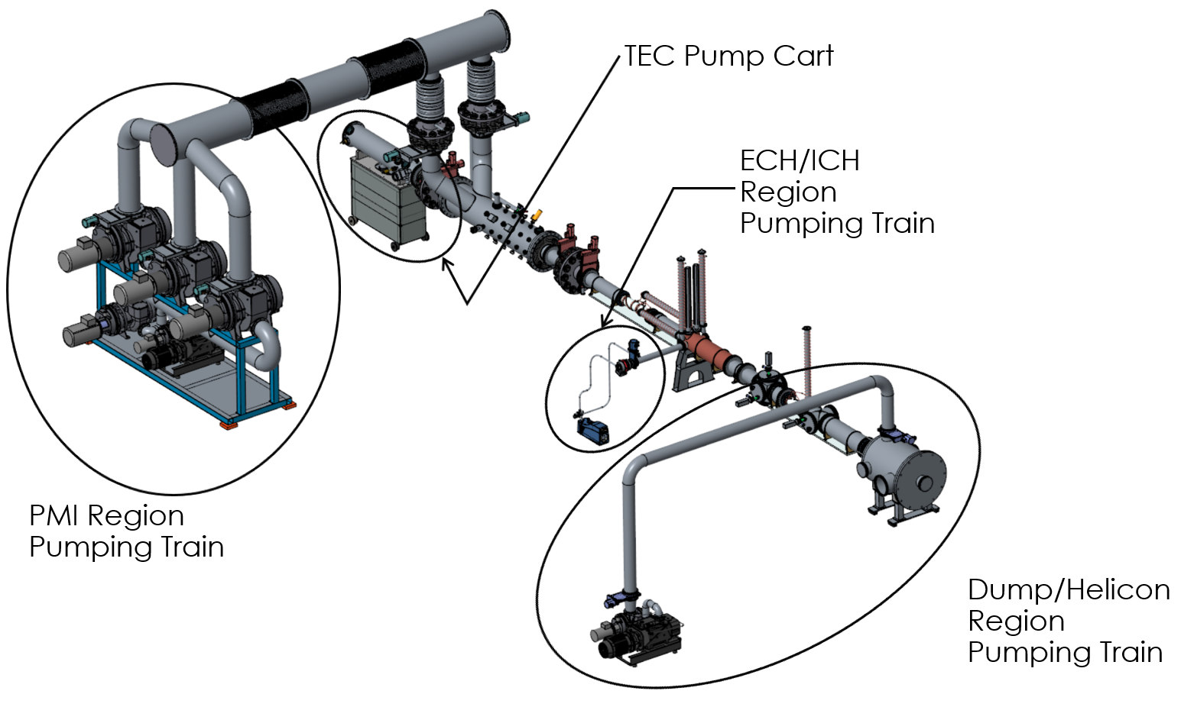

Figure 6‑4. Various pumping trains used on MPEX.

In addition to the pressure and thermal requirements, the vacuum system will be designed to be radiologically (rad) compatible. The two primary features that will be incorporated into the design are “ash trays” and “q-tips”. The ash tray will be a pan like device placed in the bottom of the PMI chamber to catch and contain any debris falling from activated samples. The ash tray will be designed for easy removal and installation by technicians. In order to understand the evolution and buildup of contamination, sample coupons (q-tips) will be place at various locations throughout the MPEX machine, see Figure 6‑5. The coupons will be a q-tip type probe secured to a linear actuator and mounted on the axial vacuum chambers, see Figure 6‑6. Space for the q-tips has been identified in the following areas: dump chamber, diagnostic crosses in the helicon region, ECH chamber, PMI chamber and the target exchange chamber (TEC). The vacuum system design also incorporates all-metal seals wherever possible.

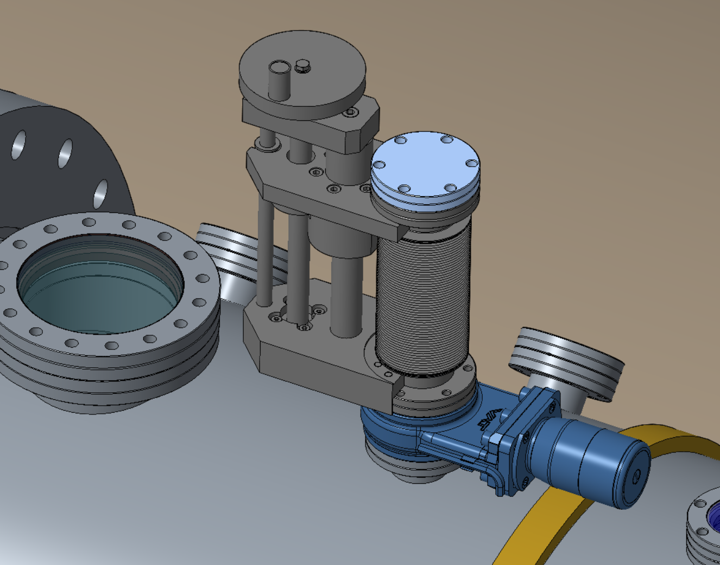

Figure 6‑5: Q-tip assembly mounted on the PMI chamber.

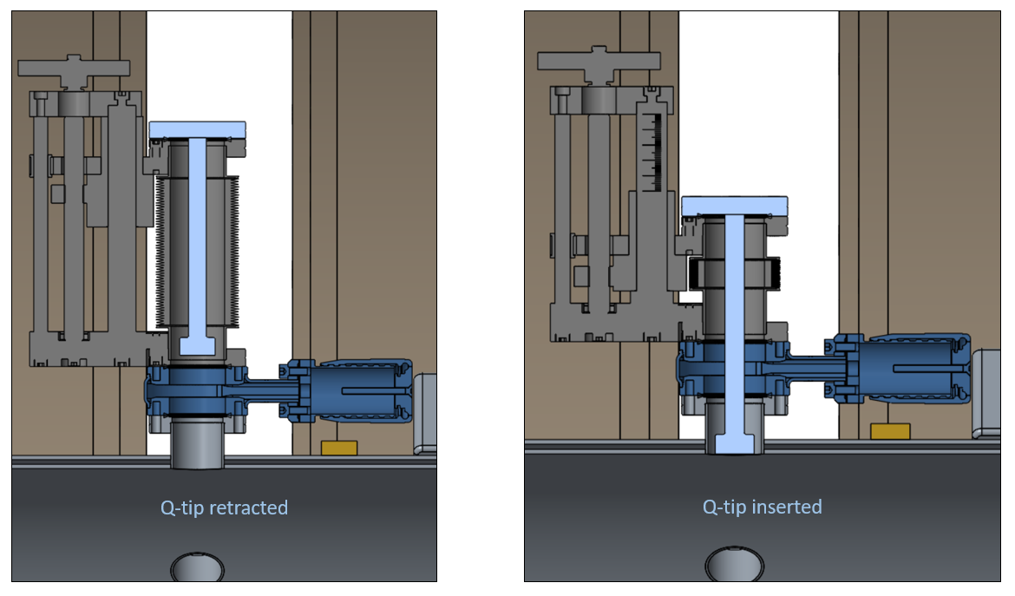

Figure 6‑6: Q-tip is shown in the retracted and inserted positions.

## References for Chapter 6

Caneses, J. F., and B. D. Blackwell. 2016. “Collisional damping of helicon waves in a high density hydrogen linear plasma device,” *Plasma Sources Sci. Technol*., vol. 25, no. 5, p. 055027, 2016.

Caneses, J. F., et al. 2019. “Ion fluxes and neutral gas ionization efficiency of the 100-kW light-ion helicon plasma source concept for the Materials Plasma Exposure eXperiment,” *submitted to Fusion Sci. Technol.*

Goulding, R. H., et al. 2017. “Progress in the Development of a High Power Helicon Plasma Source for the Materials Plasma Exposure Experiment,” *Fusion Sci. Technol*., vol. 72, no. 4, pp. 588–594, November.

Lindeburg, M. 2001. *Mechanical Engineering Reference Manual for the PE Exam, 11th Edition*, Professional Publications, Inc., 2001.

Rapp, J., et al. 2015. *Design and Demonstration of a Material-Plasma Exposure Target Station for Neutron Irradiated Samples*, Oak Ridge National Laboratory, ORNL/TM-2015/646 (<https://info.ornl.gov/sites/publications/Files/Pub59792.pdf>).

*Vacuum Technology Book Volume II, Part 2.* 2013. Pfeiffer Vacuum GmbH, April 2013, <https://www.pfeiffer-vacuum.com/en/know-how/>.

# COOLING SYSTEM AND IN-VESSEL COMPONENTS

The design of the in-vessel components, which will experience high heat-fluxes and must be water cooled, are described below. The load specifications for the in-vessel components are given in Section 4.4 starting on page 145. Furthermore, a conceptual design of the overall water cooling system for MPEX is provided.

## Target design

The MPEX target is the location where the plasma terminates, and the PMI science is studied. The target can be retracted from the PMI chamber retracted into the Target Exchange Chamber (TEC) without breaking vacuum. (Details on the TEC are given in Section 6.8. Figure 7‑1 shows these components in further detail. The target is exposed to the steady state plasma within the PMI chamber, and a telescoping arm allows the target to move into the target exchange chamber. While remaining in vacuum, the TEC can be decoupled from the PMI chamber, and then moved via a rail system into another room that is outside of any magnetic field in order to examine the target surface using sensitive diagnostics (such as Scanning Electron Microscopy or X-ray Photoelectron Spectroscopy). This can also allow for the examination of surface evolution during a high fluence plasma exposure.

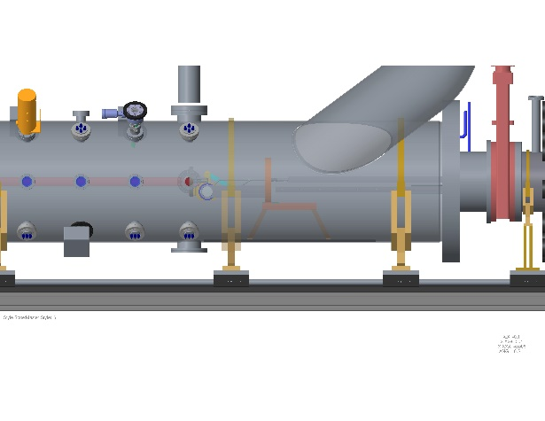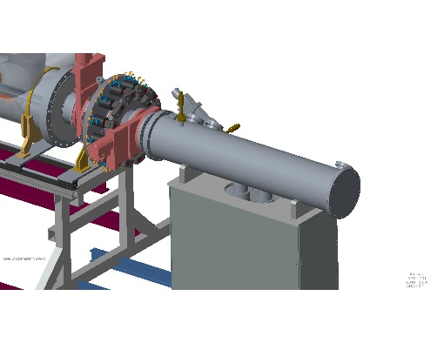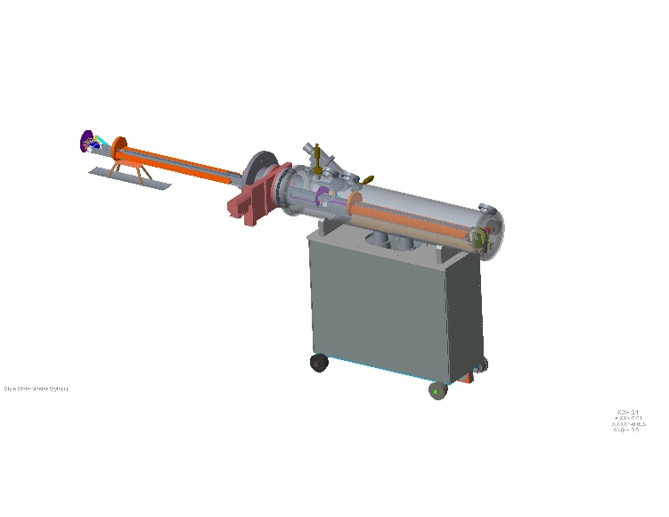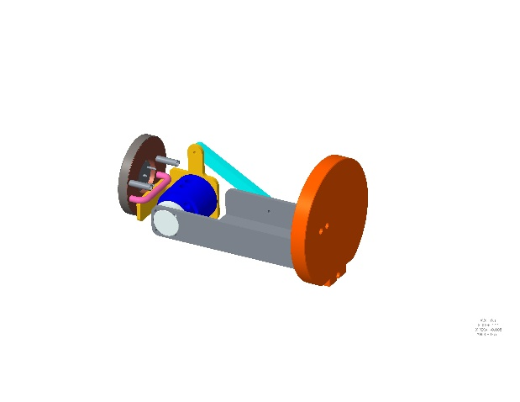

**(a) PMI Chamber (b) Decoupler & TEC (c) TEC transparency (d) 90° target assembly**

Figure 7‑1. The removable target system design. From right to left, (d) shows the 90 degree target attached to the articulating arm; (c) shows a transparent view of the TEC with the target fully extended; (b) shows the TEC connected to the PMI through the decoupler; (a) shows a transparent view of the PMI chamber with the 90 degree target in extended position.

The requirements for the target that are pertinent to the design are as follows:

* Ability to place and remove irradiated samples remotely and without breaking vacuum
* Target must be able to be in a position perpendicular (90 degrees) to plasma flux, at a 15 degree incident angle, and at a 5 degree incident angle
* For 90 degree target
* Peak steady state heat flux = 10 MW/m2
* Plasma diameter = 10 cm (1 MW/m2 at edge)
* Total steady-state power on target = 31 kW
* For 5 degree target
* Peak steady state parallel heat flux = 40 MW/m2
* Plasma diameter = 3.5 cm (1 MW/m2 at edge, 40 cm major axis)
* Total steady-state power on target = 15 kW
* Irradiated target diameter = 10 mm

Vibration levels must be measured and monitoredReferences for Chapter 7

Coffey, E., et al. 2017. “Update on Cooling for the ITER ECH Waveguide Transmission Line,” *Fusion Sci. Technol.*, **72**, *3*, 505, (2017).

Ellis, R. J., and Rapp, J. 2015. “Neutron-Irradiated Samples as Test Materials for MPEX,” *Fusion Sci. Technol.*, 68, *4*, 750, (2015).

Lumsdaine, A., Tipton, J., Youchison, D., Varma, V., Logan, K., and Rapp, J. submitted 2018. “High Heat-Flux Target Design for the Materials Plasma Exposure eXperiment,” submitted to *Fusion Science and Technology*, 2018.

Wagner, W. and Kretzschmar, H. J. 2008. *International Steam Tables: Properties of Water and Steam Based on the Industrial Formulation IAPWS-IF97*, 2nd Edition, Springer, Berlin Heidelberg, 2008.

1. ACTIVITIES BY NUCLIDE FOR FIVE LIKELY MATERIALS IRRADIATED IN HFIR AND COOLED FOR AT LEAST 2 YEARS

APPENDIX A. ACTIVITIES BY NUCLIDE FOR FIVE LIKELY MATERIALS IRRADIATED IN HFIR AND COOLED FOR AT LEAST 2 YEARS

The following tables (Table A.1 to Table A.5) tabulate the activities of five likely MPEX sample materials after irradiation in HFIR for 10 cycles (to a nominal displacement damage level of 10 DPA). The tables show the activities of the main nuclides in the irradiated material compositions as a function of cooling time from the time of discharge until at least 2 years later. The nuclides are ordered according to large-to-small activities at the 2 year cooling (highlighted in blue) column. After 2 years of cooling, the most active nuclide for each of the irradiated materials is 185W.

These activities are in units of Ci per gram of initial sample material. Each irradiated sample disk initially had a mass of about 2.1 g.

Table A.1. Activities (Ci) as function of cooling time per gram of 99% enriched 182W material irradiated in HFIR for 10 cycles.

|  |  |  |  |  |  |  |  |  |  |  |  |  |  |
| --- | --- | --- | --- | --- | --- | --- | --- | --- | --- | --- | --- | --- | --- |
| **99% 182W** | **0.0 h** | **2.0 h** | **24.0 h** | **48.0 h** | **168.0 h** | **336.0 h** | **600.0 h** | **1100.0 h** | **2100.0 h** | **4320.0 h** | **8760.0 h** | **17520 h** | **26280 h** |
| **w185** | 1.66E+01 | 1.66E+01 | 1.65E+01 | 1.63E+01 | 1.56E+01 | 1.46E+01 | 1.32E+01 | 1.09E+01 | 7.40E+00 | 3.15E+00 | 5.72E-01 | 1.97E-02 | 6.78E-04 |
| **w181** | 4.07E-02 | 4.07E-02 | 4.04E-02 | 4.02E-02 | 3.91E-02 | 3.75E-02 | 3.53E-02 | 3.13E-02 | 2.47E-02 | 1.45E-02 | 5.04E-03 | 6.25E-04 | 7.75E-05 |
| **re188** | 9.04E+00 | 8.34E+00 | 3.44E+00 | 1.34E+00 | 7.31E-02 | 5.94E-02 | 5.32E-02 | 4.33E-02 | 2.86E-02 | 1.14E-02 | 1.82E-03 | 4.84E-05 | 1.29E-06 |
| **w188** | 6.75E-02 | 6.75E-02 | 6.68E-02 | 6.62E-02 | 6.30E-02 | 5.87E-02 | 5.27E-02 | 4.28E-02 | 2.83E-02 | 1.13E-02 | 1.80E-03 | 4.79E-05 | 1.28E-06 |
| **ir192** | 2.59E-03 | 2.59E-03 | 2.56E-03 | 2.54E-03 | 2.42E-03 | 2.27E-03 | 2.05E-03 | 1.68E-03 | 1.14E-03 | 4.78E-04 | 8.41E-05 | 2.73E-06 | 8.87E-08 |
| **ta182** | 1.98E-04 | 1.98E-04 | 1.97E-04 | 1.96E-04 | 1.90E-04 | 1.82E-04 | 1.71E-04 | 1.50E-04 | 1.17E-04 | 6.68E-05 | 2.19E-05 | 2.41E-06 | 2.66E-07 |
| **os185** | 3.24E-05 | 3.24E-05 | 3.22E-05 | 3.19E-05 | 3.08E-05 | 2.92E-05 | 2.69E-05 | 2.31E-05 | 1.70E-05 | 8.54E-06 | 2.17E-06 | 1.46E-07 | 9.75E-09 |
| **ir194** | 4.89E-02 | 4.55E-02 | 2.06E-02 | 8.71E-03 | 1.17E-04 | 3.57E-07 | 7.92E-08 | 7.86E-08 | 7.76E-08 | 7.54E-08 | 7.11E-08 | 6.33E-08 | 5.64E-08 |
| **re186** | 1.72E+01 | 1.70E+01 | 1.43E+01 | 1.19E+01 | 4.67E+00 | 1.27E+00 | 1.63E-01 | 3.35E-03 | 1.43E-06 | 1.15E-08 | 1.15E-08 | 1.15E-08 | 1.15E-08 |
| **re184** | 1.77E-06 | 1.76E-06 | 1.73E-06 | 1.70E-06 | 1.55E-06 | 1.37E-06 | 1.13E-06 | 7.82E-07 | 3.95E-07 | 1.19E-07 | 3.45E-08 | 7.45E-09 | 1.67E-09 |
| **hf181** | 3.53E-06 | 3.53E-06 | 3.47E-06 | 3.42E-06 | 3.15E-06 | 2.81E-06 | 2.35E-06 | 1.67E-06 | 8.44E-07 | 1.86E-07 | 9.04E-09 | 2.31E-11 | 5.91E-14 |
| **os191** | 8.64E-02 | 8.66E-02 | 8.61E-02 | 8.34E-02 | 6.69E-02 | 4.88E-02 | 2.98E-02 | 1.17E-02 | 1.79E-03 | 2.78E-05 | 6.72E-09 | 4.93E-16 | 3.61E-23 |
| **ir191m** | 8.64E-02 | 8.66E-02 | 8.61E-02 | 8.34E-02 | 6.69E-02 | 4.88E-02 | 2.98E-02 | 1.17E-02 | 1.79E-03 | 2.78E-05 | 6.72E-09 | 4.93E-16 | 3.61E-23 |
| **ir193m** | 6.88E-03 | 6.84E-03 | 6.44E-03 | 6.03E-03 | 4.34E-03 | 2.74E-03 | 1.33E-03 | 3.37E-04 | 2.17E-05 | 4.92E-08 | 2.53E-13 | 9.30E-24 | 0.00E+00 |
| **hf179m** | 4.13E-06 | 0.00E+00 | 0.00E+00 | 0.00E+00 | 0.00E+00 | 0.00E+00 | 0.00E+00 | 0.00E+00 | 0.00E+00 | 0.00E+00 | 0.00E+00 | 0.00E+00 | 0.00E+00 |
| **ta180** | 2.47E-06 | 2.08E-06 | 3.21E-07 | 4.17E-08 | 1.55E-12 | 9.72E-19 | 1.74E-28 | 0.00E+00 | 0.00E+00 | 0.00E+00 | 0.00E+00 | 0.00E+00 | 0.00E+00 |
| **ta182m** | 1.65E-05 | 0.00E+00 | 0.00E+00 | 0.00E+00 | 0.00E+00 | 0.00E+00 | 0.00E+00 | 0.00E+00 | 0.00E+00 | 0.00E+00 | 0.00E+00 | 0.00E+00 | 0.00E+00 |
| **ta183** | 5.21E-02 | 5.15E-02 | 4.55E-02 | 3.97E-02 | 2.01E-02 | 7.77E-03 | 1.74E-03 | 1.03E-04 | 3.56E-07 | 1.24E-12 | 1.49E-23 | 0.00E+00 | 0.00E+00 |
| **w183m** | 1.98E+02 | 2.63E-03 | 2.32E-03 | 2.02E-03 | 1.03E-03 | 3.96E-04 | 8.88E-05 | 5.23E-06 | 1.82E-08 | 6.30E-14 | 7.58E-25 | 0.00E+00 | 0.00E+00 |
| **w185m** | 8.15E-02 | 1.91E-23 | 0.00E+00 | 0.00E+00 | 0.00E+00 | 0.00E+00 | 0.00E+00 | 0.00E+00 | 0.00E+00 | 0.00E+00 | 0.00E+00 | 0.00E+00 | 0.00E+00 |
| **w187** | 7.11E+00 | 6.71E+00 | 3.56E+00 | 1.78E+00 | 5.56E-02 | 4.34E-04 | 2.12E-07 | 1.13E-13 | 3.25E-26 | 0.00E+00 | 0.00E+00 | 0.00E+00 | 0.00E+00 |
| **w189** | 9.48E-03 | 3.99E-06 | 0.00E+00 | 0.00E+00 | 0.00E+00 | 0.00E+00 | 0.00E+00 | 0.00E+00 | 0.00E+00 | 0.00E+00 | 0.00E+00 | 0.00E+00 | 0.00E+00 |
| **re188m** | 2.43E-01 | 2.77E-03 | 1.17E-24 | 0.00E+00 | 0.00E+00 | 0.00E+00 | 0.00E+00 | 0.00E+00 | 0.00E+00 | 0.00E+00 | 0.00E+00 | 0.00E+00 | 0.00E+00 |
| **re189** | 2.58E-02 | 2.44E-02 | 1.30E-02 | 6.58E-03 | 2.15E-04 | 1.78E-06 | 9.54E-10 | 6.10E-16 | 2.50E-28 | 0.00E+00 | 0.00E+00 | 0.00E+00 | 0.00E+00 |
| **os189m** | 8.63E-01 | 6.80E-01 | 5.08E-02 | 3.69E-03 | 2.89E-05 | 2.39E-07 | 1.33E-10 | 1.38E-12 | 1.55E-13 | 1.20E-15 | 7.27E-20 | 0.00E+00 | 0.00E+00 |
| **os190m** | 5.70E-06 | 1.28E-09 | 0.00E+00 | 0.00E+00 | 0.00E+00 | 0.00E+00 | 0.00E+00 | 0.00E+00 | 0.00E+00 | 0.00E+00 | 0.00E+00 | 0.00E+00 | 0.00E+00 |
| **os191m** | 1.44E-01 | 1.29E-01 | 4.03E-02 | 1.13E-02 | 1.98E-05 | 2.73E-09 | 2.34E-15 | 7.58E-27 | 0.00E+00 | 0.00E+00 | 0.00E+00 | 0.00E+00 | 0.00E+00 |
| **os193** | 8.83E-04 | 8.43E-04 | 5.08E-04 | 2.93E-04 | 1.85E-05 | 3.86E-07 | 8.86E-10 | 8.88E-15 | 8.93E-25 | 0.00E+00 | 0.00E+00 | 0.00E+00 | 0.00E+00 |
| **ir192m** | 5.64E-02 | 0.00E+00 | 0.00E+00 | 0.00E+00 | 0.00E+00 | 0.00E+00 | 0.00E+00 | 0.00E+00 | 0.00E+00 | 0.00E+00 | 0.00E+00 | 0.00E+00 | 0.00E+00 |
| **ir194m** | 7.87E-05 | 0.00E+00 | 0.00E+00 | 0.00E+00 | 0.00E+00 | 0.00E+00 | 0.00E+00 | 0.00E+00 | 0.00E+00 | 0.00E+00 | 0.00E+00 | 0.00E+00 | 0.00E+00 |
| **pt193m** | 1.33E-04 | 1.31E-04 | 1.13E-04 | 9.62E-05 | 4.32E-05 | 1.41E-05 | 2.42E-06 | 8.63E-08 | 1.09E-10 | 4.06E-17 | 5.58E-30 | 0.00E+00 | 0.00E+00 |
| **pt195m** | 4.02E-05 | 3.96E-05 | 3.38E-05 | 2.84E-05 | 1.20E-05 | 3.57E-06 | 5.34E-07 | 1.46E-08 | 1.09E-11 | 1.23E-18 | 0.00E+00 | 0.00E+00 | 0.00E+00 |
| **total** | **2.50E+02** | **4.98E+01** | **3.82E+01** | **3.16E+01** | **2.06E+01** | **1.61E+01** | **1.36E+01** | **1.10E+01** | **7.49E+00** | **3.19E+00** | **5.80E-01** | **2.04E-02** | **7.59E-04** |

Table A.2. Activities (Ci) as function of cooling time per gram of natural W material irradiated in HFIR for 10 cycles.

|  |  |  |  |  |  |  |  |  |  |  |  |  |  |
| --- | --- | --- | --- | --- | --- | --- | --- | --- | --- | --- | --- | --- | --- |
| **nat\_W** | **0.0 h** | **2.0 h** | **24.0 h** | **48.0 h** | **168.0 h** | **336.0 h** | **600.0 h** | **1100.0 h** | **2100.0 h** | **4320.0 h** | **8760.0 h** | **17520 h** | **26280 h** |
| **w185** | 4.12E+01 | 4.12E+01 | 4.08E+01 | 4.04E+01 | 3.86E+01 | 3.62E+01 | 3.27E+01 | 2.70E+01 | 1.84E+01 | 7.82E+00 | 1.42E+00 | 4.88E-02 | 1.68E-03 |
| **re188** | 5.88E+02 | 5.42E+02 | 2.24E+02 | 8.69E+01 | 4.88E+00 | 3.98E+00 | 3.57E+00 | 2.90E+00 | 1.92E+00 | 7.65E-01 | 1.22E-01 | 3.24E-03 | 8.63E-05 |
| **w188** | 4.52E+00 | 4.52E+00 | 4.48E+00 | 4.44E+00 | 4.22E+00 | 3.94E+00 | 3.53E+00 | 2.87E+00 | 1.90E+00 | 7.57E-01 | 1.21E-01 | 3.21E-03 | 8.55E-05 |
| **ir192** | 1.78E-01 | 1.78E-01 | 1.76E-01 | 1.74E-01 | 1.66E-01 | 1.56E-01 | 1.41E-01 | 1.16E-01 | 7.81E-02 | 3.28E-02 | 5.77E-03 | 1.88E-04 | 6.09E-06 |
| **w181** | 1.08E-02 | 1.07E-02 | 1.07E-02 | 1.06E-02 | 1.03E-02 | 9.92E-03 | 9.32E-03 | 8.27E-03 | 6.52E-03 | 3.84E-03 | 1.33E-03 | 1.65E-04 | 2.05E-05 |
| **pt193** | 6.00E-05 | 6.00E-05 | 6.03E-05 | 6.06E-05 | 6.15E-05 | 6.19E-05 | 6.21E-05 | 6.21E-05 | 6.20E-05 | 6.18E-05 | 6.13E-05 | 6.05E-05 | 5.97E-05 |
| **ir194** | 3.39E+00 | 3.15E+00 | 1.43E+00 | 6.03E-01 | 8.07E-03 | 2.48E-05 | 5.52E-06 | 5.48E-06 | 5.41E-06 | 5.25E-06 | 4.95E-06 | 4.41E-06 | 3.93E-06 |
| **os194** | 5.56E-06 | 5.56E-06 | 5.56E-06 | 5.55E-06 | 5.55E-06 | 5.53E-06 | 5.51E-06 | 5.48E-06 | 5.41E-06 | 5.25E-06 | 4.95E-06 | 4.41E-06 | 3.93E-06 |
| **os185** | 2.26E-04 | 2.26E-04 | 2.25E-04 | 2.23E-04 | 2.15E-04 | 2.04E-04 | 1.88E-04 | 1.61E-04 | 1.18E-04 | 5.97E-05 | 1.52E-05 | 1.02E-06 | 6.81E-08 |
| **ta182** | 5.28E-05 | 5.28E-05 | 5.25E-05 | 5.22E-05 | 5.06E-05 | 4.85E-05 | 4.54E-05 | 4.00E-05 | 3.11E-05 | 1.78E-05 | 5.82E-06 | 6.42E-07 | 7.08E-08 |
| **re186** | 5.90E+01 | 5.81E+01 | 4.89E+01 | 4.06E+01 | 1.60E+01 | 4.34E+00 | 5.58E-01 | 1.15E-02 | 4.92E-06 | 5.92E-08 | 5.92E-08 | 5.92E-08 | 5.92E-08 |
| **re184** | 5.88E-06 | 5.87E-06 | 5.78E-06 | 5.67E-06 | 5.18E-06 | 4.56E-06 | 3.75E-06 | 2.61E-06 | 1.32E-06 | 3.96E-07 | 1.16E-07 | 2.50E-08 | 5.59E-09 |
| **hf181** | 3.39E-06 | 3.38E-06 | 3.33E-06 | 3.28E-06 | 3.02E-06 | 2.69E-06 | 2.25E-06 | 1.60E-06 | 8.09E-07 | 1.78E-07 | 8.66E-09 | 2.22E-11 | 5.67E-14 |
| **os191** | 5.90E+00 | 5.91E+00 | 5.88E+00 | 5.69E+00 | 4.57E+00 | 3.33E+00 | 2.03E+00 | 7.95E-01 | 1.22E-01 | 1.90E-03 | 4.59E-07 | 3.36E-14 | 2.47E-21 |
| **ir191m** | 5.90E+00 | 5.91E+00 | 5.88E+00 | 5.69E+00 | 4.57E+00 | 3.33E+00 | 2.03E+00 | 7.95E-01 | 1.22E-01 | 1.90E-03 | 4.59E-07 | 3.36E-14 | 2.47E-21 |
| **ir193m** | 4.74E-01 | 4.71E-01 | 4.44E-01 | 4.16E-01 | 2.99E-01 | 1.89E-01 | 9.14E-02 | 2.32E-02 | 1.49E-03 | 3.39E-06 | 1.74E-11 | 6.40E-22 | 0.00E+00 |
| **ir190** | 8.23E-06 | 8.19E-06 | 7.76E-06 | 7.32E-06 | 5.45E-06 | 3.61E-06 | 1.89E-06 | 5.55E-07 | 4.78E-08 | 2.07E-10 | 3.87E-15 | 1.82E-24 | 0.00E+00 |
| **hf179m** | 1.09E-06 | 0.00E+00 | 0.00E+00 | 0.00E+00 | 0.00E+00 | 0.00E+00 | 0.00E+00 | 0.00E+00 | 0.00E+00 | 0.00E+00 | 0.00E+00 | 0.00E+00 | 0.00E+00 |
| **ta182m** | 6.07E-06 | 0.00E+00 | 0.00E+00 | 0.00E+00 | 0.00E+00 | 0.00E+00 | 0.00E+00 | 0.00E+00 | 0.00E+00 | 0.00E+00 | 0.00E+00 | 0.00E+00 | 0.00E+00 |
| **ta183** | 1.39E-02 | 1.37E-02 | 1.21E-02 | 1.06E-02 | 5.36E-03 | 2.07E-03 | 4.64E-04 | 2.74E-05 | 9.50E-08 | 3.29E-13 | 3.96E-24 | 0.00E+00 | 0.00E+00 |
| **w183m** | 6.04E+01 | 7.00E-04 | 6.18E-04 | 5.39E-04 | 2.73E-04 | 1.06E-04 | 2.37E-05 | 1.40E-06 | 4.84E-09 | 1.68E-14 | 2.02E-25 | 0.00E+00 | 0.00E+00 |
| **w185m** | 1.64E-01 | 3.83E-23 | 0.00E+00 | 0.00E+00 | 0.00E+00 | 0.00E+00 | 0.00E+00 | 0.00E+00 | 0.00E+00 | 0.00E+00 | 0.00E+00 | 0.00E+00 | 0.00E+00 |
| **w187** | 4.43E+02 | 4.18E+02 | 2.21E+02 | 1.11E+02 | 3.46E+00 | 2.70E-02 | 1.32E-05 | 7.06E-12 | 2.02E-24 | 0.00E+00 | 0.00E+00 | 0.00E+00 | 0.00E+00 |
| **w189** | 6.36E-01 | 2.68E-04 | 0.00E+00 | 0.00E+00 | 0.00E+00 | 0.00E+00 | 0.00E+00 | 0.00E+00 | 0.00E+00 | 0.00E+00 | 0.00E+00 | 0.00E+00 | 0.00E+00 |
| **re188m** | 1.58E+01 | 1.80E-01 | 7.59E-23 | 0.00E+00 | 0.00E+00 | 0.00E+00 | 0.00E+00 | 0.00E+00 | 0.00E+00 | 0.00E+00 | 0.00E+00 | 0.00E+00 | 0.00E+00 |
| **re189** | 1.70E+00 | 1.61E+00 | 8.59E-01 | 4.33E-01 | 1.41E-02 | 1.17E-04 | 6.29E-08 | 4.02E-14 | 1.65E-26 | 0.00E+00 | 0.00E+00 | 0.00E+00 | 0.00E+00 |
| **os189m** | 5.19E+01 | 4.10E+01 | 3.07E+00 | 2.27E-01 | 1.90E-03 | 1.58E-05 | 8.75E-09 | 9.51E-11 | 1.07E-11 | 8.29E-14 | 5.00E-18 | 0.00E+00 | 0.00E+00 |
| **os190m** | 3.71E-04 | 8.34E-08 | 0.00E+00 | 0.00E+00 | 0.00E+00 | 0.00E+00 | 0.00E+00 | 0.00E+00 | 0.00E+00 | 0.00E+00 | 0.00E+00 | 0.00E+00 | 0.00E+00 |
| **os191m** | 9.76E+00 | 8.78E+00 | 2.74E+00 | 7.70E-01 | 1.35E-03 | 1.86E-07 | 1.59E-13 | 5.15E-25 | 0.00E+00 | 0.00E+00 | 0.00E+00 | 0.00E+00 | 0.00E+00 |
| **os193** | 6.12E-02 | 5.84E-02 | 3.52E-02 | 2.03E-02 | 1.28E-03 | 2.68E-05 | 6.14E-08 | 6.15E-13 | 6.19E-23 | 0.00E+00 | 0.00E+00 | 0.00E+00 | 0.00E+00 |
| **ir192m** | 3.87E+00 | 0.00E+00 | 0.00E+00 | 0.00E+00 | 0.00E+00 | 0.00E+00 | 0.00E+00 | 0.00E+00 | 0.00E+00 | 0.00E+00 | 0.00E+00 | 0.00E+00 | 0.00E+00 |
| **ir194m** | 5.44E-03 | 0.00E+00 | 0.00E+00 | 0.00E+00 | 0.00E+00 | 0.00E+00 | 0.00E+00 | 0.00E+00 | 0.00E+00 | 0.00E+00 | 0.00E+00 | 0.00E+00 | 0.00E+00 |
| **pt191** | 3.03E-06 | 2.97E-06 | 2.36E-06 | 1.85E-06 | 5.36E-07 | 9.48E-08 | 6.24E-09 | 3.61E-11 | 1.20E-15 | 1.39E-25 | 0.00E+00 | 0.00E+00 | 0.00E+00 |
| **pt193m** | 9.22E-03 | 9.09E-03 | 7.85E-03 | 6.69E-03 | 3.01E-03 | 9.80E-04 | 1.68E-04 | 6.00E-06 | 7.61E-09 | 2.82E-15 | 3.88E-28 | 0.00E+00 | 0.00E+00 |
| **pt195m** | 2.80E-03 | 2.76E-03 | 2.36E-03 | 1.98E-03 | 8.36E-04 | 2.49E-04 | 3.72E-05 | 1.02E-06 | 7.57E-10 | 8.61E-17 | 1.11E-30 | 0.00E+00 | 0.00E+00 |
| **pt197** | 3.38E-05 | 3.16E-05 | 1.47E-05 | 6.37E-06 | 9.73E-08 | 2.79E-10 | 2.82E-14 | 7.66E-22 | 0.00E+00 | 0.00E+00 | 0.00E+00 | 0.00E+00 | 0.00E+00 |
| **pt197m** | 1.81E-06 | 7.57E-07 | 5.18E-11 | 1.48E-15 | 0.00E+00 | 0.00E+00 | 0.00E+00 | 0.00E+00 | 0.00E+00 | 0.00E+00 | 0.00E+00 | 0.00E+00 | 0.00E+00 |
| **au199** | 9.90E-06 | 9.72E-06 | 7.94E-06 | 6.36E-06 | 2.11E-06 | 4.50E-07 | 3.96E-08 | 3.98E-10 | 4.02E-14 | 5.41E-23 | 0.00E+00 | 0.00E+00 | 0.00E+00 |
| **total** | **1.30E+03** | **1.13E+03** | **5.60E+02** | **2.97E+02** | **7.68E+01** | **5.55E+01** | **4.47E+01** | **3.45E+01** | **2.25E+01** | **9.38E+00** | **1.67E+00** | **5.57E-02** | **1.95E-03** |

Table A.3. Activities (Ci) as function of cooling time per gram of 10 wt% Ta-W material irradiated in HFIR for 10 cycles.

|  |  |  |  |  |  |  |  |  |  |  |  |  |  |
| --- | --- | --- | --- | --- | --- | --- | --- | --- | --- | --- | --- | --- | --- |
| **Ta10-W** | **0.0 h** | **2.0 h** | **24.0 h** | **48.0 h** | **168.0 h** | **336.0 h** | **600.0 h** | **1100.0 h** | **2100.0 h** | **4320.0 h** | **8760.0 h** | **17520 h** | **26280 h** |
| **w185** | 3.86E+01 | 3.86E+01 | 3.82E+01 | 3.79E+01 | 3.62E+01 | 3.39E+01 | 3.06E+01 | 2.53E+01 | 1.72E+01 | 7.33E+00 | 1.33E+00 | 4.57E-02 | 1.57E-03 |
| **ta182** | 5.47E-01 | 5.47E-01 | 5.44E-01 | 5.41E-01 | 5.25E-01 | 5.03E-01 | 4.71E-01 | 4.15E-01 | 3.23E-01 | 1.85E-01 | 6.03E-02 | 6.65E-03 | 7.33E-04 |
| **re188** | 5.35E+02 | 4.93E+02 | 2.04E+02 | 7.91E+01 | 4.44E+00 | 3.62E+00 | 3.24E+00 | 2.64E+00 | 1.74E+00 | 6.96E-01 | 1.11E-01 | 2.95E-03 | 7.85E-05 |
| **w188** | 4.12E+00 | 4.11E+00 | 4.08E+00 | 4.04E+00 | 3.84E+00 | 3.58E+00 | 3.21E+00 | 2.61E+00 | 1.73E+00 | 6.89E-01 | 1.10E-01 | 2.92E-03 | 7.77E-05 |
| **ir192** | 1.62E-01 | 1.62E-01 | 1.60E-01 | 1.59E-01 | 1.51E-01 | 1.42E-01 | 1.28E-01 | 1.05E-01 | 7.11E-02 | 2.98E-02 | 5.25E-03 | 1.71E-04 | 5.54E-06 |
| **w181** | 9.79E-03 | 9.78E-03 | 9.73E-03 | 9.68E-03 | 9.40E-03 | 9.04E-03 | 8.48E-03 | 7.53E-03 | 5.93E-03 | 3.50E-03 | 1.21E-03 | 1.51E-04 | 1.87E-05 |
| **pt193** | 5.46E-05 | 5.46E-05 | 5.49E-05 | 5.52E-05 | 5.59E-05 | 5.64E-05 | 5.65E-05 | 5.65E-05 | 5.64E-05 | 5.62E-05 | 5.58E-05 | 5.51E-05 | 5.43E-05 |
| **ir194** | 3.08E+00 | 2.87E+00 | 1.30E+00 | 5.49E-01 | 7.35E-03 | 2.25E-05 | 5.02E-06 | 4.99E-06 | 4.92E-06 | 4.78E-06 | 4.51E-06 | 4.02E-06 | 3.58E-06 |
| **os194** | 5.06E-06 | 5.06E-06 | 5.06E-06 | 5.06E-06 | 5.05E-06 | 5.04E-06 | 5.02E-06 | 4.99E-06 | 4.92E-06 | 4.78E-06 | 4.51E-06 | 4.02E-06 | 3.58E-06 |
| **ta179** | 4.06E-06 | 4.06E-06 | 4.06E-06 | 4.05E-06 | 4.03E-06 | 4.00E-06 | 3.96E-06 | 3.87E-06 | 3.71E-06 | 3.37E-06 | 2.78E-06 | 1.90E-06 | 1.30E-06 |
| **os185** | 2.08E-04 | 2.08E-04 | 2.06E-04 | 2.05E-04 | 1.97E-04 | 1.87E-04 | 1.73E-04 | 1.48E-04 | 1.09E-04 | 5.48E-05 | 1.39E-05 | 9.32E-07 | 6.25E-08 |
| **re186** | 5.47E+01 | 5.39E+01 | 4.54E+01 | 3.77E+01 | 1.48E+01 | 4.03E+00 | 5.18E-01 | 1.07E-02 | 4.57E-06 | 5.45E-08 | 5.45E-08 | 5.45E-08 | 5.45E-08 |
| **re184** | 5.47E-06 | 5.46E-06 | 5.37E-06 | 5.27E-06 | 4.81E-06 | 4.24E-06 | 3.48E-06 | 2.42E-06 | 1.22E-06 | 3.68E-07 | 1.07E-07 | 2.32E-08 | 5.19E-09 |
| **hf181** | 1.73E-03 | 1.73E-03 | 1.70E-03 | 1.67E-03 | 1.54E-03 | 1.38E-03 | 1.15E-03 | 8.17E-04 | 4.13E-04 | 9.11E-05 | 4.42E-06 | 1.13E-08 | 2.89E-11 |
| **os191** | 5.37E+00 | 5.38E+00 | 5.35E+00 | 5.18E+00 | 4.16E+00 | 3.03E+00 | 1.85E+00 | 7.24E-01 | 1.11E-01 | 1.73E-03 | 4.18E-07 | 3.06E-14 | 2.24E-21 |
| **ir191m** | 5.37E+00 | 5.38E+00 | 5.35E+00 | 5.18E+00 | 4.16E+00 | 3.03E+00 | 1.85E+00 | 7.24E-01 | 1.11E-01 | 1.73E-03 | 4.18E-07 | 3.06E-14 | 2.24E-21 |
| **ir193m** | 4.31E-01 | 4.29E-01 | 4.04E-01 | 3.78E-01 | 2.72E-01 | 1.72E-01 | 8.32E-02 | 2.11E-02 | 1.36E-03 | 3.08E-06 | 1.59E-11 | 5.83E-22 | 0.00E+00 |
| **ir190** | 7.49E-06 | 7.45E-06 | 7.06E-06 | 6.66E-06 | 4.96E-06 | 3.29E-06 | 1.72E-06 | 5.05E-07 | 4.35E-08 | 1.88E-10 | 3.52E-15 | 1.66E-24 | 0.00E+00 |
| **hf179m** | 1.29E-06 | 0.00E+00 | 0.00E+00 | 0.00E+00 | 0.00E+00 | 0.00E+00 | 0.00E+00 | 0.00E+00 | 0.00E+00 | 0.00E+00 | 0.00E+00 | 0.00E+00 | 0.00E+00 |
| **ta180** | 8.62E-03 | 7.27E-03 | 1.12E-03 | 1.46E-04 | 5.41E-09 | 3.40E-15 | 6.09E-25 | 0.00E+00 | 0.00E+00 | 0.00E+00 | 0.00E+00 | 0.00E+00 | 0.00E+00 |
| **ta182m** | 1.09E-02 | 0.00E+00 | 0.00E+00 | 0.00E+00 | 0.00E+00 | 0.00E+00 | 0.00E+00 | 0.00E+00 | 0.00E+00 | 0.00E+00 | 0.00E+00 | 0.00E+00 | 0.00E+00 |
| **ta183** | 1.46E+02 | 1.44E+02 | 1.27E+02 | 1.11E+02 | 5.63E+01 | 2.18E+01 | 4.88E+00 | 2.87E-01 | 9.98E-04 | 3.46E-09 | 4.16E-20 | 0.00E+00 | 0.00E+00 |
| **w183m** | 6.48E+01 | 7.35E+00 | 6.49E+00 | 5.67E+00 | 2.87E+00 | 1.11E+00 | 2.49E-01 | 1.47E-02 | 5.09E-05 | 1.76E-10 | 2.12E-21 | 0.00E+00 | 0.00E+00 |
| **w185m** | 1.54E-01 | 3.62E-23 | 0.00E+00 | 0.00E+00 | 0.00E+00 | 0.00E+00 | 0.00E+00 | 0.00E+00 | 0.00E+00 | 0.00E+00 | 0.00E+00 | 0.00E+00 | 0.00E+00 |
| **w187** | 4.02E+02 | 3.80E+02 | 2.01E+02 | 1.01E+02 | 3.14E+00 | 2.46E-02 | 1.20E-05 | 6.42E-12 | 1.84E-24 | 0.00E+00 | 0.00E+00 | 0.00E+00 | 0.00E+00 |
| **w189** | 5.78E-01 | 2.43E-04 | 0.00E+00 | 0.00E+00 | 0.00E+00 | 0.00E+00 | 0.00E+00 | 0.00E+00 | 0.00E+00 | 0.00E+00 | 0.00E+00 | 0.00E+00 | 0.00E+00 |
| **re188m** | 1.43E+01 | 1.63E-01 | 6.91E-23 | 0.00E+00 | 0.00E+00 | 0.00E+00 | 0.00E+00 | 0.00E+00 | 0.00E+00 | 0.00E+00 | 0.00E+00 | 0.00E+00 | 0.00E+00 |
| **re189** | 1.55E+00 | 1.46E+00 | 7.82E-01 | 3.94E-01 | 1.29E-02 | 1.07E-04 | 5.72E-08 | 3.66E-14 | 1.50E-26 | 0.00E+00 | 0.00E+00 | 0.00E+00 | 0.00E+00 |
| **os189m** | 4.73E+01 | 3.73E+01 | 2.79E+00 | 2.06E-01 | 1.73E-03 | 1.44E-05 | 7.96E-09 | 8.65E-11 | 9.70E-12 | 7.54E-14 | 4.55E-18 | 0.00E+00 | 0.00E+00 |
| **os190m** | 3.38E-04 | 7.59E-08 | 0.00E+00 | 0.00E+00 | 0.00E+00 | 0.00E+00 | 0.00E+00 | 0.00E+00 | 0.00E+00 | 0.00E+00 | 0.00E+00 | 0.00E+00 | 0.00E+00 |
| **os191m** | 8.88E+00 | 7.99E+00 | 2.49E+00 | 7.00E-01 | 1.22E-03 | 1.69E-07 | 1.45E-13 | 4.69E-25 | 0.00E+00 | 0.00E+00 | 0.00E+00 | 0.00E+00 | 0.00E+00 |
| **os193** | 5.57E-02 | 5.32E-02 | 3.20E-02 | 1.84E-02 | 1.16E-03 | 2.44E-05 | 5.59E-08 | 5.60E-13 | 5.63E-23 | 0.00E+00 | 0.00E+00 | 0.00E+00 | 0.00E+00 |
| **ir192m** | 3.52E+00 | 0.00E+00 | 0.00E+00 | 0.00E+00 | 0.00E+00 | 0.00E+00 | 0.00E+00 | 0.00E+00 | 0.00E+00 | 0.00E+00 | 0.00E+00 | 0.00E+00 | 0.00E+00 |
| **ir194m** | 4.96E-03 | 0.00E+00 | 0.00E+00 | 0.00E+00 | 0.00E+00 | 0.00E+00 | 0.00E+00 | 0.00E+00 | 0.00E+00 | 0.00E+00 | 0.00E+00 | 0.00E+00 | 0.00E+00 |
| **pt191** | 2.76E-06 | 2.70E-06 | 2.15E-06 | 1.68E-06 | 4.88E-07 | 8.63E-08 | 5.68E-09 | 3.28E-11 | 1.10E-15 | 1.26E-25 | 0.00E+00 | 0.00E+00 | 0.00E+00 |
| **pt193m** | 8.39E-03 | 8.28E-03 | 7.15E-03 | 6.09E-03 | 2.74E-03 | 8.92E-04 | 1.53E-04 | 5.46E-06 | 6.92E-09 | 2.57E-15 | 3.53E-28 | 0.00E+00 | 0.00E+00 |
| **pt195m** | 2.55E-03 | 2.51E-03 | 2.15E-03 | 1.81E-03 | 7.61E-04 | 2.27E-04 | 3.39E-05 | 9.25E-07 | 6.89E-10 | 7.83E-17 | 1.01E-30 | 0.00E+00 | 0.00E+00 |

Table A.4. Activities (Ci) as function of cooling time per gram of W-La2O3 material irradiated in HFIR for 10 cycles.

|  |  |  |  |  |  |  |  |  |  |  |  |  |
| --- | --- | --- | --- | --- | --- | --- | --- | --- | --- | --- | --- | --- |
| **W-La2O3** | **0.0 h** | **2.0 h** | **24.0 h** | **48.0 h** | **168.0 h** | **336.0 h** | **600.0 h** | **1100.0 h** | **2100.0 h** | **4320.0 h** | **8760.0 h** | **17520 h** |
| **w185** | 4.07E+01 | 4.07E+01 | 4.03E+01 | 4.00E+01 | 3.82E+01 | 3.58E+01 | 3.23E+01 | 2.67E+01 | 1.82E+01 | 7.73E+00 | 1.40E+00 | 4.83E-02 |
| **re188** | 5.81E+02 | 5.36E+02 | 2.21E+02 | 8.59E+01 | 4.82E+00 | 3.93E+00 | 3.52E+00 | 2.86E+00 | 1.89E+00 | 7.55E-01 | 1.20E-01 | 3.20E-03 |
| **w188** | 4.47E+00 | 4.47E+00 | 4.43E+00 | 4.38E+00 | 4.17E+00 | 3.89E+00 | 3.49E+00 | 2.84E+00 | 1.87E+00 | 7.48E-01 | 1.19E-01 | 3.17E-03 |
| **ir192** | 1.76E-01 | 1.75E-01 | 1.74E-01 | 1.72E-01 | 1.64E-01 | 1.54E-01 | 1.39E-01 | 1.14E-01 | 7.72E-02 | 3.24E-02 | 5.70E-03 | 1.85E-04 |
| **w181** | 1.06E-02 | 1.06E-02 | 1.06E-02 | 1.05E-02 | 1.02E-02 | 9.80E-03 | 9.20E-03 | 8.17E-03 | 6.44E-03 | 3.79E-03 | 1.32E-03 | 1.63E-04 |
| **pt193** | 5.93E-05 | 5.93E-05 | 5.96E-05 | 5.99E-05 | 6.07E-05 | 6.12E-05 | 6.14E-05 | 6.13E-05 | 6.12E-05 | 6.10E-05 | 6.06E-05 | 5.98E-05 |
| **ir194** | 3.35E+00 | 3.11E+00 | 1.41E+00 | 5.96E-01 | 7.98E-03 | 2.45E-05 | 5.45E-06 | 5.41E-06 | 5.34E-06 | 5.19E-06 | 4.89E-06 | 4.36E-06 |
| **os194** | 5.49E-06 | 5.49E-06 | 5.49E-06 | 5.49E-06 | 5.48E-06 | 5.47E-06 | 5.45E-06 | 5.41E-06 | 5.34E-06 | 5.19E-06 | 4.89E-06 | 4.36E-06 |
| **os185** | 2.24E-04 | 2.24E-04 | 2.22E-04 | 2.21E-04 | 2.13E-04 | 2.02E-04 | 1.86E-04 | 1.59E-04 | 1.17E-04 | 5.90E-05 | 1.50E-05 | 1.01E-06 |
| **ta182** | 5.22E-05 | 5.21E-05 | 5.19E-05 | 5.15E-05 | 5.00E-05 | 4.79E-05 | 4.49E-05 | 3.96E-05 | 3.08E-05 | 1.76E-05 | 5.75E-06 | 6.34E-07 |
| **ce139** | 1.48E-05 | 1.48E-05 | 1.48E-05 | 1.47E-05 | 1.43E-05 | 1.38E-05 | 1.31E-05 | 1.18E-05 | 9.55E-06 | 5.99E-06 | 2.36E-06 | 3.76E-07 |
| **re186** | 5.83E+01 | 5.74E+01 | 4.84E+01 | 4.02E+01 | 1.58E+01 | 4.29E+00 | 5.52E-01 | 1.14E-02 | 4.86E-06 | 5.85E-08 | 5.85E-08 | 5.85E-08 |
| **re184** | 5.82E-06 | 5.81E-06 | 5.71E-06 | 5.61E-06 | 5.12E-06 | 4.51E-06 | 3.71E-06 | 2.58E-06 | 1.30E-06 | 3.92E-07 | 1.14E-07 | 2.47E-08 |
| **ce141** | 8.66E-02 | 8.64E-02 | 8.48E-02 | 8.30E-02 | 7.46E-02 | 6.43E-02 | 5.09E-02 | 3.26E-02 | 1.34E-02 | 1.87E-03 | 3.61E-05 | 1.51E-08 |
| **pr144** | 2.26E-05 | 2.98E-07 | 2.42E-08 | 2.42E-08 | 2.39E-08 | 2.35E-08 | 2.28E-08 | 2.17E-08 | 1.96E-08 | 1.57E-08 | 9.99E-09 | 4.11E-09 |
| **pr144m** | 1.56E-05 | 3.81E-10 | 2.31E-10 | 2.31E-10 | 2.28E-10 | 2.24E-10 | 2.18E-10 | 2.07E-10 | 1.87E-10 | 1.50E-10 | 9.54E-11 | 3.92E-11 |
| **hf181** | 3.34E-06 | 3.34E-06 | 3.29E-06 | 3.24E-06 | 2.98E-06 | 2.66E-06 | 2.22E-06 | 1.58E-06 | 8.00E-07 | 1.76E-07 | 8.56E-09 | 2.19E-11 |
| **os191** | 5.83E+00 | 5.84E+00 | 5.81E+00 | 5.62E+00 | 4.51E+00 | 3.29E+00 | 2.01E+00 | 7.86E-01 | 1.21E-01 | 1.87E-03 | 4.53E-07 | 3.32E-14 |
| **ir191m** | 5.83E+00 | 5.84E+00 | 5.81E+00 | 5.62E+00 | 4.51E+00 | 3.29E+00 | 2.01E+00 | 7.86E-01 | 1.21E-01 | 1.87E-03 | 4.53E-07 | 3.32E-14 |
| **pr143** | 1.12E-04 | 1.12E-04 | 1.12E-04 | 1.09E-04 | 8.83E-05 | 6.21E-05 | 3.54E-05 | 1.22E-05 | 1.45E-06 | 1.29E-08 | 1.02E-12 | 8.12E-21 |
| **ir193m** | 4.68E-01 | 4.66E-01 | 4.39E-01 | 4.11E-01 | 2.95E-01 | 1.86E-01 | 9.03E-02 | 2.29E-02 | 1.48E-03 | 3.35E-06 | 1.72E-11 | 6.33E-22 |
| **ir190** | 8.13E-06 | 8.09E-06 | 7.67E-06 | 7.23E-06 | 5.39E-06 | 3.57E-06 | 1.87E-06 | 5.48E-07 | 4.72E-08 | 2.04E-10 | 3.83E-15 | 1.80E-24 |
| **n 16** | 4.33E-05 | 0.00E+00 | 0.00E+00 | 0.00E+00 | 0.00E+00 | 0.00E+00 | 0.00E+00 | 0.00E+00 | 0.00E+00 | 0.00E+00 | 0.00E+00 | 0.00E+00 |
| **la140** | 9.02E+00 | 8.71E+00 | 5.97E+00 | 3.95E+00 | 5.01E-01 | 2.78E-02 | 2.96E-04 | 5.46E-08 | 3.34E-11 | 2.19E-13 | 9.40E-18 | 0.00E+00 |
| **la141** | 1.88E-02 | 1.32E-02 | 2.70E-04 | 3.87E-06 | 2.36E-15 | 2.96E-28 | 0.00E+00 | 0.00E+00 | 0.00E+00 | 0.00E+00 | 0.00E+00 | 0.00E+00 |
| **ce139m** | 7.60E-05 | 0.00E+00 | 0.00E+00 | 0.00E+00 | 0.00E+00 | 0.00E+00 | 0.00E+00 | 0.00E+00 | 0.00E+00 | 0.00E+00 | 0.00E+00 | 0.00E+00 |
| **ce143** | 1.34E-04 | 1.28E-04 | 8.07E-05 | 4.88E-05 | 3.93E-06 | 1.16E-07 | 4.56E-10 | 1.27E-14 | 9.80E-24 | 0.00E+00 | 0.00E+00 | 0.00E+00 |
| **pr140** | 1.14E-06 | 1.30E-11 | 1.07E-11 | 8.74E-12 | 3.12E-12 | 7.40E-13 | 7.71E-14 | 1.06E-15 | 2.01E-19 | 0.00E+00 | 0.00E+00 | 0.00E+00 |
| **pr142** | 1.98E-02 | 1.85E-02 | 8.31E-03 | 3.48E-03 | 4.49E-05 | 1.02E-07 | 7.10E-12 | 9.53E-20 | 0.00E+00 | 0.00E+00 | 0.00E+00 | 0.00E+00 |
| **pr142m** | 6.93E-03 | 2.33E-05 | 0.00E+00 | 0.00E+00 | 0.00E+00 | 0.00E+00 | 0.00E+00 | 0.00E+00 | 0.00E+00 | 0.00E+00 | 0.00E+00 | 0.00E+00 |
| **hf179m** | 1.08E-06 | 0.00E+00 | 0.00E+00 | 0.00E+00 | 0.00E+00 | 0.00E+00 | 0.00E+00 | 0.00E+00 | 0.00E+00 | 0.00E+00 | 0.00E+00 | 0.00E+00 |
| **ta182m** | 5.99E-06 | 0.00E+00 | 0.00E+00 | 0.00E+00 | 0.00E+00 | 0.00E+00 | 0.00E+00 | 0.00E+00 | 0.00E+00 | 0.00E+00 | 0.00E+00 | 0.00E+00 |
| **ta183** | 1.37E-02 | 1.36E-02 | 1.20E-02 | 1.05E-02 | 5.30E-03 | 2.05E-03 | 4.59E-04 | 2.70E-05 | 9.38E-08 | 3.25E-13 | 3.91E-24 | 0.00E+00 |
| **w183m** | 5.97E+01 | 6.91E-04 | 6.10E-04 | 5.33E-04 | 2.70E-04 | 1.04E-04 | 2.34E-05 | 1.38E-06 | 4.78E-09 | 1.66E-14 | 2.00E-25 | 0.00E+00 |
| **w185m** | 1.62E-01 | 3.79E-23 | 0.00E+00 | 0.00E+00 | 0.00E+00 | 0.00E+00 | 0.00E+00 | 0.00E+00 | 0.00E+00 | 0.00E+00 | 0.00E+00 | 0.00E+00 |
| **w187** | 4.37E+02 | 4.13E+02 | 2.19E+02 | 1.09E+02 | 3.42E+00 | 2.67E-02 | 1.30E-05 | 6.97E-12 | 2.00E-24 | 0.00E+00 | 0.00E+00 | 0.00E+00 |
| **w189** | 6.28E-01 | 2.64E-04 | 0.00E+00 | 0.00E+00 | 0.00E+00 | 0.00E+00 | 0.00E+00 | 0.00E+00 | 0.00E+00 | 0.00E+00 | 0.00E+00 | 0.00E+00 |
| **re188m** | 1.56E+01 | 1.78E-01 | 7.50E-23 | 0.00E+00 | 0.00E+00 | 0.00E+00 | 0.00E+00 | 0.00E+00 | 0.00E+00 | 0.00E+00 | 0.00E+00 | 0.00E+00 |
| **re189** | 1.68E+00 | 1.59E+00 | 8.49E-01 | 4.28E-01 | 1.40E-02 | 1.16E-04 | 6.21E-08 | 3.97E-14 | 1.63E-26 | 0.00E+00 | 0.00E+00 | 0.00E+00 |
| **os189m** | 5.13E+01 | 4.05E+01 | 3.03E+00 | 2.24E-01 | 1.88E-03 | 1.56E-05 | 8.64E-09 | 9.40E-11 | 1.05E-11 | 8.19E-14 | 4.94E-18 | 0.00E+00 |
| **os190m** | 3.67E-04 | 8.24E-08 | 0.00E+00 | 0.00E+00 | 0.00E+00 | 0.00E+00 | 0.00E+00 | 0.00E+00 | 0.00E+00 | 0.00E+00 | 0.00E+00 | 0.00E+00 |
| **os191m** | 9.64E+00 | 8.67E+00 | 2.71E+00 | 7.60E-01 | 1.33E-03 | 1.83E-07 | 1.57E-13 | 5.09E-25 | 0.00E+00 | 0.00E+00 | 0.00E+00 | 0.00E+00 |
| **os193** | 6.04E-02 | 5.77E-02 | 3.48E-02 | 2.00E-02 | 1.26E-03 | 2.64E-05 | 6.06E-08 | 6.08E-13 | 6.11E-23 | 0.00E+00 | 0.00E+00 | 0.00E+00 |
| **ir192m** | 3.82E+00 | 0.00E+00 | 0.00E+00 | 0.00E+00 | 0.00E+00 | 0.00E+00 | 0.00E+00 | 0.00E+00 | 0.00E+00 | 0.00E+00 | 0.00E+00 | 0.00E+00 |
| **ir194m** | 5.38E-03 | 0.00E+00 | 0.00E+00 | 0.00E+00 | 0.00E+00 | 0.00E+00 | 0.00E+00 | 0.00E+00 | 0.00E+00 | 0.00E+00 | 0.00E+00 | 0.00E+00 |
| **pt191** | 2.99E-06 | 2.93E-06 | 2.34E-06 | 1.82E-06 | 5.29E-07 | 9.37E-08 | 6.17E-09 | 3.56E-11 | 1.19E-15 | 1.37E-25 | 0.00E+00 | 0.00E+00 |
| **pt193m** | 9.11E-03 | 8.99E-03 | 7.76E-03 | 6.61E-03 | 2.97E-03 | 9.68E-04 | 1.66E-04 | 5.93E-06 | 7.52E-09 | 2.79E-15 | 3.83E-28 | 0.00E+00 |
| **pt195m** | 2.77E-03 | 2.73E-03 | 2.33E-03 | 1.96E-03 | 8.26E-04 | 2.46E-04 | 3.68E-05 | 1.00E-06 | 7.48E-10 | 8.50E-17 | 1.10E-30 | 0.00E+00 |
| **pt197** | 3.34E-05 | 3.12E-05 | 1.45E-05 | 6.29E-06 | 9.62E-08 | 2.76E-10 | 2.79E-14 | 7.57E-22 | 0.00E+00 | 0.00E+00 | 0.00E+00 | 0.00E+00 |
| **pt197m** | 1.79E-06 | 7.48E-07 | 5.12E-11 | 1.47E-15 | 0.00E+00 | 0.00E+00 | 0.00E+00 | 0.00E+00 | 0.00E+00 | 0.00E+00 | 0.00E+00 | 0.00E+00 |
| **au199** | 9.78E-06 | 9.60E-06 | 7.84E-06 | 6.29E-06 | 2.08E-06 | 4.44E-07 | 3.92E-08 | 3.93E-10 | 3.97E-14 | 5.35E-23 | 0.00E+00 | 0.00E+00 |
| **total** | **1.29E+03** | **1.13E+03** | **5.59E+02** | **2.98E+02** | **7.65E+01** | **5.50E+01** | **4.42E+01** | **3.41E+01** | **2.23E+01** | **9.28E+00** | **1.65E+00** | **5.51E-02** |

Table A.5. Activities (Ci) as function of cooling time per gram of WRe material irradiated in HFIR for 10 cycles.

|  |  |  |  |  |  |  |  |  |  |  |  |  |  |
| --- | --- | --- | --- | --- | --- | --- | --- | --- | --- | --- | --- | --- | --- |
| **WRe** | **0.0 h** | **2.0 h** | **24.0 h** | **48.0 h** | **168.0 h** | **336.0 h** | **600.0 h** | **1100.0 h** | **2100.0 h** | **4320.0 h** | **8760.0 h** | **17520 h** | **26280 h** |
| **w185** | 3.38E+01 | 3.37E+01 | 3.35E+01 | 3.31E+01 | 3.17E+01 | 2.97E+01 | 2.68E+01 | 2.21E+01 | 1.51E+01 | 6.41E+00 | 1.16E+00 | 4.00E-02 | 1.38E-03 |
| **re188** | 6.19E+02 | 5.71E+02 | 2.35E+02 | 9.06E+01 | 4.14E+00 | 3.26E+00 | 2.92E+00 | 2.37E+00 | 1.57E+00 | 6.26E-01 | 9.96E-02 | 2.65E-03 | 7.07E-05 |
| **w188** | 3.70E+00 | 3.70E+00 | 3.67E+00 | 3.63E+00 | 3.46E+00 | 3.22E+00 | 2.89E+00 | 2.35E+00 | 1.55E+00 | 6.20E-01 | 9.86E-02 | 2.63E-03 | 7.00E-05 |
| **ir192** | 5.11E-01 | 5.11E-01 | 5.06E-01 | 5.02E-01 | 4.79E-01 | 4.48E-01 | 4.04E-01 | 3.32E-01 | 2.25E-01 | 9.43E-02 | 1.66E-02 | 5.39E-04 | 1.75E-05 |
| **pt193** | 2.21E-04 | 2.21E-04 | 2.22E-04 | 2.23E-04 | 2.26E-04 | 2.28E-04 | 2.28E-04 | 2.28E-04 | 2.28E-04 | 2.27E-04 | 2.25E-04 | 2.22E-04 | 2.19E-04 |
| **w181** | 8.49E-03 | 8.49E-03 | 8.44E-03 | 8.39E-03 | 8.16E-03 | 7.84E-03 | 7.36E-03 | 6.53E-03 | 5.15E-03 | 3.03E-03 | 1.05E-03 | 1.31E-04 | 1.62E-05 |
| **ir194** | 1.05E+01 | 9.78E+00 | 4.44E+00 | 1.87E+00 | 2.51E-02 | 7.98E-05 | 2.01E-05 | 2.00E-05 | 1.97E-05 | 1.92E-05 | 1.81E-05 | 1.61E-05 | 1.44E-05 |
| **os194** | 2.03E-05 | 2.03E-05 | 2.03E-05 | 2.03E-05 | 2.02E-05 | 2.02E-05 | 2.01E-05 | 2.00E-05 | 1.97E-05 | 1.92E-05 | 1.81E-05 | 1.61E-05 | 1.43E-05 |
| **os185** | 1.15E-03 | 1.15E-03 | 1.14E-03 | 1.13E-03 | 1.09E-03 | 1.04E-03 | 9.56E-04 | 8.20E-04 | 6.02E-04 | 3.03E-04 | 7.71E-05 | 5.17E-06 | 3.46E-07 |
| **ta182** | 4.19E-05 | 4.18E-05 | 4.16E-05 | 4.14E-05 | 4.01E-05 | 3.85E-05 | 3.60E-05 | 3.17E-05 | 2.47E-05 | 1.41E-05 | 4.61E-06 | 5.09E-07 | 5.61E-08 |
| **re186** | 5.46E+01 | 5.38E+01 | 4.53E+01 | 3.76E+01 | 1.48E+01 | 4.02E+00 | 5.17E-01 | 1.06E-02 | 4.63E-06 | 1.31E-07 | 1.31E-07 | 1.31E-07 | 1.31E-07 |
| **re184** | 7.21E-06 | 7.20E-06 | 7.08E-06 | 6.95E-06 | 6.35E-06 | 5.59E-06 | 4.60E-06 | 3.20E-06 | 1.62E-06 | 4.86E-07 | 1.42E-07 | 3.07E-08 | 6.87E-09 |
| **hf181** | 2.71E-06 | 2.70E-06 | 2.66E-06 | 2.62E-06 | 2.41E-06 | 2.15E-06 | 1.80E-06 | 1.28E-06 | 6.47E-07 | 1.43E-07 | 6.92E-09 | 1.77E-11 | 4.53E-14 |
| **ir191m** | 1.65E+01 | 1.66E+01 | 1.65E+01 | 1.59E+01 | 1.28E+01 | 9.32E+00 | 5.68E+00 | 2.22E+00 | 3.41E-01 | 5.30E-03 | 1.28E-06 | 9.41E-14 | 6.90E-21 |
| **os191** | 1.65E+01 | 1.66E+01 | 1.65E+01 | 1.59E+01 | 1.28E+01 | 9.32E+00 | 5.68E+00 | 2.22E+00 | 3.41E-01 | 5.30E-03 | 1.28E-06 | 9.41E-14 | 6.90E-21 |
| **ir193m** | 1.40E+00 | 1.39E+00 | 1.31E+00 | 1.22E+00 | 8.80E-01 | 5.55E-01 | 2.69E-01 | 6.83E-02 | 4.40E-03 | 9.97E-06 | 5.13E-11 | 1.89E-21 | 0.00E+00 |
| **ir190** | 2.41E-05 | 2.40E-05 | 2.27E-05 | 2.14E-05 | 1.60E-05 | 1.06E-05 | 5.53E-06 | 1.62E-06 | 1.40E-07 | 6.05E-10 | 1.13E-14 | 5.33E-24 | 0.00E+00 |
| **ta182m** | 4.78E-06 | 0.00E+00 | 0.00E+00 | 0.00E+00 | 0.00E+00 | 0.00E+00 | 0.00E+00 | 0.00E+00 | 0.00E+00 | 0.00E+00 | 0.00E+00 | 0.00E+00 | 0.00E+00 |
| **ta183** | 1.10E-02 | 1.09E-02 | 9.60E-03 | 8.38E-03 | 4.25E-03 | 1.64E-03 | 3.68E-04 | 2.17E-05 | 7.53E-08 | 2.61E-13 | 3.14E-24 | 0.00E+00 | 0.00E+00 |
| **w183m** | 4.83E+01 | 5.55E-04 | 4.90E-04 | 4.28E-04 | 2.17E-04 | 8.37E-05 | 1.88E-05 | 1.11E-06 | 3.84E-09 | 1.33E-14 | 0.00E+00 | 0.00E+00 | 0.00E+00 |
| **w185m** | 1.34E-01 | 3.15E-23 | 0.00E+00 | 0.00E+00 | 0.00E+00 | 0.00E+00 | 0.00E+00 | 0.00E+00 | 0.00E+00 | 0.00E+00 | 0.00E+00 | 0.00E+00 | 0.00E+00 |
| **w187** | 3.62E+02 | 3.42E+02 | 1.81E+02 | 9.06E+01 | 2.83E+00 | 2.21E-02 | 1.08E-05 | 5.78E-12 | 1.66E-24 | 0.00E+00 | 0.00E+00 | 0.00E+00 | 0.00E+00 |
| **w189** | 5.20E-01 | 2.19E-04 | 0.00E+00 | 0.00E+00 | 0.00E+00 | 0.00E+00 | 0.00E+00 | 0.00E+00 | 0.00E+00 | 0.00E+00 | 0.00E+00 | 0.00E+00 | 0.00E+00 |
| **re188m** | 1.66E+01 | 1.89E-01 | 8.00E-23 | 0.00E+00 | 0.00E+00 | 0.00E+00 | 0.00E+00 | 0.00E+00 | 0.00E+00 | 0.00E+00 | 0.00E+00 | 0.00E+00 | 0.00E+00 |
| **re189** | 1.65E+00 | 1.56E+00 | 8.31E-01 | 4.19E-01 | 1.37E-02 | 1.13E-04 | 6.08E-08 | 3.89E-14 | 1.59E-26 | 0.00E+00 | 0.00E+00 | 0.00E+00 | 0.00E+00 |
| **os189m** | 1.02E+02 | 8.01E+01 | 5.90E+00 | 3.87E-01 | 1.84E-03 | 1.53E-05 | 9.02E-09 | 2.79E-10 | 3.13E-11 | 2.43E-13 | 1.47E-17 | 0.00E+00 | 0.00E+00 |
| **os190m** | 8.44E-04 | 1.89E-07 | 0.00E+00 | 0.00E+00 | 0.00E+00 | 0.00E+00 | 0.00E+00 | 0.00E+00 | 0.00E+00 | 0.00E+00 | 0.00E+00 | 0.00E+00 | 0.00E+00 |
| **os191m** | 2.68E+01 | 2.41E+01 | 7.52E+00 | 2.11E+00 | 3.69E-03 | 5.09E-07 | 4.36E-13 | 1.41E-24 | 0.00E+00 | 0.00E+00 | 0.00E+00 | 0.00E+00 | 0.00E+00 |
| **os193** | 1.99E-01 | 1.90E-01 | 1.14E-01 | 6.58E-02 | 4.15E-03 | 8.68E-05 | 1.99E-07 | 2.00E-12 | 2.01E-22 | 0.00E+00 | 0.00E+00 | 0.00E+00 | 0.00E+00 |
| **ir192m** | 1.10E+01 | 0.00E+00 | 0.00E+00 | 0.00E+00 | 0.00E+00 | 0.00E+00 | 0.00E+00 | 0.00E+00 | 0.00E+00 | 0.00E+00 | 0.00E+00 | 0.00E+00 | 0.00E+00 |
| **ir194m** | 1.69E-02 | 0.00E+00 | 0.00E+00 | 0.00E+00 | 0.00E+00 | 0.00E+00 | 0.00E+00 | 0.00E+00 | 0.00E+00 | 0.00E+00 | 0.00E+00 | 0.00E+00 | 0.00E+00 |
| **pt191** | 1.02E-05 | 9.97E-06 | 7.95E-06 | 6.20E-06 | 1.80E-06 | 3.19E-07 | 2.10E-08 | 1.21E-10 | 4.05E-15 | 4.67E-25 | 0.00E+00 | 0.00E+00 | 0.00E+00 |
| **pt193m** | 3.11E-02 | 3.06E-02 | 2.65E-02 | 2.26E-02 | 1.01E-02 | 3.30E-03 | 5.68E-04 | 2.02E-05 | 2.56E-08 | 9.51E-15 | 1.31E-27 | 0.00E+00 | 0.00E+00 |
| **pt195m** | 1.01E-02 | 9.97E-03 | 8.50E-03 | 7.15E-03 | 3.02E-03 | 8.99E-04 | 1.34E-04 | 3.66E-06 | 2.73E-09 | 3.11E-16 | 4.02E-30 | 0.00E+00 | 0.00E+00 |
| **pt197** | 1.47E-04 | 1.38E-04 | 6.40E-05 | 2.77E-05 | 4.24E-07 | 1.22E-09 | 1.23E-13 | 3.34E-21 | 0.00E+00 | 0.00E+00 | 0.00E+00 | 0.00E+00 | 0.00E+00 |
| **pt197m** | 7.86E-06 | 3.29E-06 | 2.25E-10 | 6.44E-15 | 0.00E+00 | 0.00E+00 | 0.00E+00 | 0.00E+00 | 0.00E+00 | 0.00E+00 | 0.00E+00 | 0.00E+00 | 0.00E+00 |
| **au198** | 3.56E-06 | 3.49E-06 | 2.76E-06 | 2.13E-06 | 5.90E-07 | 9.77E-08 | 5.78E-09 | 2.73E-11 | 6.04E-16 | 2.80E-26 | 0.00E+00 | 0.00E+00 | 0.00E+00 |
| **au199** | 4.63E-05 | 4.54E-05 | 3.71E-05 | 2.97E-05 | 9.86E-06 | 2.10E-06 | 1.85E-07 | 1.86E-09 | 1.88E-13 | 2.53E-22 | 0.00E+00 | 0.00E+00 | 0.00E+00 |
| **au200** | 1.48E-06 | 2.65E-07 | 4.58E-11 | 1.88E-11 | 2.20E-13 | 4.35E-16 | 2.45E-20 | 0.00E+00 | 0.00E+00 | 0.00E+00 | 0.00E+00 | 0.00E+00 | 0.00E+00 |
| **total** | **1.33E+03** | **1.16E+03** | **5.52E+02** | **2.94E+02** | **8.39E+01** | **5.98E+01** | **4.52E+01** | **3.17E+01** | **1.91E+01** | **7.77E+00** | **1.38E+00** | **4.62E-02** | **1.80E-03** |

1. DOSE EQUIVALENT RATES (MREM/HR) FOR SEVERAL MPEX MATERIAL SAMPLES THAT WERE IRRADIATED IN THE HFIR CENTRAL FLUX TRAP FOR 10 CYCLES AS A FUNCTION OF COOLING TIME

APPENDIX B. DOSE EQUIVALENT RATES (MREM/HR) FOR SEVERAL MPEX MATERIAL SAMPLES THAT WERE IRRADIATED IN THE HFIR CENTRAL FLUX TRAP FOR 10 CYCLES AS A FUNCTION OF COOLING TIME

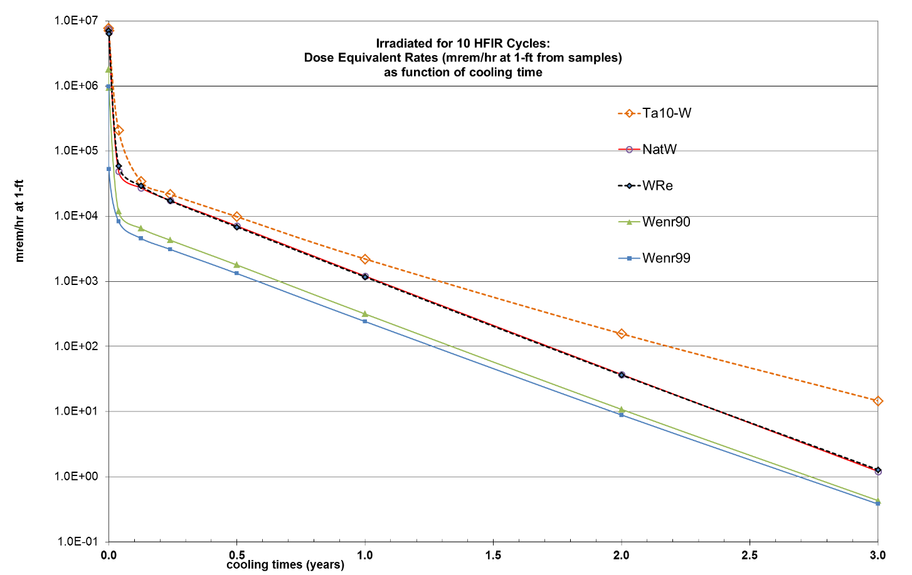



1. DIFFERENCES IN SNS AND HFIR IRRADIATIONS

APPENDIX C. DIFFERENCES IN SNS AND HFIR IRRADIATIONS

To compare the relative effects of irradiating tungsten samples in the flux trap region of HFIR and in a target site in SNS, a series of dose rate and radionuclide activity calculations were completed for two similar irradiation scenarios: (1) the SNS irradiation scenario (spallation neutrons and residual high-energy protons) was calculated for 2 years at the center of the SNS target location designated “rod\_3 cm” with a nominal beam power of 1.4 MW and (2) the corresponding HFIR neutron irradiation was taken to be 14 HFIR cycles (equivalent to seven cycles per year in HFIR for 2 years). The irradiation time duration for this comparison was taken to be 2 full years for both SNS and HFIR, for consistency between the simulation models.

In Table C.1, the most active radionuclides in the tungsten samples (and the percentage differences in their activities) are tabulated for the SNS and for the HFIR irradiations. As shown in Table C.1, the radionuclide compositions of the irradiated tungsten samples are very different for the two irradiations because the reaction channels are very different for neutron irradiations in HFIR and neutron/proton irradiations in SNS. The DPA damage level for the natural tungsten samples is similar in the HFIR irradiation (14 DPA) and in the SNS irradiation (13 DPA).

Table C.1. Differences in radionuclide composition (in terms of percentage of total activity) for natural tungsten samples irradiated for 2 years in HFIR and in SNS. The 12 topmost active radionuclides are listed for each case, at zero cooling and after 1 year cooling periods.

|  |  |  |  |  |  |  |  |
| --- | --- | --- | --- | --- | --- | --- | --- |
| **SNS: Zero Cooling** | | **HFIR: Zero Cooling** | | **SNS: 1-Yr Cooling** | | **HFIR: 1-Yr Cooling** | |
| W-187 | 45.5 | Re-188 | 42.5 | W-185 | 21.0 | W-185 | 89.5 |
| W-183m | 24.0 | W-187 | 27.5 | W-181 | 19.9 | Re-188 | 4.80 |
| W-185 | 5.35 | Os-189m | 6.32 | H-3 | 16.7 | W-188 | 4.75 |
| Re-188 | 2.65 | Re-186 | 6.07 | Ta-179 | 12.4 | Ir-192 | 0.916 |
| W-185m | 1.60 | W-183m | 4.61 | Lu-173 | 7.07 | W-181 | 0.0602 |
| W-181 | 1.41 | W-185 | 4.15 | Lu-172 | 4.93 | Pt-193 | 0.0193 |
| Re-186 | 0.991 | Os-191m | 2.24 | Hf-172 | 4.88 | Ir-194 | 0.00158 |
| Ta-178 | 0.385 | Os-191 | 1.42 | Sm-145 | 2.00 | Os-194 | 0.00158 |
| W-179 | 0.384 | Ir-191m | 1.42 | Pm-143 | 1.79 | Os-185 | 0.00126 |
| Ta-177 | 0.357 | Re-188m | 1.14 | Dy-159 | 1.48 | Ta-182 | 0.000351 |
| Ta-183 | 0.353 | Ir-194 | 1.03 | Ce-139 | 1.06 | Os-191 | 0.000082 |
| Yb-169 | 0.310 | Ir-192m | 0.961 | Ta-182 | 0.972 | Ir-191m | 0.000082 |

Radionuclide compositions for the two irradiation samples are so different in these two irradiation environments, and the gamma source strengths and spectra from the two tungsten samples yield different trends in the dose rates. Table C.2 compares rem/hr dose rates at a distance of 1 ft (about 30 cm) from the SNS and HFIR samples at various cooling times. To provide appropriate results for comparison, the dose rates are presented in rem/hr and are for tungsten samples of 1 cm3 (about 19.3 g in mass). Note that this simulation sample size is much larger than the sample size considered for the HFIR disk sample irradiation results presented in the neutronics section.

Table C.2. Comparison of dose rates for tungsten sample irradiations in HFIR and SNS for 2 full years. The dose rates are in rem/hr for 1 cm3 of tungsten sample (~19 g of tungsten).

|  |  |  |  |
| --- | --- | --- | --- |
| **Cooling time** | **Zero** | **6 months** | **1 year** |
| Enriched W (90 wt% W-182) in HFIR | 12600 | 21.4 | 4.0 |
| Natural W in HFIR | 49300 | 64.6 | 10.6 |
| Natural W in SNS | 2990 | 21.0 | 12.0 |

In comparing the behavior of natural tungsten irradiated in HFIR or in SNS for 2 years, it is apparent that the dose rate from the HFIR sample is much higher at shorter cooling times but will be less than that from SNS after 1 year of cooling.

Similar length irradiations in HFIR and SNS produced about the same level of DPA damage in the irradiated samples. The dose rates for the samples from HFIR were found to be significantly higher for short cooling times but less than those for the SNS-irradiated samples after a cooling time of 1 year. The use of tungsten enriched in 182W (90–99 wt%) significantly reduced the sample activity and dose rate.

1. PLASMA-FACING COMPONENTS EXPOSED TO HIGH THERMAL FLUXES

APPENDIX D. Plasma facing components exposed to high thermal fluxes

J. Rapp

Draft, February 15th 2012

In future fusion devices the plasma facing components are exposed to unprecedented heat fluxes. During steady-state operation 10 MW/m2 are foreseen, while transiently up to several GW/m2 are expected. High flux components must be developed, and they must have a reasonably long lifetime in order to maximize the availability and hence the economic viability of a fusion reactor. This is a major new challenge, when compared to other engineering challenges. For example the nose of the space shuttle or a space glider has to withstand power loads of about 1 MW/m2 at the tip during reentry. Here the “plasma” facing components (e.g. silicon carbide composites) are only inertially cooled. On the other hand rocket nozzles of big new rockets like the ARIANE 5 or the booster rocket for the space shuttle experience heat loads of 50-100 MW/m2. However, those components have only a lifetime of a few minutes. A fusion reactor plasma-facing component should have a lifetime of a few years at least.

1. Steady-state heat fluxes

The maximum steady-state power fluxes to the plasma facing components (PFCs) are determined by the heat sink structure and the cooling solution. Currently 10 MW/m2 [Merola10] is taken as design requirement for the ITER carbon fiber composite (CFC) divertor PFCs. The tungsten monoblocks on the upper vertical target (baffle region) are designed for a heat removal of 5 MW/m2. Tungsten heat flux components for the lower vertical target for a thermal load of 10 MW/m2 are currently being designed. For a fusion reactor the divertor has not been designed yet. The more challenging conditions will require new sophisticated design solutions. Joining techniques have to be developed and qualified. The material mix at the transition between the plasma-facing material and the heat sink structure material has to fit the temperature range and gradient in the PFC or vice versa. The design challenge is amplified by the wish to limit the divertor materials to low-activation materials. For heat sink components this might be challenging or even impossible [Rieth11]. To allow a reliable divertor design with practical heat extraction systems might require a lower power flux to the plasma facing components. In Europe it has been agreed to develop designs for DEMO with divertor power loads of 5 MW/m2 [Rieth09]. This would of course require a stronger reduction of the power fluxes from the plasma core to the plasma-facingcomponent, which has to be achieved by impurity radiation or novel divertor concepts.

* 1. M. Merola et al., *ITER plasma-facing components* Fus. Eng. Des. 85 (2010) 2312-2322
  2. M. Rieth, *International tungsten development efforts and the gas cooled divertor design* ICFRM-15 (Charleston, SC, USA, October 16-22, 2011)
  3. M. Rieth, EFDA Technical Meeting on DEMO (Garching, Germany September 29-30, 2009)

1. Transient heat fluxes

On top of the steady-state power fluxes transient heat fluxes will occur in fusion reactors. They are created by instabilities in the plasma, which can expel several GW/m2 in a time scale of ms [Federici03]. The so-called ELMs (Edge Localized Modes) are instabilities that appear frequently during normal tokamak operation. Their magnitude depends on the plasma stored energy and the collisionality of the plasma [Loarte03]. High confinement regimes will have ELMs that are likely too large for the plasma-facing materials, and will need mitigation with appropriate methods. Abnormal events like disruptions will expel even more energy to the PFCs on short time scales (several ms). Their appearance is difficult to control.

Mitigation techniques exist, however those techniques are not fully reliable yet. The tolerance to those transient heat loads is dictated by the material choice.

Carbon based materials such as graphite, CFCs and SiC-composites are mostly forgiving to transient heat loads. In the worst case carbon sublimates. Cracking of the surface is not observed. However, the lifetime of the carbon based PFCs will be strongly impacted by the transient heat loads. Metals, like tungsten or molybdenum, on the other hand will melt in the worst case. The melt layer loss will then determine the lifetime of the PFC. But before melting occurs, at temperature significantly below the melting temperature recrystallization takes place, which will have a detrimental impact on the brittleness of refractory metals. Furthermore the thermal shocks lead to cracks in the metal surface extending to some degree into the bulk of the PFC.

The maximum allowable transient heat load is defined by the acceptable margin between the DBTT as the minimum temperature and the lowest temperature at which crack formation and recrystallization occur. In ITER the maximum allowed transient energy load is 0.5 MJ/m2 [Pitts11].

1. G. Federici, A. Loarte, G. Strohmeyer, *Assessment of erosion of the ITER divertor targets during type-I ELMs,* Plasma Phys. Control. Fusion 45 (2003) 1523
2. A. Loarte et al., *Characteristics of type-I ELM energy and particle losses in existing devices and their extrapolation to ITER*, J. Nucl. Mater. 40 (2003) 845
3. R.A. Pitts et al., *Physics basis and design of the ITER plasma-facing components,* J. Nucl. Mater. 415 (2011) S957-S964
4. Parallel to perpendicular heat fluxes

Parallel power fluxes from the main plasma have to be transformed into acceptable perpendicular power fluxes, compliant with the limits mentioned above, namely steady-state heat fluxes and transient heat fluxes. With constant parallel power fluxes the perpendicular power fluxes can be reduced by a good divertor design and to some degree with optimized magnetic configurations. The approach for minimizing the perpendicular power fluxes is simply summarized:

* Maximizing toroidal wetted fraction (TWF)
* Maximizing ratio of tile length to gap
* Minimizing tolerances in design and assembly
* Maximizing the toroidal magnetic field line angle to the plasma facing material (|) by lowering q95 and increasing the distance from X-point to target strike point in magnetic configurations
* Increasing poloidal wetted fraction
* Increasing poloidal flux expansion in divertor
* Decreasing angle between target and field line in poloidal plane

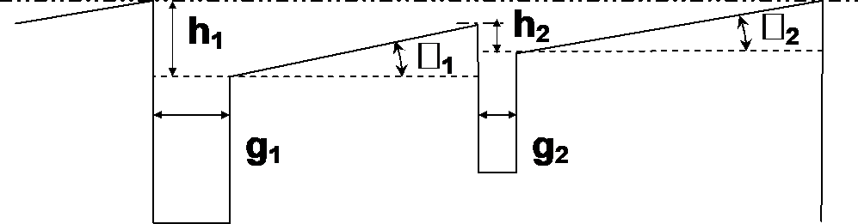

Figure D.1. Divertor tile geometry with two tiles and different gaps and shadowing.

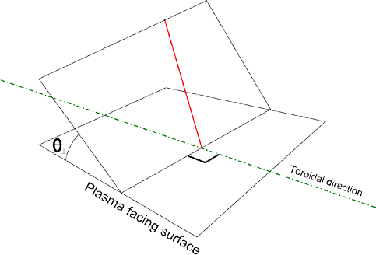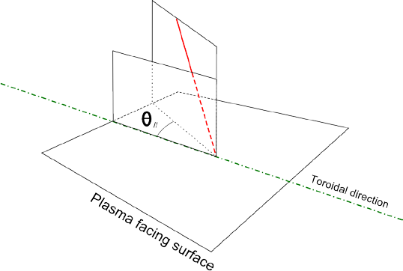

Figure D.2. Definition of | and ||.

In ITER for standard inductive scenarios with q95=3 the typical | values are 2.5 degrees on the outer vertical target strike point and 3 degrees on the inner vertical target strike point. The shadowing to leading edges in toroidal direction makes a tilting of the target modules by an angle  necessary.  has to be at a minimum 0.11 degree to shadow plasma configurations down to a q95 of 2.3. 0.8 degree is necessary to account for the material loss at the end of the divertor lifetime. In addition tolerances from the manufacturing and the assembly have to be taken into account. Typically another 0.1 degree has to be taken into account for those tolerances. This brings the total angle (| plus ) to about 4 degrees. In the worst case another degree has to be added to account for tolerances resulting from local different heat expansion. This could be an issue appearing towards the end of the PFC lifetime. At 4 degrees the ratio between parallel to perpendicular heat flux is about 14. For 10 MW/m2 perpendicular heat flux this would translate into 140 MW/m2 parallel heat flux. However, as already mentioned above, the maximum perpendicular heat flux might rather only be 5 MW/m2. In this case the parallel heat flux is about 70 MW/m2. It should be also noted that the maximum convected power flux in the partial detached divertor operation is not at the strike point, but a little further into the scrape-off-layer.

The following Table D.1 summarizes the power fluxes to be expected in ITER and compares those with the ones achieved in a linear plasma generator, Pilot-PSI,which makes use of a cascaded arc source, and those being considered as the design values for the future device PMTS.

Table D.1.

|  |  |  |  |  |
| --- | --- | --- | --- | --- |
|  | **P| [MW/m2]** | **P|| [MW/m2]** | **Angle**  **  |** | **Comment** |
| ITER, CFC monoblock | 10 | 140 (110) | 4 (5) | Design values |
| ITER, W monoblock | 5 | 70 (55) | 4 (5) | Design values for upper vertical target |
| Reactor | 5 |  |  | EU assumptions |
| Pilot-PSI | 80 | 80 | 90 | Achieved max |
| MPEX | 2 (3) | 30 | 4 (5) | Design values |
| MPEX | 5 | 30 | 10 | Design values |
| MPEX | 10 | 30 | 20 | Design values |

1. Physics at small angles of magnetic field line to the plasma facing surface

As stated above the angle between the magnetic field line and the plasma-facing component is in the region of 4 - 5 degrees in future fusion reactors. At small angles between the magnetic field and the surface the sheath and pre-sheath might become more important. In a simplified view the ions and electrons undergo a longer path through the sheath and pre-sheath. In the parameter range of future fusion reactors ions sputtered from the surface will get ionized in the sheath and will then subsequently get accelerated towards the surface again [Brooks90]. This process is particular important for tungsten ions, where a large fraction of the sputtered tungsten is so re-deposited immediately. Furthermore the ion energy of the re-deposited tungsten is low, since the mean charge state the sputtered tungsten is ionized to is much lower in the case of oblique incidence sheath [Brooks90]. This can make a large difference in the erosion and re-deposition behavior in high divertor Te cases. However, no statistically significant differences were observed for tungsten between magnetic field line angles of 1 to 10 degrees [Brooks90]. The aforementioned results were obtained with fluid plasma codes [Brooks90]. Recently this problem has been re-assessed with kinetic plasma codes (particle-in-cell codes and Vlasov Eulerian code) [Tskhakaya05, Tskhakaya10, Devaux06, Devaux08, Ohya11].

Secondary electron emission can lower the potential drop over the sheath [Ohya11]. Evidence of strong secondary electron emission has been found already in tokamaks [Gunn12]. This secondary electron emission effectively reduces the ion energy of the impinging ions and change the erosion yield. However, if the surface is tilted with respect to the magnetic field to very shallow angles, electrons being reflected from the surface or being emitted as secondary electrons will be re-absorbed by the surface to a large fraction after only one gyro-motion. 5 degrees seems to be sufficient to re-absorb almost all secondary electrons [Ohya11]. Otherwise the ion energy distribution does not depend on the angle of the magnetic field at all, whereas the gyro-motion strongly affects the impactangle of the ion [Ohya11]. For shallow angles of 5 degrees the angle of incidence of the ions is a distribution function with its maximum at about 20 degrees and a minimum of zero at 0 degrees and larger than 40 degrees. Contrary to Ohya’s statement Devaux found that the ion energy distribution is affected by the magnetic-field line angle [Devaux08]. In his simulations the average kinetic energy of the impinging ions drops significantly from normal incidence to 10 degrees resulting in a reduction of the sputtering yield.

From the above mentioned effects one can conclude that a field-line angle of about 5 degrees is probably low enough to cover all the physics related to the secondary electron emission. Prompt re-deposition of eroded ions will be affected in the same manner. Since the angle of incidence of ions coming towards the surface is on average substantially larger than the angle of the magnetic field to the target, an investigation of very shallow angles between the magnetic field and the target is not necessary. A reduction of the sputtering yield due to a reduced average kinetic energy of the impinging ions, if present, should be observable already at field-line angles of 10 or 20 degrees.

* 1. J.N. Brooks *Near-surface sputtered particle transport for an oblique incidence magnetic field plasma,* Phys. Fluids B 2 (1990) 1858
  2. D. Tskhakaya, S. Kuhn, *Kinetic (PIC) simulations of the magnetized plasma- wall transition,* Plasma Phys. Control. Fusion 47 (2005) A327
  3. D.D. Tskhakaya, F. Bint-E-Munir, S. Kuhn, *Magnetized plasma-wall transition layer with cold ions,* J. Plasma Physics 76 (2010) 559
  4. K. Ohya *Progress in modeling erosion and redeposition on plasma facing materials* J. Nucl. Mater. 415 (2011) S10-S18
  5. S. Devaux, G. Manfredi *Vlasov simulations of plasma-wall interactions in a magnetized and weakly collisional plasma*, Phys. Plasmas 13 (2006) 083504
  6. S. Devaux, G. Manfredi *Magnetized plasma-wall transition – consequences for wall sputtering and erosion,* Plasma Phys. Control. Fusion 50
  7. J.P. Gunn *Evidence for strong secondary electron emission in the tokamak scrape-off layer* Plasma Phys. Control. Fusion 54 (2012) 085007

1. COLD HIGH-DENSITY DIVERTOR PLASMAS IN FUTURE FUSION REACTORS

APPENDIX E. Cold high density divertor plasmas in future fusion reactors

J. Rapp

February 22nd, 2012

In addition to the rich field of plasma surface interactions the plasma physics itself will be different. In the conditions expected in future fusion divertor plasmas at densities of several times 1021 m-3 and at the low plasma temperatures of a 1 eV or even less the divertor plasma is close to the strongly coupled limit, where the kinetic energies are in the same range or lower than the interaction potential energies. This has a strong impact on the plasma chemistry and atomic physics. The understanding of those processes in the strongly coupled regime is difficult and its science has to be developed. In the following table an overview of the important plasma parameters in such a cold high density plasma are given.

Table E.1.

|  |  |  |
| --- | --- | --- |
|  | **ITER** | **DEMO, Reactor, extreme** |
| ne | 3 x 1021 m-3 | 6 x 1021 m-3 |
| Te | 1 eV | 0.5 eV |
| ve | 4.2 x 105 m/s | 2.9 x 105 m/s |
| vi | 9.8 x 103 m/s | 6.7 x 103 m/s |
| ln☹ electrons/ions) | 6.6/5.3 | 5.6/3.9 |
| D | 1.4 x 10-7 m | 6.6 x 10-8 m |
| ie | 1.8 x 10-11 s | 7.1 x 10-12 s |
|  = 1/n D3 | 0.12 | 0.58 |

As one can see from table B1 the Debye length becomes several nanometers in the most extreme case. In this short Debye length large angle scattering of electrons and ions becomes more important. But also the chances of dust formation in suspension become larger as does the agglomeration of dust particles.

 is a parameter introduced to characterize the coupling of the plasma. At  << 1 the plasma regarded as ideal for  > 1 the plasma is regarded as non-ideal or strongly coupled. In this latter case the interaction potential energy is in the same range as the kinetic energies. The behavior of such a system is more liquid-like [Bonitz10]. In such a system the movement of the ions is strongly correlated. This has profound effects on the plasma.

The consequences of this physics and chemistry understanding are absolutely necessary for the interpretation of the optical emission spectroscopy in fusion reactor grade divertor plasmas. This has connections to other fields of science where similar strongly coupled plasmas are found like in high pressure arc discharges as well as the plasmas which constitute the atmosphere of collapsed objects such as white dwarfs (although their densities are much higher). Examples for the changed physics and chemistry in such cold and high density plasmas have already been found in cascading arc discharges. It was found that the dissociation of methane in those cold high density plasmas is not dominated by electron impact, but rather by charge exchange processes followed by dissociative recombination [ Westerhout09, Westerhout10].

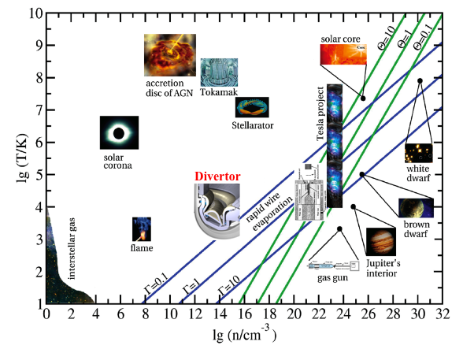

Figure E.1. Density – Temperature plane with typical values for the plasma parameters  and . Here  = 0.1 is the boundary of strongly coupled plasmas. The parameters  is proportional to n D3. From R. Redmer: Strongly Coupled Plasmas [Redmer05].

In these strongly coupled plasmas the formation of dust in suspension is much more likely. This regime will open the vast physics of such dusty plasmas [Bonitz13], which includes the charging of dust grains, dust dynamics under the influence of various forces, as well as collective interactions such as waves and instabilities. The dust particles introduce vastly different length scales into the problem of plasma surface interactions. Several fundamental assumptions in basic plasma physics are violated – the Debye screening length loses its meaning – only one example which will complicate the theory and the understanding of those plasmas. This is not only interesting for nuclear fusion applications, but also for general dusty plasma research and materials synthesis. For example, a dense cloud of nanoparticles in a plasma might act like a meta-material with completely new properties [Sakai12]. In the divertor plasma dust particles are confined by the magnetic field. The system size and the magnetic field strength will determine the concentration and the maximum size of the dust particles. Their growth rate, in the relevant size range, scales approximately quadratically with their concentration. The so generated dust in suspension will of course interact with the material surface and will get deposited, thereby adding to the complexity of the surface morphology in this regime. Already first indications of this dust formation and interaction with the material surface have been found in plasma generators producing this high density. They cluster together on the surface in cauliflower-like structures [Bystrov11]. The growth of those cauliflower-like structures is important for the understanding of the tritium inventory of fusion reactors.

Furthermore, in these high density plasmas radiation transport will play a larger role [Reiter02]. The plasma will be optically thick, which strongly affects the overall transport and energy balance picture. It has a particularly strong effect in the highly radiating partially detached divertor plasmas and can affect the plasma detachment process significantly. A fundamental understanding of the radiation transport in those high density plasmas is necessary.

1. M. Bonitz, C. Henning and D. Block *Complex plasmas: a laboratory for strong correlations* Rep. Prog. Phys. 73 (2010) 066501
2. R. Redmer: *Strongly Coupled Plasmas*, Lect. Notes Phys. 670, 117-133 (2005) Springer Verlag Berlin Heidelberg 2005
3. J. Westerhout, N.L. Lopes Cardozo, J. Rapp, G.J. van Rooij, *CH spectroscopy for carbon chemical erosion analysis in high density low temperature hydrogen plasma* Appl. Phys. Lett. 95 (2009) 151501
4. J. Westerhout et al., *The breakup of methane under ITER divertor hydrogen plasma conditions for carbon chemical erosion analysis with CH spectroscopy* Nucl. Fusion 50 (2010) 095003
5. M. Bonitz, H. Kaehlert, T. Ott and H Loewen *Magnetized strongly coupled plasmas and how to realize them in a dusty plasma setup* Plasma Sources Sci. Technol. 22 (2013) 015007
6. Osamu Sakai and Kunihide Tachibana *Plasmas as metamaterials: a review* Plasma Sources Sci. Technol. 21 (2012) 013001
7. K. Bystrov et al., J. Nucl. Mater. 415 (2011) S149
8. D. Reiter, S. Wiesen and M. Born *Towards radiation transport modeling in divertors with the EIRENE code* Plasma Phys. Control. Fusion 44 (2002) 1723
9. COMPLEXITY OF FUSION REACTOR MATERIAL SURFACES

APPENDIX F. Complexity of fusion reactor material surfaces

J. Rapp

April 22nd, 2013

In addition to the high flux exposure the plasma-material system under these extreme conditions is characterized by its complexity. The solid is strongly coupled to the plasma. In case of metals the complexity is increased by adding a liquid layer which is exposed not only to the plasma pressure but also to strong electromagnetic forces. The complexity of those so-called multiphase plasma-material systems is huge. The understanding of this so-called strongly coupled plasma surface interaction regime [Kleyn06] is essential for the design of the next step fusion device in the US, a Fusion Nuclear Science Facility (FNSF) and fusion reactors beyond (e.g. DEMO). In this regime the mean free path of the erosion products is smaller than the typical scale length of the system, which is determined by the magnetic field the plasma density, the electron as well as the ion temperature and the particular geometry of the target with respect to the magnetic field. This essentially means that the erosion products are trapped in the plasma and return to the surface in a modified form (as neutral or ionized molecules, dissociated atoms or ions or possibly as dust in form of nano-particles). Hence the plasma surface interaction determines the plasma composition in front of the target and has a feedback effect on the plasma surface interactions locally. This feedback effect will strongly modify the surface morphology in a non-linear way. The surface morphology is characterized by multi-scale dimensional changes. A rich variety of nano-structures are being observed in other devices: e.g. nano-tubes, nano-spheres and nano-pillars [Ohno09, Bystrov11]. The size variation is often in very narrow ranges depending on the magnetic field. In addition cauliflower like structures (Figure F.1) are sometimes observed, which grow to much larger sizes of several m in an irregular way. These structures can become so large that they eventually even peel-off during transient power flux excursions. The stability of these surface layers is of utmost importance, determining large-scale erosion processes, which should be avoided as much as possible since they can have very detrimental effects on the plasma core performance of a fusion device due to instantaneous release of a large particle source.

|  |  |
| --- | --- |
| Description: Description: Fig2 | Figure F.1. Formation of cauliflower structures at high density and high ion fluxes obtained in the device Pilot-PSI [Bystrov11]. |

Understanding of the formation of those cauliflower structures is not only important for the fusion applications. It could also give insights to other sciences. The formation of actual cauliflowers might be described by similar mathematical models [Castro12].

Similar effects are expected with tungsten plasma facing materials where, at high fluence of H and He, grain ejection or delamination of nano-structures from the surface might occur. These ejected grains [Ueda07] might be trapped in the plasma in front of the target and, after returning to the surface, alter it significantly. Neutron irradiation might enhance these effects. Increased dust formation in neutron irradiated target samples was seen in electron beam experiments [Linke13] already. Such modifications of the surface will be only visible in experiments, which can capture the electric field in the sheath, as well as have a sufficient magnetic field to confine the dust particles in the plasma.

As interesting as the formation of those complex surface structure is the consequences arising from those complex structures.

The erosion of the deposited surfaces will be altered due to the morphology of the surface and the composition of the surface layers. Thermally loosely bound deposition layers will have increased surface temperatures, which will change erosion yields. The surface area will increase by the increased roughness, possibly leading to effectively lower ion flux densities to the surface, which will in itself have an effect on the chemical erosion yield of carbon for example. However, it is not clear how the plasma will interact with surface areas, which are not in direct line-of-sight in those complex 3D-nanostructures. In addition the surface potential might be influenced leading to unipolar arcing. This was actually already observed in a toroidal device [Tokitani11]. The field enhancement factor on nano-structured tungsten was found to be ~200 [Kajita13]. The field emission current from the surface adjacent to the plasma is significantly increased. Together with the increased surface temperature due to reduced heat conductivity of the nano-structured surface unipolar arcing is triggered [Kajita13].

Understanding of the fundamental processes leading to the formation of these complex structures might open routes to control the surface morphology changes by acting on the plasma parameters or their composition in front of the surface. In addition the findings from the surface morphology changes might even give insights in self-organized assembly of complex structures, which could possibly lead to an equilibrium via self-passivation or self-healing processes.

1. A.W. Kleyn, W. Koppers, N. Lopes Cardozo *Plasma-surface interaction in ITER* Vacuum 80 (2006) 1098
2. N. Ohno et al., *Spherical cauliflower-like carbon dust formed by interaction between deuterium plasma and graphite target and its internal structure* J. Nucl. Mater. 390-391 (2009) 61
3. K. Bystrov et al., *Erosion yields of carbon under various plasma conditions in Pilot-PSI* J. Nucl. Mater. 415 (2011) S149
4. M. Castro et al., *Universality of cauliflower-like fronts: from nanoscale thin films to macroscopic plants* New Journal of Physics 14 (2012) 103039
5. Y. Ueda et al., *Development of tungsten materials for plasma facing components in Japan* Fusion Sci. Technol. 52 (2007) 513
6. J. Linke et al., *High heat flux test facilities for plasma facing components in future fusion reactors*, PMIF 2013, Oak Ridge, TN, September 9-13, 2013.
7. M. Tokitani et al., *Exfoliation of the tungsten fibreform nanostructure by unipolar arcing in the LHD divertor plasma* Nucl. Fusion 51 (2011) 102001
8. S. Kajita et al., Impact of arcing on carbon and tungsten: from the observations in JT-60U, LHD and NAGDIS-II
9. IMPACT OF NEUTRON IRRADIATION ON PLASMA FACING MATERIALS AND COMPONENTS

APPENDIX G. Impact of neutron irradiation on plasma facing materials and components

J. Rapp, V. Philipps

February 7th, 2012

A new era of fusion research has started with ITER under construction and DEMO for power demonstration on the horizon. However, the related fusion reactor material science requires further development before DEMO can be designed. One of the most crucial and most complex outstanding science issues to be solved is the plasma surface interaction (PSI) in the hostile environment of a nuclear reactor. Not only are materials exposed to unprecedented steady-state and transient power fluxes, but they are also exposed to unprecedented neutron fluxes. Both the ion fluxes and the neutron fluxes will change the properties and the micro-structure of the plasma-facing materials (PFM) significantly.

Hydrogen and helium together with neutron created defects will undergo synergistic effects, which are only partly understood in future plasma facing materials such as tungsten. No data exist with fast fusion neutrons, He production and high power plasma fluxes to the plasma facing surfaces from which deuterium and tritium can diffuse long distances into the bulk material. In particular no data at all exist on synergistic effects resulting from the aforementioned ion and neutron exposures. However, synergistic effects of neutron and ion bombardment might very likely amplify issues such as degradation of power handling capability, tritium retention, lifetime limitation, impurity and dust production.

Ions from the thermal divertor plasma or the far scrape-off-layer impinging on the divertor targets and main chamber walls respectively can change the structure of the surface in the region of the ion implantation zone (few to 10 nm in depth). The implanted hydrogen isotopes will diffuse into the bulk material far beyond the implantation range. Fusion neutrons damage the material in the implantation zone and far deeper. This damage has a strong influence on the bulk material by a variety of effects and will also change the properties of the plasma-facing surface of the material. With increasing neutron fluence the thermal properties of the material will degrade resulting in an increase of surface temperature due to the reduction in thermal conductivity. This will increase the hydrogen retention and increase the erosion yield due to an enhanced possibility of evaporation and increased sputtering by microstructure changes within the grains. Dust production might be enhanced due to changes in the microstructure at the grain boundary and embrittlement leading even to ejection of whole grains. Furthermore, the interstitials and vacancies in the bulk material created by neutrons will open up new trapping sites and transport channels for hydrogen isotopes and helium strongly affecting their concentration and profile in the material. These promote the formation of blisters and nano-structures on the surface, with the possibility of further enhancing the erosion and degrading the mechanical integrity of the PFCs.

Altogether the synergistic coupling of high plasma fluxes and neutron irradiation can have severe impact on the surface and bulk material properties and integrity of the plasma facing component. These will lead to a reduced lifetime of the plasma-facing component and increase the impurity production due to sputtering and dust production. The higher surface temperatures will reduce the tolerance to transient heat loads as the margins to sublimation, cracking, recrystallization and melting are reduced. An adjustment of the cooling to compensate for the strongly reduced thermal conductivity is technically not possible. Swelling will change the shape of the PFC. This will have to be taken into account in the design of the PFC, leading to a reduced power handling capability.

In this document we summarize the present understanding of the effects of neutron irradiation on plasma facing materials, identifying direct and indirect synergistic coupling effects of the neutron material interaction and the plasma material interaction.

1. Influence of transmutation products on properties of PFCs

Neutron irradiation of materials leads to the formation of transmutation elements in the material, which will change their properties. This transmutation production is neutron fluence and spectrum dependent. Furthermore the final structure of the irradiated materials depends on irradiation temperature. The by far most important transmutation product is helium since it has very strong effects on the material properties. This is basically due to the very low solubility of He in metals leading to precipitation of He in defects with lower electron density. These defect sites are vacancies, vacancy clusters, dislocations and grain boundaries. In general He precipitation tends to enhance the formation of bubbles and voids. He-precipitation at the grain boundaries weakens the mechanical stability of the materials, leading to He embrittlement.

For low-Z materials the He-transmutation is very large. In Be the Helium production is He/dpa~1000 for the fusion neutron spectrum [Barabash03].

For high-Z materials like W however the He-transmutation is negligible, which is a clear advantage of high-Z materials. Instead the production of solid transmutants due to neutron capture or decay elements is more important. The main transmutant elements for tungsten are Re and Os. Calculations show that that pure W will become W-18Re-3Os after the irradiation up to 50 dpa at the first wall [Hasegawa11]. The effects of transmutation elements on material properties of W are complicated and only very few data exist both on the rate of transmutation and also on the influence of properties such a thermal conductivity and mechanical behavior. Research is going on to address the uncertainties related to the production of transmutants.

The effects of the transmutants are manifold. They change the chemical composition, have an influence on the Ductile to Brittle Temperature Threshold (DBTT), thermal conductivity, hydrogenic retention and possibly erosion. Their effects are being discussed in the following subsections.

Tailoring the relative fractions of the tungsten isotopes in the material would make it possible to avoid some of those drawbacks resulting from the transmutants [Gilbert11]. Natural occurring tungsten is made of 5 isotopes 180W, 182W, 183W, 184W and 186W from which the isotopes 184W and 186W contribute together to 60% of the total. But unfortunately those isotopes are responsible for the high production of the transmutants Re and Os. Tailoring the tungsten material to the lighter isotope 182W by enrichment techniques would allow a much reduced concentration of Re and Os and would also lead to a much lower activation after the irradiation.

1. V. Barabash, G. Federici, J. Linke, C.H. Wu *Material/plasma surface interaction issues following neutron damage* J. Nucl. Mater. 313-316 (2003) 42
2. A. Hasegawa, T. Tanno, S. Nogami, M. Satou *Property change mechanism in tungsten under neutron irradiation in various reactors* J. Nucl. Mater. 417 (2011) 491
3. M.R. Gilbert and J.-Ch. *Sublet Neutron-induced transmutation effects in W and W-alloys in a fusion environment* Nucl. Fusion 51 (2011) 043005
4. Brittleness

Brittleness is an unwanted characteristic of materials. A material breaks, when it is subjected to stress, without significant deformation. On the opposite a material is ductile, when it deforms plastically subjected to stress. Ductility is due to the gliding ability of metallic atoms. Their valence shell electrons are delocalized and shared by many atoms such that the atoms can move without too high repulsive forces. However, this movement might be hindered by the introduction of defects. Effectively this leads to brittleness. Alloying and nano-structuring of materials tend to pin down defects and thus avoiding their agglomeration. This is a way to minimize the effect of defects on brittleness. At too high temperatures

Brittleness leads to a non-elastic behavior of materials against mechanical and thermal shocks and must be avoided under all circumstances for structural materials. Materials for plasma facing components have to tolerate some degree of brittleness. R&D is needed to define this acceptable degree of brittleness of PFMs.

Brittleness occurs below a certain temperature, the so-called Ductile to Brittle Temperature Threshold (DBTT). This determines the low temperature limit for the use of materials and is one of the major disadvantages of refractory metals, which has a DBTT above room temperature. The brittleness and the DBTT is influenced by the neutron irradiation. The upper temperature is limited by creep. The creep limit is also enhanced by the creation and movement of defects, which is amplified by neutron irradiation. Hence the temperature operation window is expected to shrink with increasing neutron fluence.

In order to improve the brittleness of pure tungsten for example, alloying of tungsten is undertaken. Presently R&D is being carried out to identify the best alloys for tungsten. Typical tungsten alloys contain nickel and iron (Densimet) or rhenium. This lowers DBTT of the un-irradiated tungsten. Neutron irradiation particular at low irradiation temperatures will increase DBTT [Barabash00]. At low irradiation temperatures (< 500 C) the DBTT can increase up to 1000 C [Barabash00], while at higher irradiation temperatures the change in DBTT is marginal. This would mean that the high flux divertor components, where at the strike point surface temperatures in excess of 800 C are expected, the increase in DBTT due to neutron irradiation might be insignificant. However, it was found that the addition of rhenium to tungsten leads after irradiation to a more rapid embrittlement [Barabash00]. Since rhenium is also a predominant transmutant element, after high fluence irradiations an increase of DBTT might be even expected at higher temperatures.

In nano-structured alloys the situation might be different. However novel tungsten alloys and nano-structured alloys are still in the development phase.

1. V. Barabash, G. Federici, M. Roedig, L.L. Snead, C.H. Wu *Neutron irradiation effects on plasma facing materials* J. Nucl. Mater. 383-387 (2000) 138
2. V. Barabash, G. Federici, J. Linke, C.H. Wu *Material/plasma surface interaction issues following neutron damage* J. Nucl. Mater. 313-316 (2003) 42
3. Change in micro-structure

Neutron irradiation leads to a change in the micro-structure. The neutrons lead to a sequence of knock-on atomic collisions, displacing lattice atoms and creating self-interstitial atoms and vacancies (Frenkel pairs). A large part will annihilate directly in the defect spike. Some of the interstitials and vacancies survive and diffuse, with interstitials moving much faster. Those interstitials and vacancies can cluster to dislocation loops and vacancy clusters respectively. Large vacancy clusters then ultimately lead to large voids [Cottrell03]. In tungsten a void lattice is formed at irradiation levels of 1.54 dpa [Tanno09]. The size of those voids is 4.7 nm and their spacing is 15 nm. In W irradiated to less than 0.4 dpa small voids (2-3 nm) are formed, which are distributed randomly. Generally the neutron irradiation increases the W-Re lattice constant [Fujitsuka00]. This effect is largest at high Re concentrations though. As the neutron irradiation fluence increases radiation hardening occurs due to precipitation [Tanno09]. Needle and plate-like precipitates were observed [Tanno09]. It would be interesting to know, how precipitation takes place in nano-structured alloys and how this does effect radiation hardening.

1. G.A. Cottrell *Void migration, coalescence and swelling in fusion materials* Fus. Eng. Des. 66-68 (2003) 253
2. M. Fujitsuka, B. Tsuchiya, I. Mutoh, T. Tanabe, T. *Shikama Effect of neutron irradiation on thermal diffusivity of tungsten rhenium alloys* J. Nucl. Mater. 283-287 (2000) 1148
3. T. Tanno, A. Hasegawa, J.C. He, M. Fujiwara, M. Satou, S. Nogami, K. Abe, T. Shishido *Effects of transmutation elements on the microstructural evolution and electrical resistivity of neutron-irradiated tungsten* J. Nucl. Mater. 386-388 (2009) 218
4. Impact of neutron irradiation on tritium retention

Many investigators around the world have taken up the issue of hydrogenic retention in plasma facing materials. While for carbon and beryllium the hydrogenic retention in a fusion device is determined mainly by the co-deposition of hydrogen with the erosion products coming from the main chamber wall via poloidal flows into the divertor, the hydrogenic retention in all-refractory metal devices (tungsten and molybdenum) is mainly determined by its hydrogen inventory in the bulk of the material. The hydrogen isotopes are trapped in natural trap sites, resulting from lattice imperfections; grain boundaries and hydrogen produced trap sites and they will be trapped in neutron produced trap sites. Hence it is expected that the neutron irradiation will increase the hydrogenic retention in the refractory metals. In most investigations the neutron irradiation is mimicked by high-energy ion irradiation [Wampler09, Tyburska09, Wright10b, Ogorodnikova11, Hoen12, Shimada11, Khripunov11]. Mostly self-implantation is used to create the damage and accumulate the displacements per atom. Only in one study neutron-irradiated tungsten was exposed to plasmas [Shimada11]. For low flux plasma exposures (1022 ions m-2 s-1) as well as for high flux plasma exposures (1024 ions m-2 s-1) a saturation of retention at about 0.5 dpa was found [Tyburska09, Hoen12]. Most of the trap sites can be annealed at high temperatures [Tyburska09]. However, large fluxes can induce trap sites itself in the implantation zone [Ogorodnikova08]. The pressure due to high hydrogen fluxes can be so large that cracks are formed to release the stress [Tyburska09]. Additional neutron irradiation might elevate this by effectively increasing the solubility of hydrogen in the damaged tungsten, which might then reduce the pressure in the implantation zone. Simultaneously, hydrogen is able to reach trap sites deeper in the material by this increased solubility [Wampler09, Wright10b]. This can then increase the hydrogen retention in particular at high temperatures when Fraunfelder diffusion is high [Wright10b].

The addition of transmutant elements to pure tungsten might change the hydrogen retention. Golubeva et al. [Golubeva07] studied this in rhenium-doped tungsten. They came to the conclusion that Re itself does not lead per se to an increased hydrogen retention. However, structural changes do change the hydrogen retention. Those structural changes will occur of course during neutron irradiation but also occur during the process of adding alloying elements to a pure tungsten material. Currently W-Ta alloys are under investigation. It is well known that Ta is able to dissolve large amounts of hydrogen [Pick79]. However, preliminary results indicate that the deuterium retention in W-Ta alloys does not differ significantly from pure W samples [Zayachuk11].

The influence of deuterium retention in neutron-irradiated tungsten has been investigated by Shimada et al. [Shimada11]. Tungsten samples were exposed to fast fission neutrons (E > 0.1 MeV) in HFIR up to damage levels of 0.025 dpa. Those samples were subsequently exposed to plasmas in the TPE experiment. Some increase (40%) in the deuterium retention was observed in the neutron-irradiated tungsten samples. But as high energy ion irradiated tungsten experiments have demonstrated the saturation of hydrogenic retention is expected at much higher damage levels than those obtained in the neutron irradiated samples. It should be noted here that the data obtained from these experiments were achieved in conditions far away from the fusion reactor conditions (dpa levels 1 – 2 orders of magnitude below, neutron energy levels 2 order of magnitude below, ion fluxes 2 orders of magnitude below and ion energies 1 order of magnitude above the fusion reactor conditions).

1. O.V. Ogorodnikova, J. Roth, M. Mayer Ion-driven deuterium retention in tungsten J. Appl. Phys. 103 (2008) 034902, doi: 10.1063/1.2828139
2. B. Tyburska, V.Kh. Alimov, O.V. Ogorodnikova, K. Schmid, K. Ertl *Deuterium retention in self-damaged tungsten* J. Nucl. Mater. 395 (2009) 150
3. W.R. Wampler and R. Doerner *The influence of displacement damage on deuterium retention in tungsten exposed to plasma* Nucl. Fusion 49 (2009) 115023
4. G.M. Wright, E. Alves, L.C. Alves, N.P. Barradas. P.A. Carvalho, R. Mateus, and J. Rapp, *Hydrogenic retention of high Z refractory metals exposed to ITER divertor-relevant plasma conditions* Nucl. Fusion 50 (2010) 055004
5. A. Manhard, K. Schmid, M. Balden, and W. Jacob *Influence of the microstructure on the deuterium retention in tungsten* J. Nucl. Mater. (2010), doi:10.1016/j.nucmat.2010.10.045.
6. W.R. Wampler, D.L. Rudakov, J.G. Watkins, and C.J. Lasnier *The influence of displacement damage on deuterium retention in tungsten exposed to divertor plasma in DIII-D* J. Nucl. Mater. (2010), doi:10.1016/j.jnucmat.2010.11.043.
7. G.M. Wright, M. Mayer, K. Ertl, G. de Saint-Aubin, and J. Rapp, *Hydrogenic retention in irradiated tungsten exposed to high-flux plasma* Nucl. Fusion 50, (2010) 075006
8. O.V. Ogorodnikova, B. Tyburska, V. Kh. Alimov, K. Ertl, *The influence of radiation damage on the plasma-induced deuterium retention in self-implanted tungsten* J. Nucl. Mater. 415 (2011) xxx
9. M.H.J. ‘t Hoen, B. Tyburska-Püschel, K. Ertl, M. Mayer, J. Rapp, A.W. Klein, and P.A. Zeijlmans van Emmichoven *Saturation of deuterium retention in self-damaged tungsten exposed to high-flux plasma* to be published in Nucl. Fus. (2012).
10. A.V. Golubeva, M. Mayer, J. Roth, V.A. Kurnaev, O.V. Ogorodnikova *Deuterium retention in rhenium-doped tungsten* J. Nucl. Mater. 363-365 (2007) 893
11. M.A. Pick, J.W. Dawenport, M. Strongin, G.J. Dienes *Enhancement of hydrogen uptake rates for Nb and Ta by thin surface overlayers* Phys. Rev. Lett. 43 (1979) 286
12. Y. Zayachuk, M.H.J. ‘t Hoen, I. Uytdenhouwen, G. van Oost *Thermal desorption spectroscopy of W-Ta alloys, exposed to high-flux deuterium plasma* Phys. Scr. T145 (201) 014041
13. M. Shimada, Y. Hatano, P. Calderoni, T. Oda, M. Sokolov, K. Zhang, G. Cao, R. Kolasinski, J.P. Sharpe *First result of deuterium retention in neutron-irradiated tungsten exposed to high flux plasma in TPE* J. Nucl. Mater. 415 (2011) S667
14. Difference between irradiation by neutrons and high energy ions

The advantage of high energy ion beams with respect to irradiation is that the flux in most accelerators is much higher than the neutron flux. In this way damage of materials by displacements of atoms can be accumulated much faster than with neutron irradiations. But this advantage of accelerated lifetime tests has the disadvantage that the time for relaxations between incoming particles is much shorter in high energy ion irradiation when compared to neutron irradiations. This effect can be partly mimicked by increasing the irradiation temperature during high energy ion irradiations to increase diffusion and lower the characteristic time constants for the annihilation of Frenckel pairs.

A clear disadvantage is of course, that the high energy ion irradiation is limited to the first microns of the surface. This might change a lot in the interpretation of the data in particular with respect to H and He migration/permeation and retention. Since trap sites produced by neutrons in the bulk lead effectively to a higher solution of hydrogen in the bulk of the material, it is expected that the transport of H and He is increased. This will have an impact on the hydrogen concentrations close to the surface in the ion implantation zone of the plasma ions. Increased transport due to an effective higher solubility in the bulk of the material will most likely deplete the ion implantation zone of H or He. Consequentially the pressure in the ion implantation zone close to the surface is decreased, which might have an impact on the blister formation.

1. Influence of neutron irradiation on thermal conductivity of PFCs

In carbon based materials the thermal conductivity changes strongly with dpa. Already at 0.2 dpa the thermal conductivity of CFC (NB31) is reduced by a factor of 7 at low irradiation temperatures (room temperature) [Linke05]. At high irradiation temperatures of 750 C the reduction in thermal conductivity is still a factor of 3 for 0.2 dpa. Increasing the dpa value to 1 dpa will decrease the thermal conductivity by a further 20%.

For tungsten the change in thermal conductivity is not obvious. Also data at large values of dpa are missing due to the fact that tungsten is highly activated after neutron irradiation. At low values of dpa (0.1-0.6 dpa) the change of thermal conductivity is about 10-20%, depending on the irradiation temperature [Linke05]. However, the addition of transmutation products has a larger impact on the thermal conductivity. The effect of neutron irradiation on thermal diffusivity of W-Re alloys has been studied by Fujitsuka et al. [Fujitsuka00]. W-alloys with up to 25% of Re (mass %) were investigated. For Re concentrations of more than 10% the thermal diffusivity is reduced by more than a factor of 3 at low temperatures (room temperatures). At higher temperatures (973 K) the reduction in thermal diffusivity is less pronounced and is only a factor of 2. Irradiation by neutrons leads to an increase of thermal diffusivity at the highest Re concentrations, which limits the overall reduction of thermal diffusivity by increasing Re concentrations to a factor of 2.5 (instead of factor 3). Similar results were obtained from electrical resistivity measurements [Tanno09]. For W-Re-alloys the electrical resistivity changes linearly with the Re concentration and changes by a factor of 3 at 25% Re. The additional irradiation by neutrons does not change the behavior in any significant way. For W-Os-alloys the change in resistivity for un-irradiated W samples is the similar, i.e. resistivity changes by factor 4 at Os concentrations of 5%. However, in the case of W-Os alloys additional neutron irradiation limits this change in resistivity. This limitation does depend on the irradiation damage level. At 1.54 dpa the resistivity change to the increase of Os concentration is at max a factor 2.

1. J. Linke *Plasma facing materials and components for future fusion devices – development, characterization and performance under fusion specific loading conditions*, Phys. Scr. T123 (2006) 45
2. J. Linke, P. Lorenzetto, P. Majerus, M. Merola, D. Pitzer, and M. Roedig *EU development of high heat flux components* Fusion Sci. Technol. 47 (2005) 678
3. M. Fujitsuka, B. Tsuchiya, I. Mutoh, T. Tanabe, T. *Shikama Effect of neutron irradiation on thermal diffusivity of tungsten rhenium alloys* J. Nucl. Mater. 283-287 (2000) 1148
4. T. Tanno, A. Hasegawa, J.C. He, M. Fujiwara, M. Satou, S. Nogami, K. Abe, T. Shishido *Effects of transmutation elements on the microstructural evolution and electrical resistivity of neutron-irradiated tungsten* J. Nucl. Mater. 386-388 (2009) 218
5. Influence of hydrogen and helium embrittlement on properties of PFCs

In addition to embrittlement by neutrons and re-crystallization embrittlement of tungsten by hydrogen and helium plays a large role. A review of the influence of helium on the plasma facing material properties can be found in [Ullmaier84]. Helium is produced in the plasma during the fusion process. The high energy alpha particles are confined in the plasma core, and only a small fraction is lost due to trapped particle orbits. This small fraction is going to hit the main chamber walls. Most of the alpha particles are slowed down and hit the divertor targets with energies of around 100 eV, meaning their implantation is close to the very surface of the plasma facing material. In addition helium as well as hydrogen is produced in the material due to nuclear reactions. In tungsten their production is restricted to rather low concentrations (H: 0.1appm; He: 2appm) [Barabash03]. The helium ions implanted into tungsten materials form bubbles through migration and coalescence at elevated temperatures [Ueda07]. Helium bubbles diffuse in the bulk of the tungsten PFC and accumulate at the grain boundaries. The He bubbles along the grain boundaries reduce the adhesion between the grains [Ueda07]. Eventually whole grains are ejected from the surface leading to macroscopic erosion through W dust. Thermal stresses and pressures resulting from transient leads due to ELMs might amplify this dust production. This production of W dust could have severe impact on the operation of a fusion device.

1. Influence of neutrons on H/He embrittlement

Helium and hydrogen implanted in the PFC or produced as a result of transmutations will undergo synergistic effects with neutron irradiation. He and H diffused into empty vacancy cluster or voids produced by neutron irradiation will help to stabilize those vacancy clusters or voids and form spheroidal bubbles [Cottrell03]. Empty voids might collapse to platelets leading to dislocations. However, theoretical calculations do predict that those voids will not migrate to any significant amount in tungsten [Cottrell03]. From those calculations it seems unlikely that those helium filled voids will reach the grain boundary amplifying the de-cohesion of the boundaries. However, vacancies are mobile and will reach the grain boundaries at elevated temperatures. For lower-Z metals the situation is different and this process will lead to migration of filled voids to the grain boundaries. The voids move against the temperature gradient, meaning towards the surface of the plasma facing material. This will amplify any effect on the grain ejection. Proper grain orientation might help to avoid grain ejection, so that the grain elongation is normal to the material surface.

1. Influence of helium and hydrogen on other properties

The helium bubbles lead to enhanced surface roughness and nano-structured surfaces of W [Baldwin08]. The formation of the nano-structures depends on the surface temperature and hence the transport of He in the material. The formed nano-structures are a concern since they might lead to enhanced erosion and delamination due to arcing. Influencing the transport of hydrogen and helium by neutron damage for example will have an impact on the formation of those nano-structures. This might even have beneficial effects on the nano-structure formation, meaning they might not be formed. Adding He bubbles will also reduce the effective thermal conductivity and increase the DBTT.

1. H. Ullmaier *The influence of helium on the bulk properties of fusion reactor structural materials* Nucl. Fusion 24 (1984) 1039
2. V. Barabash, G. Federici, J. Linke, C.H. Wu *Material/plasma surface interaction issues following neutron damage* J. Nucl. Mater. 313-316 (2003) 42
3. Y. Ueda, N. Ohno, S. Kajita, H. Kurishita, H. Iwakiri, K. Tokunaga, N. Yoshida *Development of tungsten materials for plasma facing components in Japan* Fus. Sci. Technol. 52 (2007) 513
4. G.A. Cottrell *Void migration, coalescence and swelling in fusion materials* Fus. Eng. Des. 66-68 (2003) 253
5. M.J. Baldwin, R.P. Doerner *Helium nanoscopic morphology on tungsten under fusion relevant plasma conditions* Nucl. Fusion 48 (2008) 035001
6. Influence of neutron irradiation on erosion

The effect of neutron irradiation on the erosion of plasma facing materials has been studied on graphite, CFC and tungsten targets [Khripunov09]. The graphite and CFC targets were irradiated by high-energy ion beams of 5 MeV up to 10 dpa. The irradiated material samples were exposed to plasmas in the device LENTA. Evidence of an increased erosion rate was measured for the irradiated carbon samples. The erosion yield of irradiated targets is twice that of un-irradiated samples.

Tungsten samples were irradiated with He ions of energies between 3 and 4 MeV up to damage levels of 81 dpa [Khripunov11]. It should be noted here that self-implantation is preferable to He irradiation in order to minimize effects due to the introduction of an impurity (in this case helium). Although the helium irradiation is a good way to mimic fast fusion alpha particles hitting the main chamber wall elements. In contrast to the results with carbon targets in tungsten no difference in the erosion yield for damaged and non-damaged samples was observed. In both cases the weight loss measurements indicate an erosion yield of approximately 4 x 10-3 at/ion, which is well in line with literature [Khripunov11]. However, it should be noted that the erosion experiments on LENTA were carried out with a biased target leading to deuterium ion energies of 100-250 eV. This is about the threshold energy of physical sputtering of tungsten by deuterium. Neutron irradiation or irradiation due to self-implantation leads to displacements, which eventually lead to ad-atoms on the surface roughening it. Those ad-atoms have a lower binding energy. Hence, in theory, the so roughened surface should have a higher erosion yield. This might lead to synergies between neutron damage and erosion: although the damage rate due to plasma bombardment is several orders of magnitude greater than that due to neutrons, the lifetime of the PFC surface layer is limited in a net-erosion regime, so that the accumulated damage between the two processes can be comparable. For example, if the net erosion rate is 99%, then the surface will be made up of atoms that have been sputtered and re-deposited ~100 times, comparable to the ~50 displacements per atom from neutron damage. While this last point is more speculative, it indicates the importance of assessing fully the possible synergies between neutron damage and PMI processes that will be present in a DEMO-class device.

1. B.I. Khripunov et al. *Evidence of radiation damage impact on material erosion in plasma environment* J. Nucl. Mat. 390 (2009) 921
2. B.I. Khripunov et al., *Plasma effect on tungsten damaged by high-energy alpha particles: Erosion and deuterium trapping* J. Nucl. Mater. 415 (2011) S649
3. Swelling

Material swelling is an important issue for plasma facing components. The swelling would lead to a deformation of the plasma-facing component. It probably has to be taken into account during the design of the plasma-facing component. This will increase the manufacturing uncertainties and the tolerances, which have to be accounted for during the design. Larger tolerances usually lead to lower toroidal wetted fraction of the divertor and hence lower power handling capabilities. The swelling is a result of growing gas-filled bubbles as mentioned above. But even at low temperatures, when the gas pressure does not expand the bubbles, swelling can still occur through the accumulation of vacancies as a result from neutron irradiation. This occurs because more of the interstitials are being absorbed on dislocation cores due to an attractive strain field, leaving behind a surplus of vacancies which are less attracted and which usually cluster together to form voids [Cottrell03]. Hydrogen and helium can be synergetic to this void formation since they act stabilizing on the void [Cottrell03], meaning that gas filled voids are in this way prevented from a collapse and keep a spheroidal bubble. A maximum of 1.7% swelling was measured at 9.7 dpa and 800 C. calculations [Barabash00]. Adding of rhenium does suppress the swelling.

1. G.A. Cottrell *Void migration, coalescence and swelling in fusion materials* Fus. Eng. Des. 66-68 (2003) 253
2. V. Barabash, G. Federici, M. Roedig, L.L. Snead, C.H. Wu *Neutron irradiation effects on plasma facing materials* J. Nucl. Mater. 383-387 (2000) 138
3. COOLING WATER CHEMISTRY

APPENDIX H. Cooling water chemistry

A. Lumsdaine

December 7th, 2013

Since some of the MPEX cooling channels will be copper or copper alloy, there is a concern that the erosion / corrosion mechanisms could compromise the functioning of the cooling of these components of the operational lifetime of the device.

###### ELECTRIC POWER RESEARCH INSTITUTE (EPRI) GUIDELINES

The electric power generation industry has generated a considerable amount of information concerning the effects of cycle fluid chemistry on copper corrosion. Copper alloys can be found in the condenser, in feedwater heaters, and in water-cooled generator stator coils. Figure H.1 (R. Svoboda and H. Seipp, “ Flow Restrictions in Water-Cooled Generation Stator Coils-Prevention, Diagnosis and Removal, Part 1” Power Plant Chemistry vol 6, no 1, pp 7-15, 2004) summarizes measurements of copper corrosion in generator stator coils and highlights the importance of dissolved oxygen concentration (DOC).

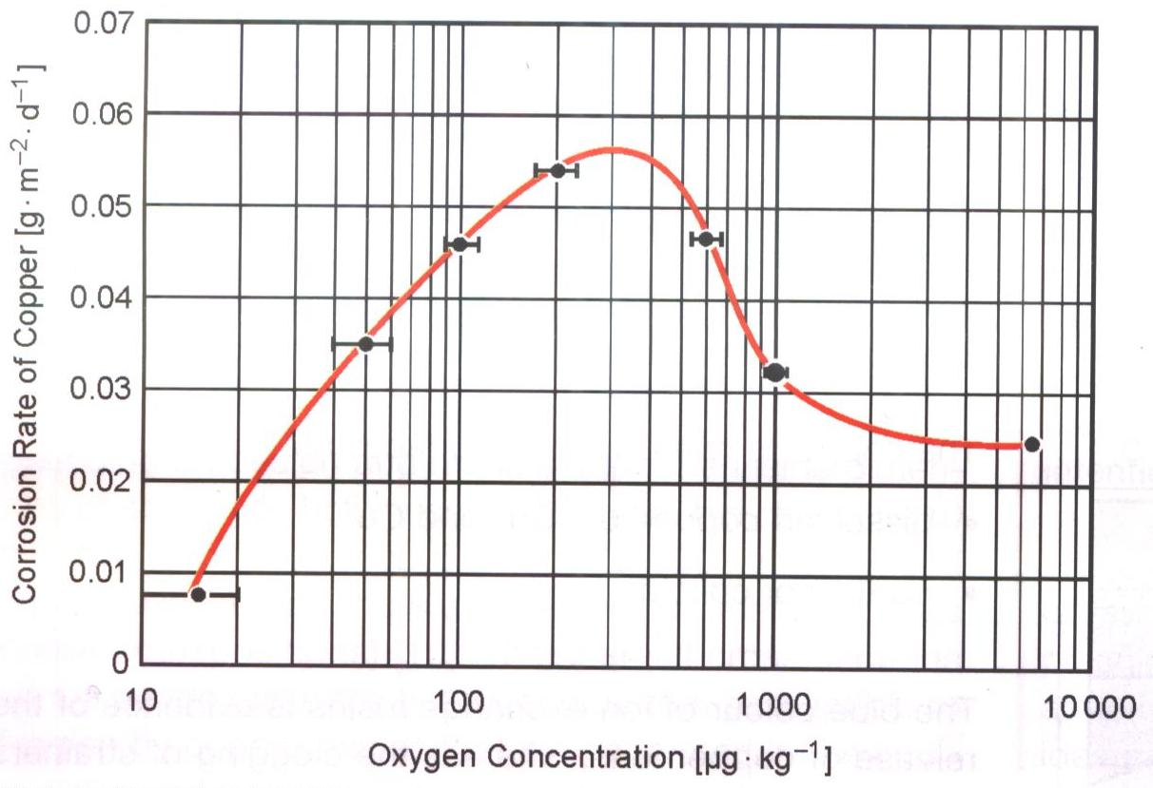

Figure H.1. Effect of Oxygen Concentration on Copper Corrosion Rate. Corrosion rate is mass per area per time (day). Testing parameters are pH = 6.5-7.0, Temperature = 40 °C, and Velocity = 1.2 m/s.

The Electric Power Research Institute (EPRI) recommends that mixed-metallurgy systems (i.e. those containing copper alloys in the feedwater) operate under a Reducing All-Volatile AVT(R) chemistry regime. Table H.1 (“Cycle Chemistry Guidelines for Fossil Plants: All-Volatile Treatment: Revision 1,” EPRI (#1004187), Palo Alto, CA, 2002) gives the specified parameters and limits.

Table H.1. EPRI Recommended Feedwater Limits for Systems Including Copper. Note: EI = economizer inlet; CPD = condensate pump discharge; DAI = deaerator inlet.

|  |  |
| --- | --- |
| **Parameter** | **Limit** |
| pH | **9.0 – 9.3** |
| Cation Conductivity | **< 0.2 µS/cm** |
| Oxygen (at EI) | **< 5 ppb** |
| Oxygen (at CPD) | **< 10 ppb** |
| Reducing Agent | **As Needed to Meet ORP** |
| ORP (at DAI) | **-300 to -350 mV** |

The oxidation-reduction potential (ORP) provides a measurement of the concentration of oxidizing and reducing species in the coolant water. It along with pH shows which corrosion processes are thermodynamically stable. Figure H.2 (“Copper Pourbaix Diagram,” PACE Technologies, 2006. [Online]. Available: http://www.metallographic.com/Data%20Storage/Pourbaix-copper.htm. [Accessed 7 June 2013]) shows a graphical representation of ORP and pH, called a Pourbaix diagram. The star roughly indicates the EPRI recommended operation point. Hydrazine is most commonly used as a reducing agent to enforce the ORP.

From the start, MPEX can expect a more challenging copper corrosion environment as the pH must be kept close to neutral to mitigate current leakage effects. Aside from the pH, it is noted that the MPEX specifications will not meet the electric power industry guidelines. As seen in Figure H.2, this could result in weakly-protective oxidation layers or even active corrosion of copper into the coolant.

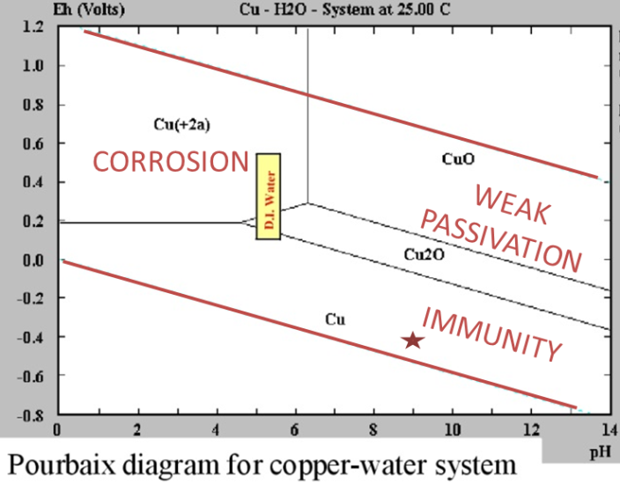

Figure H.2. Potential-pH Diagram for Copper-Water System. The star qualitatively indicates the operation point recommended by EPRI. Image modified from.

###### EXAMPLE: ARGONNE NATIONAL LABORATORY (ANL) ADVANCED PHOTON SOURCE (APS)

*Sources:* (R. Dortwegt and E. Maughan, "The Chemistry of Copper in Water and Related Studies Planned at the Advanced Photon Source," in *Proceedings of the 2001 Particle Accelerator Conference*, Chicago, IL, 2001, and R. Dortwegt, C. Putnam and E. Swetin, "Mitigation of Copper Corrosion and Agglomeration in APS Process Water Systems," in *2nd International Workshop on Mechanical Engineering Design of Synchotron Radiation Equipment and Instrumentation (MEDSI02)*, Argonne, IL, 5-6 September 2002).

In 1998, copper agglomeration and clogging in the APS cooling system reached a peak resulting in malfunctions of system flow components. Personnel at the APS became aware of copper corrosion issues common in the power industry (EPRI). Upon analysis, APS learned their deaerator unit was providing 100 ppb DOC which corresponded to the maximum rate of copper corrosion. An upgrade provided 5-10 ppb DOC along with better particle filtration. This was found to significantly reduce the rate of copper corrosion.

As an accelerator, the APS shares a unique trait with MPEX in that pH levels close to neutral are required to reduce leakage currents. After becoming aware of EPRI guidelines, APS reported a planned experiment to move coolant pH from 6.8 to 7.5 to further reduce copper corrosion rates.

###### EXAMPLE: ITER, TASK 511 SUBTASK 3

*Sources:* (W. Bogaerts, J. Zheng and J. Huyberechts, "Copper Alloy Corrosion in High-Temperature Water (Intermediate Report for Task T511, Subtask 3)," University of Leuven, Leuven, Belgium, May 2001, and J. Zheng and W. H. J. Bogaerts, "Erosion-Corrosion Tests of Copper Alloys under Incident Heat Flux (Final Report for Subtask 3 of the ITER Task 511)," University of Leuven, Leuven, Belgium, July 2003

Experimental investigation of corrosion of ITER-relevant copper alloys (OFHC, Glidcop, CuCrZr) provides further insight into the effects of oxygen concentration. Table H.2 summarizes testing at high flow rates. Marginal performance is seen in a high temperature and reducing environment. Unacceptable performance is seen in a high heat flux and oxidizing environment. The miter bend components of the ECH TL are expected to see heat fluxes peaking as high as 5 MW/m2. While temperature and flow velocities are expected to be lower, the factor of increase in corrosion under high DOC is cause for concern.

Table H.2. Corrosion experiments of ITER relevant Cu alloys (OFHC, Glidcop, CuCrZr). Corrosion loss measurements were estimated by weight loss.

|  |  |  |  |  |
| --- | --- | --- | --- | --- |
| **Velocity** | **Temperature** | **O2 Env.** | **Heat Flux** | **Corrosion Loss** |
| 10 m/s | **100 °C** | **Both** | **--** | **~ 20-30 µm/yr** |
| 10 m/s | **250 °C** | **Reducing** | **--** | **~ 100 µm/yr** |
| 10 m/s | **100 °C** | **Oxidizing** | **10 MW/m2** | **~ 500 µm/yr** |

1. In the context of helicon plasmas, fast and slow waves refer to the fast and low branches of the whistler wave. Moreover, in cylindrical geometry, the fast and slow waves can form eigenmodes and are referred to as the helicon and Trivelpiece-Gould (TG) modes, respectively. [↑](#footnote-ref-2)